**Figure 1. GetPrice.jsp display page.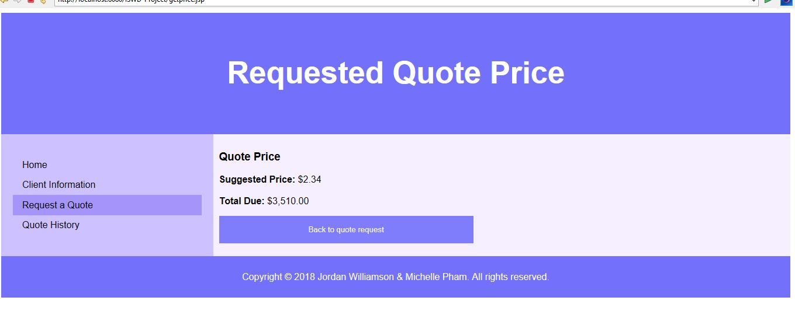Figure 2. getPrice.jsp code.**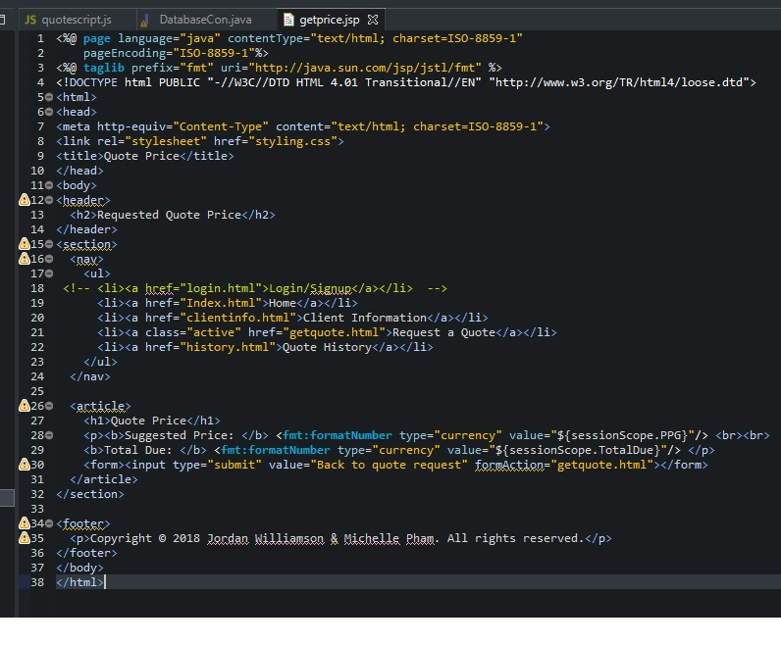

**Figure 3. quotescript.js for filling/saving values on RequestQuote page.**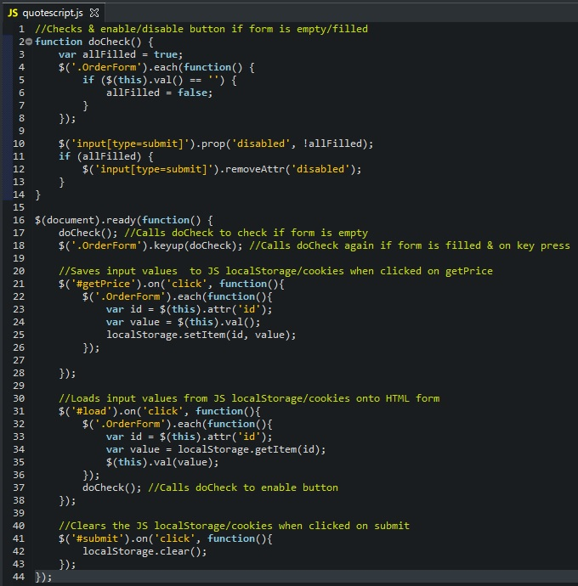

**Figure 4. Pricing module as a servlet.**