Test run: Fei-Tzin

Not all functionality implemented yet. For calendar, since some events are recurring, it may be best to let the user choose the date of the event rather than showing every single recurrence on the calendar (for instance, a user may not want to see every one of the showings of a movie, only the one they're going to).

Before:

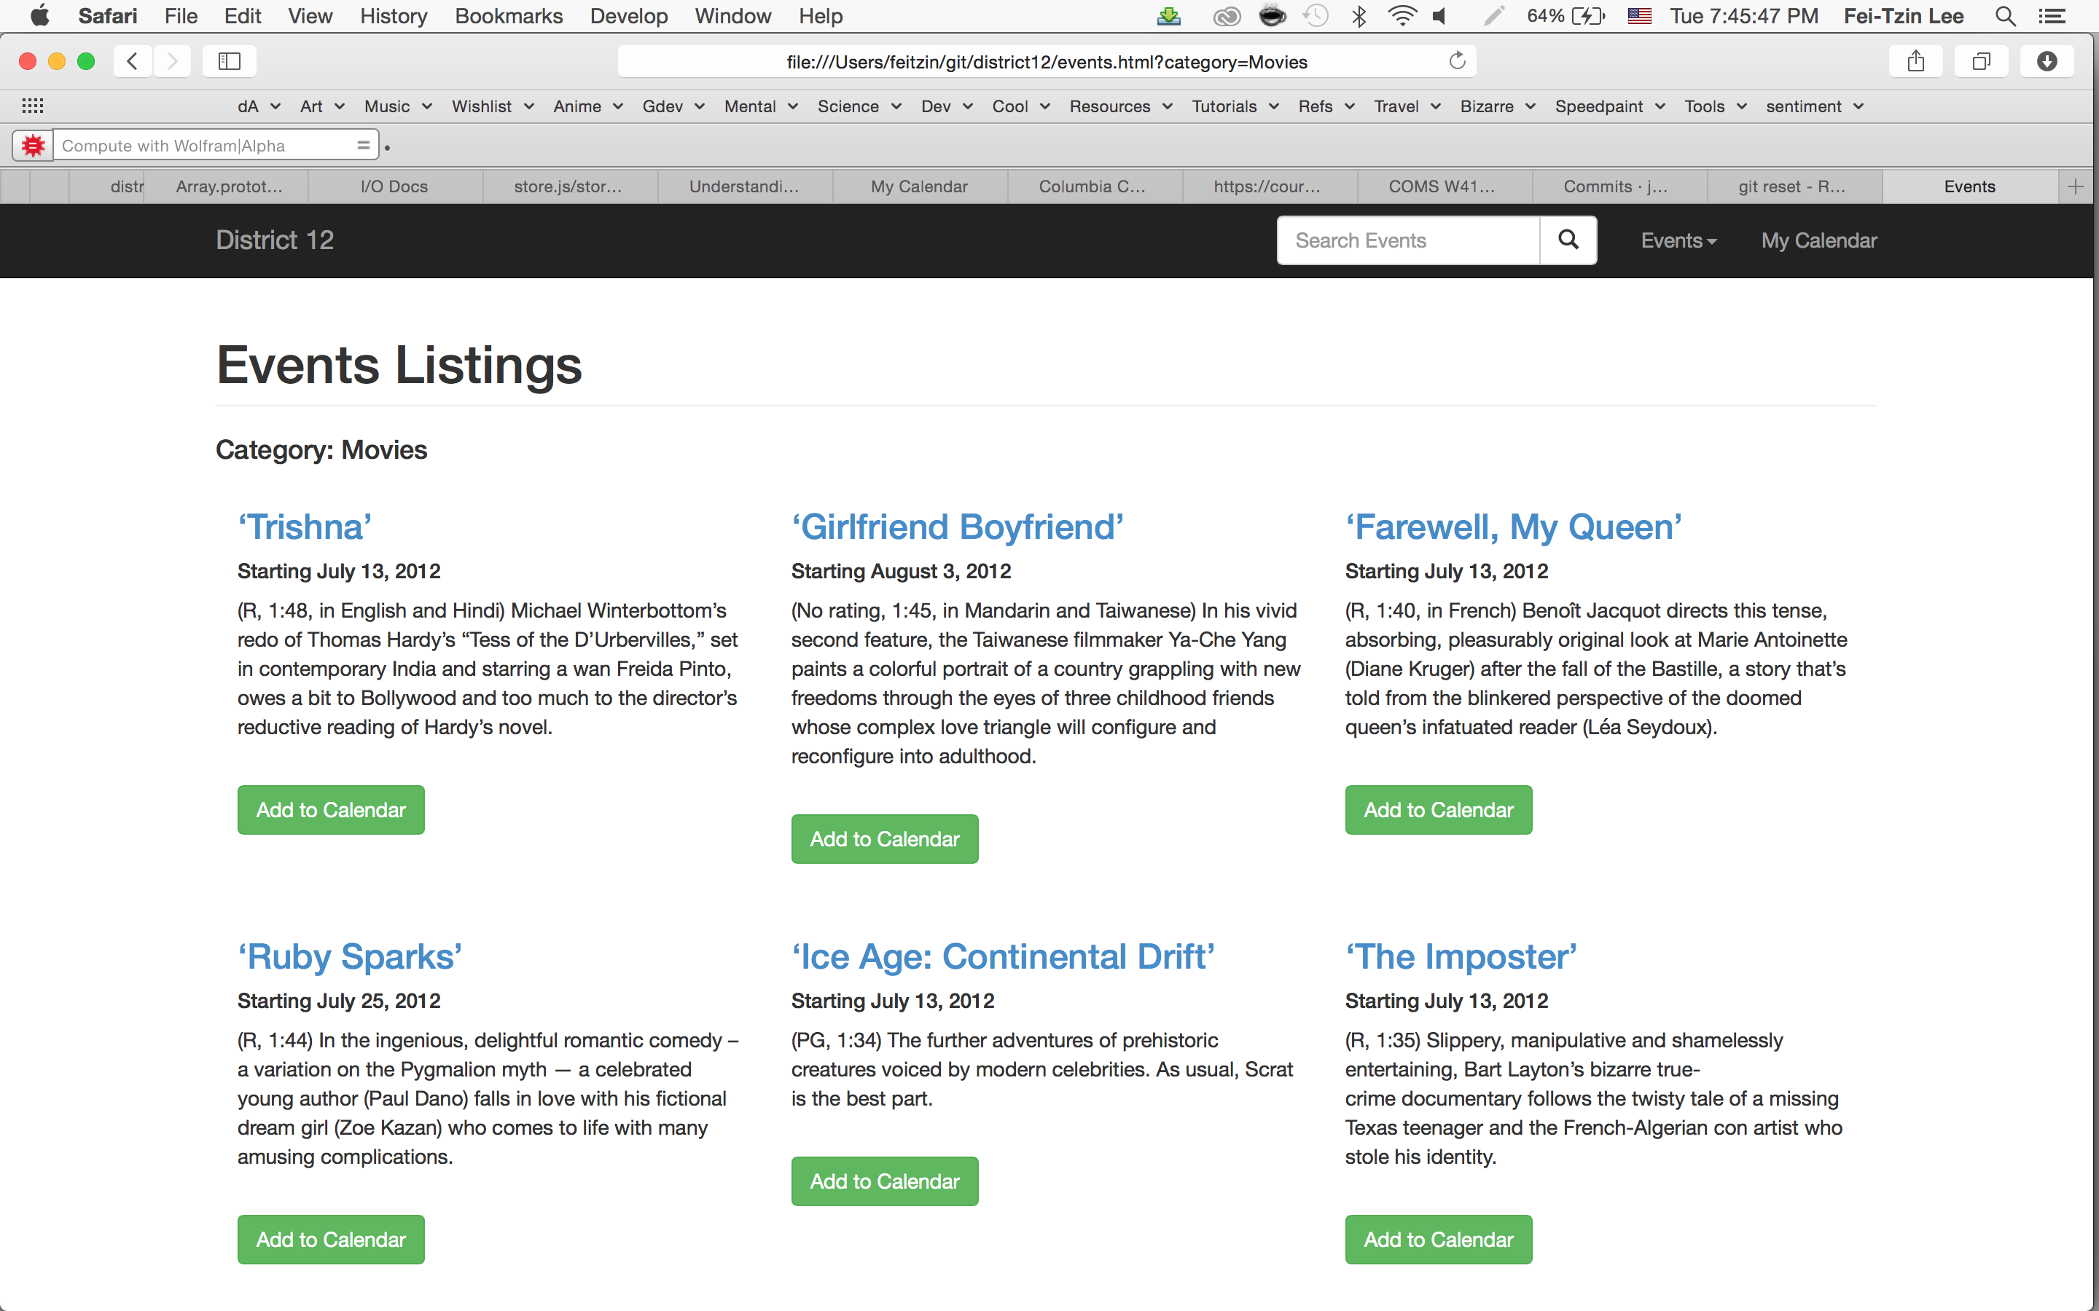

After:

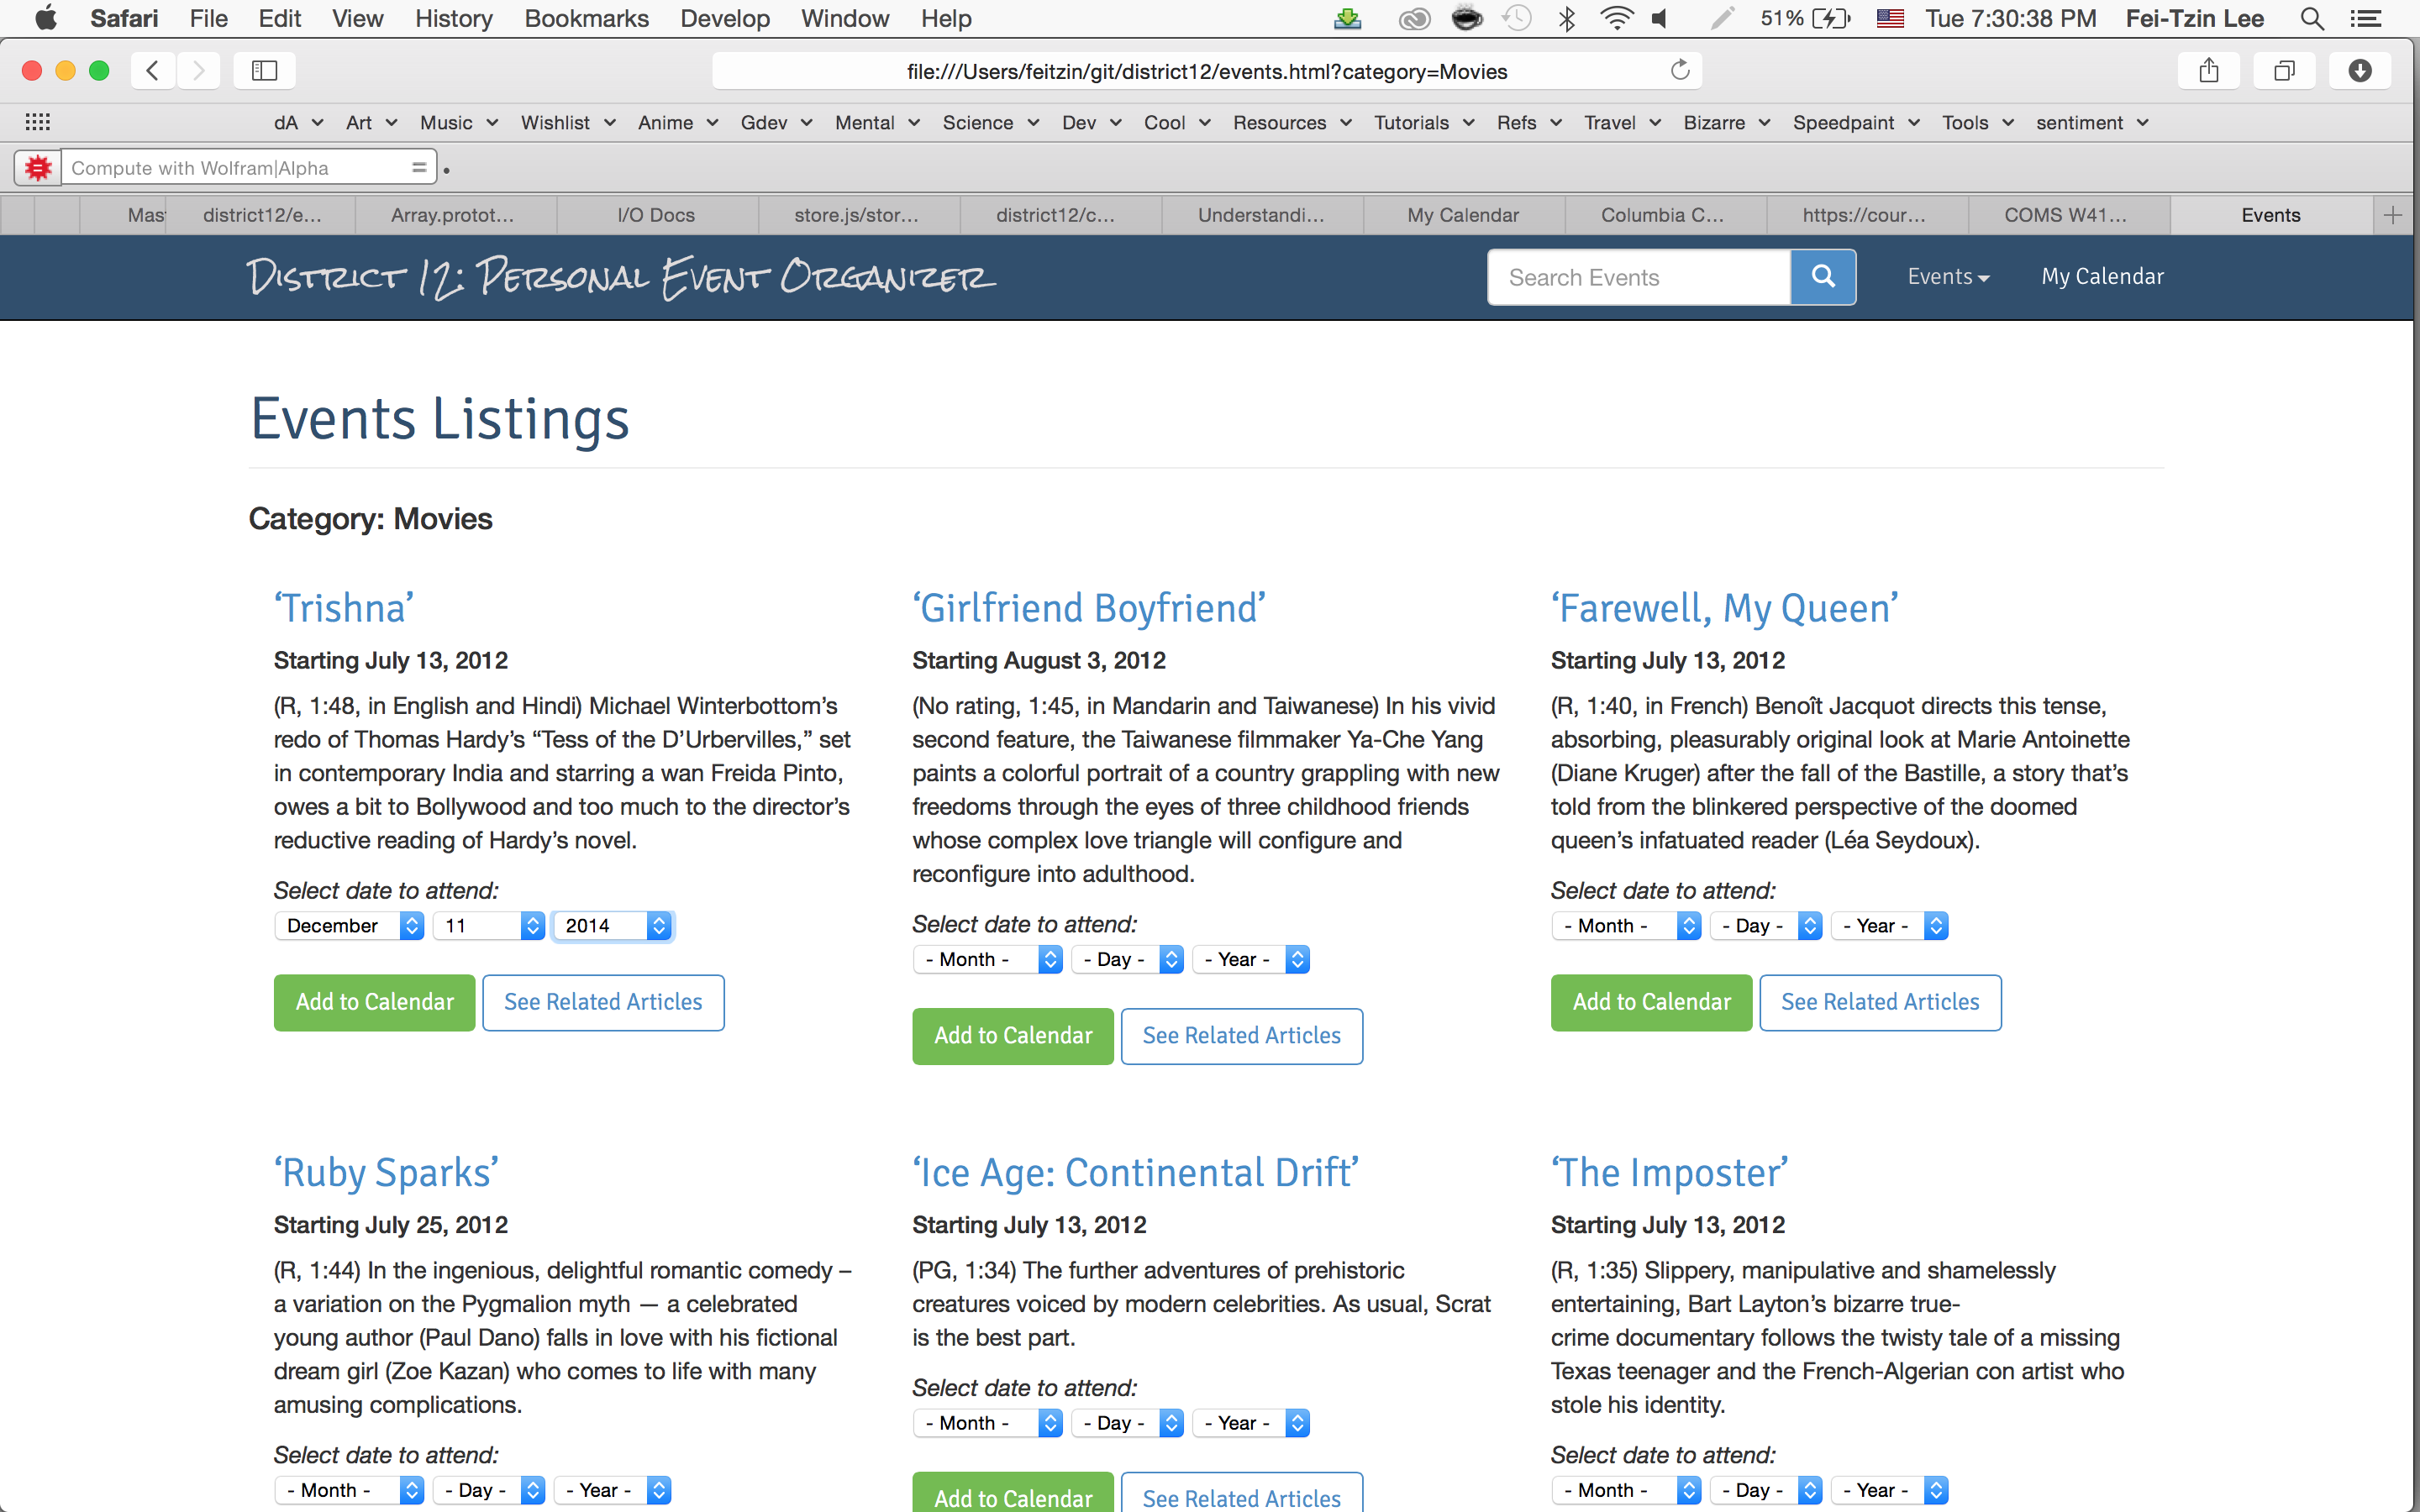
A dropdown menu was implemented to allow user selection of event date/time.

