**Assignment 2 Report**

**Johnny Wilson**

**jew574**

**Github: jw5743**

**Function:**

**Goal**

* The goal of my Body Mass Index function is to initiate height and weight calculations in order to inform the user of their health condition based on inputs entered by the user.

**Test 1:** The user must input integers that result in an 'underweight' Body Mass Index.

**Outcome (Pass or Fail?): PASS**

**Justify Outcome:**If the user inputs a height of 60 inches and a weight of 95 the Body Mass Index will result in the user being underweight.

**Recommend Improvements (if any):** None

**Justify your Improvement recommendation:** None

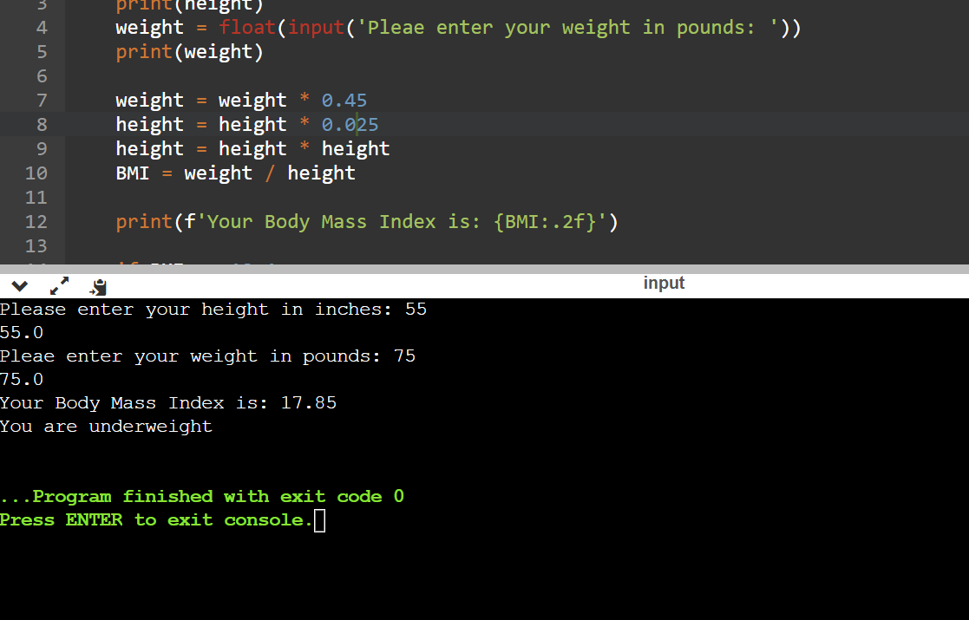

**Test 2:**The user must input integers that result in an 'overweight' Body Mass Index.

**Outcome (Pass or Fail?): PASS**

**Justify Outcome:**If the user inputs a height of 61 inches and a weight of 140 the Body Mass Index will result in the user being overweight.

**Recommend Improvements (if any):** None

**Justify your Improvement recommendation:** None

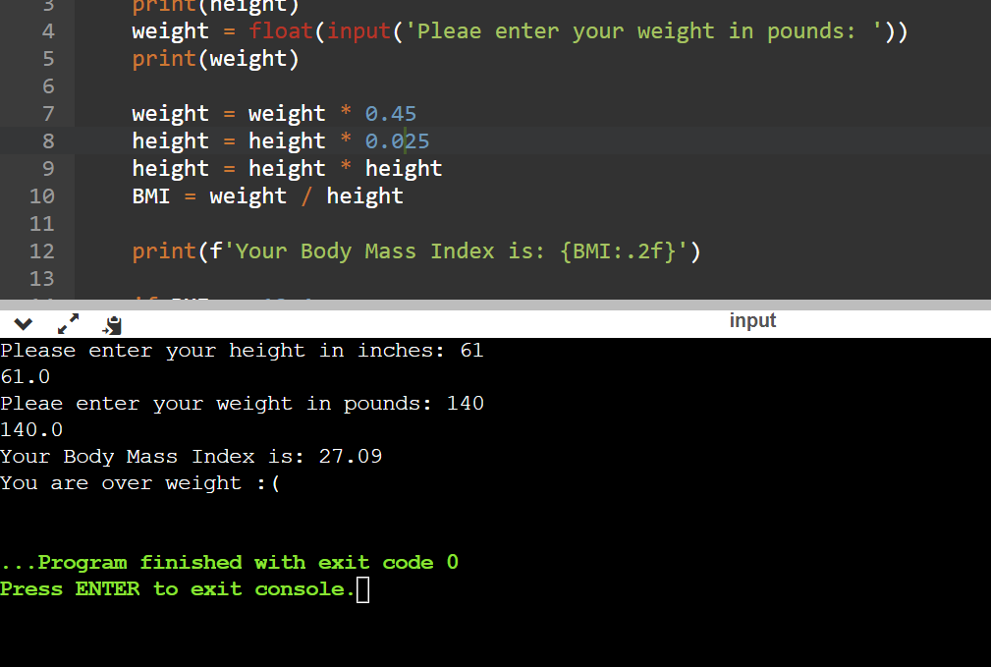

**Test 3:** The user must input integers that result in a 'healthy' Body Mass Index.

**Outcome (Pass or Fail?): PASS**

**Justify Outcome:**If the user inputs a height of 60 inches and a weight of 95 the Body Mass Index will result in the user being healthy.

**Recommend Improvements (if any):** None

**Justify your Improvement recommendation:** None

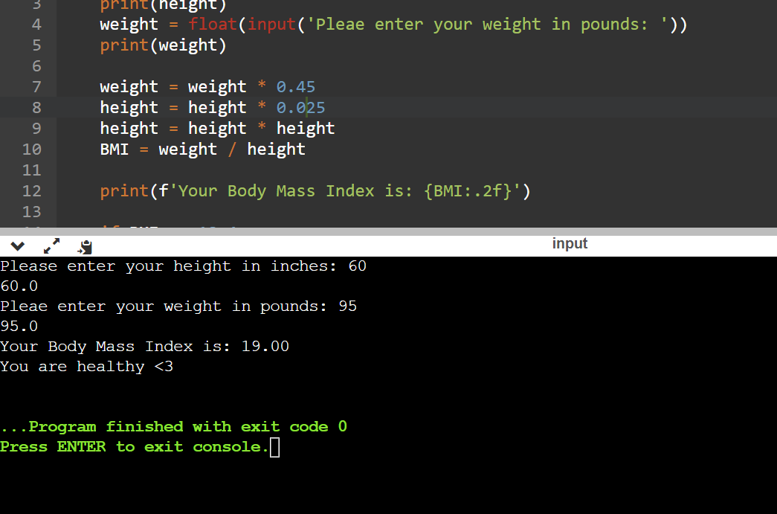

**Test 4:**The user must input integers that result in an 'obese' Body Mass Index.

**Outcome (Pass or Fail?): PASS**

**Justify Outcome:**If the user inputs a height of 70 inches and a weight of 300 the Body Mass Index will result in the user being obese.

**Recommend Improvements (if any):** None

**Justify your Improvement recommendation:** None

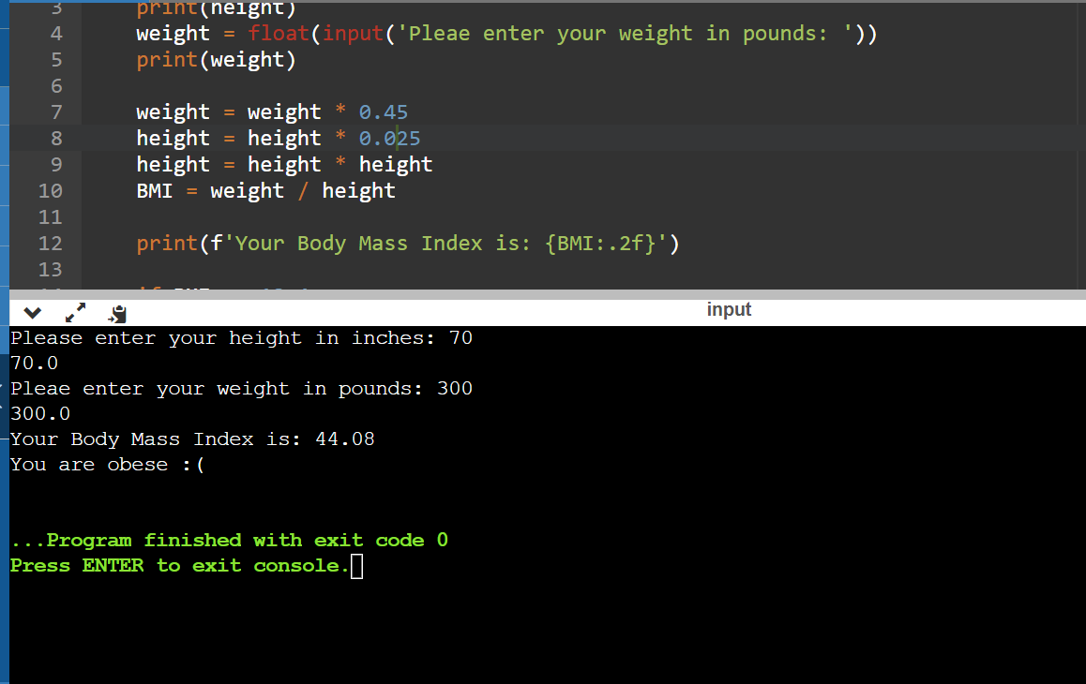

**Boundary Testing Technique**

* I used Input Domain Partitioning because it is what I could comprehend the best. I used the user’s integers they inputted to obtain the Body Mass Index which is the output.

**Lower Boundary Shift by 0.1 for Normal Weight**

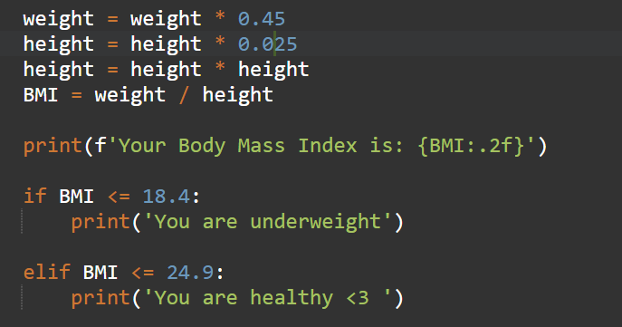

**Setup and Execution**

1. Go to my Github repository through link. (Repository Name: Software-Q-Assignment2)

<https://github.com/jw5743/Software-Q-Assignment2>

1. Download file from Main Branch
2. Navigate to online complier used for project through link below:

<https://www.onlinegdb.com/online_c_compiler>

1. Filter coding language in top-right corner to ‘Python 3’
2. Paste code downloaded from Github repository to online compiler,
3. Run the program using the green button located at the top of the page.