**Introduction to Metro do Porto and Snowball Strategy**

Metro do Porto (MdP) is a transport utility company, created to manage and develop the subway network in the metropolitan area of Porto, operating since 2002. It needed vast quantities of liquidity in order to finance its operations, which includes building new railways. Some of these loans were given by the European Investment Bank (EIB), and some of them with governmental guarantees. With such high debt levels, there might exist some incentives in terms of lowering the amount of interests paid. However, in an environment of financial constraints, in which the Government is not able to provide additional loan guarantees and also demands for less expenses, such incentives might turn into real pressure. Debt-laden MdP signed deals with investment banks, hoping to reduce debt repayments. But many of these complex deals have since gone spectacularly sour.

**Snowball Swap Characteristics**

The company was urged to reduce its fixed-rate of 4.76% semi-annually relative to a straightforward 20-year fixed-for-floating swap. This contract, traded with Banco Comercial Português (BCP), was initially designed to cover a floating 20-year loan, which was an adequate hedging strategy considering interest-rate risk. After considering the proposals from various banks, MdP entered in another swap with Banco Santader Totta (BST), with and underlying of 89 Million euros, in which the bank agreed to pay a fixed coupon of 4.76% semi-annually. In the opposite direction, MdP agreed not only to pay the bank a semi-annual coupon of 1.76%, but also a quarterly floating rate coupon with a calculated spread tied to the 3-month Euribor that responded to the following conditions that would only become active after the first two years:

* Previous quarter spread, plus:
  + 2 times the difference between 2% and 3-month Euribor at the payment period of the coupon, if 3-month Euribor is below 2%;
  + Or, 2 times the difference between 3-month Euribor, at the payment period of the coupon, and 6%, if 3-month Euribor is above 6%
* Or, Previous quarter spread, minus:
  + 0.5% if 3-month Euribor at the payment of the coupon was between 2% and 6%, but the spread would never go negative.

In a simpler way, we can explain that, after two years, for every quarter that 3-month Euribor would be outside the interval of 2% and 6%, the clause would be activated, having a memory effect, i.e. taking into account the previous spread. The calculated spread would successively decrease in 0.5% for each time the 3-month Euribor was in the interval of 2% and 6%, but never going below zero.

1. Probable mistakes made by management in utilizing this type of swap
2. At firm level, this snowball case there is a clear deviation from hedging and keeping simple hedging strategies/structures as the contract revealed to have a certain degree of complexity and potential toxicity (5th degree by the IGCP scale).
3. Transparency was also an issue, at firm and regulatory levels, as the accounting standards were not clear in presenting the derivatives portfolio before the SNC, and when the new standards were adopted, it was too late.
4. On another hand, the firm may have relied too much in the fact that historically had never left the 2-6% range before, but when the money market suffered a shock all the assumptions no longer hold.
5. Adding to this, it also seemed that a certain short-termism from managers might have been present, due to the fact that the contract enabled certain refinancing savings for the first 2 years, during which the calculated spread was not to be activated.
6. A list of alternative interest rate management instruments/strategies that might have been used instead of the swap.
7. Normal Interest rate swap without snowball clause
8. Interest rate futures
9. General types of potential and actual risks created when using derivatives to solve organizational problems (to educate management)

* Market risk
* Model risk
* Business risk
* Strategic risk
* Insurance risk
* Credit and counterparty risk
* Liquidity risk
* Operational risk (Enterprise risk)
* Legal and regulatory risk
* Compliance risk
* Foreign exchange risk
* Model risk
* Accounting risk
* Reputational risk
* Interest Rate risk
* Funding risk
* Systemic risk

1. Your proposed design of an Enterprise Risk Management (ERM) framework that would help Metro do Porto to identify and control future risks, thereby minimizing the chance of future outcomes such as happened with the Snowball Swap.

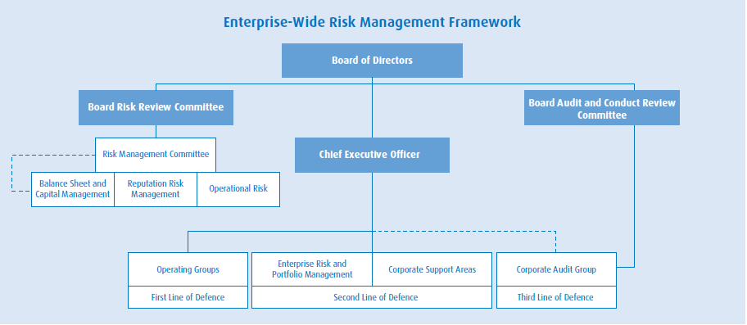

Source: Enterprise-Wide Risk Management

|  |  |
| --- | --- |
| **Board of Directors** | is responsible for the stewardship of BMO and protecting the interest of BMO’s shareholders. The board, either directly or through its committees, is responsible for oversight in the following areas: strategic planning, defining risk appetite, identification and management of risk, capital management, promoting a culture of integrity, governance, internal controls, succession planning and evaluation of senior management, communication, public disclosure  and corporate governance. |
| **Risk Review Committee of the Board of Directors (RRC)** | assists the board in fulfilling its oversight responsibilities in relation to BMO’s identification and management of risk, adherence to risk management corporate policies and procedures, compliance with risk-related regulatory requirements and evaluation of the Chief Risk Officer. |
| **Audit and Conduct Review Committee of the Board of Directors** | assists the board in fulfilling its oversight responsibilities for the integrity of BMO’s financial reporting, effectiveness of BMO’s internal controls and performance of its internal and external audit functions. |
| **Chief Executive Officer (CEO)** | is directly accountable to the board for all of BMO’s risk-taking activities. The CEO is supported by the Risk Management Committee and its sub-committees, as well as Enterprise Risk and Portfolio Management. |
| **Chief Risk Officer (CRO)** | reports directly to the CEO and is head of Enterprise Risk and Portfolio Management (ER&PM). The CRO is responsible for providing independent review and oversight of enterprise-wide risks and leadership on risk issues, developing and maintaining a risk management framework and fostering a strong risk culture across the enterprise. |
| **Risk Management Committee (RMC)** | is BMO’s senior risk committee. RMC reviews and discusses significant risk issues and action plans that arise in executing the enterprise-wide strategy. RMC provides risk oversight and governance at the highest levels of management. This committee is chaired by the CRO. |
| **RMC Sub-committees** | have oversight responsibility for the risk and balance sheet impacts of management strategies, governance, risk measurement and contingency planning. RMC and its sub-committees provide oversight over the processes whereby the risks assumed across the enterprise are identified, measured, monitored and reported in accordance with policy guidelines and are held within delegated limits. |
| **Enterprise Risk and Portfolio Management (ER&PM)** | Provides independent oversight of the credit and counterparty, operational and market risk functions. It promotes consistency of risk management practices and standards across the enterprise. ER&PM facilitates a disciplined approach to risk-taking through the execution of independent transactional approval and portfolio management, policy formulation, risk reporting, stress testing, modelling, vetting and risk education responsibilities. This approach seeks to meet enterprise objectives and to ensure that risks assumed are consistent with BMO’s risk appetite. |
| **Operating Groups** | are responsible for managing risk within their respective areas. They exercise business judgment and seek to ensure that policies, processes and internal controls are in place and that significant risk issues are appropriately escalated to ER&PM. |

Reference

* Interest-rate Risk Management and the usage of Interest-rate Swap Derivatives in State Owned Enterprises: A Portuguese Case Study by João Aguiar Jorge da Silva
* Enterprise-Wide Risk Management