**Login v1**

Step1. Please install XAMPP

Step2.click config in Apache, ->( Apache(httpd.conf) )

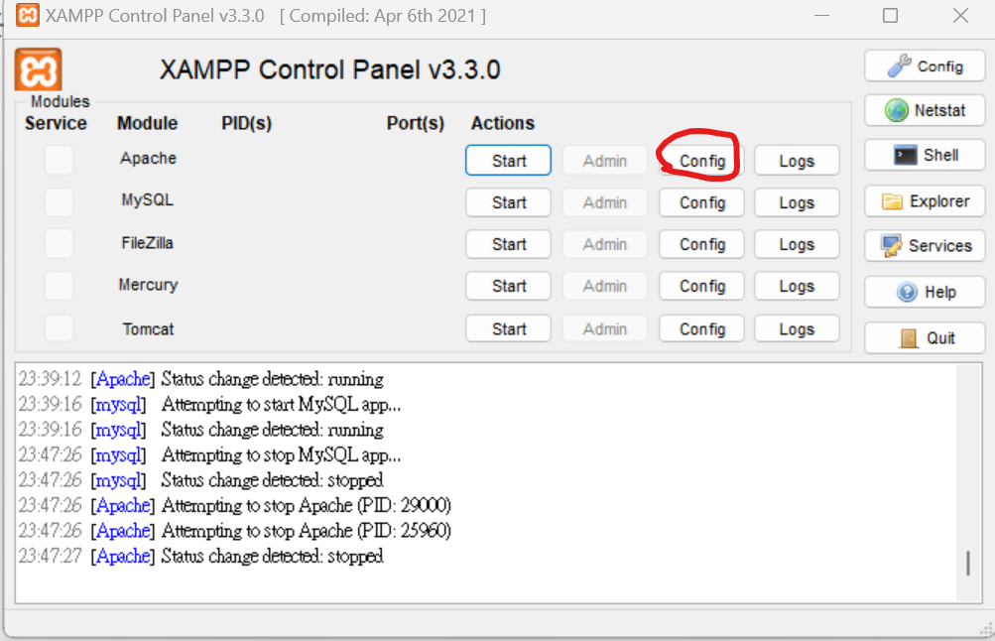

Step3. Change “ Listen:8080”

Step4. Start Apache, MySQL

Step5: goto localhost:8080 , click phpMyAdmin

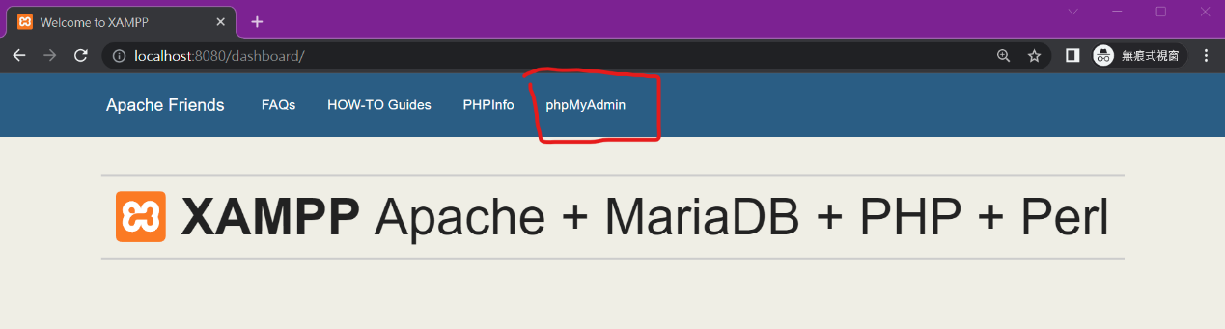

Step6. 新增 -> plz import csci3100 (SQL Text File)

It includes courses, users table.

Step7.open frontend and backend in VSC

Frontend:

Terminal:

npm i

install -g nodemon

npm run dev

* url: http://localhost:3000

backend:

Terminal:

npm i

nodemon app

(may has problem -> please run “powershell”->Set-ExecutionPolicy Unrestricted)

nodemon app

* step8: <http://localhost:3000> can login, reg ac