Genetics Review Session for Final

**Question 2 on Exam 1**

597

299

Lethality will always give you a 2 to 1 ratio

Monohybrid crosses yield 1AA: 2Aa: 1aa

Lose 1 category being lethal either AA or aa

If it were 3:1, then it would be complete dominance

**Epistasis & Gene Interaction**

Epistasis is a specific type of gene interaction

2 genes working together to create 1 phenotype

In Mendelian inheritance if you have 2 genes, AaBB- one would code for red, b would code for tall

In epistasis, those two together make one phenotype- becomes tall

Aa BB

Red Tall

Brown Medium

Green Short

(Color)

Together make arrangement of branches- needs both genes to make it exist

9:3:3:1

When you do a dihybrid cross, it’s a phenotypic ratio from AaBb x AaBb

9 Furry, green

3 bald, green

3 Furry, purple

1 bald, purple

Two traits represented by each phenotypic category- traditional kind  
When you’re doing gene interaction, you only have one thing

9 Healthy Two dominants

3 Healthy One dominant (A- bb)

3 Sickly One dominant (aa B-)

1 Sickly Two recessive (aa bb)

Combination of categories 12:4 (always combines, never random numbers)

Either epistasis or gene interaction

Everything in the a will overpower the b

B helps out, but it’s not as important

9 Healthy Two dominants

3 Healthy A- bb

3 Susceptible to illness aa B-

1 Sickly aa bb

Know your ratios going in- get yourself in the right spot

Going to use the classic examples: phenotypes

3:1 complete dominance

1:2:1 incomplete dominance or co dominance

9:3:3:1 dihybrid

Monohybrid cross: 1 gene is being tested

Bigger crosses can be reduced to monohybrid crosses

Work with one at a time

Product rule

**Translocation Cross**

If you have a translocation you have a chromosome with a translocation from another non homologous chromosome

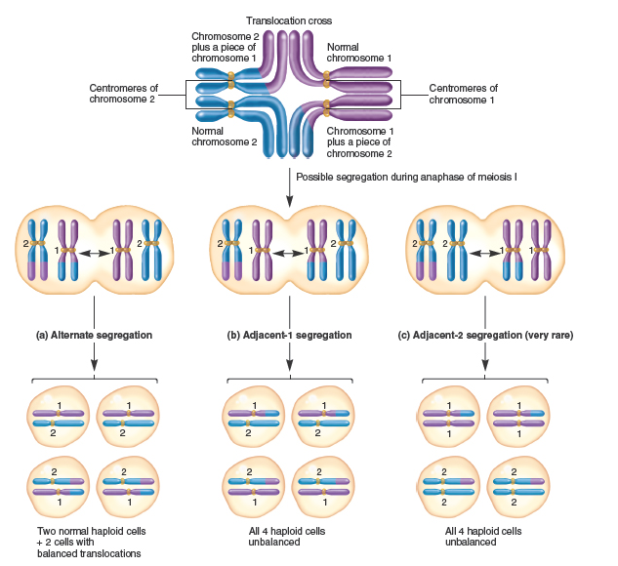

If you pick alternate, 2 are normal 2 are not but they’re at least balanced- so they will be viable

Adjacent they’re not balanced so they won’t be viable

**Chi Squared Analysis**

2 ways they can be used

1. Goodness of fit: looking at hypothetical data- look at a hypothesis that you think fits. Test it against the data, see if it fits the hypothesis.
2. Linkage: You can’t predict how far they are from each other so you create a null hypothesis: that they are unlinked (independent assortment)
   1. We only use a test cross- 1:1:1:1

**Linkage Problem**

Straightforward problem

Chapter 6 E14

Looking at garden peas

Pods Leaves

117 green normal

115 yellow curling

78 green curling

80 yellow normal

390

yellow, curling x green, normal

F1: All offspring had green, normal

Telling you what the heterozygous is (green and normal are dominant)

Green, normal from F1 x yellow, curling (test cross)

Expect 1:1:1:1

If we want to determine if it’s truly a linkage we would do a chi square test

We want to look at the recombination frequency

Recombination frequency = map units = cM

# recombinant offspring x 100

total

total = 390

recombinant frequency = 158

158/390 = 40.5% recombination frequency

Any time you have a linkage problem, the lower numbers are always the recombinants, the higher numbers are always the parentals

Chapter 8 E13

151 tall s n

33 tall s o

11 tall p o

2 tall p n

155 dwarf p o

29 dwarf p n

12 dwarf s n

0 dwarf s o

Determine gene order

1. Arrangement of gene on heterozygous parents
   1. Parentals are 155 and 151- look at the arrangement of heterozygous parent

This is cis because all dominants and recessives are on their own side

T S N

t s n

* 1. DCO are 0 and 2

T s N

t S n S is in the middle because it’s the one that switched

Gene order is T N S

t n s

Other pairs are single cross overs, based on how close they are to each other

1st single cross over

33+29+2+0 = 16 mu

393

2nd single cross over

12+11+2+0 = 6 mu

393

We can also look at interference

I = 1 – #DCO obs/ # DCO exp

Exp # DCO = distance1/100 * distance2/100 * total

6/100 * 16/100 * 393 = 3.7

I = 1- 2/3.7 = 4.6%

**Product and Sum Rules**

Look at this to remind yourself…. Know the difference between what you would use and when.

If you are making something easier with OR you add the two probabilities together (makes it bigger, therefore more likely)

Never get more than 100%

Product rule decreases the probability

If it means that it’s increasing it, you need to use the sum rule somewhere

**Blood Typing**

Multiple alleles and codominance

Most traits have multiple alleles

Also have dominant and recessive

**Sex Linked, Sex Limited, Sex Influenced**

Sex linked- on the sex chromosome

It’s really X linked, father to daughter, mother to son

Females can be the carrier or be affected by it

Males always get it from their mom, are always affected (can’t be carriers)

Sex influenced and limited are on autosomes

Same for genotypes, but the difference is in when you interpret the phenotype

Sex limited: both can have the genotype but only one sex can have it

Can have the genes and pass it on, but don’t show the trait

Sex influenced: The dominant and recessive are switched – how easily it is for a trait to be expressed

**Meiosis and Mitosis**

Know what it is and know the differences

Compare and contrast

Two whole cycles in meiosis

CARE WHAT HAPPENS TO CHROMOSOMES

Know when homologous chromosomes pair and separate in meiosis

Should be able to relate it to genotype, how they relate to what’s actually happening in meiosis.

Nondisjunction: Chromosomes don’t separate during metaphase in meiosis I or II

**Case Study**

Data analysis

What is epigenetics?

What is the relationship between schizophrenia and epigenetics?

Can you look at the data and tell me what’s going on? Relationship between REELN, methylation, expression of genes. When twins start out, they are very similar in their methylation patterns, as they grow up they have different methylation patterns

**Chapter 15**

Terms, regulation, how they’re regulated

Methylation

CpG islands

Eukaryotic gene regulation

**Replication**

DNA structure

Objective question or two

Chromosome structure

Nucleosome: related to gene regulation, structure, how it’s changed to be regulated

Chromatin remodeling, histones

New things we learned: difference between prokaryotes and eukaryotes, rolling circle, d loop, telomere replication

**Sex Determination**

Difference between ZW and ZZ systems

Drosophila – number of sex chromosomes compared to total autosomes

**No plant stuff**

What is the difference between gametogenesis and meiosis

What is the difference between spermatogenesis and oogenesis

Spermatogenesis- 4

Oogenesis – Makes polar bodies, only makes 1 haploid gamete at the end of oogenesis, others are lost

**Independent Assortment and Random Segregation**

Independent assortment: Doesn’t apply in linkage

Has to do with two alleles

Random segregation: One allele

**Linkage**: Chapter 6- first two sections, up to 3point cross

Know major contributions by scientists

A sentence about each one, not the particular details

LacOperon: Section 1 and 2 of chapter 14

Chapter 15

Chapter 16: Epigenetics case study and a little bit of reading