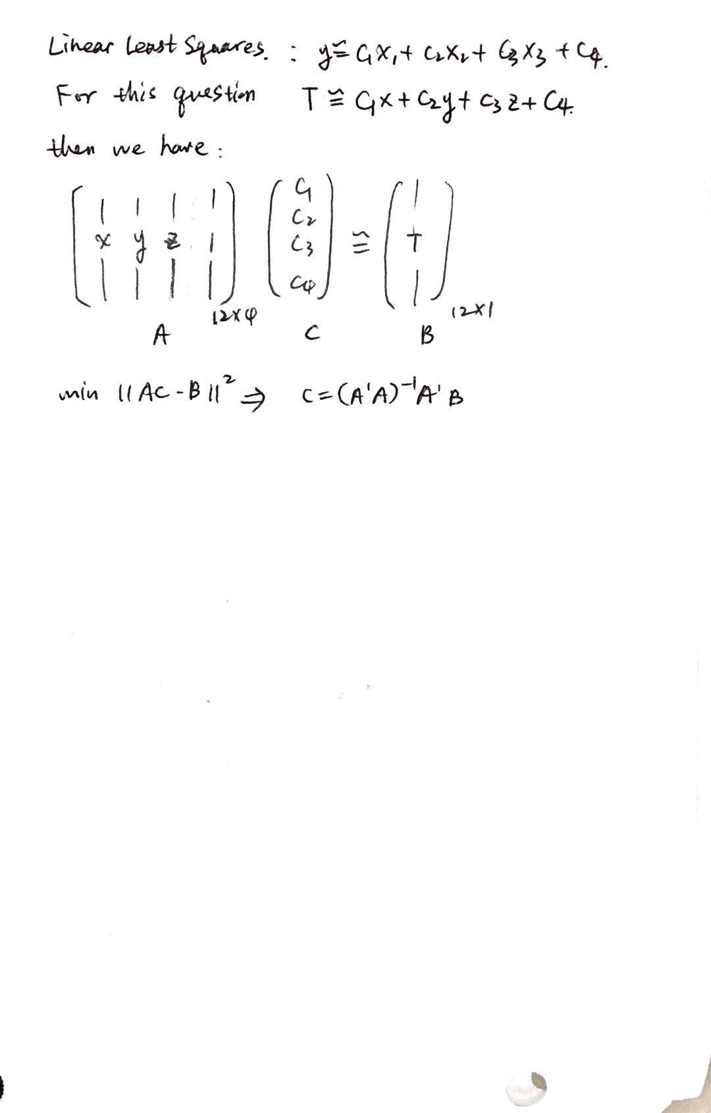

T(5,5,5) =21.39

1. As shown in the plot, one should move to negative z direction to experience the largest decrease in temperature.



How this work:

By setting two variables fixed and change the other variable, we can see the change in T according to only one parameter.

(actually we can also find that through c vector)

For instance,

Only change x=(4:0.1:6)', keep y and z as 5.

Then we have A matrix in the form of:

|  |  |  |  |
| --- | --- | --- | --- |
| 4 | 5 | 5 | 1 |
| 4.1 | 5 | 5 | 1 |
| 4.2 | 5 | 5 | 1 |
| 4.3 | 5 | 5 | 1 |
| 4.4 | 5 | 5 | 1 |
| 4.5 | 5 | 5 | 1 |
| 4.6 | 5 | 5 | 1 |
| 4.7 | 5 | 5 | 1 |
| 4.8 | 5 | 5 | 1 |
| 4.9 | 5 | 5 | 1 |
| 5 | 5 | 5 | 1 |
| 5.1 | 5 | 5 | 1 |
| 5.2 | 5 | 5 | 1 |
| 5.3 | 5 | 5 | 1 |
| 5.4 | 5 | 5 | 1 |
| 5.5 | 5 | 5 | 1 |
| 5.6 | 5 | 5 | 1 |
| 5.7 | 5 | 5 | 1 |
| 5.8 | 5 | 5 | 1 |
| 5.9 | 5 | 5 | 1 |
| 6 | 5 | 5 | 1 |

Then we compute T according to c calculated in part(a) and above matrix. Which will generate three different lines for the change in x, y, z. And the one with largest slope gives the most temperature decrease/increase.