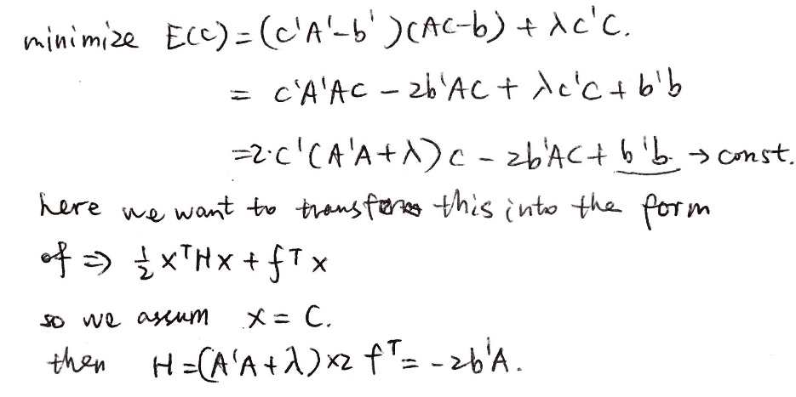

Using c = quadprog(H,f), we get same outcome as that in (b).

C=

17.5389466253032

-22.0064863584709

-21.0691332541080

7.03986694510145

33.8281939478690

20.7969710303193

-38.3829232836674

-5.43879579847226

8.07409936364838

-0.0974101610758693

C_diff=zeros(10,1)