Brendan Stratham  Minneapolis, Minnesota  ASU  Psychology | Constantino Jakobson  Park City, Utah  Southern Utah University  English | Edgar Power  Kansas City, Missouri  University of Kansas  Political Science | Michael Fiddler  Stevens Point, Wisconsin  University of Arizona  Electrical Engineering | Luvinia Phillips  Boston, Massachusetts  Umass  Economics
Eli Strange  San Diego, California  UC San Diego  Political Science | Douglas Collins  Phoenix, Arizona  ASU  Political Science & International Relations | Frederica Chester  Phoenix, Arizona  Northern Arizona University  Accounting | Cherise English  Chicago, Illinois  LSU  Human Resources | Tucker Wright  Paso Robles, California  Cal Poly SLO  Economics & Supply Chain Management
 |  |  |  | 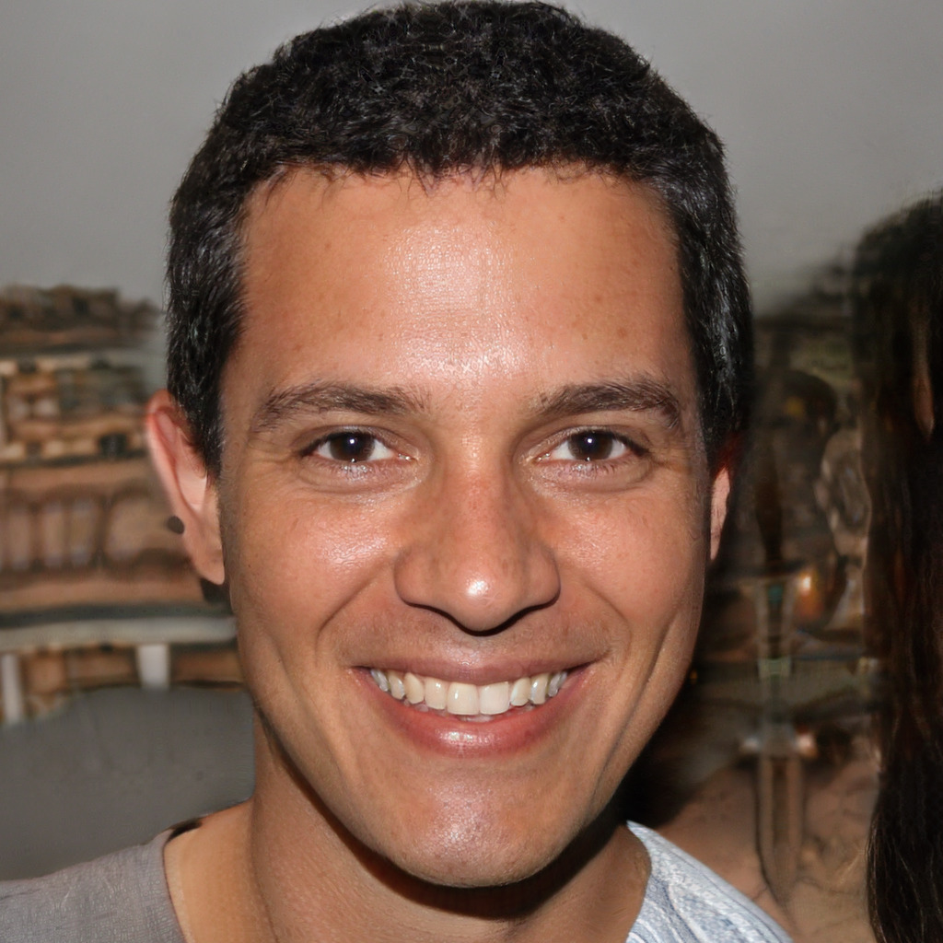
 |  |  | 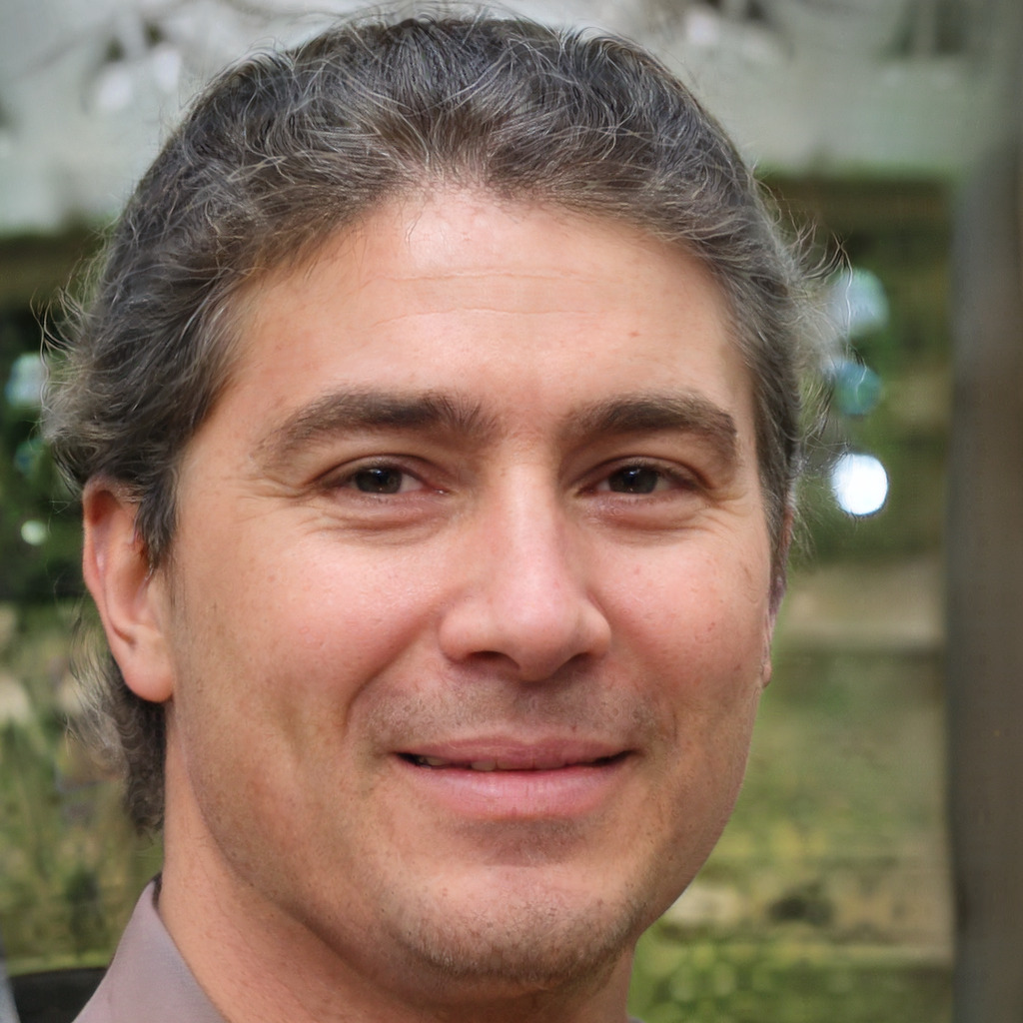 | 
Brianna Crawford  Dallas, Texas  BYU  Political Science | Alana Janson  Chandler, Arizona  ASU  Business Law | Eugene Carmen  Scottsdale, Arizona  ASU  Law & Psychology | Marta Abbes  Mesa, Arizona  Grand Canyon University  Political Science | Therese Godard  Phoenix, Arizona  ASU  Finance
Angela Waldo
Tacoma, Washington
University of Washington
Political Science
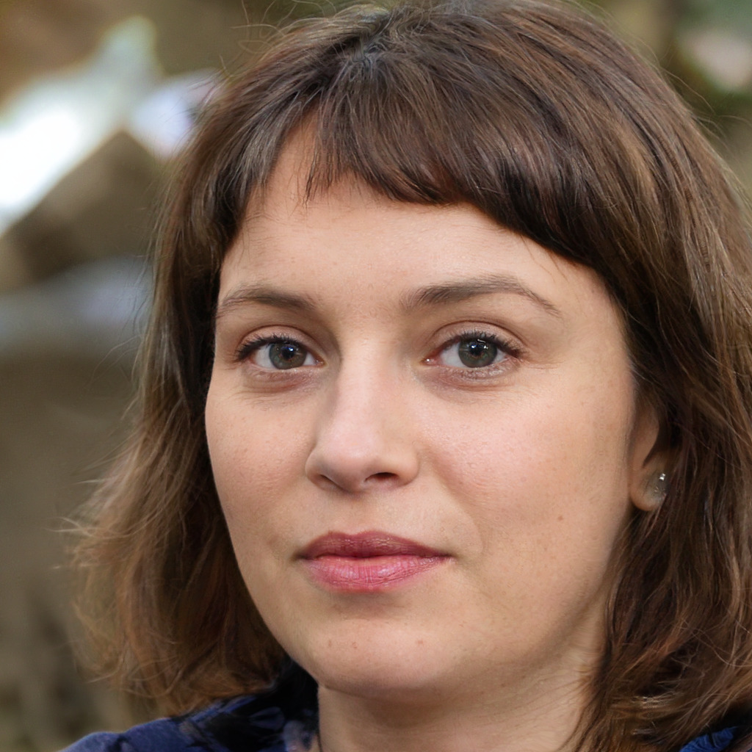 | 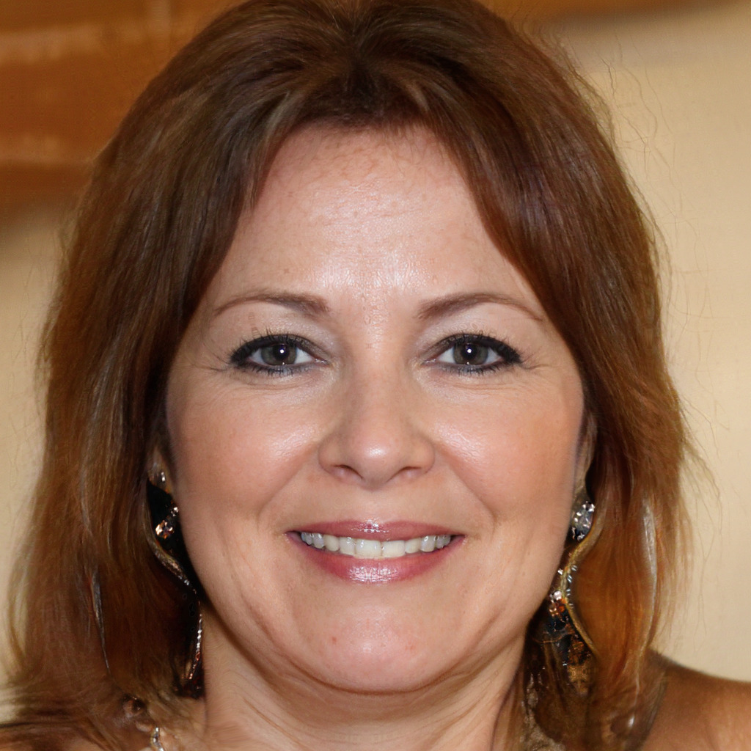 | 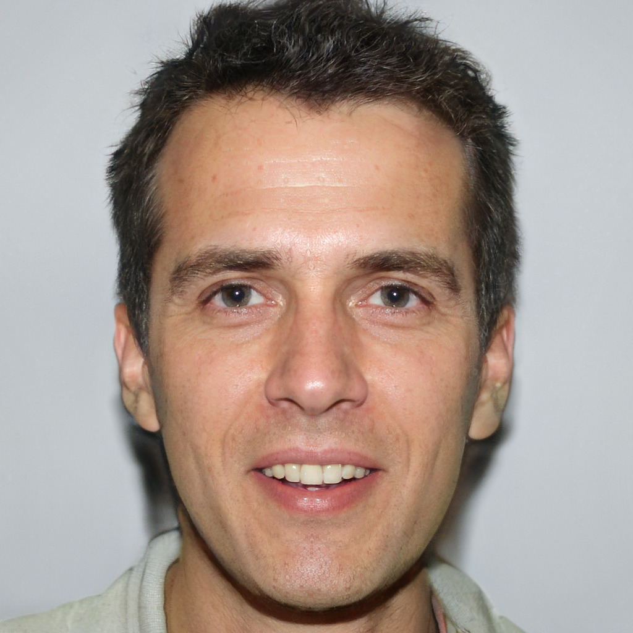 | 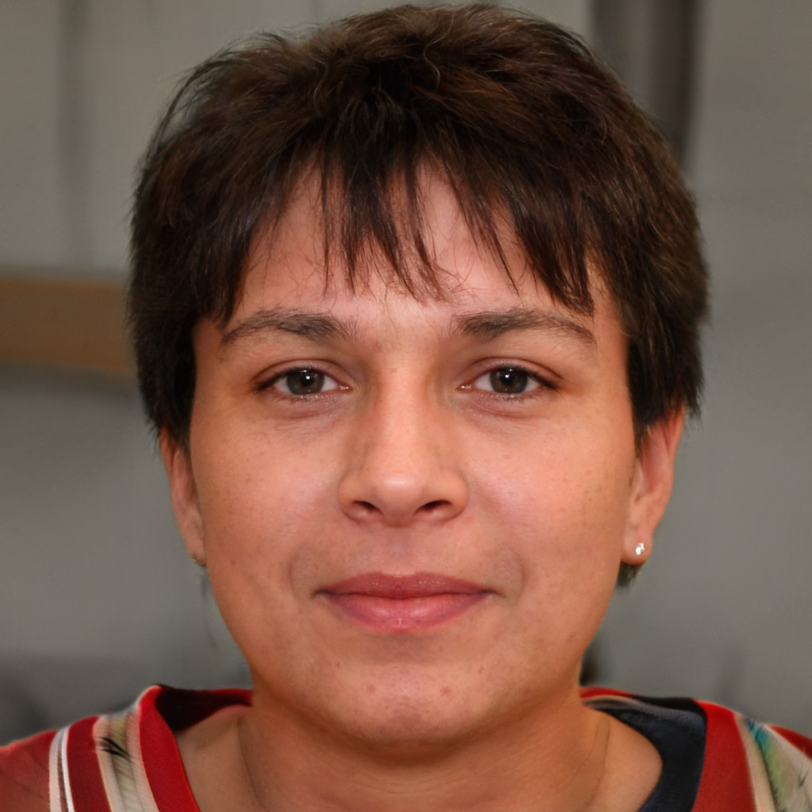 | 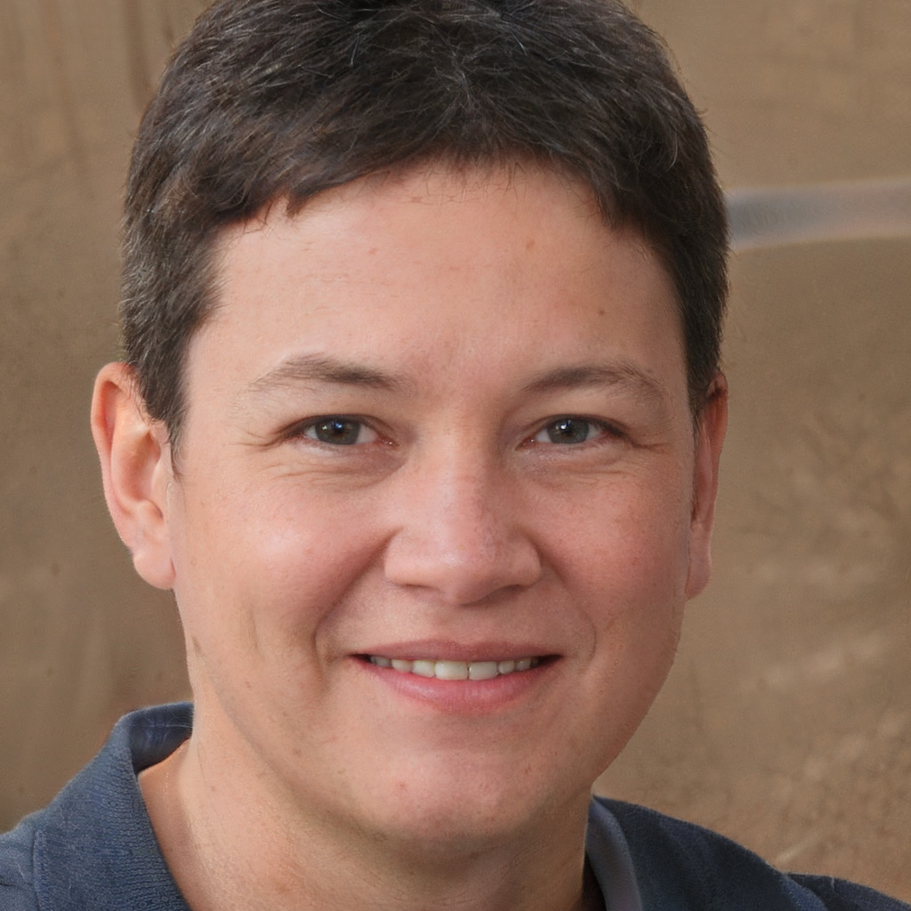
 |  |  |  | 

