Jade Jwa

04/14/21

EE 371

Lab 1 Report

Procedure

This lab required us to create a parking lot system that will detect using two sensors if a car is coming in or exiting. From the information, the system also keeps track of how many cars are currently in the parking lot and display the information on the FPGA board. There are two sensors to help keep track of whether the car is entering or exiting; and these sensors are connected to the LEDs’ so that the LEDs’ light up whenever the car is passing through a certain sensor. The occupancy of the parking lot is 25 cars, and the system also notifies when the parking lot is empty, when the parking lot is full, and otherwise displays the number of cars in the parking lot. I divided up the work for the parking lot in three parts: the counter, the FSM, and the display.

Task 1: Parking Lot Occupancy Counter

I created four modules to create the counter: the DE1_SoC, the Counter, the FSM, and the Display. The top module that brings all the components together is the DE1_SoC module. The counter module is used to count how many cars are currently in the parking lot. The counter module keeps track of how many cars are in the parking lot by taking in input signals increment and decrement. If it receives a signal to increment, then it increases the number of cars in the parking lot by one, and when it receives a signal to decrement, it decreases the number of cars in the parking lot by one. The FSM module is used to determine what state the car is in. It takes in the signals of the a and b sensors and brings it together to determine whether or not the car is leaving or entering the parking lot. It then subsequently returns if the number of cars should be incremented or decremented by looking at the order of signals that were inputted.

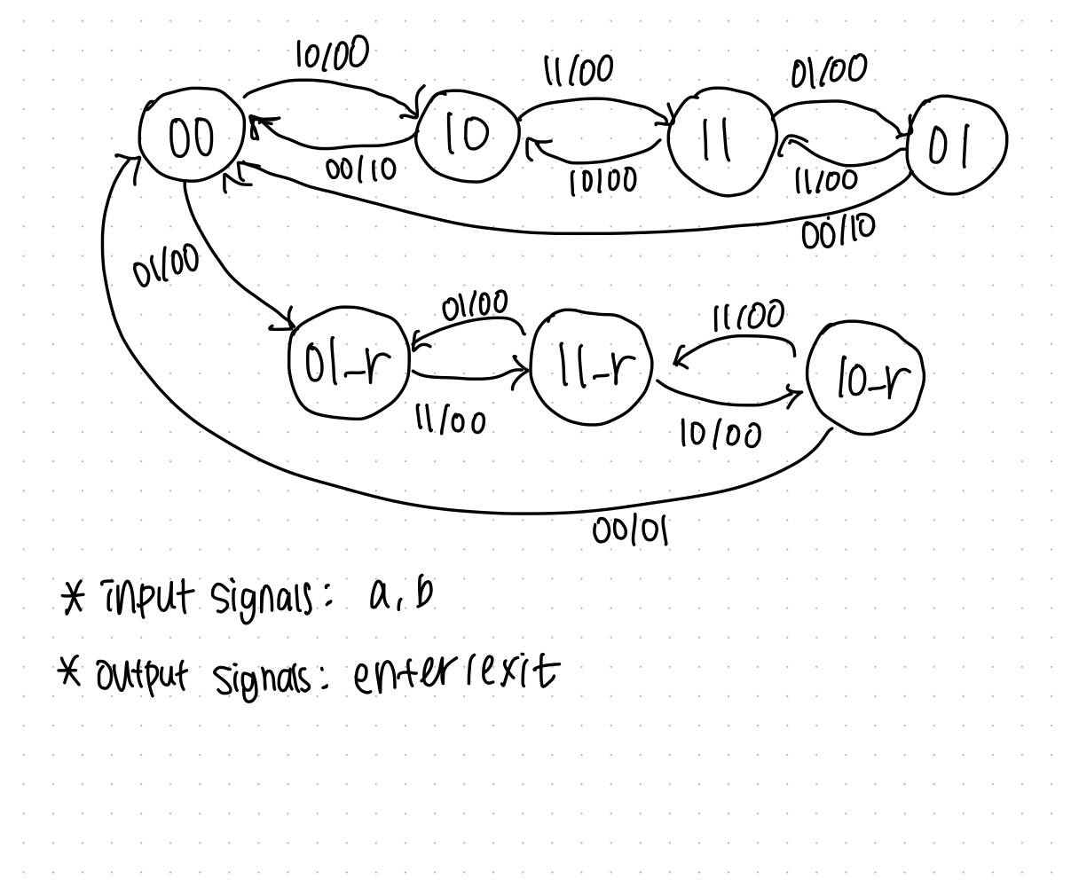

Finally, the display module is the one that puts the number of cars in the parking lot into the HEXs. It uses 7-bit input to correctly display the number of cars if the parking lot is not empty nor full, and the word “empty” when it is unoccupied, and the word “FULL” when there are 25 cars in the parking lot.

Results

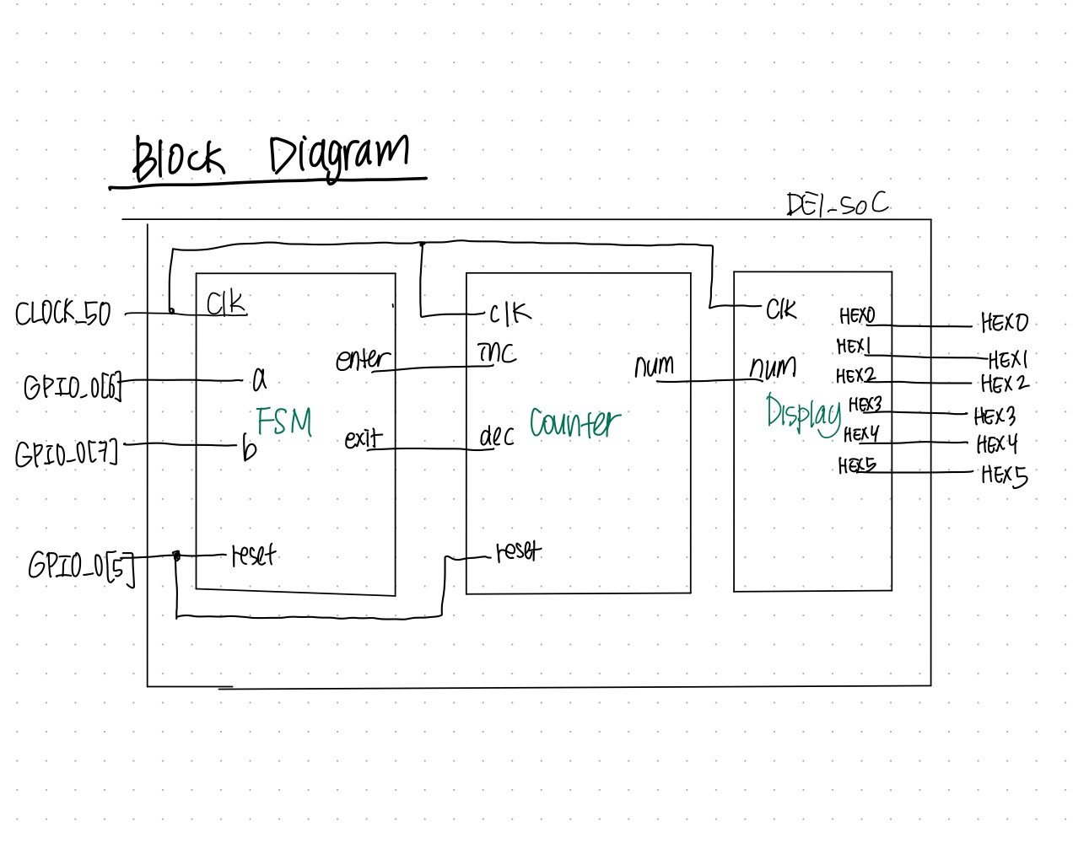

Appendix

DE1_SoC

FSM

Counter

Display