Task 1
- The cloud watch part is yet to be taken.
While browsing I could see there is no direct connection to the CloudWatch log and s3 only we can provide it using cloud Trail and Server access logging.

Server access logging
Created 2 buckets one for adding logs and other to do actions like upload delete etc
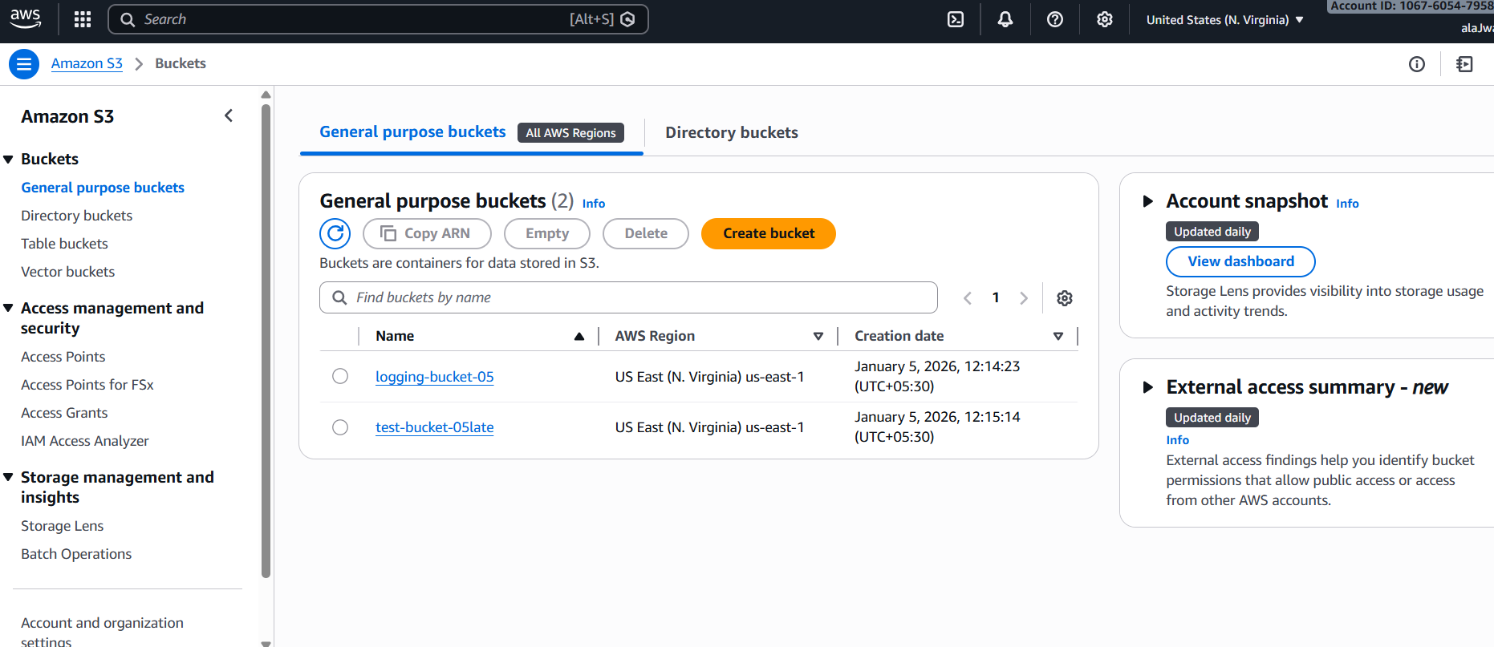

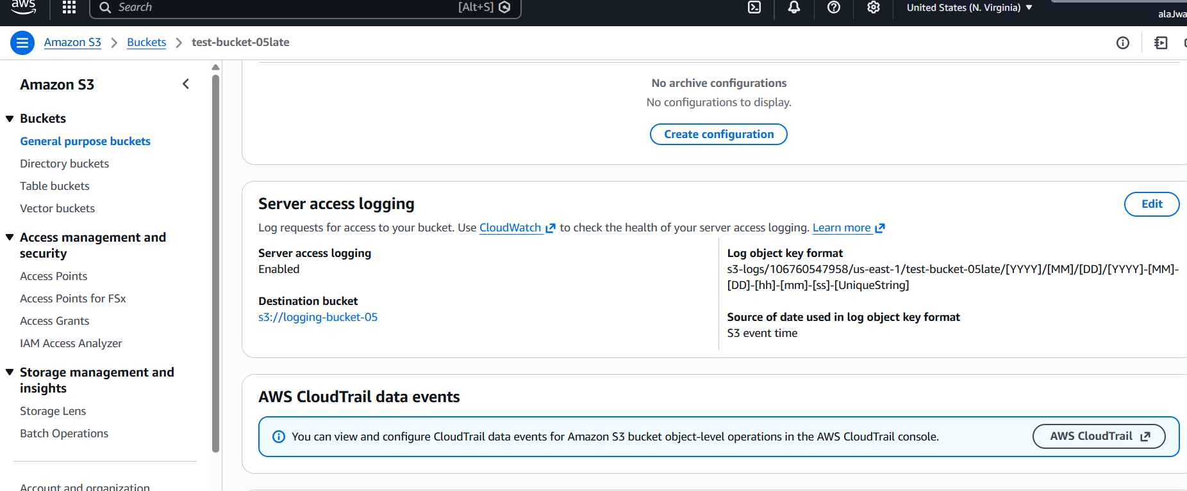

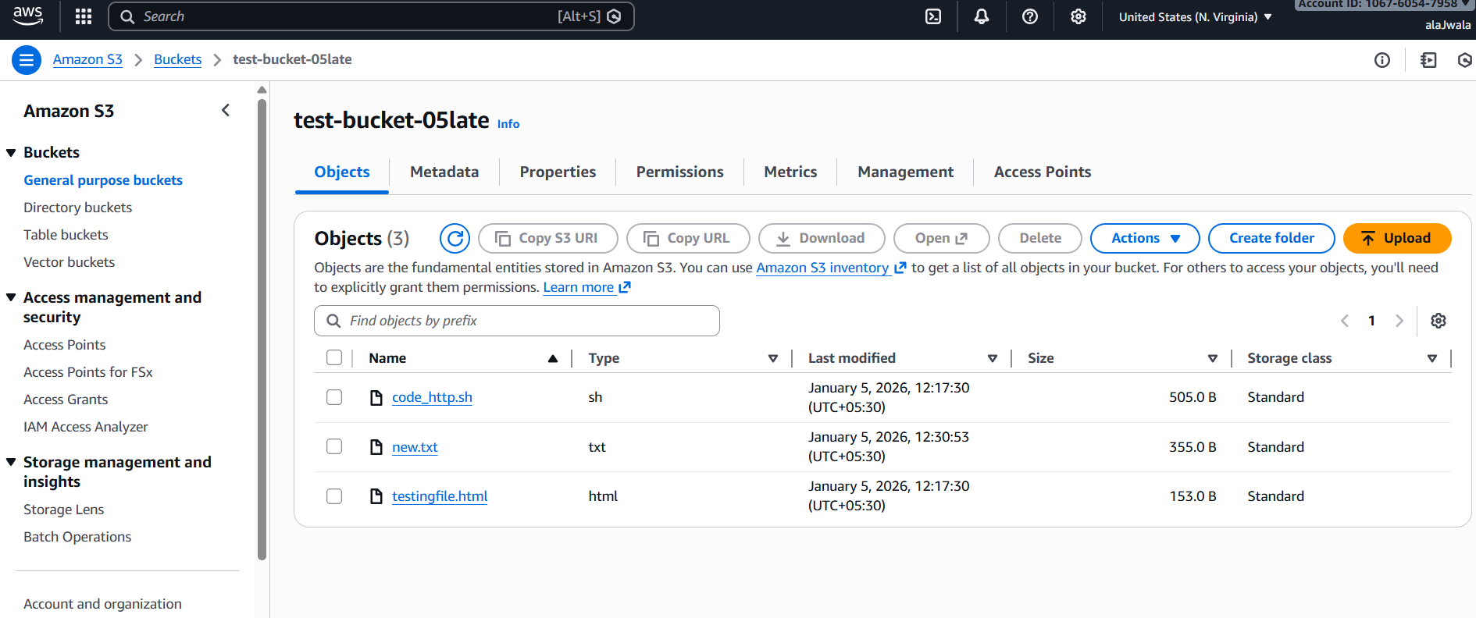

Log created in logging bucket

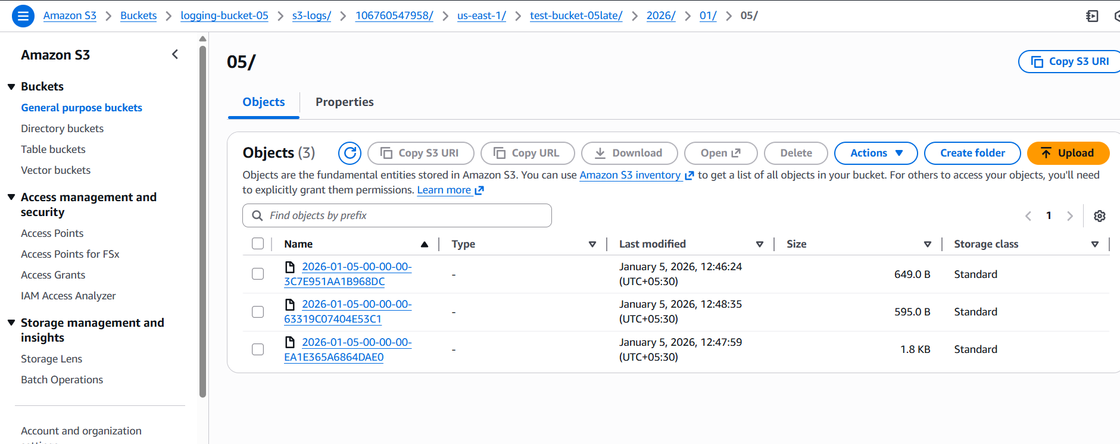

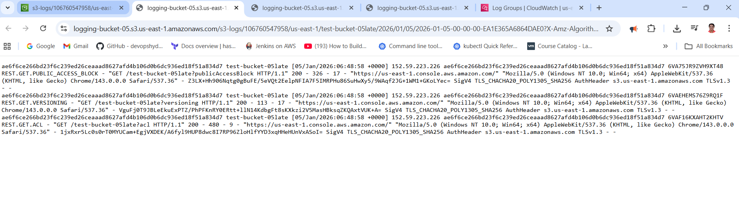

With cloud Trail
Created the private bucket with private access . S3 does not send direct logs to CloudWatch.
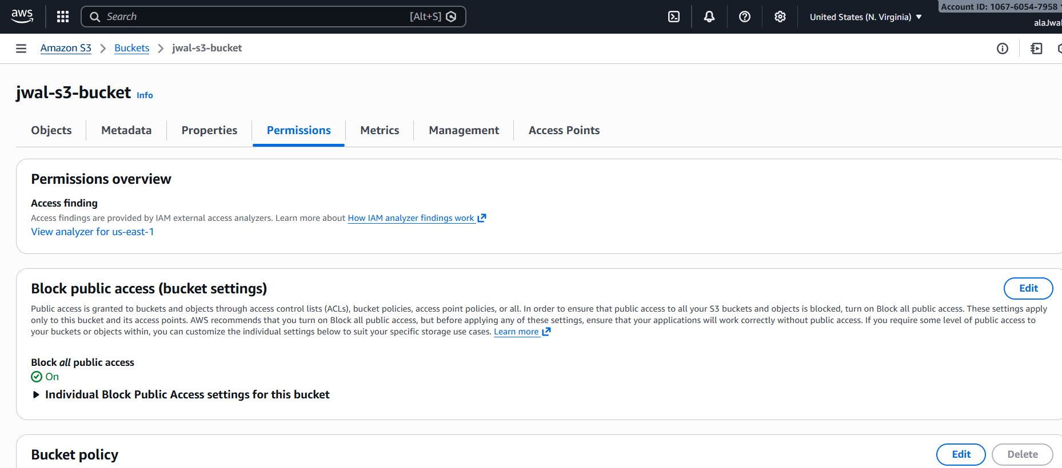
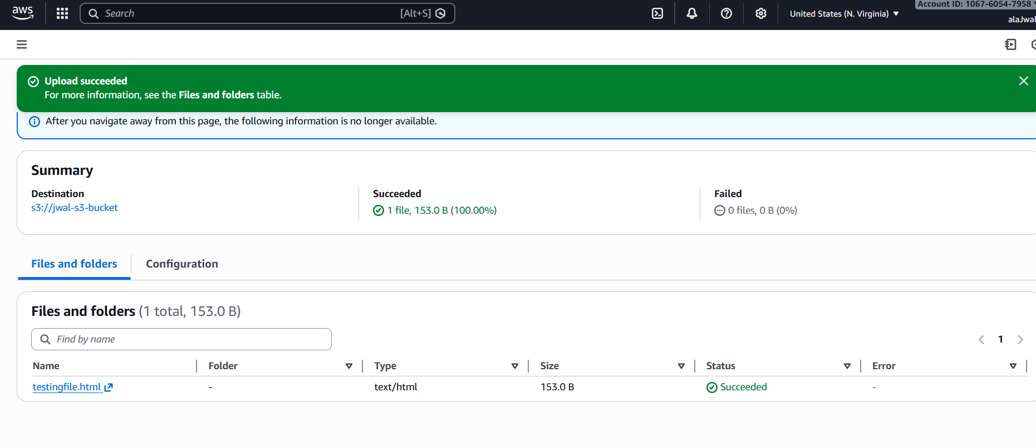
Logs after adding cloud trail – cloud watch part is not yet completed . so based on search completed this task .
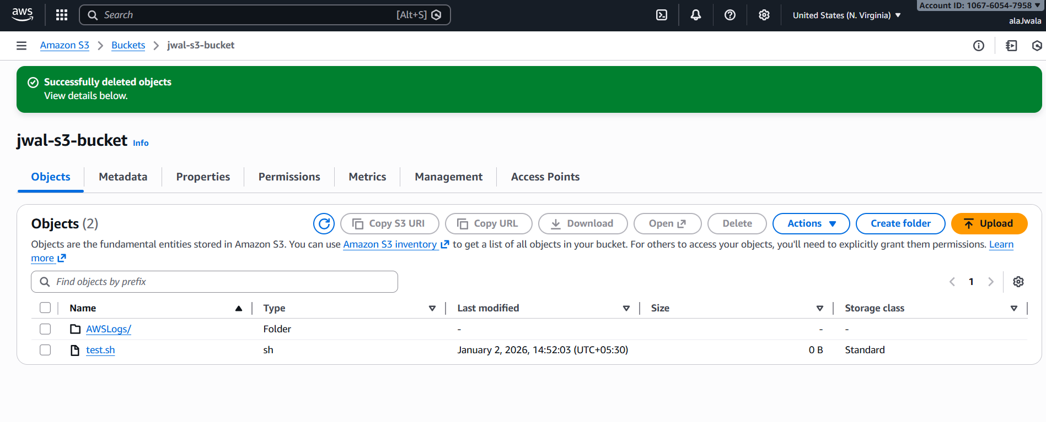
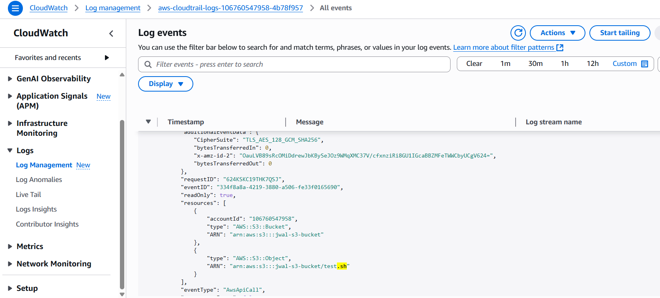

TASK 2

- Created security group for ALB and EC2 and added inbound rules with http
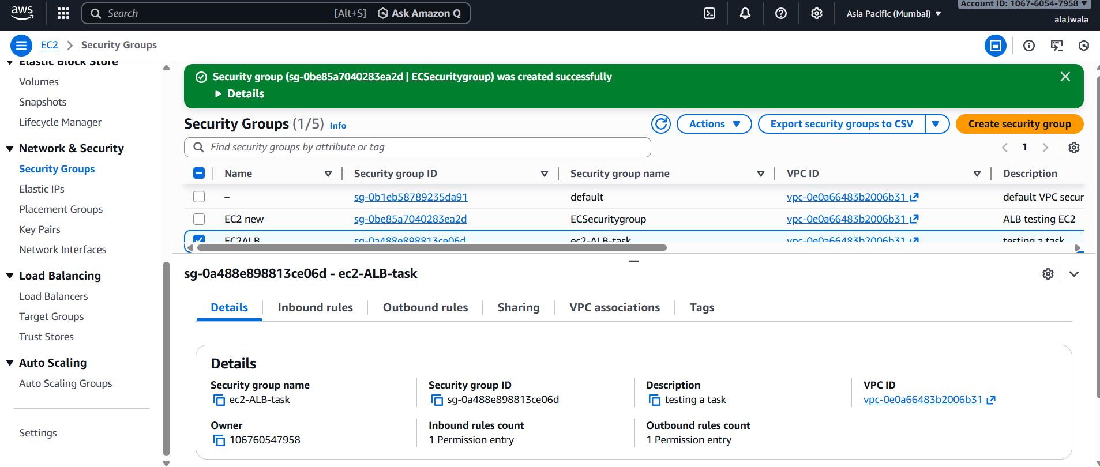
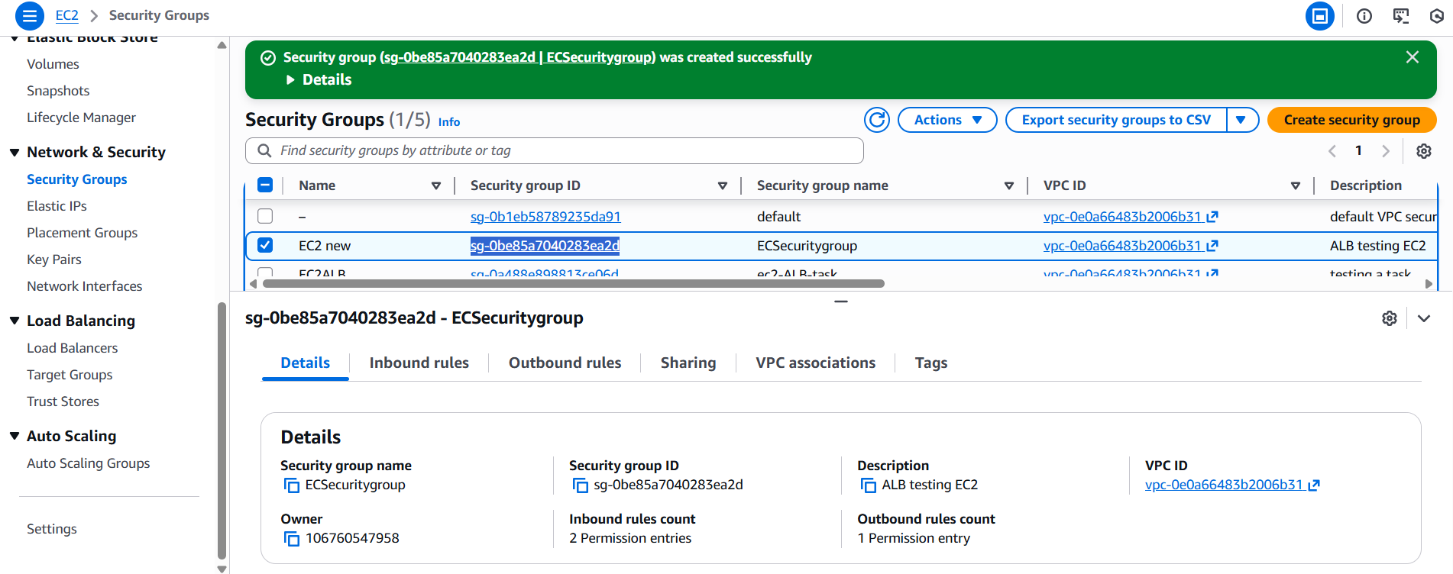

2 . Created 2 EC@ instance and attached the EC2 security group to both the instance
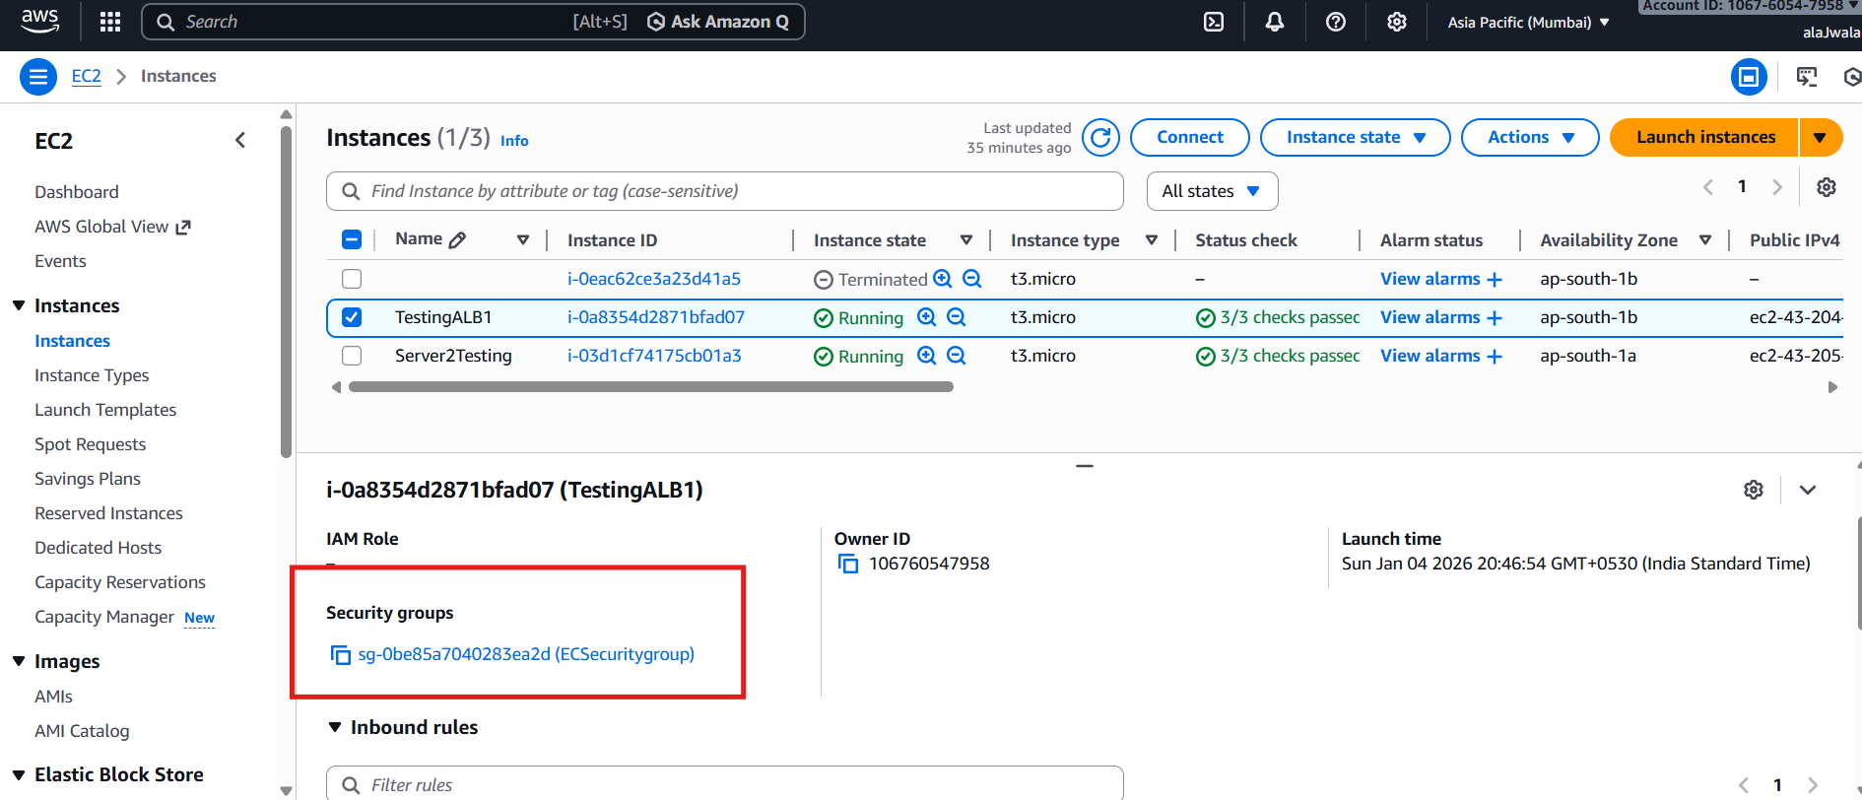
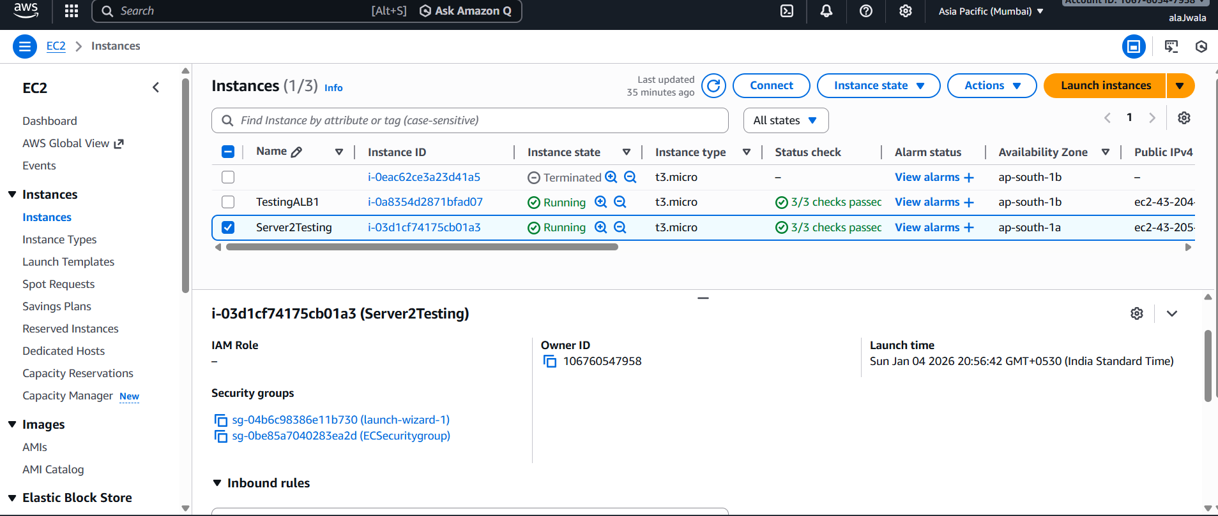

3. Created Target group and added http portal and Ec2 servers
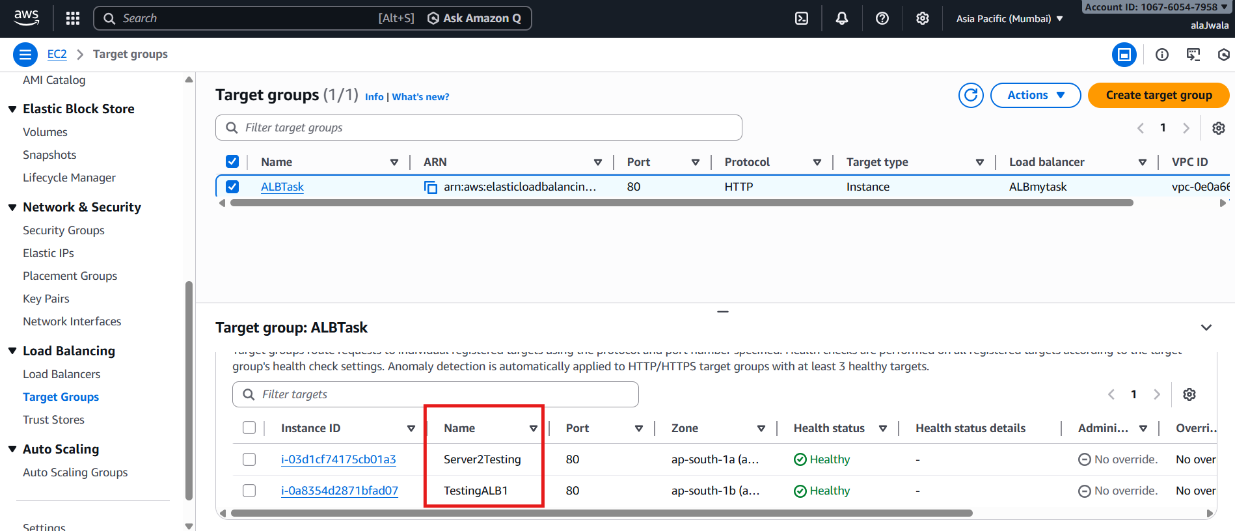

4. Created the Application load balancer and add target group to Listener so that traffic forwarded
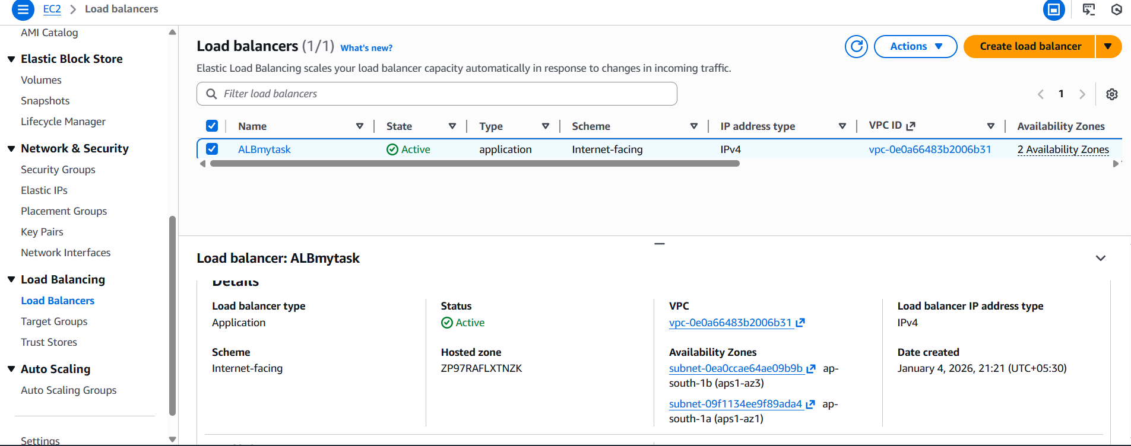

5 . Used the ALB Dns for connecting the server
