- Please provide the website to check failure also checking only 2XX and 3XX ie guvi.com and guvi.in is tested
Program
#!/bin/bash

url="https://www.guvi.in/"
code=$(curl -o /dev/null -s -w "%{http_code}" $url )
echo $code
echo "The http code of given web page is $code "

if [ $code -eq 200 ]; then
echo "200 comes under Success"
else
echo " Failure webpage is not reachable"
if [ $code -ge 400 ] && [ $code -lt 500 ]; then
echo "Client side error!!! "
elif [ $code -ge 500 ] && [ $code -lt 600 ]-; then
echo "Serverside error !!!"
else
echo "OTHER RESPONSE "
fi
fi
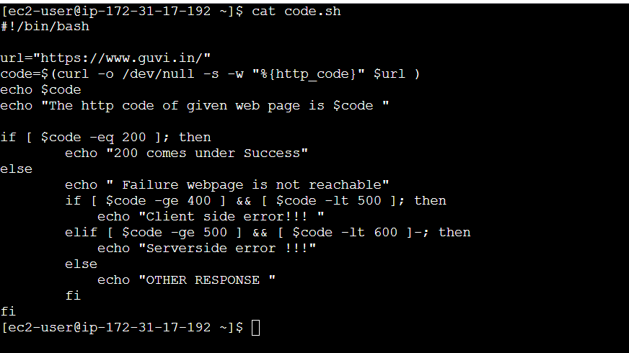
Output s
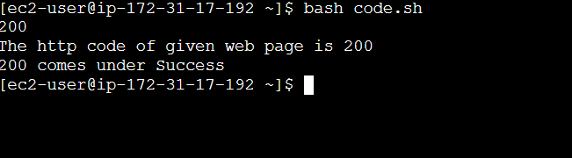

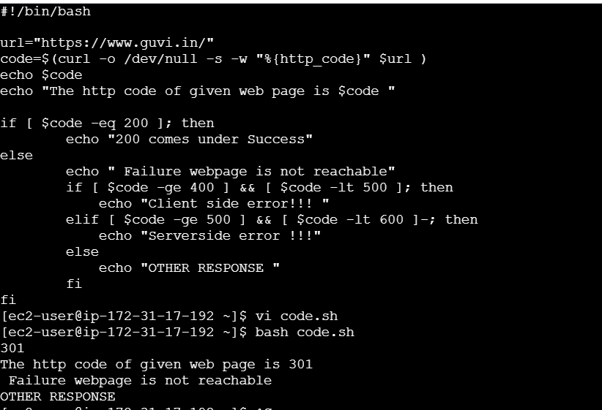

2 .
Code used
#!/bin/bash
filename="input_file.txt"

if [ ! -f "$filename" ]; then
echo "File not found"
exit 1
fi
sed -i '5,$ {/welcome/ s/give/learning/g}' "$filename"
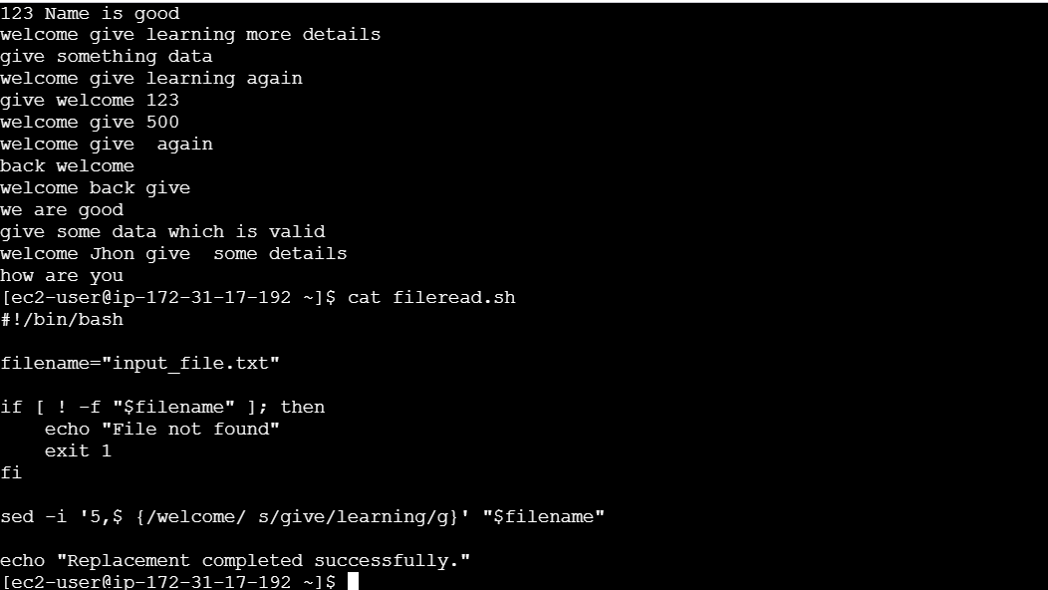

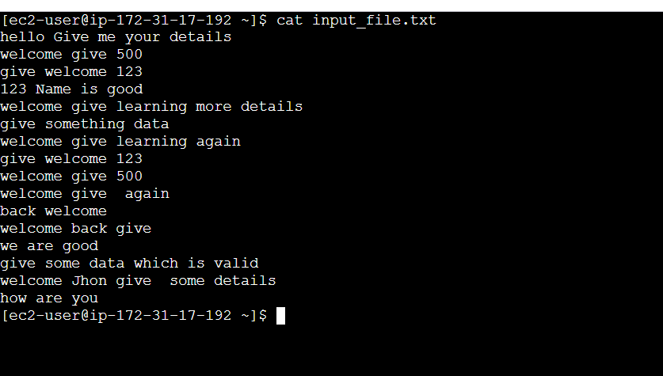

Output
