Linux
- Created an linux server with no additional volume attached only default volume is 8gb present .
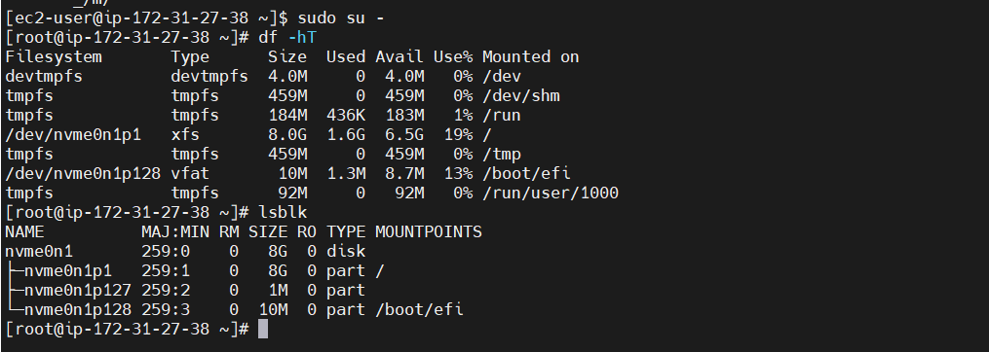
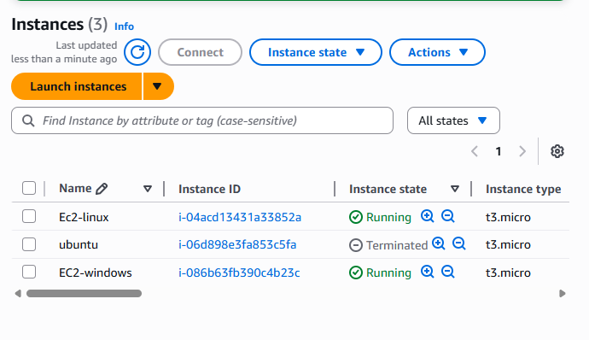
- Created an EBS volume of 5gb in same avalablity zone as the EC2 instance .
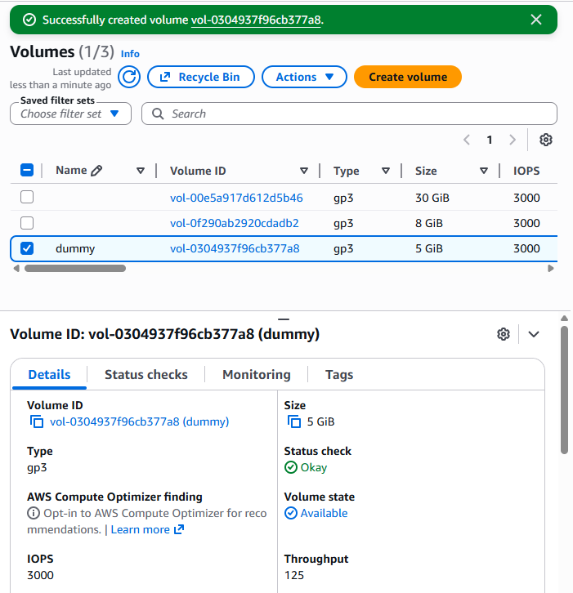

- Attaching the EBS volume with the EC2 instance
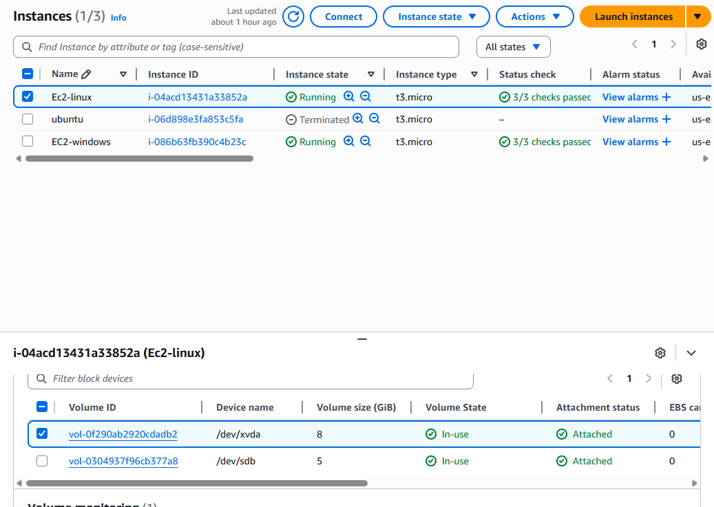
- Mounting the EBS volume of 5gb
- Create a file system and mount it

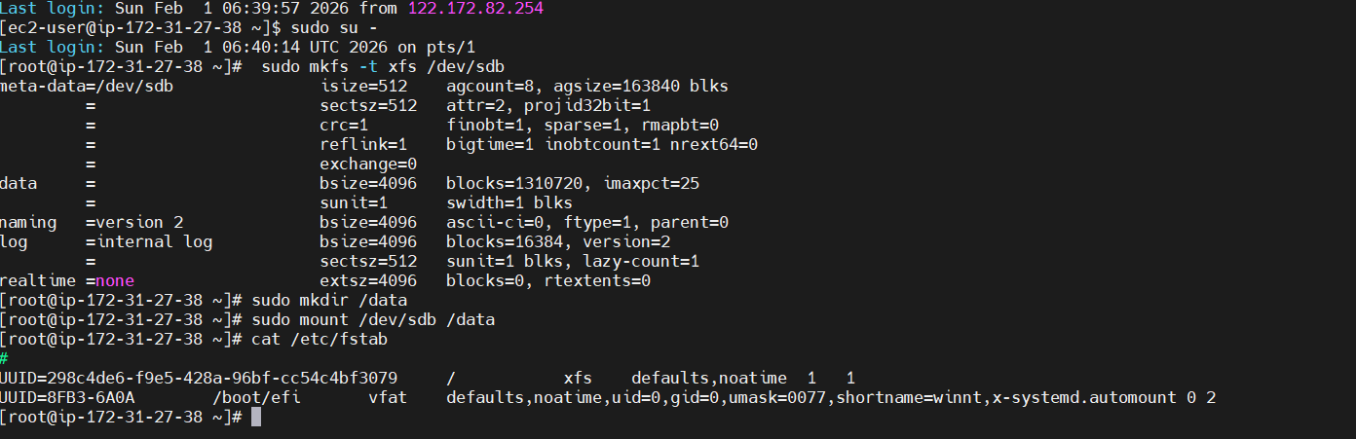

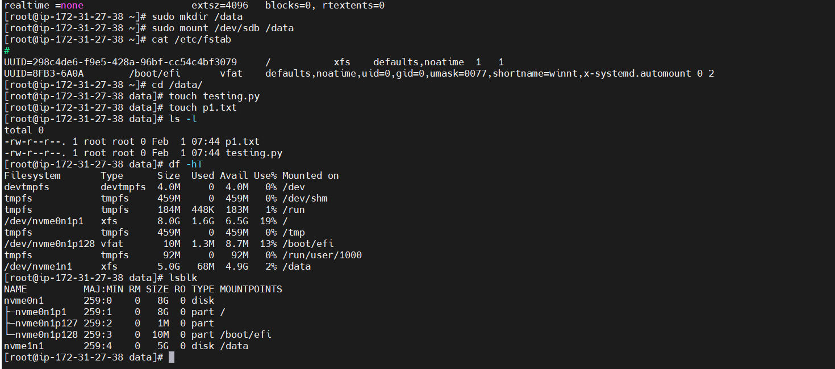
- Saving the mount details in /etc/fstab so that when it reboot data is not gone
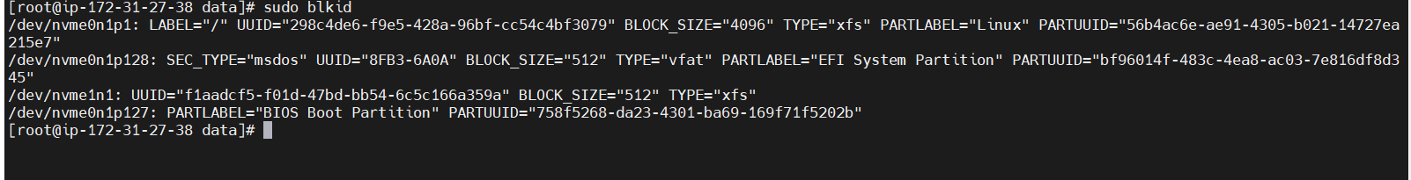

- Taking snap short of the volume for the same is given in last part

Windows
- Created an ec2 instance with windows details is provided below
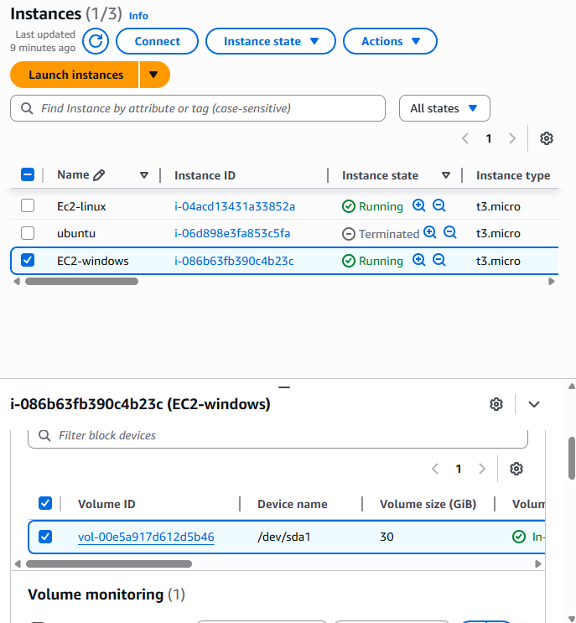

- Creating an EBS voulume with 5GB
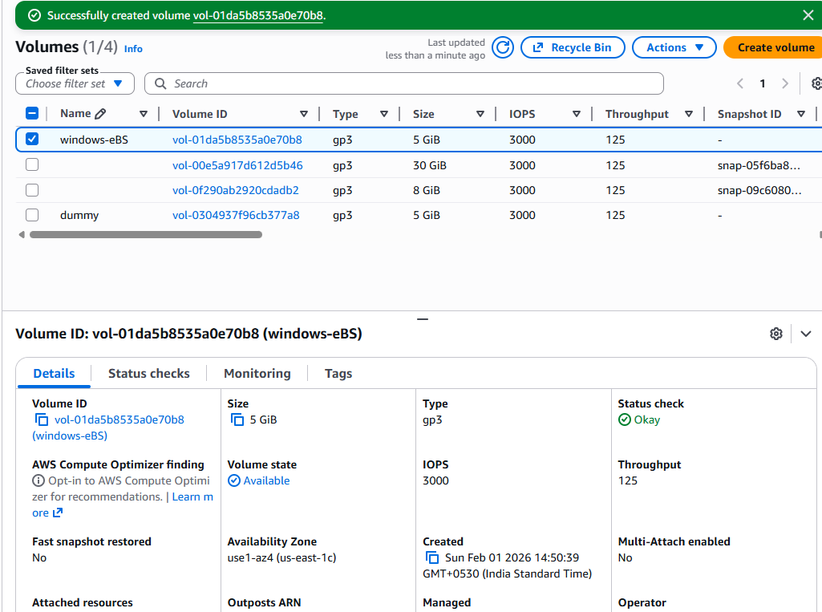
- Attached EBS
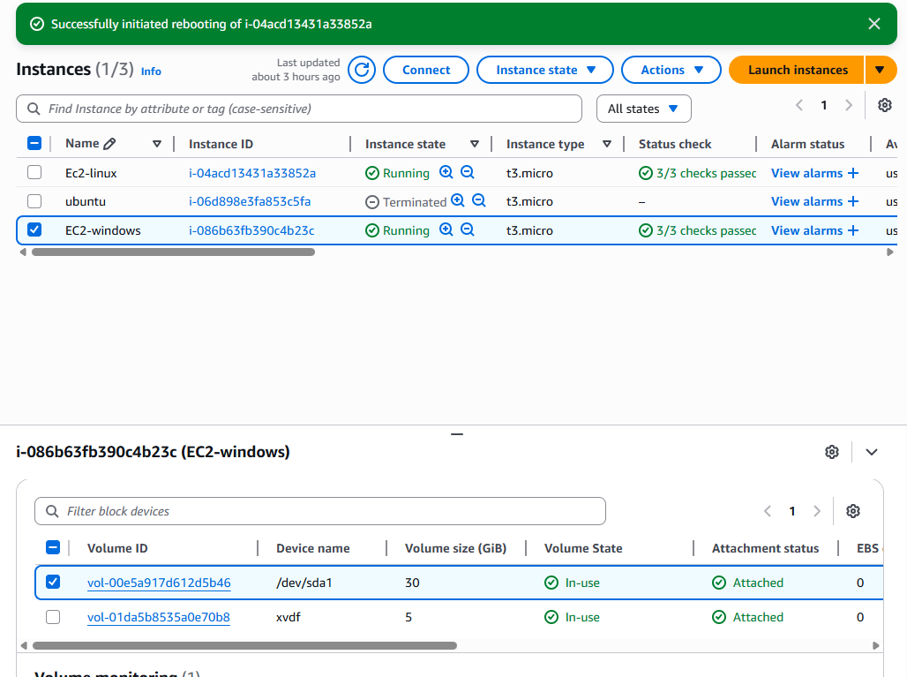
- No storage is found we need to mount the same . we can see using server manager -> file and storage -> disk it is added but not mounted .
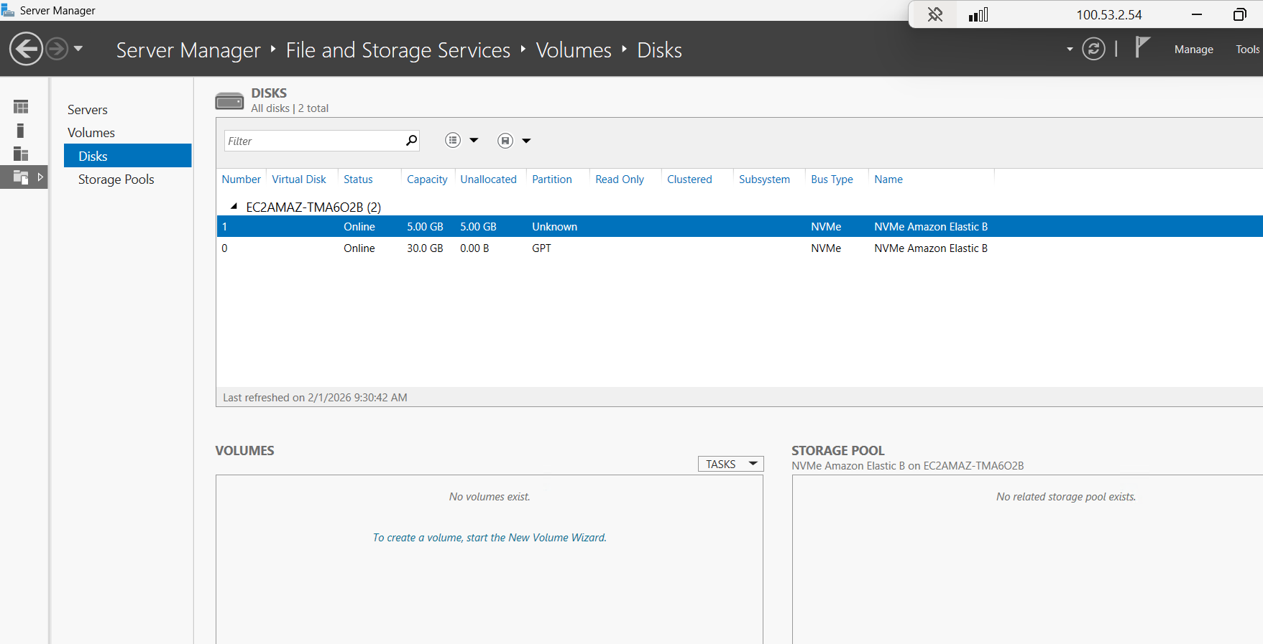

- Mount the same from server manager
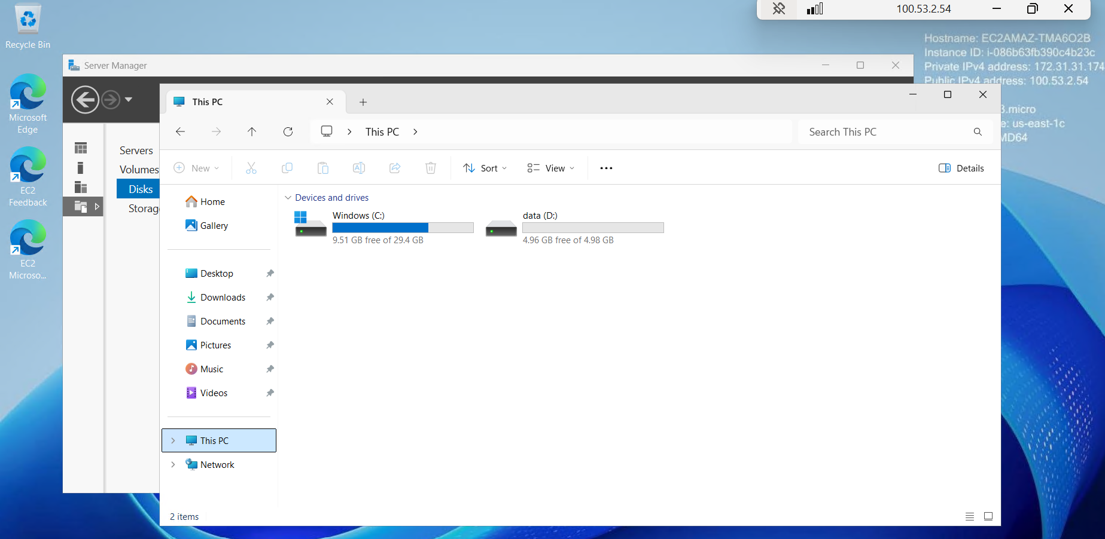

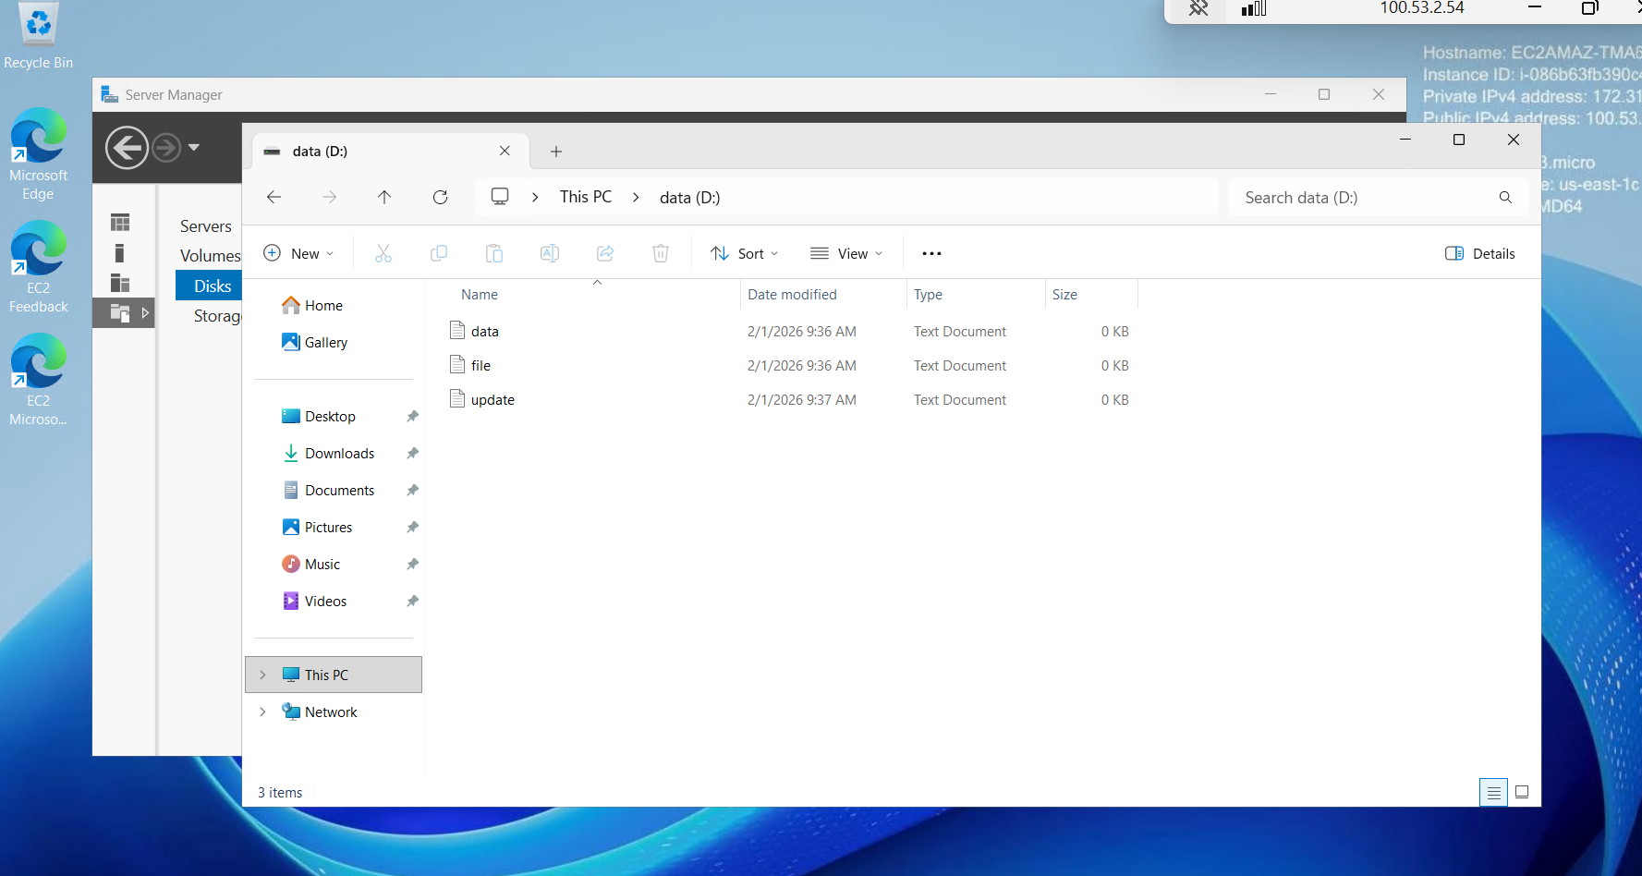

Snapshot

Taking the snapshot of volume we created and attached to the instance
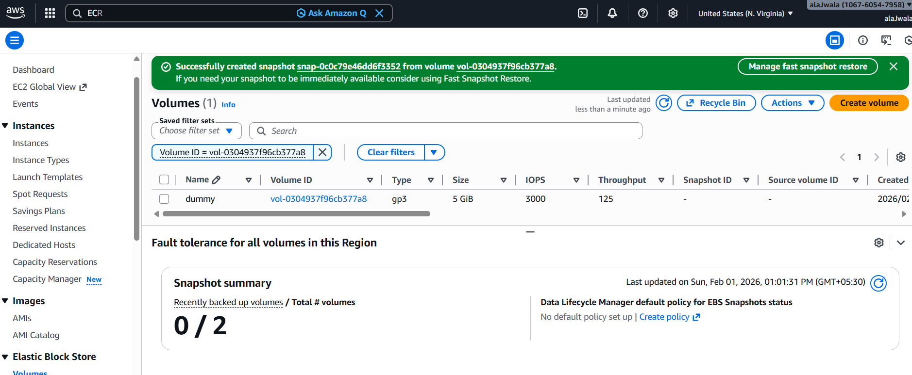

Also taking the snapshot of the main default volume of the instance
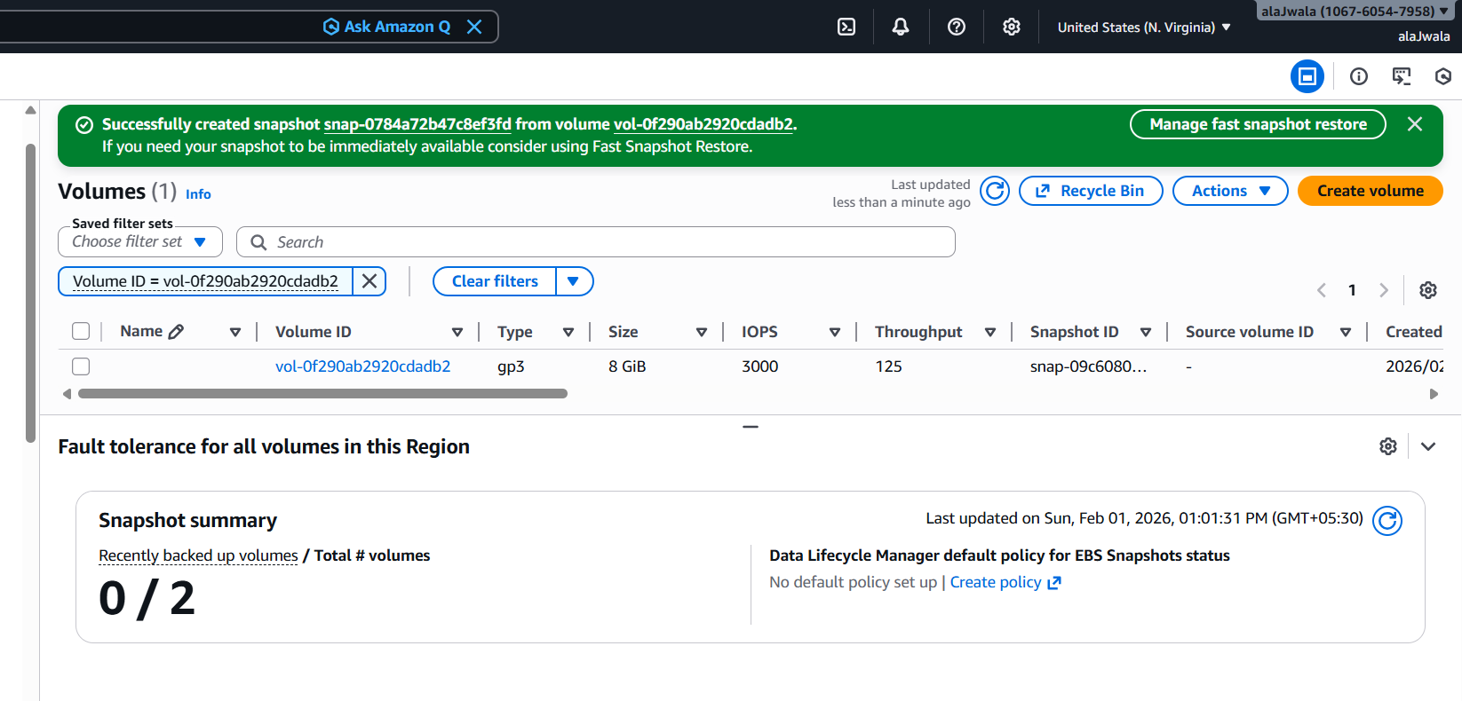

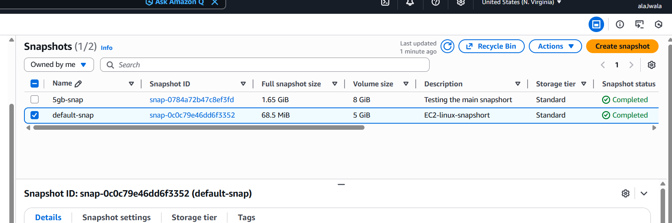

Creating volume from snapshot with an 8gb

