This application contains a database and 5 control elements to filter what should be displayed. At the moment of loading the application, all the data appears in a stripped table format.

The 5 filter elements are

1. Date - a calendar – shown in **Fig*ure 1***
2. Country – a dropdown box
3. State – a dropdown box
4. City – a dropdown box
5. Shape – a dropdown box – shown in **Figure 2**

It is important to point out that there is a strong relation among country, state and city control elements:

1. If we do not choose a country, we will have the option to pick up any state or any city available in the database (**Figure 3** and **Figure 4**)
2. If we choose a country only, we can only pick up states and cities located in that country (**Figure 5** and **Figure 6**)
3. If we choose a state and not a country, we can select all the cities available for that state. This option will work even in the case where two or more countries have states with equal names (**Figure 7**).
4. If we choose a country and a state, the dropdown city will contain only cities located in the country and state of choice (**Figure 8**).

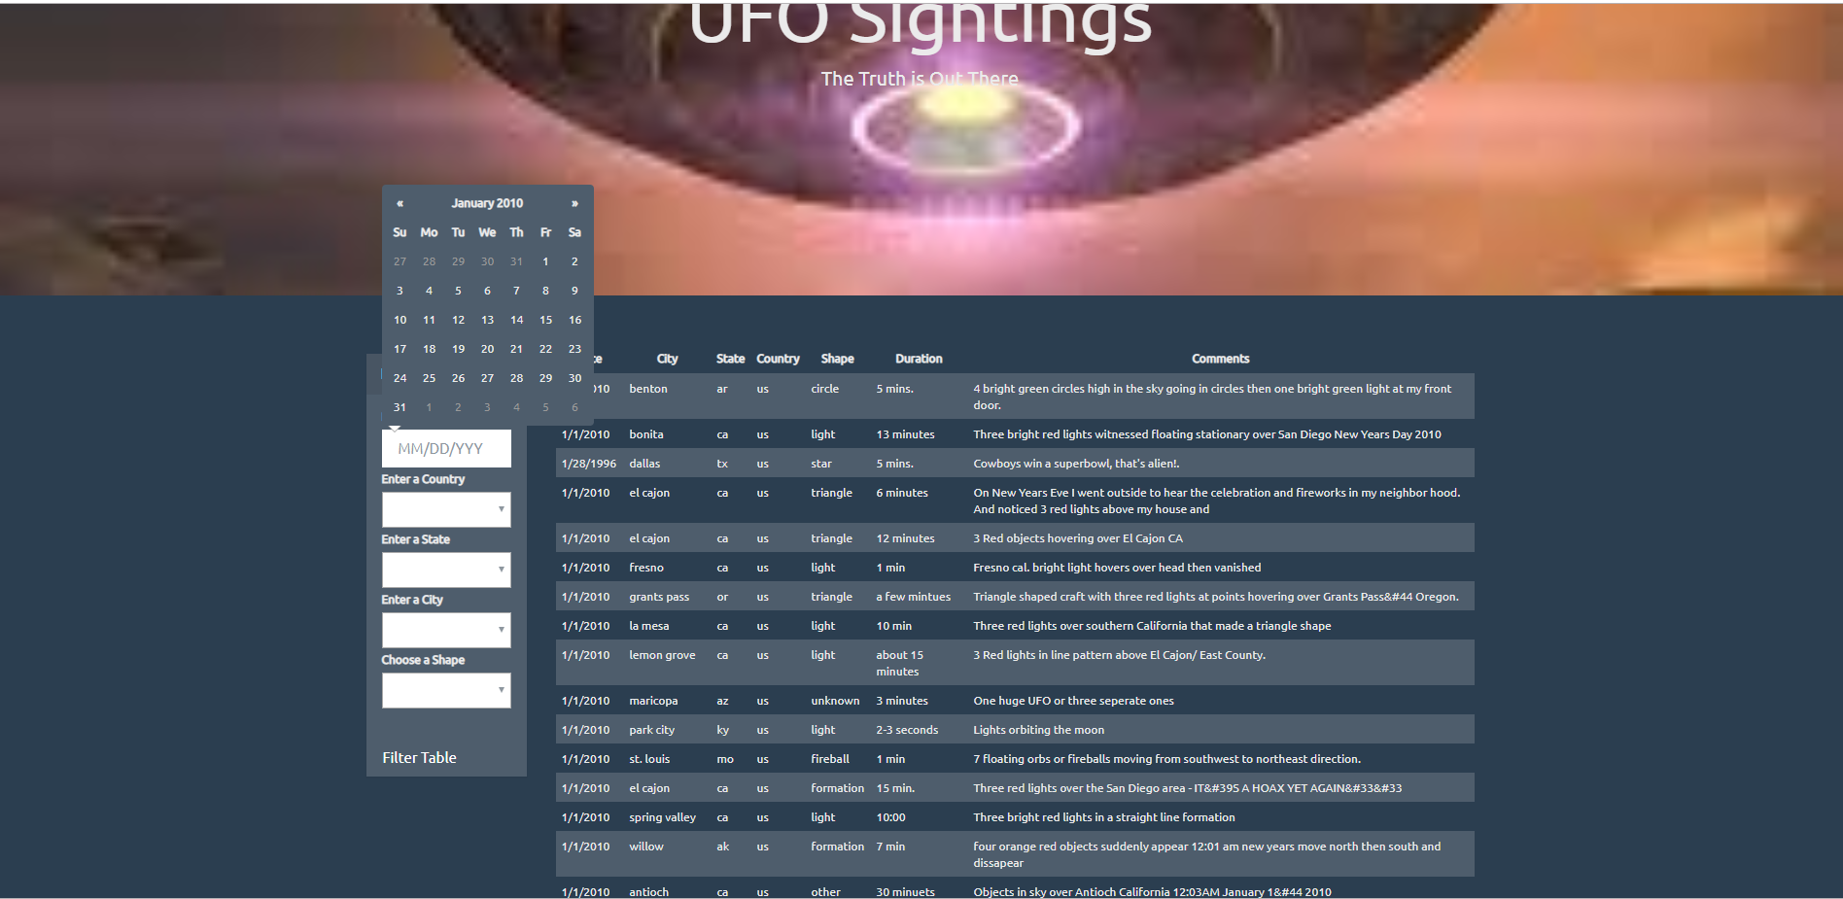

**Figure 1: Calendar**

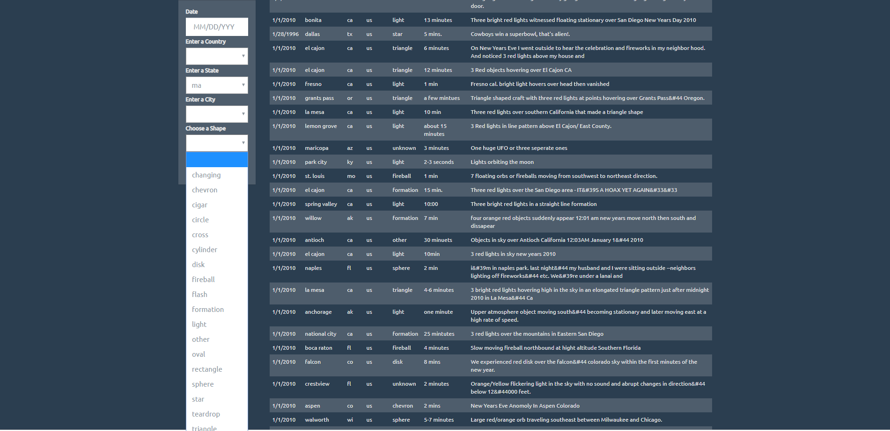

**Figure 2: Shape Dropdown**

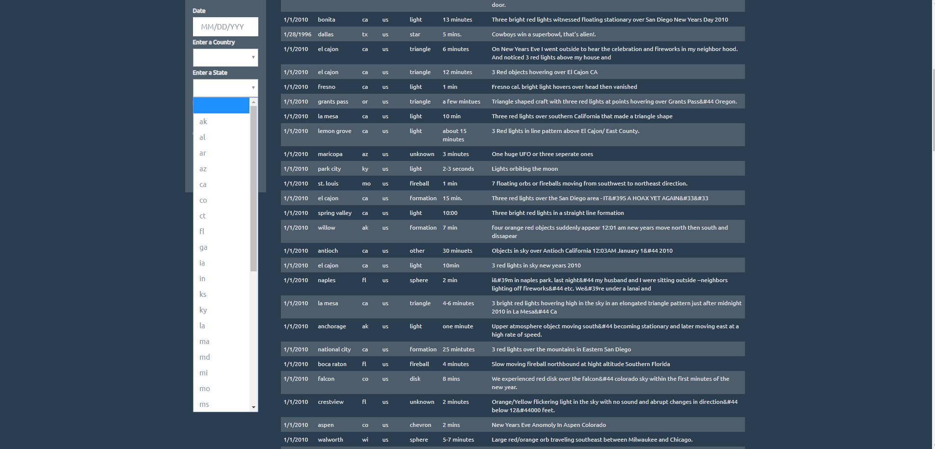

**Figure 3: If a country is not chosen, then all the states available can be selected**

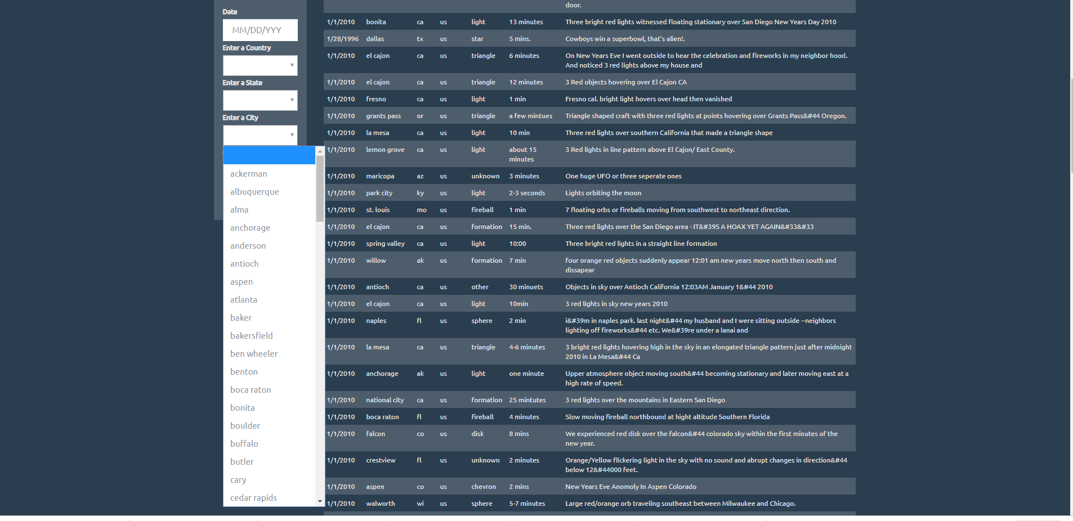

**Figure 4: If a country is not chosen, then all the cities available can be selected**

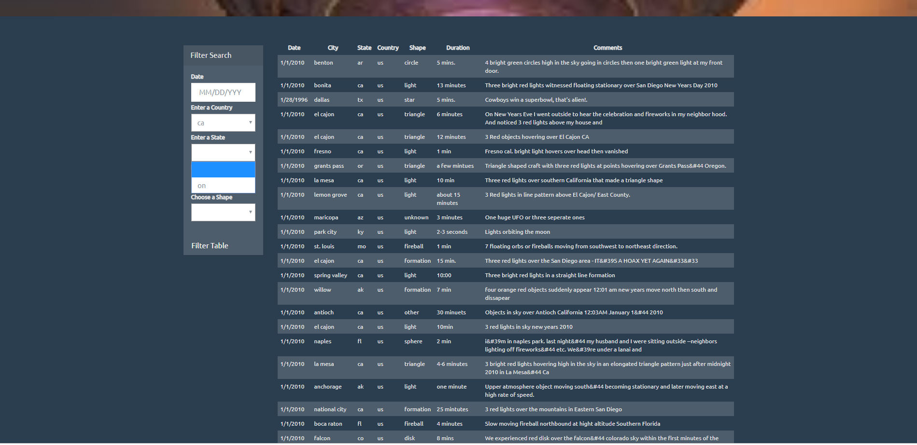

**Figure 5: If a country is chosen, then only states available for that country can be selected**

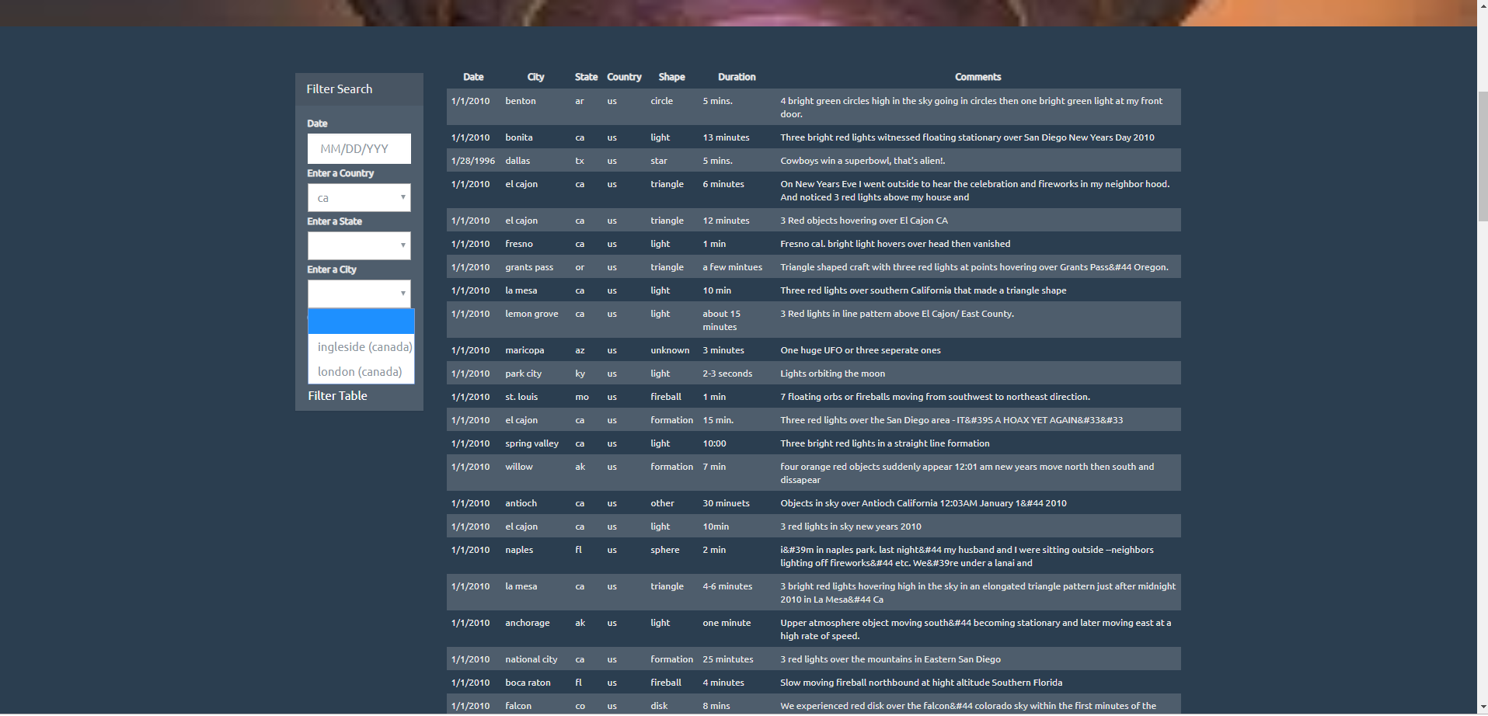

**Figure 6: If a country is chosen, then only cities available for that country can be selected**

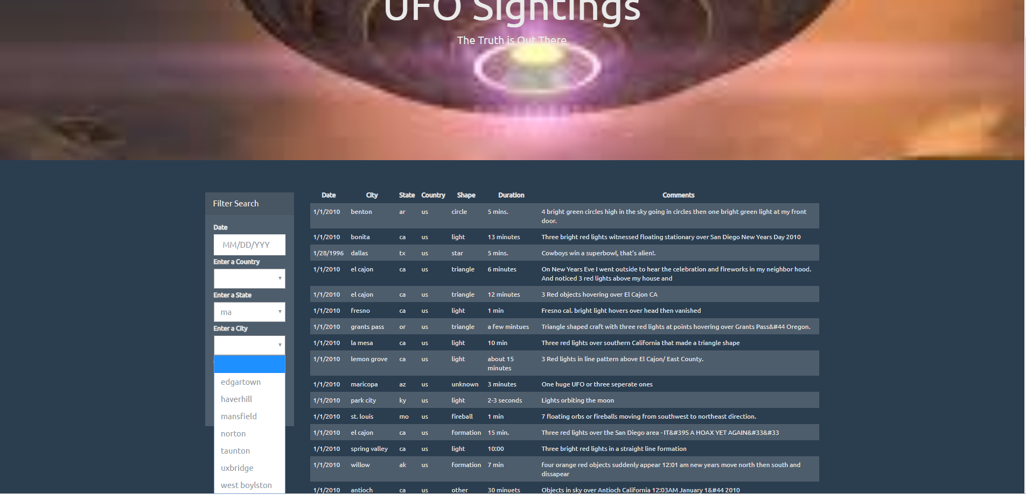

**Figure 7: If a state is chosen, then only cities available for that state can be selected**

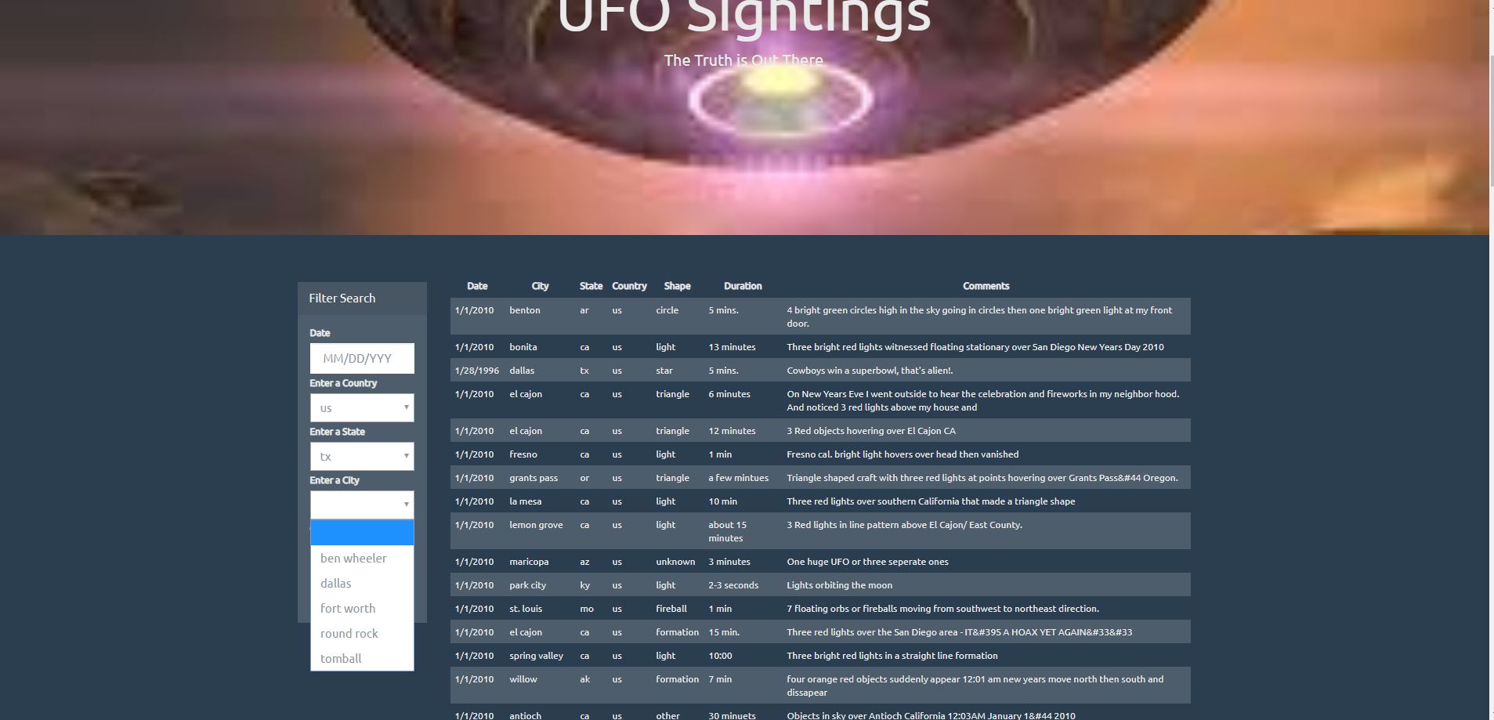

**Figure 8: If a state and a city are chosen, then only cities available for that country and state can be selected**