

MA 374: Financial Engineering Lab

Lab 01



Jwalit Bharatkumar Devalia (200123026)

6th Jan 2023

**Check for the *no-arbitrage condition***

We first need to check for the no-arbitrage condition.

We know that,

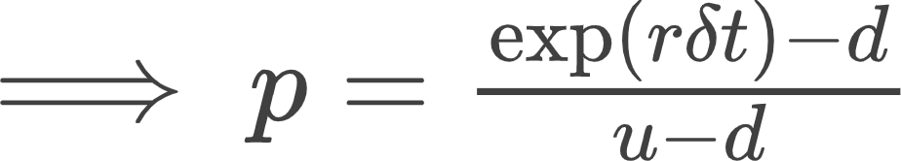

Hence, we will calculate this probability and see if 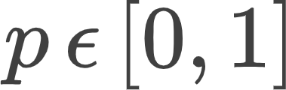, and if it does not, we know that the ***no-arbitrage principle is getting violated.***

***Question 1***

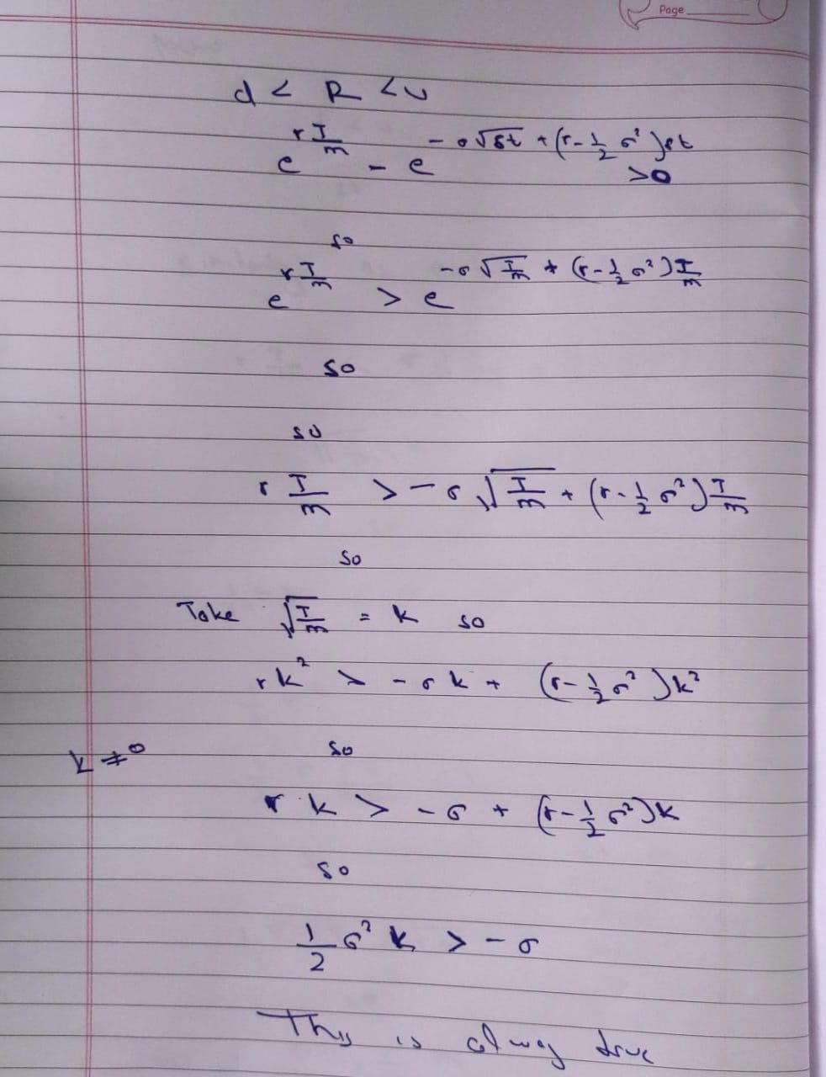

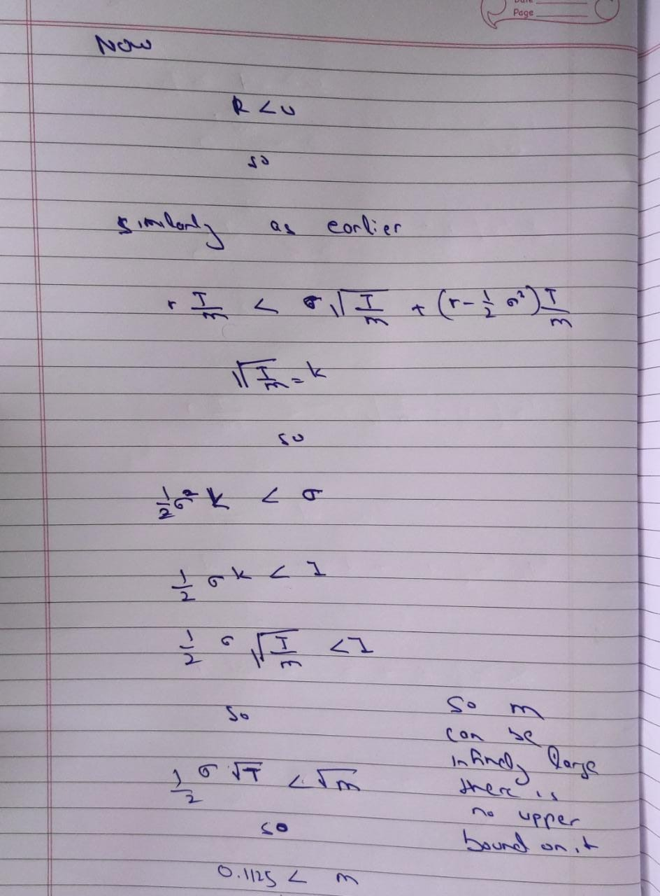

***There is no upperbound on M.***

1. we calculate the price of the option using the respective payoff

function for both the call and put option, i.e,

C M = max( S M - K, 0) , 0 <= n <= M

n n

P M = max( K - S M, 0) , 0 <= n <= M

n n

where, C M is the nth possible price of the call option for the Mth interval, and

n

P M is the nth possible price of the put option for the Mth interval

n

1. Now, we continuously apply **Backward Induction** to find out the option price at t = 0 by using following relation:

C i = (1 – p) . C i+1 + p .C i+1 , 0 <= n <= i & 0 <= i <= M - 1

n n+1 n

P i = (1 – p) . C i+1 + p .P i+1 , 0 <= n <= i & 0 <= i <= M - 1

n n+1 n

1. C00 and P00 are the required values, i.e, initial option prices.

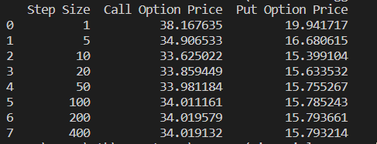

Question 2

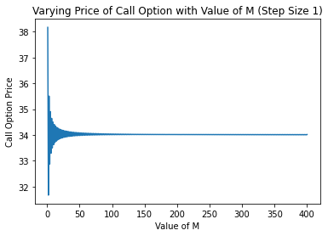 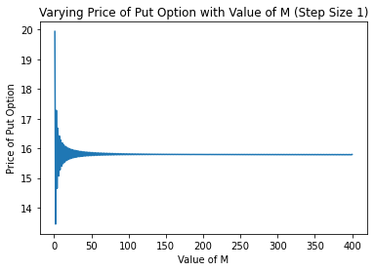

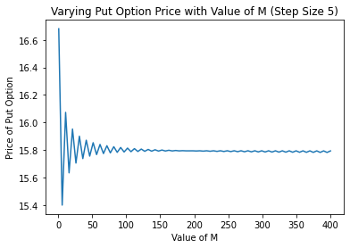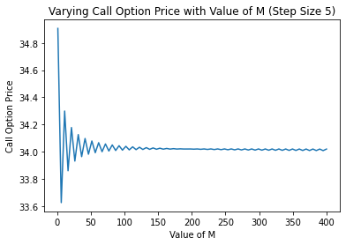

**Observations:**

1. We observe that the value of the **European call option** converges to **34.0** while the **European put option** converges to **15.7**.
2. The convergence of the plot is faster when step value is 5. The deviations from the convergence value is higher when the value of M is less.
3. This convergence is however not perfect. There is still some deviation(values tend to oscillate around specified values as in first point).
4. On increasing the value of M, the prices of both the call and the put options slowly converge and the deviation between consecutive values reduces. However, on further increasing M, the error increases. This pattern repeats and the option value converges slowly.

# Question 3.

The values of the options at **t = 0, 0.50, 1, 1.50, 3, 4.5** for the case **M**

**= 20** are tabulated below:

We have (i+1) different values of option as there are (i+1) possible values for the underlying asset for the ith step.

For call and put option Respectively

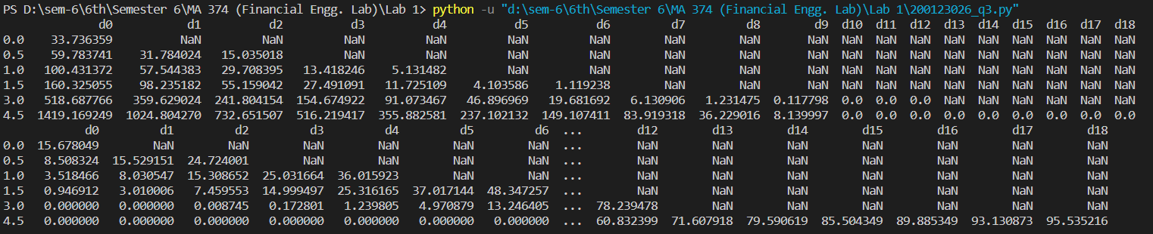

***Thank you***