# CS 211 Homework #1

Please complete the homework problems. Note that this is an individual assignment and all work must be your own. Be sure to show your work when appropriate. This assignment is due **in class** on Thursday, September 27, 2018.

1. [3] Given the following pre-order and in-order traversals, reconstruct the appropriate binary tree. **NOTE: You must draw a single tree that works for both traversals**.

Pre-order: A, E, D, G, B, F, I, C

In-order: D, E, B, G, A, F, I, C

2. [3] Starting with an empty BST, show the result of the following sequence of operations. Assume that all removals come from the left subtree when the node to remove is full.

Insert(5), Insert(10), Insert(2), Insert(9), Insert(1), Insert(3), Remove(5).

3. [3] Starting with an empty BST, show the result of the following sequence of operations. Assume that all removals come from the right subtree when the node to remove is full.

Insert(10), Insert(5), Insert(23), Insert(4), Insert(19), Insert(7), Insert(9), Insert(6), Remove(5).

4. [2] Assume that we have two algorithms that accomplish the same task. Algorithm A has a non-simplified runtime of O(n^2 + 5n) and Algorithm B has a runtime of O(n^3). Which should we use? Why?

5. [3] Provided are counts of computation for various series. Indicate the most likely runtime complexity for each:

|  |  |  |  |  |  |  |  |  |
| --- | --- | --- | --- | --- | --- | --- | --- | --- |
|  | N = 1 | N = 2 | N = 3 | N = 4 | N = 5 | N = 6 | N = 7 | N = 8 |
| Alg. A | 6 | 14 | 24 | 36 | 50 | 66 | 85 | 104 |
| Alg. B | 2 | 8 | 18 | 32 | 50 | 70 | 99 | 128 |
| Alg. C | 1 | 4 | 9 | 16 | 23 | 31 | 39 | 48 |
| Alg. D | 1 | 7 | 11 | 14 | 17 | 19 | 21 | 22 |
| Alg. E | 2 | 4 | 6 | 8 | 10 | 12 | 14 | 16 |

6. Given the following binary tree:

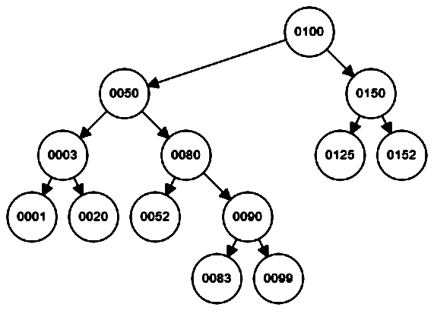

1. [1] What is the height of the tree?
2. [1] What is the depth of node 90?
3. [1] What is the height of node 90?
4. [3] Give the pre-order, in-order, and post-order traversal of this tree.