Jeff Wallhermfechtel

E-Portfolio

Table of Contents

1. Project Plan Document
2. Usability Study
3. Alexa Radio Skills
4. BlackJack pi
5. Alexa Morse Code Translator

Project Plan Document

This assignment was one of the documentation steps for my final project in my capstone class (See Alexa Radio Skills for the actual implementation). The idea was to accurately describe our project, plan how we were going to do it, and describe milestones we would hit along the way. This assignment taught me a lot about the planning that goes into a large-ish project, compared to the “wing-it” approach I’ve been using throughout my college career. The only change I would have liked to make is to have estimated how many man-hours I expected each task to take. This document can be found in my Github repository here:

<https://github.com/jwallher/e-portfilio>

Usability Study

This assignment was to explain how a user would interact with my final project in my capstone class (See Alexa Radio Skills). This assignment taught me the value of asking other people, specifically end-users, for input on how the user model should be designed. There were a few ideas that I wouldn’t have thought of that were mentioned in the interview section of the assignment (Part 2). Next time I would like to follow this same approach on a project that has a visual user interface, instead of the auditory user interface this project had. This document can be found in my Github repository here:

<https://github.com/jwallher/e-portfilio>

Alexa Radio Skills

This assignment was to create and publish two skills for Amazon’s Alexa service that would stream live radio from two of centennial-broadcasting’s stations: B101.5FM and News Talk 1230. This assignment taught me a lot - from basics of Java Script, to software development/publication processes, and a whole lot of Amazon Alexa skill development specifics. If I could do this project over I would like to be able to complete it. Our Client wanted the ability to play podcasts in addition to streaming live radio, but due to complications with hosting the podcasts and specifications of Amazons Skills Kit we were unable to attempt that portion of the project. Unfortunately due to a non-disclosure agreement I am unable to post the source code of this project. Hopefully we will have the skills (“b. one oh one point five” and “news talk twelve thirty”) published soon, and they will be accessible through amazon’s marketplace.

BlackJack Pi

This was a fun project I did at a hackathon at UMD. A partner and I tried to get a Raspberry pi to play black jack by looking at real cards through a camera. This project taught me a lot, it was my first time working with computer vision, and at the time I was still a bit rusty with Python. This project also taught me a lot about pushing my body’s limits, as I was awake for about 50 hours. If I were ever to do this project again I would like to be more prepared walking in. My partner and I pretty much came up with the idea on the drive up, and we had not even configured our Raspberry pies with clean builds of Raspbian until the hackathon started. The source code to this project is located here:

<https://github.com/jwallher/BlackPi>

However, the directory is a bit of a mess, and I never went back to clean it up. I believe the code is located in blackpi.py, and pretty much everything else is garbage. The idea was to setup a raspberry pi with a piCam and output monitor attached so that is looks like this:

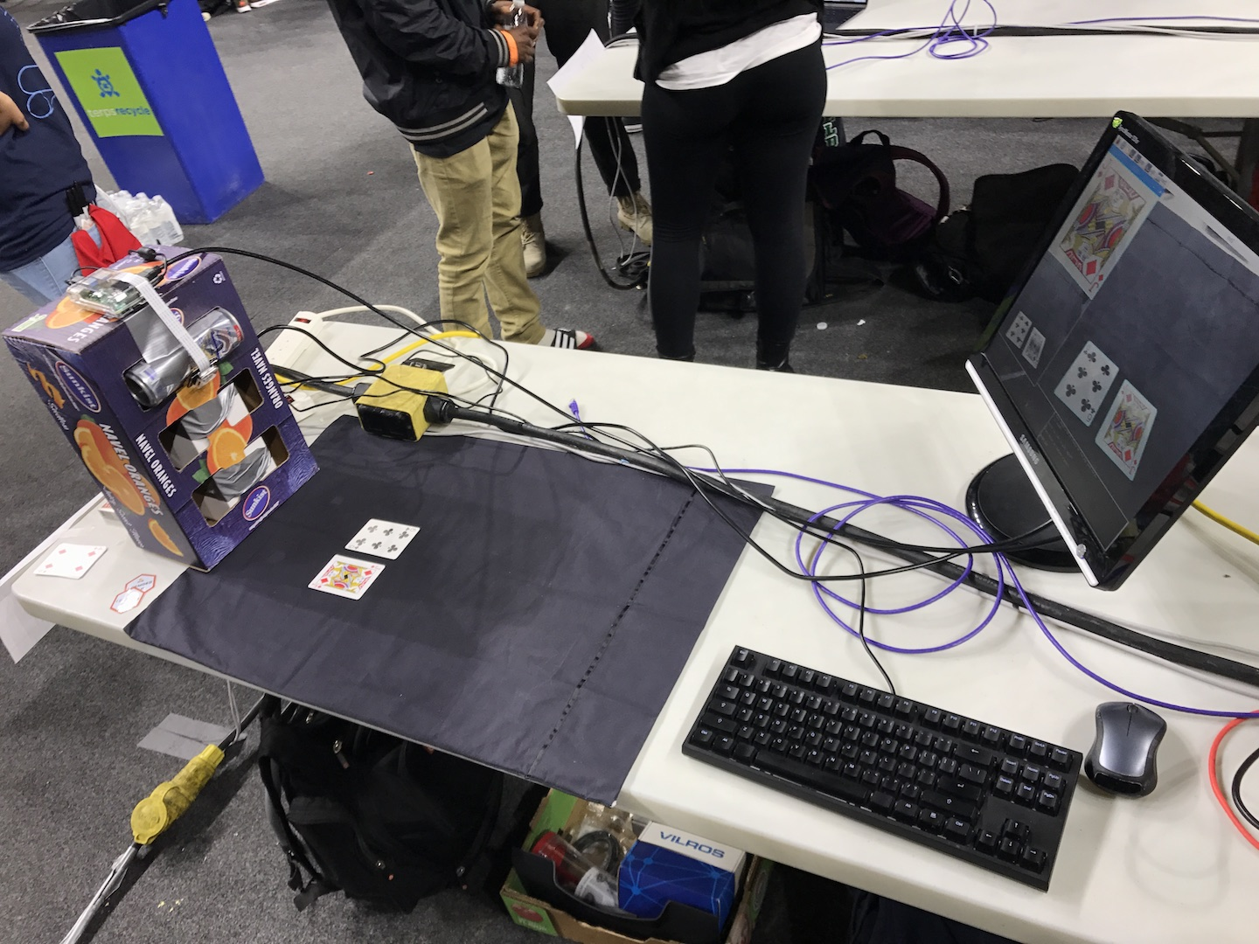

Our pi is located on top of the box of oranges, and the piCam is attached to the redbull can that is taped onto the front of the box. The screen displays the card that was most recently placed in the top left, a live feed of the camera in the top right, a gray scale of the live feed in the bottom left, and text output in the bottom right. The system would add up the value of the cards presented in front of it, and use a simple algorithm to determine if it wanted a hit or to stand.

Alexa Morse Code Translator

This was a project I did on my own. My goal was to be able to give a word or phrase to Amazon Alexa and have her output the phrase back to me in Morse code using “dit”s and “dah”s. This was my very first time writing software for Amazon Alexa, and so I learned a lot about the development process and basics of writing an alexa skill, specifically details in using the intents and slots. If I were to do this project over again I would try to have Alexa respond with the proper beeps and long-beeps of traditional morse code. I think that it would be a fun challenge, and seems to be the biggest request from people who have rated my skill. The source code for this project is located here:

<https://github.com/jwallher/morseCodeTranslator>

The project is also published to the Amazon marketplace, so all you need to do is ask alexa to, “Enable skill, Morse Code Translator”, then say “Alexa, ask morse code translator how to say taco” and she will run my skill.