Giving an ID to a button and by that ID we open the screen window that has the Details of that one customer like lets say ID 1 Button once we press on that button it display on the screen window once its pressed the ID 1 Customer only no other customer will be displayed and in the

Screen for each customer That inside that screen we are allowed to enter a Type of transport Date , transport Price , transport Area Transportation, Number of how many trucks , and creation of end and monthly summary of all transports at the end of the month and the total price in the calculation of each transport.

And after pressing “Send” It will be sent to the Trucking

A picture down:

Example if Number one button pressed:

It must only show the ID 1 Customer not all of the customer so each window display only the ID of the button number it display the same number and each new customer being added a new button being added by the number of the customer ID

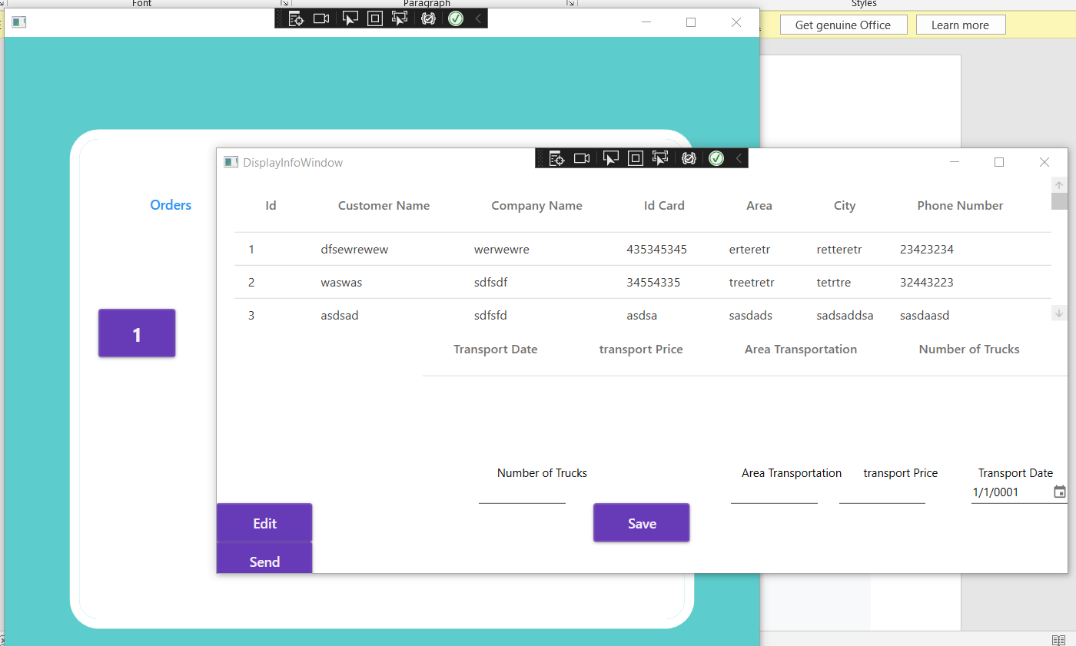

There are Models: that has the classes of the customer and the trucking

And MVVM: It was used for the button

And there is a view: that has the two windows