下一步需要做的是，基本网页不需要login。

|  |  |
| --- | --- |
| restart rest service, restart postman |  |
| http://localhost:8000/classusers/jwang@gmail.com | 401 Unauthorized |
| http://localhost:8000/topics | 401 Unauthorized |
| http://localhost:8000/sections | 401 Unauthorized |
| Postman: Basic Auth |  |
| http://localhost:8000/sections | return all sections correctly |
| remove auth |  |
| http://localhost:8000/topics | return all topics corectly |
| http://localhost:8000/classusers/jwang@gmail.com | return correct data |
| Clost Postman, restart |  |
| http://localhost:8000/classusers/jwang@gmail.com | return correct data without Authorization |
| http://localhost:8000/topics | return all topics with No Auth. |
| Stop REST server, restart |  |
| http://localhost:8000/classusers/jwang@gmail.com | cannot get data with No Auth, with Basic Auth, data back. |
|  |  |

Conclusion:

Postman save the auth into Cookies even it closed, it will bring the Cookies content back on next startup.

|  |  |
| --- | --- |
| [jwang@gmail.com](mailto:jwang@gmail.com) | {bcrypt}$2a$10$e1r48RySrXDCHCk22R4wmull3Ow4.mVhWpZwlwt2gSx9ruW0V7/ly |
|  |  |

增加SecurityConfig.java后，服务器无法启动。

|  |
| --- |
| org.springframework.beans.factory.UnsatisfiedDependencyException: Error creating bean with name 'securityConfig': Unsatisfied dependency expressed through field 'userDetailsService'; nested exception is org.springframework.beans.factory.NoSuchBeanDefinitionException: No qualifying bean of type 'org.springframework.security.core.userdetails.UserDetailsService' available: expected at least 1 bean which qualifies as autowire candidate. Dependency annotations: {@org.springframework.beans.factory.annotation.Autowired(required=true)} |

仅仅增加一个dependency就可以使整个应用软件得到保护。

|  |
| --- |
| pom.xml |
| <dependency>  <groupId>org.springframework.boot</groupId>  <artifactId>spring-boot-starter-security</artifactId>  </dependency> |

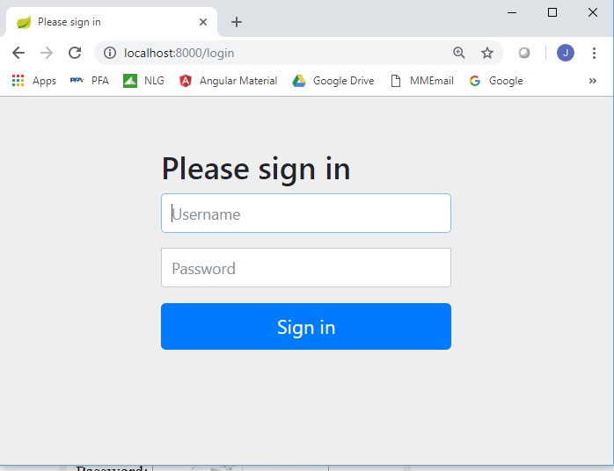

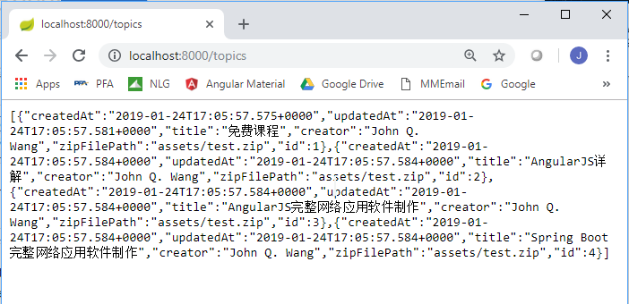

在没有加security的时候，只要键入<http://localhost:8000/topics>, 上述的内容就会从服务软件中返回。但是加入这个dependency之后，立刻打开了login的页面。

在启动angularJS的服务，打开client的网页

