**Consult the Solution Code**

To take a closer look at this solution, feel free to check out the solution workspace or click [here](https://github.com/udacity/deep-learning-v2-pytorch/blob/master/sentiment-rnn/Sentiment_RNN_Solution.ipynb) to see it as a webpage.

**Complete RNN Class**

I hope you tried out defining this model on your own and got it to work! Below, is how I completed this model.

*I know I want an embedding layer, a recurrent layer, and a final, linear layer with a sigmoid applied; I defined all of those in the __init__ function, according to passed in parameters.*

**def** **__init__**(self, vocab_size, output_size, embedding_dim, hidden_dim, n_layers, drop_prob=0.5):

"""

Initialize the model by setting up the layers.

"""

super(SentimentRNN, self).__init__()

self.output_size = output_size

self.n_layers = n_layers

self.hidden_dim = hidden_dim

*# embedding and LSTM layers*

self.embedding = nn.Embedding(vocab_size, embedding_dim)

self.lstm = nn.LSTM(embedding_dim, hidden_dim, n_layers,

dropout=drop_prob, batch_first=**True**)

*# dropout layer*

self.dropout = nn.Dropout(0.3)

*# linear and sigmoid layers*

self.fc = nn.Linear(hidden_dim, output_size)

self.sig = nn.Sigmoid()

**__init__ explanation**

First I have an **embedding layer**, which should take in the size of our vocabulary (our number of integer tokens) and produce an embedding of embedding_dim size. So, as this model trains, this is going to create and embedding lookup table that has as many rows as we have word integers, and as many columns as the embedding dimension.

Then, I have an **LSTM layer**, which takes in inputs of embedding_dim size. So, it's accepting embeddings as inputs, and producing an output and hidden state of a hidden size. I am also specifying a number of layers, and a dropout value, and finally, I’m setting batch_first to True because we are using DataLoaders to batch our data like that!

Then, the LSTM outputs are passed to a dropout layer and then a fully-connected, linear layer that will produce output_size number of outputs. And finally, I’ve defined a sigmoid layer to convert the output to a value between 0-1.

**Feedforward behavior**

Moving on to the forward function, which takes in an input x and a hidden state, I am going to pass an input through these layers in sequence.

**def** **forward**(self, x, hidden):

"""

Perform a forward pass of our model on some input and hidden state.

"""

batch_size = x.size(0)

*# embeddings and lstm_out*

embeds = self.embedding(x)

lstm_out, hidden = self.lstm(embeds, hidden)

*# stack up lstm outputs*

lstm_out = lstm_out.contiguous().view(-1, self.hidden_dim)

*# dropout and fully-connected layer*

out = self.dropout(lstm_out)

out = self.fc(out)

*# sigmoid function*

sig_out = self.sig(out)

*# reshape to be batch_size first*

sig_out = sig_out.view(batch_size, -1)

sig_out = sig_out[:, -1] *# get last batch of labels*

*# return last sigmoid output and hidden state*

**return** sig_out, hidden

**forward explanation**

So, first, I'm getting the batch_size of my input x, which I’ll use for shaping my data. Then, I'm passing x through the embedding layer first, to get my embeddings as output

These embeddings are passed to my lstm layer, alongside a hidden state, and this returns an lstm_output and a new hidden state! Then I'm going to stack up the outputs of my LSTM to pass to my last linear layer.

Then I keep going, passing the reshaped lstm_output to a dropout layer and my linear layer, which should return a specified number of outputs that I will pass to my sigmoid activation function.

Now, I want to make sure that I’m returning *only* the **last** of these sigmoid outputs for a batch of input data, so, I’m going to shape these outputs into a shape that is batch_size first. Then I'm getting the last bacth by called `sig_out[:, -1], and that’s going to give me the batch of last labels that I want!

Finally, I am returning that output and the hidden state produced by the LSTM layer.

**init_hidden**

That completes my forward function and then I have one more: init_hidden and this is just the same as you’ve seen before. The hidden and cell states of an LSTM are a tuple of values and each of these is size (n_layers by batch_size, by hidden_dim). I’m initializing these hidden weights to all zeros, and moving to a gpu if available.

**def** **init_hidden**(self, batch_size):

''' Initializes hidden state '''

*# Create two new tensors with sizes n_layers x batch_size x hidden_dim,*

*# initialized to zero, for hidden state and cell state of LSTM*

weight = next(self.parameters()).data

**if** (train_on_gpu):

hidden = (weight.new(self.n_layers, batch_size, self.hidden_dim).zero_().cuda(),

weight.new(self.n_layers, batch_size, self.hidden_dim).zero_().cuda())

**else**:

hidden = (weight.new(self.n_layers, batch_size, self.hidden_dim).zero_(),

weight.new(self.n_layers, batch_size, self.hidden_dim).zero_())

**return** hidden

After this, I’m ready to instantiate and train this model, you should see if you can decide on good hyperparameters of your own, and then check out the solution code, next!

## Hyperparameters

After defining my model, next I should instantiate it with some hyperparameters.

*# Instantiate the model w/ hyperparams*

vocab_size = len(vocab_to_int)+1 *# +1 for the 0 padding + our word tokens*

output_size = 1

embedding_dim = 400

hidden_dim = 256

n_layers = 2

net = SentimentRNN(vocab_size, output_size, embedding_dim, hidden_dim, n_layers)

print(net)

This should look familiar, but the main thing to note here is our vocab_size.

This is actually the length of our vocab_to_int dictionary (all our unique words) **plus one** to account for the 0-token that we added, when we padded our input features. So, if you do data pre-processing, you may end up with one or two extra, special tokens that you’ll need to account for, in this parameter!

Then, I want my output_size to be 1; this will be a sigmoid value between 0 and 1, indicating whether a review is positive or negative.

Then I have my embedding and hidden dimension. The embedding dimension is just a smaller representation of my vocabulary of 70k words and I think any value between like 200 and 500 or so would work, here. I’ve chosen 400. Similarly, for our hidden dimension, I think 256 hidden features should be enough to distinguish between positive and negative reviews.

I’m also choosing to make a 2 layer LSTM. Finally, I’m instantiating my model and printing it out to make sure everything looks good.

[[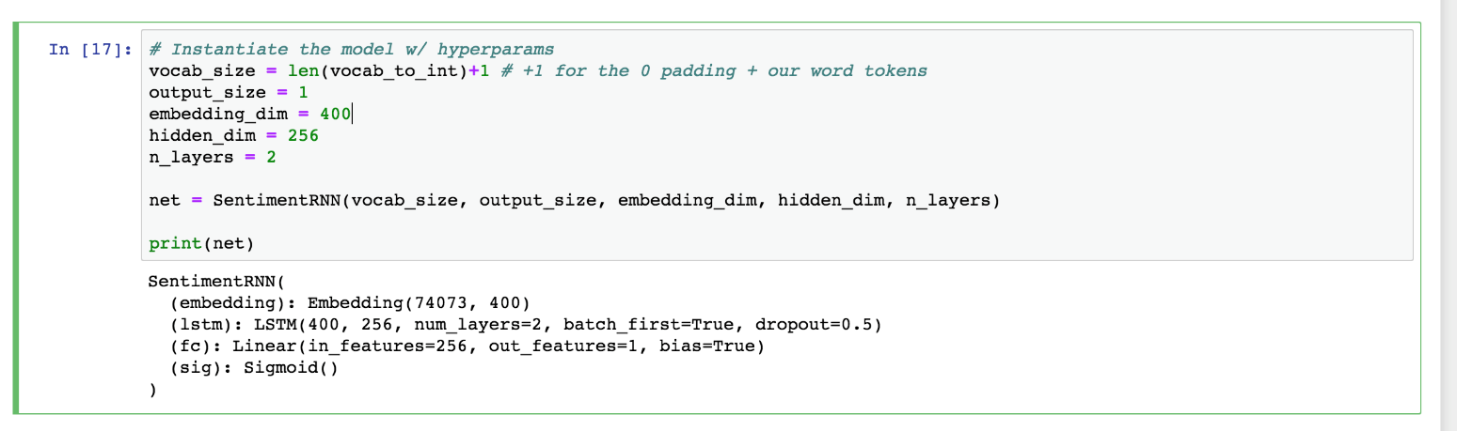](https://classroom.udacity.com/nanodegrees/nd880/parts/20d53643-50e8-41b6-8063-3d2ac4934bb2/modules/603e88cb-f190-4ede-84e7-055ce6f607c5/lessons/0a8ef0e2-8a0e-4087-8fc7-ac397da134e2/concepts/062bfbc6-34c8-4e5c-b072-6479eca5a385)](https://classroom.udacity.com/nanodegrees/nd880/parts/20d53643-50e8-41b6-8063-3d2ac4934bb2/modules/603e88cb-f190-4ede-84e7-055ce6f607c5/lessons/0a8ef0e2-8a0e-4087-8fc7-ac397da134e2/concepts/062bfbc6-34c8-4e5c-b072-6479eca5a385)

[Model hyperparameters](https://classroom.udacity.com/nanodegrees/nd880/parts/20d53643-50e8-41b6-8063-3d2ac4934bb2/modules/603e88cb-f190-4ede-84e7-055ce6f607c5/lessons/0a8ef0e2-8a0e-4087-8fc7-ac397da134e2/concepts/062bfbc6-34c8-4e5c-b072-6479eca5a385)

## Training and Optimization

The training code, should look pretty familiar. One new detail is that, we'll be using a new kind of cross entropy loss that is designed to work with a single Sigmoid output.

[*BCELoss*](https://pytorch.org/docs/stable/nn.html#bceloss)*, or****Binary Cross Entropy Loss****, applies cross entropy loss to a single value between 0 and 1.*

We'll define an Adam optimizer, as usual.

*# loss and optimization functions*

lr=0.001

criterion = nn.BCELoss()

optimizer = torch.optim.Adam(net.parameters(), lr=lr)

#### Output, target format

You should also notice that, in the training loop, we are making sure that our outputs are squeezed so that they do not have an empty dimension output.squeeze() and the labels are float tensors, labels.float(). Then we perform backpropagation as usual.

#### Train and eval mode

Below, you can also see that we switch between train and evaluation mode when the model is training versus when it is being evaluated on validation data!

### Training Loop

Below, you’ll see a usual training loop.

I’m actually only going to do four epochs of training because that's about when I noticed the validation loss stop decreasing.

* You can see that I am initializing my hidden state before entering the batch loop then have my usual detachment from history for the hidden state and backpropagation steps.
* I’m getting my input and label data from my train_dataloader. Then applying my model to the inputs and comparing the outputs and the true labels.
* I also have some code that checks performance on my validation set, which, if you want, may be a great thing to use to decide when to stop training or which best model to save!

*# training params*

epochs = 4 *# 3-4 is approx where I noticed the validation loss stop decreasing*

counter = 0

print_every = 100

clip=5 *# gradient clipping*

*# move model to GPU, if available*

**if**(train_on_gpu):

net.cuda()

net.train()

*# train for some number of epochs*

**for** e **in** range(epochs):

*# initialize hidden state*

h = net.init_hidden(batch_size)

*# batch loop*

**for** inputs, labels **in** train_loader:

counter += 1

**if**(train_on_gpu):

inputs, labels = inputs.cuda(), labels.cuda()

*# Creating new variables for the hidden state, otherwise*

*# we'd backprop through the entire training history*

h = tuple([each.data **for** each **in** h])

*# zero accumulated gradients*

net.zero_grad()

*# get the output from the model*

output, h = net(inputs, h)

*# calculate the loss and perform backprop*

loss = criterion(output.squeeze(), labels.float())

loss.backward()

*# `clip_grad_norm` helps prevent the exploding gradient problem in RNNs / LSTMs.*

nn.utils.clip_grad_norm_(net.parameters(), clip)

optimizer.step()

*# loss stats*

**if** counter % print_every == 0:

*# Get validation loss*

val_h = net.init_hidden(batch_size)

val_losses = []

net.eval()

**for** inputs, labels **in** valid_loader:

*# Creating new variables for the hidden state, otherwise*

*# we'd backprop through the entire training history*

val_h = tuple([each.data **for** each **in** val_h])

**if**(train_on_gpu):

inputs, labels = inputs.cuda(), labels.cuda()

output, val_h = net(inputs, val_h)

val_loss = criterion(output.squeeze(), labels.float())

val_losses.append(val_loss.item())

net.train()

print("Epoch: {}/{}...".format(e+1, epochs),

"Step: {}...".format(counter),

"Loss: {:.6f}...".format(loss.item()),

"Val Loss: {:.6f}".format(np.mean(val_losses)))

Make sure to take a look at how training **and** validation loss decrease during training! Then, once you're satisfied with your trained model, you can test it out in a couple ways to see how it behaves on new data!

## Consult the Solution Code

To take a closer look at this solution, feel free to check out the solution workspace or click [here](https://github.com/udacity/deep-learning-v2-pytorch/blob/master/sentiment-rnn/Sentiment_RNN_Solution.ipynb) to see it as a webpage.

**Testing the Trained Model**

I want to show you two great ways to test: using test data and using inference. The first is similar to what you’ve seen in our CNN lessons. I am iterating through the test data in the test_loader, recording the test loss and calculating the accuracy based on how many labels this model got correct!

I’m doing this by looking at the **rounded value** of our output. Recall that this is a sigmoid output between 0-1 and so rounding this value will give us an integer that is the most likely label: 0 or 1. Then I’m comparing that predicted label to the true label; if it matches, I record that as a correctly-labeled test review.

*# Get test data loss and accuracy*

test_losses = [] *# track loss*

num_correct = 0

*# init hidden state*

h = net.init_hidden(batch_size)

net.eval()

*# iterate over test data*

**for** inputs, labels **in** test_loader:

*# Creating new variables for the hidden state, otherwise*

*# we'd backprop through the entire training history*

h = tuple([each.data **for** each **in** h])

**if**(train_on_gpu):

inputs, labels = inputs.cuda(), labels.cuda()

*# get predicted outputs*

output, h = net(inputs, h)

*# calculate loss*

test_loss = criterion(output.squeeze(), labels.float())

test_losses.append(test_loss.item())

*# convert output probabilities to predicted class (0 or 1)*

pred = torch.round(output.squeeze()) *# rounds to the nearest integer*

*# compare predictions to true label*

correct_tensor = pred.eq(labels.float().view_as(pred))

correct = np.squeeze(correct_tensor.numpy()) **if** **not** train_on_gpu **else** np.squeeze(correct_tensor.cpu().numpy())

num_correct += np.sum(correct)

*# -- stats! -- ##*

*# avg test loss*

print("Test loss: {:.3f}".format(np.mean(test_losses)))

*# accuracy over all test data*

test_acc = num_correct/len(test_loader.dataset)

print("Test accuracy: {:.3f}".format(test_acc))

Below, I’m printing out the average test loss and the accuracy, which is just the number of correctly classified items divided by the number of pieces of test data,total.

We can see that the test loss is 0.516 and the accuracy is about **81.1%** !

[[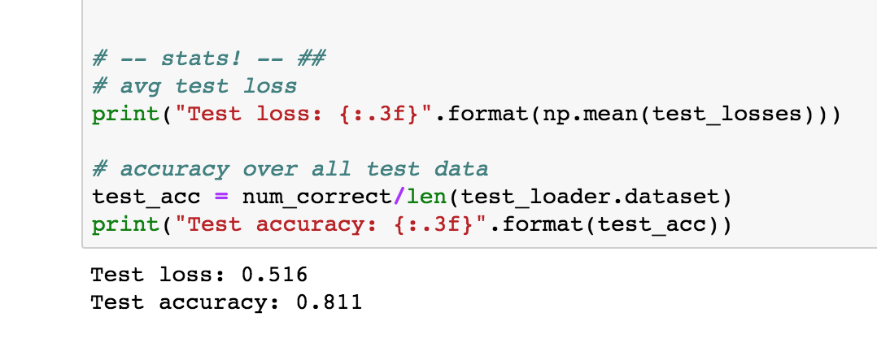](https://classroom.udacity.com/nanodegrees/nd880/parts/20d53643-50e8-41b6-8063-3d2ac4934bb2/modules/603e88cb-f190-4ede-84e7-055ce6f607c5/lessons/0a8ef0e2-8a0e-4087-8fc7-ac397da134e2/concepts/485111e1-a8fa-40d2-97a9-027069cd2ab5)](https://classroom.udacity.com/nanodegrees/nd880/parts/20d53643-50e8-41b6-8063-3d2ac4934bb2/modules/603e88cb-f190-4ede-84e7-055ce6f607c5/lessons/0a8ef0e2-8a0e-4087-8fc7-ac397da134e2/concepts/485111e1-a8fa-40d2-97a9-027069cd2ab5)

[Test results](https://classroom.udacity.com/nanodegrees/nd880/parts/20d53643-50e8-41b6-8063-3d2ac4934bb2/modules/603e88cb-f190-4ede-84e7-055ce6f607c5/lessons/0a8ef0e2-8a0e-4087-8fc7-ac397da134e2/concepts/485111e1-a8fa-40d2-97a9-027069cd2ab5)

Next, you're ready for your last task! Which is to define a predict function to perform inference on any given text review!

**Exercise: Inference on a test review**

You can change this test_review to any text that you want. Read it and think: is it pos or neg? Then see if your model predicts correctly!

***Exercise:****Write a predict function that takes in a trained net, a plain text_review, and a sequence length, and prints out a custom statement for a positive or negative review!*

* *You can use any functions that you've already defined or define any helper functions you want to complete predict, but it should just take in a trained net, a text review, and a sequence length.*

**def** **predict**(net, test_review, sequence_length=200):

''' Prints out whether a give review is predicted to be

positive or negative in sentiment, using a trained model.

params:

net - A trained net

test_review - a review made of normal text and punctuation

sequence_length - the padded length of a review

'''

*# print custom response based on whether test_review is pos/neg*

Try to solve this task on your own, then check out the solution, next!

**Inference**

Let's put all these pieces together! One of the coolest ways to test a model like this is to give it user-generated data, without any true label, and see what happens. So, in this case, that data will just be a single string: a review that you can write and here’s just one test_reviewas an example:

*# negative test review*

test_review_neg = 'The worst movie I have seen; acting was terrible and I want my money back. This movie had bad acting and the dialogue was slow.'

We can see that this review is a negative one, but let's see if our model can identify it's sentiment correctly!

Our task is to write a predict function that takes in a trained model, a test_review like this one that is just normal text and punctuation, a sequence_length for padding.

The process by which you make predictions based on user data, is called **inference**.

**Pre-process the test_review**

The first thing we'll have to do it to process the test_review, so that it is converted into a tensor that our model can see as input. In fact, this involves quite a lot of pre-processing, but nothing that you haven't seen before!

I broke this down into a series of steps.

I have a helper function tokenize_review that is responsible for doing some data processing on my test_review.

It takes in my test_review, and then does a couple of things:

1. First, I convert my test_review to lowercase, and remove any punctuation, so I’m left with all text.
2. Then I breaks it into individual words with split(), and I’m left with a list of words in the review.
3. I encode those words using the vocab_to_int dictionary that we already defined, near the start of this lesson.

Now, I am assuming a few things here, including: this review is one review, not a batch, and that this review only includes words *already* in our dictionary, and in this case that will be true, but you can add code to handle unknown characters, I just didn’t do that in my model.

**from** string **import** punctuation

**def** **tokenize_review**(test_review):

test_review = test_review.lower() *# lowercase*

*# get rid of punctuation*

test_text = ''.join([c **for** c **in** test_review **if** c **not** **in** punctuation])

*# splitting by spaces*

test_words = test_text.split()

*# tokens*

test_ints = []

test_ints.append([vocab_to_int[word] **for** word **in** test_words])

**return** test_ints

Okay, so this tokenize function returns a list of integers; my tokenized review!

**Padding and converting into a Tensor**

For my next couple of steps, I’m going to pad the ints, returned by the tokenize_review function and shape them into our sequence_length size; since our model was trained on sequence lengths of 200, I’m going to use the same length, here. I'll pad it using the pad_features function that we defined earlier.

Finally, I’m going to convert the padded result into a Tensor. So, these are all the steps, and I’m going to wrap this *all* up in my predict function.

**def** **predict**(net, test_review, sequence_length=200):

net.eval()

*# tokenize review*

test_ints = tokenize_review(test_review)

*# pad tokenized sequence*

seq_length=sequence_length

features = pad_features(test_ints, seq_length)

*# convert to tensor to pass into your model*

feature_tensor = torch.from_numpy(features)

batch_size = feature_tensor.size(0)

*# initialize hidden state*

h = net.init_hidden(batch_size)

**if**(train_on_gpu):

feature_tensor = feature_tensor.cuda()

*# get the output from the model*

output, h = net(feature_tensor, h)

*# convert output probabilities to predicted class (0 or 1)*

pred = torch.round(output.squeeze())

*# printing output value, before rounding*

print('Prediction value, pre-rounding: {:.6f}'.format(output.item()))

*# print custom response*

**if**(pred.item()==1):

print("Positive review detected!")

**else**:

print("Negative review detected.")

So, using the passed in arguments, I’m tokenizing my review using my helper function, then padding it using my pad function, and converting it into a Tensor that can be seen by my model.

Then, I’m passing this tensor into my trained net which will return an output of length one. With this output, I can grab the most likely class, which will be the rounded value 0 or 1; this is my prediction!

Lastly, I want to print out a custom message for a positive or negative detected review, and I’m doing that at the bottom of the above function!

**You can test this out on sample positive and negative text reviews to see how this trained model behaves!** Below, you can see how it identifies our negative test review correctly.

[[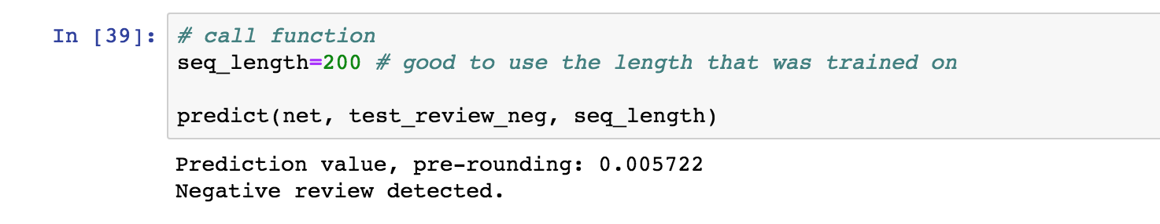](https://classroom.udacity.com/nanodegrees/nd880/parts/20d53643-50e8-41b6-8063-3d2ac4934bb2/modules/603e88cb-f190-4ede-84e7-055ce6f607c5/lessons/0a8ef0e2-8a0e-4087-8fc7-ac397da134e2/concepts/a8556c8d-3a22-4ed0-b232-ebc953269bd0)](https://classroom.udacity.com/nanodegrees/nd880/parts/20d53643-50e8-41b6-8063-3d2ac4934bb2/modules/603e88cb-f190-4ede-84e7-055ce6f607c5/lessons/0a8ef0e2-8a0e-4087-8fc7-ac397da134e2/concepts/a8556c8d-3a22-4ed0-b232-ebc953269bd0)

[Identifies negative review](https://classroom.udacity.com/nanodegrees/nd880/parts/20d53643-50e8-41b6-8063-3d2ac4934bb2/modules/603e88cb-f190-4ede-84e7-055ce6f607c5/lessons/0a8ef0e2-8a0e-4087-8fc7-ac397da134e2/concepts/a8556c8d-3a22-4ed0-b232-ebc953269bd0)

**Conclusion**

Now that you have a trained model and a predict function, you can pass in any kind of text and this model will predict whether the text has a positive or negative sentiment. You can use this to try to find what words it associates with positive or negative sentiment.

[[](https://classroom.udacity.com/nanodegrees/nd880/parts/20d53643-50e8-41b6-8063-3d2ac4934bb2/modules/603e88cb-f190-4ede-84e7-055ce6f607c5/lessons/0a8ef0e2-8a0e-4087-8fc7-ac397da134e2/concepts/a8556c8d-3a22-4ed0-b232-ebc953269bd0)](https://classroom.udacity.com/nanodegrees/nd880/parts/20d53643-50e8-41b6-8063-3d2ac4934bb2/modules/603e88cb-f190-4ede-84e7-055ce6f607c5/lessons/0a8ef0e2-8a0e-4087-8fc7-ac397da134e2/concepts/a8556c8d-3a22-4ed0-b232-ebc953269bd0)

[Dancing Beemo from](https://classroom.udacity.com/nanodegrees/nd880/parts/20d53643-50e8-41b6-8063-3d2ac4934bb2/modules/603e88cb-f190-4ede-84e7-055ce6f607c5/lessons/0a8ef0e2-8a0e-4087-8fc7-ac397da134e2/concepts/a8556c8d-3a22-4ed0-b232-ebc953269bd0)[Adventure Time](https://en.wikipedia.org/wiki/Adventure_Time) to celebrate!

Later, you'll learn how to deploy a model like this to a production environment so that it can respond to any kind of user data put into a web app!

**For now, great job implementing so *many* kinds of recurrent neural networks!!**