Lab 1 – Clash Product Description v.3
Andrew Chverchko
CS411
Janet Brunelle
Hill Price
March 30, 2015

Table of Contents
1 INTRODUCTION 3
2 PRODUCT DESCRIPTION 4
2.1 Key Product Features and Capabilities 5
2.2 Major Components (Hardware/Software) 6
3 IDENTIFICATION OF CASE STUDY 8
4 C.L.A.S.H PRODUCT PROTOTYPE DESCRIPTION 9
4.1 Hardware and Software Prototype Architecture 11
4.2 Prototype Features and Capabilities 12
4.3 Prototype Development Challenges 12
GLOSSARY 14
REFERENCES 15

List of Figures
Figure 1. Major Functional Component Diagram 7
Figure 2. Prototype Major Functional Component Diagram 11

List of Tables
Table 1. Prototype Versus Real World Diagram 10

Lab 1 – CLASH Product Description
- INTRODUCTION
Old Dominion University is a university that teaches students from all over the world. ODU requires students to pass an English language test or pass through the English as second language (ESL) learning program to attend classes. ODU’s ESL department teaches ESL students in the program over the course of 18 months. English Language Learner (ELL) students have been practicing English since birth. Some ESL students do not acquire the proficiency in English to take courses at ODU. Some of the ESL students that attend courses after the bridge program, struggle to read and comprehend English. There are cases where ESL students are word by word readers. Word by word readers learn the meanings of individual words, but lack in comprehension of the meanings of a group of words together.
ESL students have been shown to have difficulty in learning English in the past. In 2001 a test for reading comprehension was issued. Out of the participating students, 18.7 percent demonstrated an average or above (McKeon). In February that same year, the number of dropouts in ESL reached a value that was four times that of English speaking students (McKeon). ODU ESL instructors attempt to raise the amount of above average readers with software like Spreeder. Spreeder is a document reader that displays the words of the document at different speed. This software is not easy to use and does not help students with reading comprehension. Currently, there is no software designed to assist ESL students with reading speed and comprehension.
CLASH the Color Lexical Analysis algorithm and Slash Handler aims to be a program specifically for ESL students. CLASH holds two main services COLRS and Slash. The COLRS displays the text of a document with the parts of speech (POS) of the text changed in color. The color identifies the POS of the words in the text . In recent studies, colors are said to provoke a higher level of attention this will result in an increase of memory retention (Dzulkifli, Mustafar). Slash takes the document and displays the words in lexical bundles on a display. The display presents to the user the individual lexical bundles of the text from beginning to end. Lexical bundles are groups of words that occur repeatedly together within the same register. Lexical bundles are also called thought groups because they appear as a single thought. Another study affirms that lexical bundles help in word and sentence recall experiments (Tremblay, Derwing, Libben, Westbury). In the sentence recall experiments, a test group of people was exposed to a sentence with lexical bundles and a sentence with them. The test group was shown to read faster when lexical bundles were present. The CLASH aims to bring these benefits to the current ESL classroom.
- PRODUCT DESCRIPTION
CLASH is a computer program with two major applications, COLRS and Slash. The COLRS section processes a document of text and applies different colors to identify the parts of speech found in the sentences of the document. This colorization helps the user acquire a better understanding of English grammar and different parts of speech. The Slash section takes a text document and converts it into chunks of text that vary in size between three to five words. These chunks of text are called lexical bundles. Slash application uses lexical bundles to make reading and comprehension of English easier for ESL students.

  - Key Product Features and Capabilities
CLASH is a web application with features for students, instructors, administrators. The Students are able to login with a student account using a computer with an internet connection. The student can then access the COLRS module or the Slash module. The COLRS module possesses controls for highlighting individual POS from a choice of eight. The eight choices are noun, pronoun, verb, adverb, adjective, conjunction, preposition, and article. The student can select any combination of the POS for highlighting using color in the text. The student has the ability to switch to the Slash module using a single button. This simple navigation allows the program to be more accessible to new users. The Slash module will display the lexical bundles of a document using slashes. The text will have forward slashes located between lexical bundles. Another feature of the Slash module is the Slash Reader. The Slash reader puts lexical bundles on the reader display. The bundles on the display are presented one bundle at a time. The Reader displays at a default speed of 60 words per minute. This display speed in the Slash Reader can be changed at any time during use. The student also has the control capability on the user interface of the reader to pause the display and rewind to a previous lexical bundle in the document. CLASH is a unique product that is the first teacher tool that possesses both grammar through POS coloration and reading speed practice through lexical bundles specifically for ESL students.
The instructor has the same features as students with the addition of others. The instructor user has control over the student accounts in their class. They can add and remove students from their class. Instructor accounts have direct control over the students’ documents student users can open. These documents can be added, removed, or modified from the instructor account. A student account does not have the ability to add documents for liability reasons. A student can possibly upload a document that is copyrighted. The modification of documents the instructors possess allows for correction of slashed and colored documents in an editor window. A list of exceptions can be saved to help the application remember specific scenarios that the software did not perform correctly. This can be used for future documents inserted into the application. One unique feature of CLASH for instructor is the ability to see each student’s usage of the application. The instructor can see information on the student such as which documents are viewed, the total time on the application, and the average speed selected in the Slash reader. This feature will help instructors with assessing student progress and determine which students need additional help.
The administrator account has all the benefits of the previous two types with added feature to create and delete instructor accounts. The deletion of an instructor account removes access to documents from the students accounts linked to the instructor. The administrator account feature will prevent students from accessing the software after a course has been concluded. The customer will have the role of administrator at the product’s completion.
  - Major Hardware and Software Components
There is only two pieces of hardware necessary for CLASH. The user must have a computer with a web browser installed and the CLASH application requires an active server. The user opens the web browser on their computer and logs onto the CLASH server to access the documents in the database. The user then can process text through the system using the software components of CLASH.

“This Space is Intentionally Left Blank”

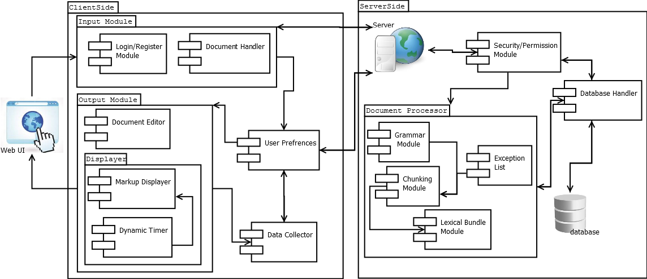
Figure 1. Major Functional Component Diagram
Figure 1 illustrates how the software of CLASH takes input and processes it. On the CLASH server, three main components make up the software of the application. These three are the Lexical Bundle module, the COLRS module, and Client-side reader. The COLRS module first takes a document and runs it through software called Natural Language Processing (NLP). This will split the document into tokens and create a tag that labels the POS of each token. This set of tokens with tags is then sent to the Lexical Bundle module. The Lexical Bundle module takes the set and determines locations to insert a specific slash tag. This slash tag splits the set into lexical bundles. The module uses instructor’s exception list to make changes in the slash tag insertion to fix the lexical bundles. If no exception list is in memory, then the module will bypass the step. The set of tokens and their tags are then sent to the Client-side reader. The Client-side reader takes the output from the previous module and organizes it based on the tags. Then the text appears on the user’s screen based on the mode the user chooses. They can choose COLRS for the parts of speech colorization or the Slash reader for the display of lexical bundles at various speeds. The user has the ability to submit a new document after CLASH processes the first.
- IDENTIFICATION OF CASE STUDY
Old Dominion University contains an ESL program called the English Language Bridge Program. This program is for the many students that attend ODU and are not native English speakers. These students that want to attend ODU for normal classes must complete the bridge program. In order to start the program, the student must first score between a 500 and 550 on the TOEFL or a 61 through 79 on the IBT. The students must spend one and a half years learning English to a level necessary to take college courses at ODU. In the one and a half years’ time, the ESL student has to learn to understand a foreign language for social and academic purposes. Failure to complete the Bridge Program will prevent the student from pursuing a college degree.
Greg Raver-Lampman is an instructor for ESL students at Old Dominion University. He teaches students with little to no experience in English. For his classes, he attempts to teach a vast amount of English language knowledge to ESL students. The class last for one and a half years. Other university students have been practicing English their entire lives. The tools available to the professor are the standard for many teachers. He can write examples on a chalkboard. Slideshows and practice assignments can be prepared. Reading homework can be assigned. Through these techniques, students can increase their understanding of the English language. These tools are sometimes not sufficient to help elevate the student to the skill level in English they desire. Many times, the students struggle with reading and comprehension. The reading speed for some students can be one word at a time. This makes the learning of English difficult.
CLASH aims to make the education of ESL students easier. The use of lexical bundles can improve reading speed and comprehension. The parts of speech colorized help students identify grammar. The application has a design with ESL users as a focus. CLASH is a new tool for ESL instructors to use.
- CLASH PRODUCT PROTOTYPE DESCRIPTION
The prototype of CLASH will be Single Page Application (SPA). A SPA means that all of the user interaction with the application will take place on a single page instead of being sent to different webpages for each interaction. This will make the application easier to use. The ESL students can access all of the application without getting lost in webpages. The database for the prototype is a relational database and all functionality will be written in JavaScript. The webserver of the prototype will use Node.js. The prototype will have the three main features. These three are the display of color for different POS, the insertion of slashes to indicate lexical bundles, and the display of lexical bundles at various speeds.

“This Space is Intentionally Left Blank”

Features | Real World Project | Prototype
Parsing Capabilities | Ability to Parse different kinds of documents | Ability to parse text copy and pasted into form
Text Modification | Ability to modify and store previously parsed documents | Ability to modify and store previously parsed documents
Color Capabilities | Ability to Color chosen parts of speech using a JSON format and javascript functions. | Ability to Color chosen parts of speech using a JSON format and javascript functions.
Slashing Capabilities | Ability to identify lexical bundles through the inserting of slashes. | Ability to identify lexical bundles through the inserting of slashes.
Displaying lexical bundles in a single bundle form | Ability to speed up, slow down and pause lexical bundles being displayed. | Ability to speed up, slow down and pause lexical bundles being displayed.
Exception list | Lists of commonly used expressions that would otherwise be incorrectly parsed and tagged. | Lists of commonly used expressions that would otherwise be incorrectly parsed and tagged.
Login interface | User Authentication in a stand alone environment | User Authentication in a stand alone environment
Student Data reporting | Tracks individual and collective student progress. To include words per minute, total time and total lexical bundles. Data to be stored in database. Displayed in graphs and statistics. | Not included.
Homework Mode | Instructors have the ability to remove coloring of words and have students correctly identify the part of speech. | Not Included.
Administrative Privileges | Administrators are able to edit, add, or remove anything in the system. | Administrators are able to edit, add, or remove anything in the system.
Print mode | Ability to print documents with slashes inserted. | Ability to print documents with slashes inserted.
Table 1. Prototype Versus Real World Diagram.
There are a few compromises that make the prototype different from the real world product as illustrated in Table 1. The activity data of the student’s use of the application is not stored. The activity data of student users was deemed to be not imperative by the customer. The available time to complete the prototype also led to the removal of the activity data feature. The ability to add homework assignments for students will not be present. The ability to add and remove users will be done manually by the instructors. This feature reduction is the result of the ODU enrollment files being inaccessible. The prototype still possesses the inclusion of an exception list that is modifiable by instructors.
  - Hardware and Software Prototype Architecture
The prototype holds a different hardware and software architecture from the real world product. The database holds simulated data because the prototype does not keep track of user actions. The application also is run on a virtual machine versus a server. The prototype does possess a similar process for converting documents into displayable text.
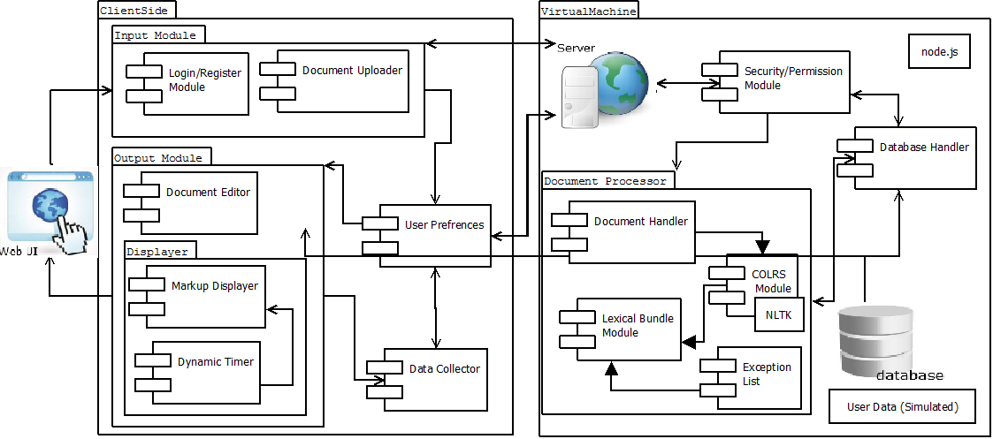
Figure 2. Prototype Major Functional Component Diagram.
Figure 2 shows the prototype’s hardware and how the software processes a document. The hardware for the application that houses the backend of the application is a virtual machine. Software components of the prototype include the Input Module, the Document Processor, and Output Module. The user logs into the input module then sends a document to the server which is Node.js. The document will then go to the Document Processor. This will run the document through the COLRS Module that contains a Natural Language Toolkit to tag the document. The tagged document will go through the Lexical bundle module to receive slash tags to make lexical bundles. The exception list checks for errors in the slashing. This server will then send a markup stream of tags to the Output Module. The Markup Displayer takes the stream and synthesizes the document for the viewer based on the view selected by the user. The document can be opened in the editor, if the instructor wants to modify the document.
  - Prototype Features and Capabilities
The CLASH prototype possesses many core features. CLASH is able to color parts of speech in a document. The user will be able to select which parts of speech are colored. The application will display the text of a document in lexical bundles one at a time. The user can pause the display and move to any lexical bundle in the document. The user can change the display speed of lexical bundles using controls on the user interface. The user has the option to view lexical bundles as a document with slashes inserted. The completion of the core features will provide the customer with an application.
The customer will then utilize the application to test the usability in an academic setting. He will be an instructor and create student accounts. Students will make use of the application in class for one semester. The instructor will then compare the course material results of the student users with nonusers. If the users demonstrate higher reading speed and comprehension, the application will gain verification of being applicable in teaching university ESL students. The customer achieves his goal and development team’s goal.
  - Prototype Development Challenges
CLASH contains its own share of potential hardships. The biggest hurdle is correctly identifying parts of speech. If they are identified incorrectly, the Slash portion will fail along with the COLRS. Slash is dependent on the P.O.S tags to place the slashes for the lexical bundles. The speed of display in Slash will also be a challenge. This is a problem because lexical bundle do not have a set size. The exception list can add a layer of complexity to the backend and has the potential to break an almost completely tagged document. The size of the exception list could slow down the application. Since the application is made with ESL students as the users, the creation of an easy to use interface can be challenging. A challenge that will require extensive testing is the amount of concurrent users that the application can handle. The prototype will have many difficulties. Testing and meetings with the mentor will help mitigate and reduce the problems.

Glossary
CLASH - Color Lexical Analysis algorithm and Slash Handler
COLRS – Colored Organized Lexical Recognition Software
COLRS module- Aspect of CLASH that displays colorized POS for a user
ELC – English Learning Center
ESL – English as second language
IBT – International benchmark test
JSON – JavaScript Object Notation
Lexical Bundle – a group of words that occur repeatedly together within the same register
MFCD – Major Functional Component Diagram
NLTK – a suite of libraries and programs for symbolic and statistical natural language processing (NLP) for the Python programming language.
Node.js – an open source, cross-platform runtime environment for server-side and networking applications.
POS – Parts of Speech
Slash module- Aspect of CLASH that displays slashed text and Slash Reader for a user
SPA – single page application, is a highly responsive web application that fits on a single page and does not reload as the web page changes states.
SPREEDER – Speed reading tool www.spreeder.com
TOEFL – Test of English as a Foreign Language
Token: Text that has been processed into individual words by the Document Processor
Ubuntu- a Debian-based Linux operating system
VM – Virtual Machine

References
Dzulkifli, M., & Mustafar, M. (2013, March 20). The Influence of Colour on Memory Performance: A Review. Retrieved February 8, 2015, from http://www.ncbi.nlm.nih.gov/pmc/articles/PMC3743993/
McKeon, D. (n.d.). Research Talking Points on English Language Learners. Retrieved December 11, 2014.
Mikowski, M., & Powell, J. Single Page Applications. Manning Publications 2014.
Tremblay, A., Derwing, B., Libben, G., & Westbury, C. (2011, January 15). Processing Advantages of Lexical Bundles: Evidence From Self-Paced Reading and Sentence Recall Tasks. Retrieved December 10, 2014.

