CS 411W Lab II

Prototype Product Specification
For
Product CLASH

Prepared by: Andrew Chverchko

Date: 3/24/2015

Table of Contents

1 Introduction 1
1.1 Purpose 2
1.2 Scope 2
1.3 Definitions, Acronyms, and Abbreviations 2
1.4 References 4
1.5 Overview 5
2 General Description 5
2.1 Prototype Architecture Description 5
2.2 Prototype Functional Description 5

List of Figures
Figure 1. Prototype Major Functional Component Diagram. 6

List of Tables
Table 1. Functional Table 7

Introduction
Old Dominion University is a university that teaches students from all over the world. In order to succeed at ODU, an understanding of English is necessary to take courses. ODU’s English as second language (ESL) department teaches students English in one and a half years. English Language Learner (ELL) students have been practicing English since birth. Some ESL students do not acquire the proficiency in English to take courses at ODU. Some of the ESL students that get into courses, struggle to read and comprehend English. There are cases where ESL students are word by word readers.
CLASH the Color Lexical Analysis algorithm and Slash Handler aims to be a program specifically for ESL students. CLASH holds two main functionalities COLRS and Slash. The COLRS displays that text of a document with different parts of speech (POS) labeled with color. In recent studies, colors are said to provoke a higher level of attention this will result in an increase of memory retention (Dzulkifli, Mustafar). Slash takes the document and displays the words in lexical bundles in order for the user to read. Lexical bundles are groups of words that occur repeatedly together within the same register. Lexical bundles are also called thought groups because they appear as a single thought. Another study affirms that lexical bundles help in word and sentence recall experiments (Tremblay, Derwing, Libben, Westbury). CLASH aims to bring these benefits to the current ESL classroom.

Purpose
CLASH is a computer program with two major applications, COLRS and Slash for the use of English as a Second Language (ESL) students. The COLRS section processes a document of text and applies different colors to identify the parts of speech found in the sentences of the document. This colorization helps the user acquire a better understanding of English grammar and different parts of speech. The Slash section takes a text document and converts it into chunks of text that vary in size between three to five words. These chunks of text are called lexical bundles. Slash application uses lexical bundles to make reading and comprehension of English easier for ESL students.

Scope
The prototype of CLASH will be Single Page Application (SPA). A SPA means that all of the user interaction with the application will take place on a single page instead of being sent to different webpages for each interaction. This will make the application easier to use. The ESL students can access all of the application without getting lost in webpages. The database for the prototype is a relational database and all functionality will be written in JavaScript. The webserver of the prototype will use Node.js. The prototype will still have the three main features. These three are the display of color for different POS, the insertion of slashes to indicate lexical bundles, and the display of lexical bundles at various speeds. The one semester’s time to complete the prototype reduces the number of extra features in the prototype. The activity data of the student’s use of the application is not stored. The activity data of student users was deemed to be not imperative by the customer. The available time to complete the prototype also led to the removal of the activity data feature. The ability to add homework assignments for students will not be present. The ability to add and remove users will be done manually by the instructors. This feature reduction is the result of the ODU enrollment files being inaccessible. The prototype still possesses the inclusion of an exception list that is modifiable by instructors.

Definitions, Acronyms, and Abbreviations
CLASH - Color Lexical Analysis algorithm and Slash Handler
COLRS – Colored Organized Lexical Recognition Software
COLRS module- Aspect of CLASH that displays colorized POS for a user
ELC – English Learning Center
ESL – English as second language
IBT – International benchmark test
JSON – JavaScript Object Notation
Lexical Bundle – a group of words that occur repeatedly together within the same register
MFCD – Major Functional Component Diagram
NLTK – a suite of libraries and programs for symbolic and statistical natural language processing (NLP) for the Python programming language.
Node.js – an open source, cross-platform runtime environment for server-side and networking applications.
POS – Parts of Speech
Slash module- Aspect of CLASH that displays slashed text and Slash Reader for a user
SPA – single page application, is a highly responsive web application that fits on a single page and does not reload as the web page changes states.
SPREEDER – Speed reading tool www.spreeder.com
TOEFL – Test of English as a Foreign Language
Token: Text that has been processed into individual words by the Document Processor
Ubuntu- a Debian-based Linux operating system
VM – Virtual Machine

References
Lab I
Dzulkifli, M., & Mustafar, M. (2013, March 20). The Influence of Colour on Memory Performance: A Review. Retrieved February 8, 2015, from http://www.ncbi.nlm.nih.gov/pmc/articles/PMC3743993/
McKeon, D. (n.d.). Research Talking Points on English Language Learners. Retrieved December 11, 2014.
Mikowski, M., & Powell, J. Single Page Applications. Manning Publications 2014.
Tremblay, A., Derwing, B., Libben, G., & Westbury, C. (2011, January 15). Processing Advantages of Lexical Bundles: Evidence From Self-Paced Reading and Sentence Recall Tasks. Retrieved December 10, 2014.

Overview
This product specification contains the CLASH prototype’s hardware and software architecture, functions, and performance. The information in the remaining sections include the prototype architecture, functional description, and functional and performance requirements. The functional requirements includes a list of capabilities of CLASH. These capabilities hold a list of parameters for creation of product functions that handle display and user input.

General Description
The prototype holds a different hardware and software architecture from the real world product. The database holds simulated data because the prototype does not keep track of user actions. The application also is run on a virtual machine versus a server. The prototype does possess a similar process for converting documents into displayable text.

Prototype Architecture Description
In CLASH, there are three main components make up the software of the application. These three are the Lexical Bundle module, the COLRS module, and Client-side reader. The COLRS module first takes a document and runs it through software called Natural Language Processing (NLP). This will split the document into tokens and create a tag that labels the POS of each token. This set of tokens with tags is then sent to the Lexical Bundle module. The Lexical Bundle module takes the set and determines locations to insert a specific slash tag. This slash tag splits the set into lexical bundles. The module uses instructor’s exception list to make changes in the slash tag insertion to fix the lexical bundles. If no exception list is in memory, then the module will bypass the step. The set of tokens and their tags are then sent to the Client-side reader. The Client-side reader takes the output from the previous module and organizes it based on the tags. Then the text appears on the user’s screen based on the mode the user chooses. They can choose COLRS for the parts of speech colorization or the Slash reader for the display of lexical bundles at various speeds. The user has the ability to submit a new document after CLASH processes the first.
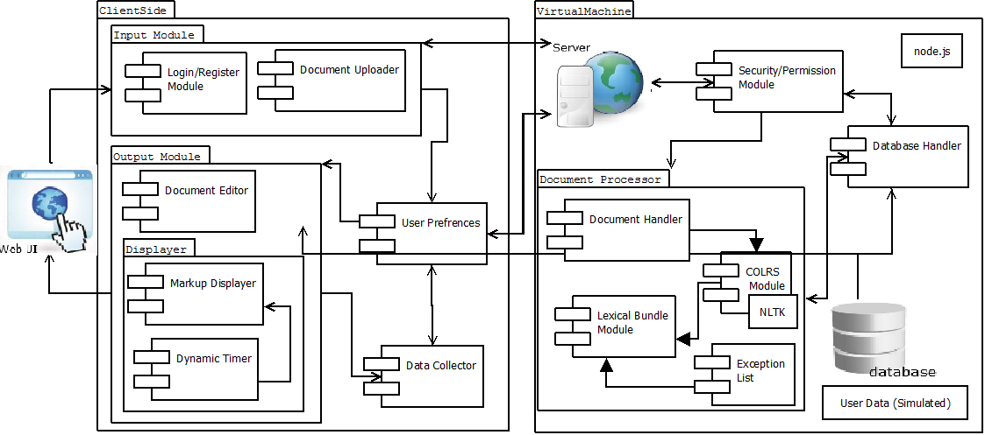
Figure 2. Prototype Major Functional Component Diagram

Prototype Functional Description
The major functional components of the product CLASH prototype include the following:
Function | Summary
Parser | This function parses text copy and pasted into form
Edit mode | This function modifies and store previously parsed documents
Colrs Displayer | This function colors chosen parts of speech using a JSON format and javascript functions.
Slash Player | This function speeds up, slows down and pauses lexical bundles being displayed.
Login interface | This function checks user authentication in a stand alone environment
Print mode | This function prints documents with slashes inserted.
Table 1. Functional Table.

