CS 411W Lab II

Prototype Product Specification v.2
For
Product CLASH

Prepared by: Andrew Chverchko

Date: 4/18/2015

Table of Contents

1 Introduction 1
1.1 Purpose 2
1.2 Scope 2
1.3 Glossary 3
1.4 References 4
1.5 Overview 5
2 General Description 5
2.1 Prototype Architecture Description 5
2.2 Prototype Functional Description 7
2.3 External Interfaces 7

List of Figures
Figure 1. Prototype Major Functional Component Diagram. 6

List of Tables
Table 1. Functional Table 7

Introduction
Old Dominion University is a university that teaches students from all over the world. ODU requires students to pass an English language test or pass through the English as second language (ESL) learning program to attend classes. ODU’s ESL department teaches ESL students in the program over the course of 18 months. English Language Learner (ELL) students have been practicing English since birth. Some ESL students do not acquire the proficiency in English to take courses at ODU. Some of the ESL students that attend courses after the bridge program, struggle to read and comprehend English. There are cases where ESL students are word by word readers. Word by word readers learn the meanings of individual words, but lack in comprehension of the meanings of a group of words together.
CLASH, the Color Lexical Analysis algorithm and Slash Handler, aims to be a program specifically for ESL students. CLASH holds two main services, COLRS and Slash. The COLRS displays the text of a document with the parts of speech (POS) of the text changed in color. The color identifies the POS of the words in the text . In recent studies, colors are said to provoke a higher level of attention; this will result in an increase of memory retention (Dzulkifli, Mustafar). Slash takes the document and displays the words in lexical bundles on a display. The display presents to the user the individual lexical bundles of the text from beginning to end. Lexical bundles are groups of words that occur repeatedly together within the same register. Lexical bundles are thought groups because they appear as a single thought. Another study affirms that lexical bundles help in word and sentence recall experiments (Tremblay, Derwing, Libben, Westbury). In the sentence recall experiments, a test group of people was exposed to a sentence with lexical bundles and a sentence with them. The test group was shown to read faster when lexical bundles were present. The CLASH aims to bring these benefits to the current ESL classroom.

Purpose
CLASH is a computer program with two major applications, COLRS and Slash. The COLRS section processes a document of text and applies different colors to identify the parts of speech found in the sentences of the document. This colorization helps the user acquire a better understanding of English grammar and different parts of speech. The Slash section takes a text document and converts it into chunks of text that vary in size between three to five words. These groups of text are called lexical bundles. Slash application uses lexical bundles to make reading and comprehension of English easier for ESL students.

Scope
The prototype of CLASH will be Single Page Application (SPA). A SPA means that all of the user interaction with the application will take place on a single page instead of being sent to different webpages for each interaction. This will make the application easier to use. The database for the prototype is a relational database and all functionality will be written in JavaScript. The webserver of the prototype will use Node.js. The prototype will still have the three main features. These three are the display of color for different POS, the insertion of slashes to indicate lexical bundles, and the display of lexical bundles at various speeds. The activity data of the student’s use of the application is not stored. The available time to complete the prototype also led to the removal of the activity data feature. The ability to add homework assignments for students will not be present. The ability to add and remove users will be done manually by the instructors. This feature reduction is the result of the ODU enrollment files being inaccessible. The prototype still possesses the inclusion of an exception list that is modifiable by instructors. The exception list is a list of lexical bundles that the system did not recognize. This list can be edited by the instructor.

Glossary
CLASH - Color Lexical Analysis algorithm and Slash Handler
COLRS – Colored Organized Lexical Recognition Software
COLRS module- Aspect of CLASH that displays colorized POS for a user
ELC – English Learning Center
ESL – English as second language
IBT – International benchmark test
JSON – JavaScript Object Notation
Lexical Bundle – a group of words that occur repeatedly together within the same register
MFCD – Major Functional Component Diagram
NLTK – a suite of libraries and programs for symbolic and statistical natural language processing (NLP) for the Python programming language.
Node.js – an open source, cross-platform runtime environment for server-side and networking applications.
POS – Parts of Speech
Slash module- Aspect of CLASH that displays slashed text and Slash Reader for a user
SPA – single page application, is a highly responsive web application that fits on a single page and does not reload as the web page changes states.
SPREEDER – Speed reading tool www.spreeder.com
TOEFL – Test of English as a Foreign Language
Token: Text that has been processed into individual words by the Document Processor
Ubuntu- a Debian-based Linux operating system
VM – Virtual Machine

References
Chverchko, A. (2015, March 30). Lab 1 Clash Product Description v.3. Retrieved April 10 2015.
Dzulkifli, M., & Mustafar, M. (2013, March 20). The Influence of Colour on Memory Performance: A Review. Retrieved February 8, 2015, from http://www.ncbi.nlm.nih.gov/pmc/articles/PMC3743993/
McKeon, D. (n.d.). Research Talking Points on English Language Learners. Retrieved December 11, 2014.
Mikowski, M., & Powell, J. Single Page Applications. Manning Publications 2014.
Tremblay, A., Derwing, B., Libben, G., & Westbury, C. (2011, January 15). Processing Advantages of Lexical Bundles: Evidence From Self-Paced Reading and Sentence Recall Tasks. Retrieved December 10, 2014.

Overview
This product specification contains the CLASH prototype’s hardware and software architecture, functions, and performance. The information in the remaining sections include the prototype architecture, functional description, and functional and performance requirements. The functional requirements includes a list of capabilities of CLASH. These capabilities hold a list of parameters for creation of product functions that handle display and user input.

General Description
The prototype contains a different hardware and software architecture from the real world product. The database holds simulated data because the prototype does not keep track of user actions. The application also is run on a virtual machine versus a server. The prototype does possess a similar process for converting documents into displayable text.

Prototype Architecture Description
In CLASH, there are three main components make up the software of the application. These three are the Lexical Bundle module, the COLRS module, and Client-side reader. The program can take input text from a document or copied text.
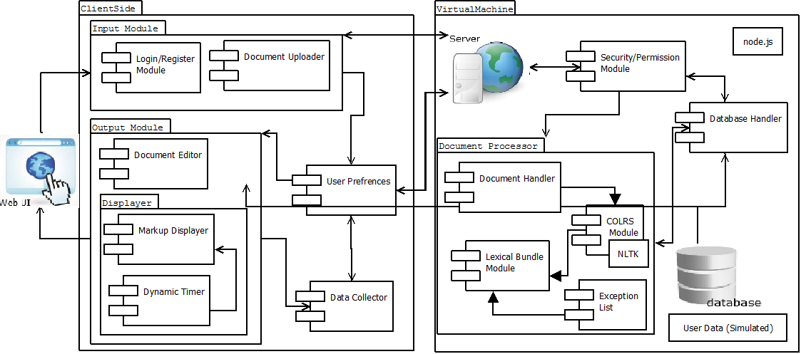
Figure 1. Prototype Major Functional Component Diagram

Figure 1 shows the prototype’s hardware and how the software processes a document. The hardware for the application that houses the backend of the application is a virtual machine. Software components of the prototype include the Input Module, the Document Processor, and Output Module. The user logs into the input module then sends a document to the server which is Node.js. The document will then go to the Document Processor. This will run the document through the COLRS Module that contains a Natural Language Toolkit to tag the document. The tagged document will go through the Lexical bundle module to receive slash tags to make lexical bundles. The exception list checks for errors in the slashing. This server will then send a markup stream of tags to the Output Module. The Markup Displayer takes the stream and synthesizes the document for the viewer based on the view selected by the user. The document can be opened in the editor, if the instructor wants to modify the document.

Prototype Functional Description
The major functional components of the product CLASH prototype include the following:
Function | Summary
Parser | This function parses text copy and pasted into form
Edit mode | This function modifies and store previously parsed documents
Colrs Displayer | This function colors chosen parts of speech using a JSON format and javascript functions.
Slash Player | This function speeds up, slows down and pauses lexical bundles being displayed.
Login interface | This function checks user authentication in a stand alone environment
Print mode | This function prints documents with slashes inserted.
Table 1. Functional Table.

External Interfaces

N.A

