LAB 1 – CLASH description

Lab 1 – Clash Product Description
Andrew Chverchko
CS411
Janet Brunelle
Hill Price
February 7, 2015

Table of Contents
1 INTRODUCTION 3
2 PRODUCT DESCRIPTION 4
2.1 Key Product Features and Capabilities 4
2.2 Major Components (Hardware/Software) 6
3 IDENTIFICATION OF CASE STUDY 7
4 C.L.A.S.H PRODUCT PROTOTYPE DESCRIPTION 8
4.1 Hardware and Software Prototype Architecture 10
4.2 Prototype Features and Capabilities 11
4.3 Prototype Development Challenges 11
GLOSSARY 12
REFERENCES 13

List of Figures
Figure 1. Hardware requirements diagram 6
Figure 2. Prototype versus real world diagram 9
Figure 3. Prototype major functional component diagram 10

Lab 1 – CLASH Product Description
- INTRODUCTION
C.L.A.S.H is short for Color Lexical Analysis algorithm and Slash Handler. CLASH is a computer program with two major applications COLRS and Slash. COLRS displays that text of a document with different part of speech (P.O.S) labeled with color. Slash takes the document and displays the words in order for the user to read. These two features of the program intend to assist in reading and comprehension is English as second language (ESL) students.
ESL students have been shown to have difficulty in learning English in the past. In 2004, the states collected data reported that nearly 4,999,481 ESL students were enrolled in public schools. This represents 10 percent of the total enrollment of students. Later in 2001 a test for reading comprehension was issued. Out of the participating students, 18.7 percent demonstrated an average or above. In February that same year, the number of dropouts ESL reached a value that was four times that of native English speakers (McKeon). ODU’s ESL department is attempting to fix this problem.
ODU teachers utilize traditional teaching methods to teach ESL students. The teacher draws up examples and points out each part of speech to the class. The teacher also assigns reading homework to help with student reading comprehension. This method relies heavily on the amount of examples a teacher can provide. Each example text would need to be written out and marked for parts of speech. In recent studies, colors are said to provoke a higher level of attention this will result in an increase of memory retention (Dzulkifli, Mustafar). Another study affirms that lexical bundles help in word and sentence recall experiments (Tremblay, Derwing, Libben, Westbury). CLASH aims to bring these benefits to the current ESL classroom.
- PRODUCT DESCRIPTION
CLASH is a computer program with two major applications COLRS and Slash. The COLRS section takes a document of text and applies different colors to identify the parts of speech found in the sentences of the document. This colorization helps the user acquire a better understanding of how English grammar and different parts of speech work. The Slash section takes a text document and breaks it up into chunks of text that vary in size between three to five words. These chunks of text are called lexical bundles. Lexical bundles are grouping of words that appear together frequently in the English language. These groupings appear as a single thought and are also given the name thought group. Lexical bundles are utilized by the Slash application to make reading and comprehension of English text easier for user.
  - Key Product Features and Capabilities
CLASH is a web application with features for students, instructors, administrators. The Students are able to login with a student account using a computer and internet connection. The student can then access the COLRS module or the Slash module. The COLRS module possesses controls for highlighting individual P.O.S from a choice of eight. The student can all types P.O.S or specific ones for more targeted viewing. The student has the ability to switch to the Slash module in a single button click. The Slash module will display the lexical bundles of a text at a set speed. This speed can be changed at any time during use. The student also has the control capability on the user interface to pause the display and rewind to a previous lexical bundle in the text. CLASH is the first tool that possesses both grammar through P.O.S coloration and reading speed practice through lexical bundles specifically for ESL students
The instructor has the same features as students with the addition of others. The instructor has control over the students in their class. They can add and remove students from their class. They have direct control over the students’ documents available when using the application. These documents can be added, removed, or modified from the instructor account. The modification of documents the instructors possesses allows for correction of slashed and colored documents. A list of exceptions can be saved to help the application remember specific scenarios that the software did not perform correctly. This can be used for future documents inserted into the application. One unique feature of CLASH for instructor is the ability to see each student’s usage of the application. The instructor can see information on the student like which documents are viewed, the total on the application, and the average speed in Slash. This feature will help instructors with assessing student progress and figure out which students need help. The administrator account has all the benefits of the previous two types with added feature to create and delete instructor accounts

  - Major Hardware and Software Components
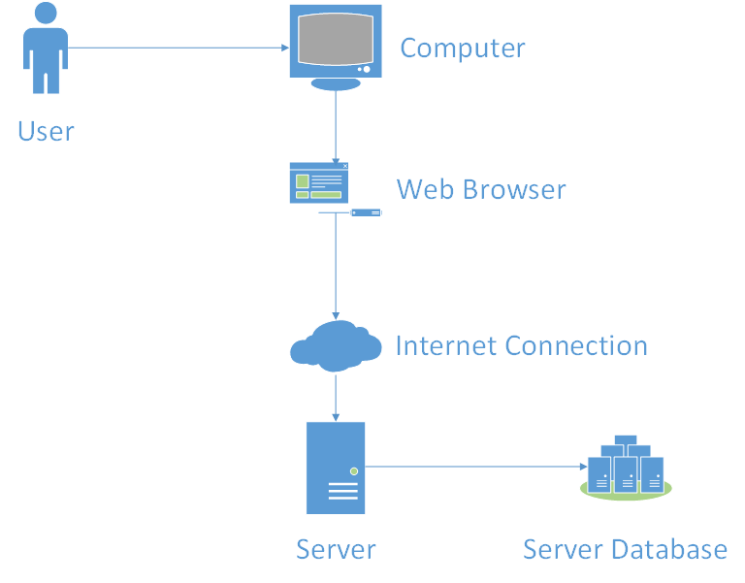
Figure 1. Hardware requirements diagram
Figure 1 illustrates the hardware that the user utilizes to access CLASH. The user must have a computer with a web browser installed. CLASH the application requires an active server. The user opens the web browser on their computer and logs onto the CLASH server to access the documents in the database. On the CLASH server, three components make up the software of the application. These three are the Lexical Bundle module, the COLRS module, and Client-side reader
The COLRS module first takes a document and runs it through software called Natural Language Processing (NLP). This will split the document into tokens and create a tag that labels the P.O.S of each token. This set of tokens with tags is then sent to the Lexical bundle module. The Lexical bundle module takes the set and determines locations to insert a specific slash tag. This slash tag splits the set into lexical bundles. The module uses instructor’s exception list to make changes in the slash tag insertion to fix the lexical bundles. If no exception list is in memory then the module will bypass the step. The set of tokens and their tags are then sent to the Client-side reader. The Client-side reader takes the output from the previous module and organizes it based on the tags. Then text is put on display based on the mode the user chooses. They can choose COLRS for the parts of speech colorization or the Slash for the reader of lexical bundles
- IDENTIFICATION OF CASE STUDY
Old Dominion University contains an ESL program called the English Language Bridge program. This program is for the many students that attend ODU and are not native English speakers. These Students that want to attend ODU for normal classes must complete the bridge program. In order to start the program, the student must first score between a 500 and 550 on the TOEFL or a 61 through 79 on the IBT. The students must spend two semesters in the bridge program to learn English to a level necessary to take normal college courses. In the two semester’s time, the ESL student has to learn to understand a foreign language for social and academic purposes. Failure to complete the bridge program will prevent the student from pursuing a college degree.
Greg Raver-Lampman is and instructor for ESL students at Old Dominion University. He teaches students with little to no experience in English. For his classes he instills knowledge into students that normal students have been practicing their entire lives. The tools available to the professor are the standard for many teachers. He can write example on a chalkboard. Slideshows and practice assignments can be prepared. Reading homework can be assigned. Through these techniques, students can increase their understanding of the English language. These tools are sometimes not sufficient to help elevate the student to the skill level in English they desire. At many times, the students struggle with reading and comprehension. The reading speed for some students can be on word at a time. This makes the learning of English difficult.
CLASH aims to make the education of ESL students easier. The use of lexical bundles can improve reading speed and comprehension. The parts of speech colorized help students identify grammar. The application has a design with ESL users as a focus. CLASH is a new tool for ESL instructors to use.
- C.L.A.S.H PRODUCT PROTOTYPE DESCRIPTION
The prototype of CLASH will be Single Page Application (SPA). A SPA means that all of the user interaction with the application will take place on a single page instead of being sent to different webpages for each interaction. The database for the prototype is a relational database and all functionality will be written in JavaScript. The webserver of the prototype will use Node.js.

“This Space is Intentionally Left Blank”

Features | Real World Project | Prototype
Parsing Capabilities | Ability to Parse different kinds of documents | Ability to parse text copy and pasted into form
Text Modification | Ability to modify and store previously parsed documents | Ability to modify and store previously parsed documents
Color Capabilities | Ability to Color chosen parts of speech using a JSON format and javascript functions. | Ability to Color chosen parts of speech using a JSON format and javascript functions.
Slashing Capabilities | Ability to identify lexical bundles through the inserting of slashes. | Ability to identify lexical bundles through the inserting of slashes.
Displaying lexical bundles in a single bundle form | Ability to speed up, slow down and pause lexical bundles being displayed. | Ability to speed up, slow down and pause lexical bundles being displayed.
Exception list | Lists of commonly used expressions that would otherwise be incorrectly parsed and tagged. | Lists of commonly used expressions that would otherwise be incorrectly parsed and tagged.
Login interface | User Authentication in a stand alone environment | User Authentication in a stand alone environment
Student Data reporting | Tracks individual and collective student progress. To include words per minute, total time and total lexical bundles. Data to be stored in database. Displayed in graphs and statistics. | Not included.
Homework Mode | Instructors have the ability to remove coloring of words and have students correctly identify the part of speech. | Not Included.
Administrative Privileges | Administrators are able to edit, add, or remove anything in the system. | Administrators are able to edit, add, or remove anything in the system.
Print mode | Ability to print documents with slashes inserted. | Ability to print documents with slashes inserted.
Figure 2. Prototype versus real world diagram.
There are a few compromises that make the prototype different from the real world product as illustrated in Figure 2. The activity data of the student’s use of the application is not stored. The ability to add homework assignments for students will not be present. The ability to add and remove users is limited to not be able to access ODU enrollment files. Instructors will have to add students manually.

  - Hardware and Software Prototype Architecture
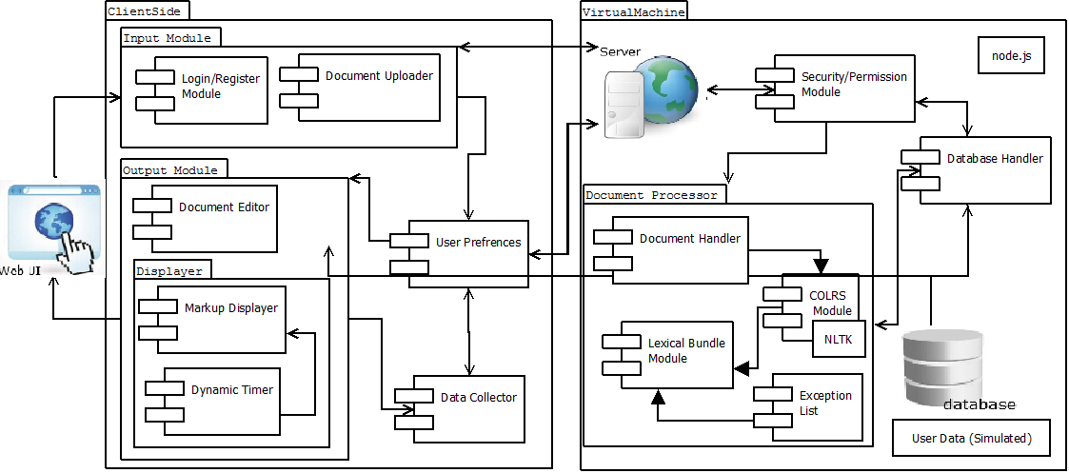
Figure 3. Prototype major functional component diagram.
Figure 2 shows the prototype’s hardware and how the software processes a document. The hardware for the application that houses the backend of the application is a virtual machine. Software components of the prototype include the Input Module, the Document Processor, and Output Module. The user logs into the input module then sends a document to the server which is Node.js. The document will then go to the Document Processor. This will run the document through the COLRS Module that contains a Natural Language Toolkit to tag the document. The tagged document will go through the Lexical bundle module to receive slash tags to make lexical bundles. The exception list checks for errors in the slashing. This server will then send a markup stream of tags to the Output Module. The Markup Displayer takes the stream and synthesizes the document for the viewer based on the view selected by the user. The document can be open in the editor is the instructor want to modify the document.

  - Prototype Features and Capabilities
The CLASH prototype possesses many core features. CLASH is able to color parts of speech in a document. The user will be able to select which parts of speech are colored. The application will display the text of a document in lexical bundles one at a time. The user can pause the display and move to any lexical bundle in the document. The speed of display is available to the user. The lexical bundle separation relies on the P.O.S tags made by the COLRS module. This tagging is very important for the output. It is imperative that the tagging does not output incorrectly.
The completion of the core features will provide the customer with an application. The customer will then utilize the product to test the usability in an academic setting. He will be an instructor and create student accounts. Students will test out the product and the instructor will compare the student users with nonusers. If the users demonstrate higher reading speed and comprehension, the product will gain verification of being applicable in teaching university ESL students. The customer achieves his goal and development team’s goal.
  - Prototype Development Challenges
CLASH contains its own share of potential hardships. The biggest hurdle is correctly identifying parts of speech. If they are identified incorrectly, the Slash portion will fail along with the COLRS. Slash is dependent on the P.O.S tags to place the slashes for the lexical bundles. The speed of display in Slash will also be a challenge. This is a problem because lexical bundle do not have a set size. The exception list can add a layer of complexity to the backend and has the potential to break an almost completely tagged document. The size of the exception list could slow down the application. Since the application is made with ESL students as the users, the creation of an easy to use interface can be challenging. A challenge that will require extensive testing is the amount of concurrent users that the application can handle. The prototype will have many difficulties. Testing and meetings with the mentor will help mitigate and reduce the hurdles.

Glossary
CLASH - Color Lexical Analysis algorithm and Slash Handler
COLRS – Colored Organized Lexical Recognition Software
ELC – English Learning Center
ESL – English as second language
IBT – International benchmark test
JSON – JavaScript Object Notation
Lexical Bundle – a group of words that occur repeatedly together within the same register
MFCD – Major Functional Component Diagram
NLTK – a suite of libraries and programs for symbolic and statistical natural language processing (NLP) for the Python programming language.
Node.js – an open source, cross-platform runtime environment for server-side and networking applications.
POS – Parts of Speech
SPA – single page application, is a highly responsive web application that fits on a single page and does not reload as the web page changes states.
TOEFL – Test of English as a Foreign Language
VM – Virtual Machine

References
Dzulkifli, M., & Mustafar, M. (2013, March 20). The Influence of Colour on Memory Performance: A Review. Retrieved February 8, 2015, from http://www.ncbi.nlm.nih.gov/pmc/articles/PMC3743993/
McKeon, D. (n.d.). Research Talking Points on English Language Learners. Retrieved December 11, 2014.
Mikowski, M., & Powell, J. Single Page Applications. Manning Publications 2014.
Tremblay, A., Derwing, B., Libben, G., & Westbury, C. (2011, January 15). Processing Advantages of Lexical Bundles: Evidence From Self-Paced Reading and Sentence Recall Tasks. Retrieved December 10, 2014.

