CS 411W Lab II

Prototype Product Specification
For
CLASH

Professor Janet Brunelle
Professor Hill Price

Prepared by: Fredrick Murry

Date: 03/25/2015
Version 1

Table of Contents
1 Introduction 1
1.1 Purpose 1
1.2 Scope 1
1.3 Definitions, Acronyms, and Abbreviations 1
1.4 References 2
1.5 Overview 2
2 General Description 3
2.1 Prototype Architecture Description 3
2.2 Prototype Functional Description 4

Figure 1. CLASH Major Functional Components 3

Table 1 CLASH Prototype Functions 4

Introduction

Purpose
The goal of CLASH is to help ESL students increase their reading speed and comprehension at a rate higher than traditional methods. CLASH will be a web-based application assessable through a standard web-browser. CLASH will consist of a server on the backend that will handle the COLRS and Slash modules. The COLRS module will identify POS using colorization. The Slash module separates sentences into lexical bundles and displays the results in the web-browser at a speed controlled by the student for reading. CLASH will allow the instructor to provide reading assignments to the students. Student usage data can also be monitored by the instructor.

Scope
The main hardware for the prototype will be a Virtual Machine (VM) hosted at ODU. The user will be able to use their own internet-enabled device for access. The software for the prototype will include a collection of open source software and custom algorithm programs. The VM will run Ubuntu 14.04 LTS. Nod.js will be used for the application and web server, so that there will be interaction with the Natural Language Toolkit. (NLTK), and the database server. The Node.js server will provide the SPA that will allow user access to the CLASH prototype.

Definitions, Acronyms, and Abbreviations
CLASH- - Color Lexical Analysis algorithm and Slash Handler
COLRS- Colored Organized Lexical Recognition Software
ELC- English Learning Center
ESL- English as second language
IBT- International benchmark test
JSON- JavaScript Object Notation
Lexical Bundle- a group of words that occur repeatedly together, or represent a single thought group.
MFCD- Major Functional Component Diagram
NLTK- a suite of libraries and programs for symbolic and statistical natural language processing for the Python programming language.
Node.js- an open source, cross-platform run-time environment for server-side and networking applications.
POS- Parts of Speech
SPA- single page application, is a highly responsive web application that fits on a single page and does not reload as the web page changes states.
TOEFL- Test of English as a Foreign Language
Ubuntu- a Debian-based Linux operating system
VM-Virtual Machine

References
Blue/Purple teams (2014, December). Clash Product Description CS410 Lab 1.

Overview
This product specification provides the hardware and software configuration, capabilities and features of the CLASH prototype. The information provided in the remaining sections of this document includes the Prototype Architecture Description, the Prototype Functional Description, detailed description of the hardware and software, the key features of the CLASH prototype. The methods that will be used to control, manage, or establish key features are also discussed later in this document. The outputs, displays, and user interactions expected of the CLASH product are specified.

General Description
The CLASH prototype will be a Single Page Application (SPA) that does not reload when changes are made to the web page. The SPA will be built using JavaScript and will utilize a JavaScript-built Graphical User Interface, application and web server, and a database. Ideally a database with JavaScript object Notation (JSON) would be used, such as NoSQL. The prototype will use a relational database instead of NoSQL. The SPA will combine the user the accessibility of a web application with the look and feel of a desktop application. There will be no software to download and install by the users.
The prototype will be a proof of concept for the real world product. The POS tagging will use open source NLP tools and will very basic in its operation. The accounts for the various users will manually set up instead of the real world product’s integration with ODU’s enrollment systems.

Prototype Architecture Description

CLASH will feature three major components software components. They will include the COLRS module, SLASH module, and the text reader viewed through the web browser. Being that CLASH is a web-based application, the only hardware requirements are an active server on the back-end and an Internet-enabled device for the user. The major hardware components can be seen in Figure1.
The COLRS module will use Natural Language Processing (NLP) to tag the POS in the input document. An open source tokenizer will be used for the process. The Slash module will use the same tokenizer from the COLRS module in its algorithm to identify lexical bundles. The text reader will use the tokenized output from the server to be viewed by the user. It will have a User Interface for control of user viewing speed and POS identification using color-coded highlights.
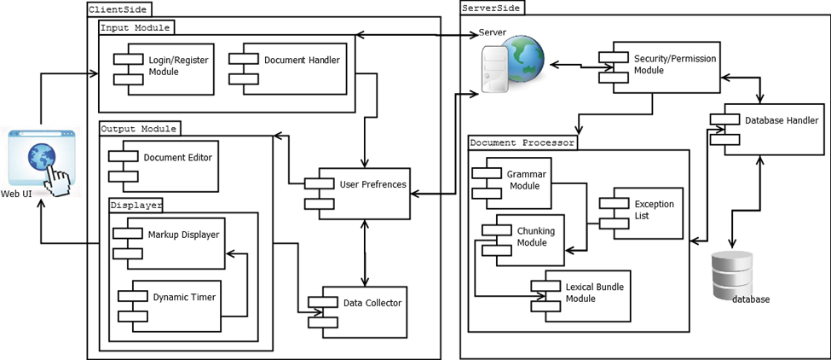
Figure 1. CLASH Major Functional Components

Prototype Functional Description
Table 1 CLASH Prototype Functions
Functions
Parsing function | to parse text copy and pasted-in text block.
Text Modifier | to modify and store previously parsed documents
Text Colorizing function | to color chosen parts of speech using a JSON format and JavaScript functions.
Slashing function | to identify Lexical Bundles through the inserting of slashes.
Login interface | to authenticate User activities in a stand-alone environment.
Student Data Reporting function | to generate reports on basic student metrics.
SLASH Reader | to view documents and control viewing of Lexical Bundles.

