Lab II - Product Specification Outline

CS 411W Lab II

Prototype Product Specification
For
CLASH

Professor Janet Brunelle
Professor Hill Price

Prepared by: Mohammed Alabdullatif

Date: 3/29/15

Table of Contents

- Introduction………………………………………………………………2
  - Purpose……………………………………………………………3
  - Scope………………………………………………………………3
  - Definitions, Acronyms, and Abbreviations…………………….....4
  - References…………………………………………………………5
  - Overview…………………………………………………………..5
- General Description……………………………………………………….6
  - Prototype Architecture Description……………………………….7
  - Prototype Functional Description…………………………………8
  - External Interfaces
    - Hardware Interfaces………………………………………9
    - Software Interfaces……………………………………….9
    - User Interfaces……………………………………………9

List of Figures
Figure 1 Major Hardware/ Software Component 7
Figure 2 Major Functional Component Diagram 8

List of Tables
Table- 1 Real World Product disparity Prototype 6

INTRODUCTION

Learning a different language may be hard, takes time and in some point it costs money. More than 819,644 students come to United States of America during 2012/2013 to pursue degrees in many programs ranging from finance, engineering, nursing, and computer science. However, for these students to start their academic studies, they will need to prove that their English is good enough for them to get along and get good grades just like their native English classmates. In order for them to prove that, they need to take plenty of tests such as the TOEFL test which is taken online and called IBT. If the students don't have enough knowledge or don't feel confident enough to take the test, then they apply for the English Language Center ELC.

Creating a software that improve student’s skill on reading in English will be useful. A web interface that has two modules CLASH; Color Lexical Analysis algorithm and Slash Handler, COLRS; Colored Organized Lexical Recognition Software and Slash. The COLRS module is used to add color on the document’s POT; part of speech which is used to help the user to understand the grammar and sentence structure. Slash module is used to separate some sentences by using lexical bundles method to help the user to increase the speed and comprehension in reading. Lexical bundle is explained as a set of words that repeatedly take place simultaneously within similar register.

PURPOSE
A web based called CLASH targeting students with low English skills to improve their English faster, easier and more fun than the old typical way. By using Graphic User Interface collaborating with the student and the database. Also it allows instructors to closely keep tracking each student’s document. There are two modules used on CLASH; Slash and COLRS.
Slash module will separate some sentences by using lexical bundles method, which will work on improving the reading speed quality of the student. By using lexical bundles method it is going to help the student to understand the idea of the document which been upload.
COLRS module will be used to add colors on the document’s part of speech to help the student to understand the sentence structure. Every part of speech will be colored by using JavaScript to color sentences; such as verbs, nouns, adjectives and different expressions from the documents.

SCOPE
As a web-based application, CLASH can be used anywhere home or school or even overseas. CLASH will allow students to increase their reading skills by the two methods COLRS and Slash. Furthermore, users can manage the speed reading display by clicking on play, pause and change the speed anytime they wish.
CLASH will use a password control to log-in to the web by three types of users student, instructor and administration. Student have the ability to view the document, mange the speed reading and use COLRS and Slash to view the document after being colored and slashed. Instructor will have the student ability, but it include a little bit more features than the students. Instructor can control, edit, add and delete documents and users. Moreover, the ability to make the documents viewed and available for the student user to view and keep up with the student activity, such as student record, how long it took the student to read and how many words? Finally, the administration which has all the ability as student and instructor. Additionally, administration can add and remove all type of users.

DEFINITIONS, ACRONYMS, and ABBREVIATIONS
CLASH: Color Lexical Analysis algorithm and Slash Handler.
Client Side: The user-interface of CLASH.
COLRS: Colored Organized Lexical Recognition Software.
ELC: English Learning Center at Old Dominion University.
ESL: English as second language.
JSON: JavaScript Object Notation. A nested data structure commonly used to pass data between a server and a client.
Lexical Bundle: A group of words that occur repeatedly together within the same register
NLTK: A suite of libraries and programs for symbolic and statistical natural language
processing (NLP).
Node.js: Open source, cross-platform run-time environment for server-side and networking
applications.
POS: Part of Speech such as noun, adjective, verb, etc….
TOEFL: English language proficiency test required by universities for enrollment for internationally based students.
VM: Virtual Machine.

REFERENCES
Open Doors 2013 Report. Institute of International Education, Inc11, 11 Nov. 2013. Web. 08 Oct. 2014.
Tremblay, A., Derwing, B., Libben, G., & Westbury, C. (2011, January 15). Processing Advantages of Lexical Bundles: Evidence From Self-Paced Reading and Sentence Recall Tasks.
Retrieved December 10, 2014.
Mikowski, M., & Powell, J. Single Page Applications. Manning Publications 2014.

OVERVIEW
This product specification provides the hardware and software configuration, capabilities and features of the CLASH prototype. The information provided in the remaining sections of this document includes a detailed description of the hardware, and software architecture of the CLASH Prototype; the key features of the prototype; and the parameters that will be used to control, manage or establish that feature.

GENERAL DESCRIPTION

There are many applications that use some features that CLASH has, so CLASH has to be unique and close to the real world product. Table 1 will show the disparity between CLASH prototype and real world product:

Features | Real World Product | Prototype
Parsing Capabilities | Ability to Parse different kinds of documents | Ability to parse text copy and pasted in text block
Text Modification | Ability to modify and store previously parsed documents | Ability to modify and store previously parsed documents
Color Capabilities | Ability to color chosen parts of speech using a JSON format and JavaScript functions. | Ability to color chosen parts of speech using a JSON format and JavaScript functions.
Slashing Capabilities | Ability to identify Lexical Bundles through the inserting of slashes. | Ability to identify Lexical Bundles through the inserting of slashes.
Displaying Lexical Bundles in a single bundle form | Ability to speed up, slow down and pause Lexical Bundles being displayed. | Ability to speed up, slow down and pause Lexical Bundles being displayed.
Exception list | Lists of commonly used expressions that would otherwise be incorrectly handled by the SLASH Algorithm. | Lists of commonly used expressions that would otherwise be incorrectly handled by the SLASH Algorithm.
Login interface | User Authentication in a stand-alone environment | User Authentication in a stand-alone environment
Student Data Reporting | Tracks individual and collective student progress. To include words per minute, total time and total Lexical Bundles. Data to be stored in database. Displayed in graphs and statistics. | Limited basic student metrics will be available such as Lexical Bundles per Minute.
Homework Mode | Instructors have the ability to remove coloring of words and have students correctly identify the part of speech. | Not Included.
Administrative Privileges | Administrators are able to edit, add, or remove users and saved documents in the system. | Administrators are able to edit, add, or remove users and saved documents in the system.
SLASH Document Viewing Mode | Ability to view documents with slashes inserted and SLASH Reader. | Ability to view documents with slashes inserted and SLASH Reader.
Table 1 - Real World Product disparity Prototype

PROTORYPE ARCHITECTURE DESCRIPTION
The only hardware needed to work the application is a simple computer owned by the user developers. Old Dominion University will provide the development Virtual Machine (VM). The operating system running on the VM will be Ubuntu 14.04 LTS. Software will use open source to allow the development into the full product. The user interface will be built in JavaScript. Also the software will be written on MySQL database and Node.js to be used as the web and application server.
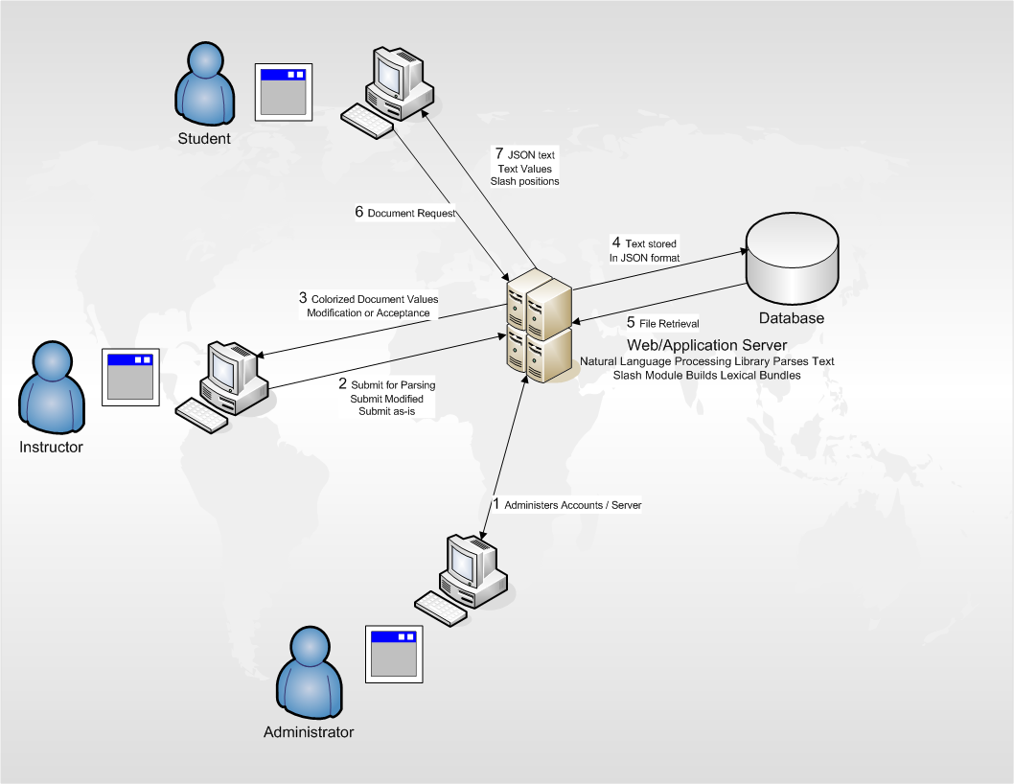
Figure 1 - Major Hardware/ Software Component

PROTOYPE FUNCTIONAL DESCRIPITION
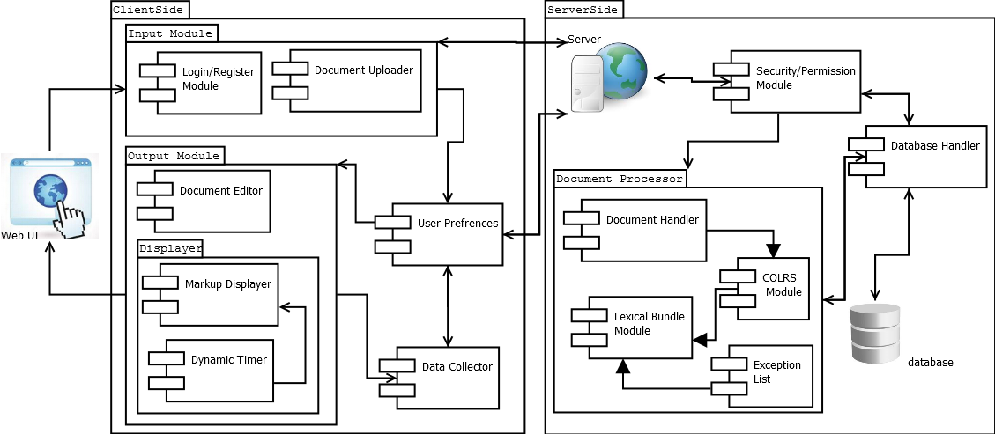 Figure 2 - Major Functional Component Diagram
Diagram shows the components to the hardware and software of CLASH. As it shows it will be web based which can be used by client from anywhere, all what they need is a computer, web browser and internet to use the web. CLASH does not need any hardware requirement except a server, database. On the other hand, software has three factors major, COLRS module, SLASH module and Reader module.
COLRS module will display the paragraph with different colors to show every sentence part of speech. Using Natural Language Processing (NLP) by python to parse text, it will be stored in a Java Script object notation file than go throw lexical bundles method.
SLASH module will use lexical bundles method by .json file. It will take tokenized streams from the COLRS than will do the lexical bundles method by separate some sentences by using slash.
Reader module receives data from the server then separates the paragraph in how the POS used. Client can use color mode or speed mode. Color mode; client can chose to color the POS and use the slash. Speed mode; client can control the reading speed and it will display lexical bundles method by the speed that chosen.

EXTERNAL INTERFACES
The prototype will not interact with any external systems.

HARDWARE INTERFACES

Client needs a computer to access the program via internet connection. Database will be located on the Virtual Machine under ODU.

SOFTWARE INTERFACES

MySQL will storage data and control access. For the text perspective, will run a python script using NLTK.

USER INTERFACES
The user will interact with the CLASH web using any computer. A keyboard for text input, a monitor for displaying text output and mouse for page navigation is required.

