LEAP Course Importer
User Guide

The CE Shop | Content Development Team
Automated Storyboard-to-LEAP Course Builder

1. What Is the LEAP Course Importer?
The LEAP Course Importer is an internal automation tool built for the CE Shop Content Development team. It reads a course storyboard Word document, converts it into a json file and automatically creates every slide in LEAP - filling in all content, questions, answers, feedback, and settings - without any manual copy-and-paste.

What it does: You prepare a storyboard. The tool reads it and builds the course in LEAP automatically.

What it does not do: The importer creates slide content only. Lessons must be created manually in LEAP before running the tool. It does not publish courses, assign learners, or manage any settings outside of slide content.

2. The Dashboard - What You Are Looking At
When the tool opens in your browser you will see three panels. Understanding these before you start will make the rest of this guide much easier to follow.
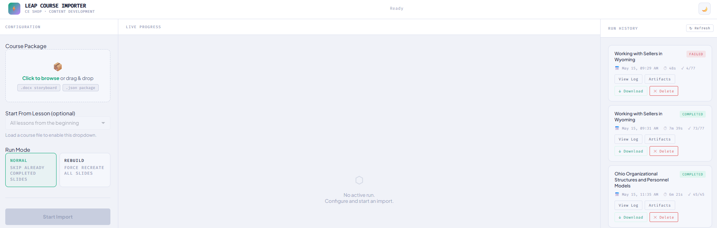

Panel | Where It Is | What It Does
Configuration | Left side | This is where you load your storyboard file, choose which lesson to start from, and select your run mode. All setup happens here before you click Start Import.
Live Progress | Center | Once a run starts, this panel shows each slide being created in real time. You can watch the tool work slide by slide. If something fails, the error appears here.
Run History | Right side | Every run you have ever done is listed here. You can view the log, download the run archive, or delete old entries. The five most recent runs are shown. A count at the bottom tells you the total.

Note
You don’t need to do anything with the Live Progress or Run History panels to run the tool. The Configuration panel on the left is where all your setup happens. The other two panels update automatically. (Clicking “clear” in activity log will just clear the visible log).

3. Before You Begin

3.1 What You Need
Before running the importer for the first time, confirm the following are installed:
- Node.js installed on your computer. If you are not sure whether it is installed (probably not), ask your IT contact. You only need to do this once.
- Google Chrome installed. The importer controls Chrome automatically. Do not use Edge or any other browser for this.
- The IMPORTER-APP folder saved on your computer with all files intact. Do not rename or move any files inside it.
- A LEAP account with content editor access to the course you are building.
- Your storyboard file formatted correctly and ready to upload. See Section 5 for formatting requirements.

3.2 Lessons Must Be Created in LEAP First
The importer creates slide content inside lessons that already exist in LEAP. It cannot create lessons on its own.

Required before every run
Log in to LEAP and manually create every lesson for the course before starting the importer. The lesson titles in LEAP must match the lesson headings in your storyboard exactly - including capitalization and punctuation.
If a lesson does not exist in LEAP when the tool reaches it, that lesson will be skipped.

4. Running the Importer - Step by Step

Step 1 - Launch the Tool
- Find your IMPORTER-APP folder on your computer.
- Double-click start.bat (Windows) or start.sh (Mac). A black terminal window will open and your browser will launch automatically with the importer ready to use.
- Do not close the terminal window while the tool is running. That window is the engine - closing it stops everything.

Note
The browser opens automatically to the right address. You do not need to type anything into the address bar.

Step 2 - Log In to LEAP
- In the Chrome window that opened, log in to LEAP with your normal username and password.
- Once you are logged in, you do not need to navigate anywhere inside LEAP. The tool will take over from there. (Don’t click inside the virtual Chrome browser it will disrupt the run and stop working). Moving the browser to a different window or minimizing it is fine.
- You have 60 seconds to complete login. If login takes longer than 60 seconds the tool will stop and you will need to double-click start.bat again.

Step 3 - Load Your Storyboard
- In the Configuration panel on the left, find the Course Package upload area.
- Drag your storyboard file onto the upload area, or click Click to browse and select the file from your computer. Both .docx storyboard files and .json package files are accepted.
- The tool will convert your storyboard automatically. Once loaded, the Start From Lesson dropdown will fill with all the lessons from your file.

After loading your file
Check the flag count that appears after conversion. A flag means the tool found something it could not read cleanly in your storyboard. Flagged slides will still be created but may be missing content. Review Section 6 to understand what each flag means and how to fix it.
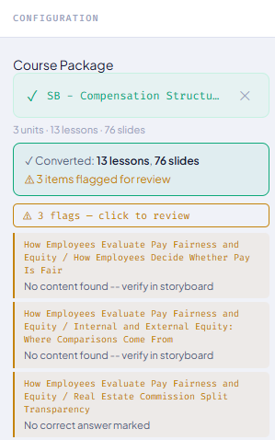

Step 4 - Set the Starting Lesson (Optional)
The Start From Lesson dropdown lets you choose where the run begins.
- Leave it on "All lessons from the beginning" for a normal full run.
- Select a specific lesson if you are resuming a run that stopped partway through, or if you only need to rebuild a particular section.
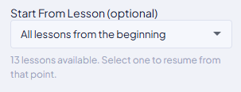

Step 5 - Choose Run Mode
Two run modes are available:

Mode | When to Use
Normal - skips slides already completed in previous runs. This is the default. | Use this for every standard run and for resuming after an interruption. The tool remembers what was completed and picks up where it left off, so you never duplicate work.
Rebuild - Adds slide regardless of what’s currently in the lesson. | Use this only when you want to add slides to a lesson regardless of if it exist or not.
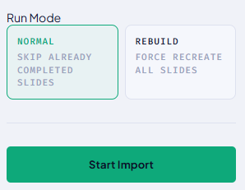

Step 6 - Start the Import
- Click the Start Import button. The Live Progress panel in the center of the screen will begin showing each slide as it is created.
- A Chrome browser window running LEAP will be visible on your screen. This is the tool working. Do not click inside it or interact with LEAP while the run is in progress.
- Each slide takes between 5 and 15 seconds to create. A full course with around 100 slides typically takes 15 minutes.
- When the run finishes, a COMPLETED or FAILED badge will appear on the run card in the Run History panel on the right.
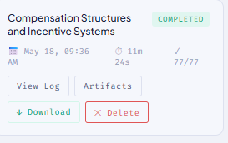
(77 slides created in 11m 24s)

Step 7 - Review Your Results
- Click View Log on the completed run card to see a detailed record of every slide that was processed.
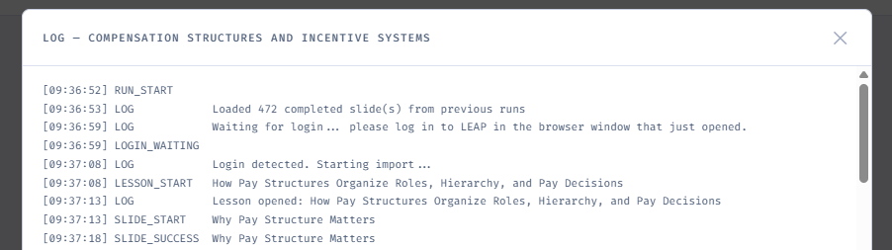
- Click Artifacts to download a zip file containing the run log and any error screenshots taken during the run.
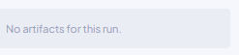
- If slides failed: fix the issue in your storyboard, reload the file, and run again in Normal mode. The tool will skip everything already completed and only starts from the failed slide.

After every run
Always log in to LEAP and spot-check a sample of slides before sharing the course. Verify at least one of each slide type to confirm the content, answer choices, and feedback all look correct. Create any slide types the app doesn’t create manually, as well as resources, linking glossary terms and add key points.

5. Storyboard Formatting Requirements
The importer reads your Word storyboard and converts it into course data. For this to work cleanly - with no flags and no missing slides - the storyboard must follow the formatting rules below. Most issues come from a small set of easy-to-avoid mistakes.

5.1 Heading Styles
The importer uses the paragraph style of each heading to understand the structure of the document. If a heading uses the wrong style, the tool may not see it at all.

Heading Type | Required Word Style | How It Should Look
Unit heading | Heading 2 | Unit 1: Course Title
Lesson heading | Heading 3 | New Lesson: Lesson Title
Slide heading | Heading 4 | Text Slide: Slide Title

Most common issue
If a slide heading is accidentally typed as Normal text, Bold text, or any style other than Heading 4, the importer will not recognize it as a slide. That slide will be skipped from the output with no warning. Always verify heading styles in Word before uploading.

5.2 Slide Heading Prefix Formats
Every slide heading must begin with the correct prefix so the importer knows what type of slide to create. The colon and spacing must be exact.

Slide Type | Heading Must Start With
Text Slide | Text Slide: followed by the slide title
Multiple Choice | INQUIRY: Multiple Choice: followed by the slide title
True/False | INQUIRY: True/False: followed by the slide title
Matching | INQUIRY: Matching: followed by the slide title
Sorting | INQUIRY: Sort: or INQUIRY: Sorting: followed by the slide title
Complete the Story | INQUIRY: Complete the Story: followed by the slide title
Student Poll | INQUIRY: Student Poll: followed by the slide title
Survey | INQUIRY: Survey: followed by the slide title

5.3 Slide-by-Slide Formatting and Examples
Each slide type requires specific tables in the storyboard. The examples below show the exact structure the tool expects. Your content replaces the placeholder text shown in italics.

Text Slide: TITLE HERE
Content for a text slide appears directly after the Heading 4 slide heading. It can be body paragraphs, a table, or a combination. The tool extracts everything between the slide heading and the next heading.

Example - Text Slide storyboard structure
Text Slide: [Slide Title Here]
Content goes here as body text or in a table. This can be multiple paragraphs, bullet points, or a structured table depending on the slide design.

Multiple Choice
Multiple choice slides require two tables: an Options table and a Question/Instructions table, followed by a Choices/Answers table. Every answer row that exists must have text - do not leave choice cells blank, as a blank row will create an empty answer option in LEAP. Answer choices are labeled A, B, C, D.

Example - Multiple Choice storyboard structure
Options
Feedback (By Question or By Choice) | By Question

Question/Instructions
Question/Instructions  <Indicate the number of correct choices (e.g., "Which two apply?"), use T/F IQ if ALL choices will apply.> | QUESTION INSTRUCTIONS HERE
Choices/Distractors
 | Correct | Choice (Minimize use of more than one correct answer.)
A |  | PLACEHOLDER
B | X | PLACEHOLDER
C |  | PLACEHOLDER
D |  | PLACEHOLDER
(LEAP max is 6.)
Feedback
Feedback Provided
Correct | PLACEHOLDER
Incorrect | PLACEHOLDER

Important - Multiple Choice
The Correct Answer column must contain the letter of the correct choice (A, B, C, or D). Only one row should be marked. If you leave all rows blank or mark more than one, the import will flag the slide.
Every row in the Choices table that has answer text must also have feedback. If you have a blank choice row in the storyboard, the tool will still create it as an empty answer option in LEAP and be sure the A,B,C,D are visible, if it’s A,B,C and the letter ‘D’ is missing that row will be skipped.

True/False
True/False slides follow the same pattern as Multiple Choice but with exactly two answer rows. You can use the default True/False labels or replace them with custom labels (for example: Agree/Disagree, Fact/Myth). If using custom labels, fill in the True Label and False Label rows.

Example - True/False storyboard structure
Options
Feedback (By Question or By Choice) | By Question
Question/Instructions
Question/Instructions | INSTRUCTIONS HERE
Choices/Distractors
<Put positive choice (e.g., True) in Category 1, negative choice (e.g., False) in Category 2> |  | Category 1 | Category 2 | Incorrect Feedback  (if Feedback by Choice)
 |  | True | False | Incorrect Feedback  (if Feedback by Choice)
A | PLACEHOLDER | X
B | PLACEHOLDER |  | X
C | PLACEHOLDER | X
D | PLACEHOLDER |  | X
(Ideally, no more than three items for mobile-friendly design. LEAP maximum is 6.)
Feedback
Feedback Provided
Correct | PLACEHOLDER
Incorrect | PLACEHOLDER

Important – true/false
If feedback is set to “By Choice” it should be labeled as By Choice. If it’s not labeled correct the slide will still be created, it will just skip the feedback by responses and you’ll have to manually add those missing rows.

Matching
Matching slides require a Question/Instructions table and a Pairs table. Every row must have both a term and a match - do not leave either cell empty. Four pairs is the recommended maximum.

Example - Matching storyboard structure
Question/Instructions
Question/Instructions | QUESTION INSTRUCTIONS HERE
Choices/Distractors
 | Choice (30-character limit) | Match (140-character limit/three lines or fewer)
A | PLACEHOLDER | PLACEHOLDER
B | PLACEHOLDER | PLACEHOLDER
C | PLACEHOLDER | PLACEHOLDER
D | PLACEHOLDER | PLACEHOLDER
E | PLACEHOLDER | PLACEHOLDER
(Ideally, no more than three items for mobile-friendly design. LEAP maximum is 6.)
Feedback
Feedback Provided
Correct | PLACEHOLDER
Incorrect | PLACEHOLDER

Sorting / Sort
The storyboard must define the category names first, then list each item with its correct category. The category name in each item row must match the category heading exactly - spelling and capitalization must be consistent.

Example - Sorting storyboard structure
Question/Instructions
Question/Instructions | INSERT INSTRUCTIONS HERE
Choices/Distractors
Order of drop targets |  | - PLACEHOLDER  - PLACEHOLDER
 | Drag Item (6 items max.) |  | Drop Target (3 items max.)
A | PLACEHOLDER |  | PLACEHOLDER
B | PLACEHOLDER |  | PLACEHOLDER
C | PLACEHOLDER |  | PLACEHOLDER
D | PLACEHOLDER |  | PLACEHOLDER
(Ideally, no more than three drag items for mobile-friendly design. LEAP maximum is six drag items.)
Feedback
Feedback Provided
Correct | PLACEHOLDER
Incorrect | PLACEHOLDER

Sorting - Category Names Must Match Exactly
The category name typed in the Drop Target column for each item must be spelled exactly the same as the category name listed in the Categories row. A single extra space or different capitalization will cause the item to fail.

Complete the Story
Complete the Story slides show learners a passage with blanks to fill in. Each blank is marked with double square brackets in the story body. Every placeholder must have a corresponding answer row in the table below. The count must match exactly.

Example - Complete the Story storyboard structure
Question/Instructions
Use judiciously. When used:  Enter your story text using [[double brackets]] around the placeholder text where you want the blanks to appear. | QUESTION INSTRUCTIONS HERE WITH CORRECT ANSWERS INSIDE BRACKETS [[example]]. ADDING [[placeholder]] HERE FOR THE ANSWER VALUE IS NOT THE CORRECT FORMAT. EACH CORRECT ANSWER NEEDS TO BE ADDED NEXT TO A PLACEHOLDER ROW.
Choices/Distractors
[[Placeholder 1]] | example
[[Placeholder 2]] | test
[[Placeholder 3]] | format
[[Placeholder 4]] | automation
(Ideally, no more than four items for mobile-friendly design. LEAP maximum is 6.)
Feedback
Feedback Provided
Correct | PLACEHOLDER
Incorrect | PLACEHOLDER

Complete the Story - Placeholder Format
Placeholders must use double square brackets: [[like this]]. Single brackets [like this] or any other format will not be recognized. The number of placeholders in the story body must equal the number of answer rows in the table below it.

Student Poll
Student Poll slides display learner responses as a chart. The storyboard must include a Chart Title, Chart Type, a question, and at least two choices. Every choice row needs both the choice text and a short chart label.

Example - Student Poll storyboard structure
Options
Multiple Answer Select (yes or no) | No
Chart Title | PLACEHOLDER
Chart Type (pie chart, bar chart, or line chart) | Bar
Question/Instructions
Question/Instructions | PLACEHOLDER
Choices/Labels
 | Choice (80-character limit) | Chart Label (100-character limit)
1 | PLACEHOLDER | PLACEHOLDER
2 | PLACEHOLDER | PLACEHOLDER
3 | PLACEHOLDER | PLACEHOLDER
4 | PLACEHOLDER | PLACEHOLDER
(Add rows as needed)
Feedback
Feedback Provided
PLACEHOLDER

Survey
Survey slides ask learners to rate or respond to their experience. Each option must have a Type (Button, Text, or Link). A Text type option creates a free-text input field. Child options - which appear when a parent is selected - use a sub-number like 3-a in the first column.

Example - Survey storyboard structure
Options
Points to Pass
Question/Instructions
Question/Instructions | Congratulations! You've completed this section on [[INSERT COURSE TITLE HERE]]. Attached is a study sheet and flashcards summarizing essential information about this topic. Bookmark it so you can quickly return to it when studying.  Please rate this section.
Options/Types/Feedback or Follow-Up Question
 |  | Option Type |  | Option Text | Text/Question to display after selected by the student.
1 |  | Button |  | Great | Awesome! We're glad you enjoyed the section. Now, on to the next one.
2 |  | Button |  | Okay | That's good to hear. Let's keep moving.
3 |  | Button |  | Needs Improvement | Tell us more. What can we do better?
 | 3-a |  | Text | Type your comments here. | Thank you! We are committed to improving, and the feedback students like you provide helps us deliver a high-quality educational experience.
4 |  | Button |  | No opinion | Don't let us slow you down. Onward!

Survey - Option Type Must Be Exact
The Option Type column must contain exactly Button, Text, or Link. Any other value including blank cells will cause that option to be skipped. If you see fewer options than expected after an import, check the Option Type column in your storyboard to make sure it says button or text.

6. Understanding Flags
After uploading your storyboard, the tool may report flags. A flag means the tool found something it could not extract cleanly. Flagged slides are still created in LEAP if you run the import, but their content may be incomplete. Always review flagged slides after a run.

Flag | What It Means | How to Fix
No content found - verify in storyboard | The slide heading was found but no body content could be extracted. | Check that the heading uses Heading 4 style and that content follows directly after it with no extra blank headings in between.
Question data not found in HTML extraction | An INQUIRY slide heading was found but the question table could not be matched to it. | Check that the heading prefix matches the required format exactly (see Section 5.2). Look for unusual characters or non-standard apostrophes in the slide title.
No survey options detected | A survey slide was found but no valid options could be read. | Each option row in the survey table must have Button, Text, or Link in the Option Type column. Rows with blank or unrecognized types are ignored.
No correct answer marked | A multiple choice, true/false, matching or sorting slide has no answer marked as correct. | Check the Correct Answer column. These slide types must contain the letter A, B, C, D, etc. etc.
Forum requires manual setup in LEAP | A Forum slide type was detected in the storyboard. | Forum slides cannot be automated. This flag is informational. Create forum slides manually in LEAP.
Branching requires manual setup in LEAP | Branching slides are created manually. | Another slide the app doesn’t automate.

7. Run History
The Run History panel on the right side of the screen shows your five most recent runs. Each run card includes:
- The course name and a status badge showing COMPLETED or FAILED
- The date, time, and how long the run took
- How many slides were processed

Each run card has buttons for:
Button | What It Does
View Log | Opens a detailed record of every slide in that run. Use this to identify which slides succeeded and which failed, and to read the exact error message for any failure.
Artifacts | Downloads a zip file containing the run log and any error screenshots captured during the run. Useful for diagnosing problems or sharing run details with another team member.
Download | Downloads the full run archive directly.
Delete | Removes the run entry from the history list. The run folder saved on your computer is not deleted - only the entry in the panel is removed.

If you have run the tool more than five times, a note at the bottom of the panel shows the total - for example "Showing 5 of 12 runs". Older runs are still saved on your computer in the run_outputs folder inside IMPORTER-APP.

8. Troubleshooting
Problem | Likely Cause | What to Do
Login timed out and the tool stopped | The 60-second login window expired before you finished logging in. | Close the terminal window, double-click start.bat again, and log in as quickly as possible.
A slide was created in LEAP but has no content | The slide type was set but content was not injected before the run was interrupted. | Delete the blank slide from LEAP manually, then run again in Normal mode. The tool will recreate it with the correct content.
The run shows FAILED with 0 slides completed | The tool crashed at startup, almost always a login timeout. | Open View Log on the failed run to read the error. Then run start.bat again and log in promptly.
Flags appeared on every slide in a lesson | The lesson heading in the storyboard is missing, incorrectly styled, or its title does not match the lesson in LEAP. | Check that the lesson heading uses Heading 3 style and that the title matches LEAP exactly.
A slide type shows the wrong number of answer choices | One or more answer rows in the storyboard table had blank choice text, which created empty options in LEAP. | Remove any blank rows from the answer table in the storyboard and re-run the affected lesson in Normal mode after deleting the incorrect slide from LEAP. (NEW FEATURE SHOULD SKIP BLANK ROWS).
The file upload is not responding to drag and drop | The browser has cached an older version of the tool. | Press Ctrl + Shift + R (Windows) or Cmd + Shift + R (Mac) to do a hard refresh of the page.
Duplicate slide title - one slide is blank | Two slides in the same lesson share the same title and the same slide type. | Rename one of the slides in your storyboard so all title-and-type combinations are unique within each lesson, then delete the blank slide from LEAP and re-run or manually create the slide.

9. Pre-Run Checklist
Go through this list before clicking Start Import. Catching an issue here can save time and avoid errors during the run.

In Your Storyboard (Before Uploading)
All slide headings use Heading 4 style - not Normal, Bold, or any other style
All lesson headings use Heading 3 and all unit headings use Heading 2
Every INQUIRY heading uses the exact prefix for its slide type
Every multiple choice and true/false ect. ect. questions has exactly one answer marked with the correct letter (A, B, C, or D)
No answer choice rows are blank - remove any unused rows from answer tables
Every question slide has feedback text - no blank feedback cells
Sorting category names are spelled the same in the category row and in every item row
Complete the Story placeholders use double square brackets: [[like this]]
Every survey option row has exactly Button, Text, or Link in the Option Type column
Every student poll has a Chart Title and a Chart Type (Pie, Bar, or Line)
No two slides in the same lesson share the same title AND the same slide type

Before Clicking Start Import
Lessons have been created manually in LEAP and their titles match your storyboard exactly
start.bat (or start.sh) is running and the terminal window is still open
You are logged in to LEAP in the Chrome window the tool opened
The correct file is loaded in the Configuration panel - check the lesson dropdown to confirm
Run Mode is set correctly (Normal mode by default; Rebuild only when recreating everything)
The Start From Lesson dropdown is set to the right starting point.

10. GitHub Repo
To access the project folder please download the zip file from https://github.com/jware1989/Leap-Automation.git

