Jared Wasinger
WR 327 Section # 002
January 24th, 2014
Automobiles: Extended Definitions

DEFINITION 1: HIGH SCHOOL AUDIENCE

GPS: A system of satellites that allows anybody with a special receiver device to know their exact global position.^{[1]}

Basics of radio communication.

Particles of light (photons) have different wavelengths. Our eyes can only perceive a small band on the vast spectrum of these wavelengths which appear to us as all the colors of the rainbow. Radio waves have longer wavelengths than the colors that make up visible light.^{[2]} By altering the frequency of a radio wave over the course of a message, information can be encoded. This is similar to Morse Code, which uses a system of precisely placed breaks in a sound tone to encode text messages.^{[3]} One important difference between the two is that Morse code uses sound waves as a medium for conveying information, whereas radio waves use electromagnetic (light) waves. Radio waves are the medium for communication between GPS satellites and receivers.

Trilateration Introduction.

Locating a GPS user's global position on the Earth is the sole purpose of the GPS system. However, this is a complicated task because the GPS satellites are in constant movement in their orbits around the Earth. This means that there can be a variable number of satellites in orbit over a receiving user's position on the Earth.

The process of locating a user's global location using data provided by GPS satellites is known as trilateration and necessitates the use of moderately complex mathematics. Each satellite is constantly transmitting messages towards the surface of the earth that can be received by any GPS receiver who can trace a line through the sky to a receiving satellite. Each message contains the time that it was sent from the satellite as well as the physical location of the satellite in space. By comparing the time that the message was sent from a satellite to the current time in the receiving device's computer, a user can calculate how long the message was in transit. In order to have enough information to calculate the user's exact position, data from three overhead satellites must be received and processed by the GPS receiver. ^{[4]}

Different uses of GPS

The GPS system has a wide array of uses in both military and civilian sectors. GPS is crucial in making aircraft and boats accurately navigate. On land, GPS is used by scientists to make precise measurements of location and time in the field. In addition, it is useful in surveying. GPS is also used in automobiles to help broadcast location to emergency responders in the event of an emergency as well as powering street navigation applications for on-board computers.^{[5]}

References

[1] “What is GPS?”. Internet: http://www.loc.gov/rr/scitech/mysteries/global.html. January 23rd, 2014
[2] “Radio Waves”. Internet: http://www.loc.gov/rr/scitech/mysteries/global.html. January 23rd, 2014
[3] “Learn Morse Code”. Internet: http://www.learnmorsecode.com/. January 23rd, 2014
[4] “Trimble- GPS Tutorial”. Internet: http://www.trimble.com/gps_tutorial/howgps-triangulating.aspx. January 23rd, 2014
[5] “Who Uses GPS?” Internet: http://www8.garmin.com/aboutGPS/applications.html. January 23rd, 2014

DEFINITION 2: GENERAL ENGINEERING AUDIENCE

GPS: A system of satellites in orbit around the Earth that allows anybody with an unobstructed view to at least three satellites as well as a special receiving device to calculate their global position.

GPS History
The original idea of a global positioning system was inspired by the Soviet Union's launch of the Sputnik satellite in 1957. The first precursor system to GPS was called Transit. By maintaining five satellites in orbit above the earth, ships were able to calculate their position on the sea once per hour.

The successor to Transit was the Timaton satellite, which provided an advantage of being able to tell time extremely accurately via the use of on-board atomic clocks. Between 1978 and 1985, eleven more Timaton satellites were launched into space for use solely by the United States Military.

However, the destruction of a Korean passenger jet by the USSR in 1983 necessitated the use of GPS for civilian purposes. Precise navigation in close proximity to politically volatile borders was a vital issue for aircraft during the Cold War.

In 1993, the 24th GPS satellite was launched into orbit completing what would become the modern Global Positioning System. Although system was declared complete in 1995, more satellites have been added bringing the current total of orbiting GPS satellites to around 30 at present day.^{[1]}

GPS System Structure
To define GPS as a system of satellites communicating with ground receiving devices is a useful abstraction but not altogether correct. In reality, the GPS structure can be broken down into three distinct segments: The User segment, Space segment and Control segment.

The Space segment consists of between 24 and 32 satellites orbiting above the Earth. The satellites are placed in orbits that provide the most even coverage over the Earth's surface. This ensures that each location on Earth has an unobstructed view to at least nine satellites at a time. Although there were originally 24 satellites in the GPS system, the number has been increased to allow for better fault tolerance and improve the accuracy of the system from the receiver's end.^{[2]}

The Control segment consists of a master control station as well as six monitoring stations and is maintained by the United States Air Force. Monitoring stations are located at bases across the world and are in constant communication with all of the GPS satellites in the network. The monitoring stations transmit information about the status of each satellite back to the master control situation at Schriever Air Force Base. The master control situation processes the status of each satellite and then sends updates to the satellites. The updates help to synchronize all of the atomic clocks in the satellites of the GPS system as well as providing course corrections to help satellites maintain correct orbits.^{[3]}

The User segment is made up of hundreds of thousands of GPS receivers in use by both military and civilian users. A GPS receiver is composed of an antenna for radio communication in addition to a highly accurate clock. Receivers often have a number of channels which enable them to read data from many satellites simultaneously for more precise calculation. In addition, a receiver with extra channels can use the data provided by additional satellites to help correct errors in its own clock.

Trilateralation

In order for a user to find their global position, mathematical calculations must be done on the receiving device. This process is called trilateration.

The first part of solving the problem is to determine the distance from a transmitting satellite to the device. Given s = v * t where v is the speed of the transmitting data (the speed of light) and t is the time that it took to transmit the data, the distance to the satellite, s can be calculated. The time of transmission, t can be calculated by finding the difference between the current clock time on the receiver and the time that the satellite sent the transmission (which is encoded in the transmission data).

Once the distance from one satellite is known, the position of the receiver can be ascertained to be somewhere on the 3D sphere formed by the satellite's position as origin and distance from the satellite as radius. After the distance from two more satellites is calculated, the location can be narrowed down to a single point which, if the clocks of both receiver and all satellites are synchronized, will be on the intersection point of the three spheres.^{[4]}
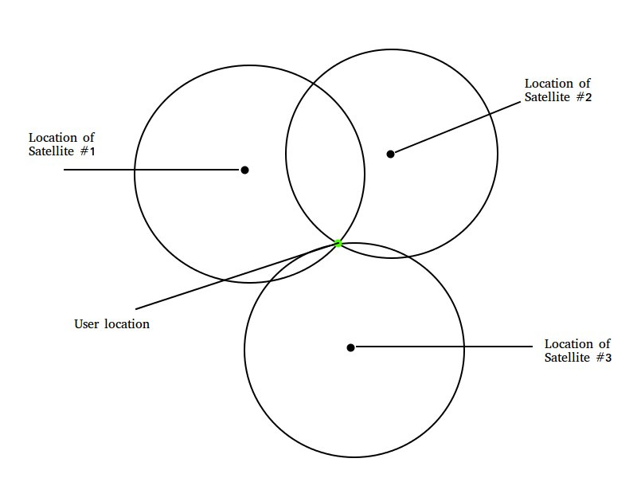

Image: A visualization of trilateration on a 2D surface.

References
[1] “History of GPS”. Internet: http://www.mio.com/technology-history-of-gps.htm January 23rd, 2014.
[2] Massatt, Paul; Wayne Brady. “Optimizing Performance through Constellation Management.” Internet: http://web.archive.org/web/20120125065043/http://www.aero.org/publications/crosslink/pdfs/CrosslinkV3N2.pdf Summer 2002, January 23rd, 2014.
[3] NAVSTAR Global Positioning System. Internet: http://tycho.usno.navy.mil/gpsinfo.html January 23rd, 2014.
[4] Marshall Brain, Tom Harris. “How GPS Receivers Work”. Internet: http://electronics.howstuffworks.com/gadgets/travel/gps.htm January 23rd, 2014

