Order Central: Streamlined Restaurant Operations Application

Jared Wasinger

Introduction

Since the late 20th century, we have seen a tremendous growth in the use of the Internet. This growth coupled with increasing computer horsepower and decreasing hardware price has made technology a powerful avenue for increasing the viability of a business model.
The fast food restaurant is a business model that has remained almost unchanged (at least on the service/restaurant side) since its inception. Given the hectic environment and the push for speed and efficiency of service and quality of food, it would make perfect sense to incorporate the use of a database application to facilitate smoother business operations and better customer service.
The application I propose will serve two purposes. The first is to provide an interface for the staff of a fast food restaurant to view and alter the inventory of a restaurant. The second is to provide the customer with a web interface so that they can order food over the Internet. Then, when they arrive in person at the restaurant, their food will be ready to eat. The advantages of having this interface would be numerous

2. Detailed Application Requirements

The application can naturally be split into two parts: the interface for restaurant management and the interface for customers. In order for a restaurant to run smoothly using Order Central, both customers and managers must have access to concise, intuitive interfaces.
The application will need a table to hold all of the consumable items that a restaurant has in stock. For this there will be Ingredients table. The ingredients table will hold information about the type of food (name), quantity, expiration date and wholesale price. In addition, there will need to be a way to relate ingredients to the companies that supply them. This will be expressed as a many-to-many relationship between a Suppliers table and the Ingredients table. A many-to-many relationship makes sense here because many times, there will be more than one provider selling the same ingredient. In addition, a supplier may sell many different types of ingredients.
Both customers and managers are represented as entries in the Users table. A manager is represented in the Users table as an entry with user_type=”manager”. A customer is represented with user_type=”customer”. The Users table also contains an entry called wallet_amt which represents the money (as type REAL) a manager or customer has. A manager's 'wallet' represents the assets of the restaurant they manage whereas a customer's represents their own personal money.
One of the most important aspects of providing a great fast food experience is offering a great menu. As with any restaurant establishment, the goal is to get the customer to spend as much of their money as possible while feeling satisfied about their purchase. Order Central facilitates this by allowing customers to order meal combinations as well as individual food items. The Items table forms a many-to-many relationship with the Ingredients table (an ingredient can be present in multiple items and an item is made up of multiple ingredients). Examples of items are: fries, burgers, drinks, etc. The Combos table forms a many-to-many relationship with the Items table (an item can be present in multiple meal combinations and a meal combination is made of multiple items). The makeup of meal combinations is left to the discretion of the restaurant.

Important Questions:
- Identify all orders pertaining to a user's user_id. This query is important because the user home page will display a table of all current orders that a user has.
Relational Algebra: σ_{Orders.user_id=id}Orders
SQL:
SELECT * FROM Orders
WHERE user_id=id
- Select the names of items that cost a dollar or less. Knowing which items are currently on the “Dollar Menu” can make it easier for customers to see which items are the cheapest.
Relational Algebra: π_{sname}(σ_{Items.price<=1}Items)
SQL:
SELECT name FROM Items
WHERE price <= 1
- Select the names of all users with an empty wallet: It is important to know which users do not have any money so that they can be barred from making purchases or notified to put more money in their account.
Relational Algebra: π_{name}(σ_{Users.wallet_amt = 0}Users)
SQL:
SELECT name FROM Users
WHERE wallet_amt=0
3. Design
The Customer-Order relationship:
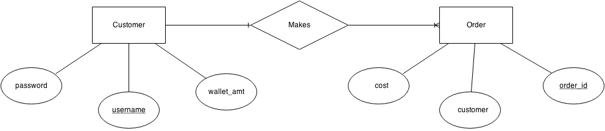
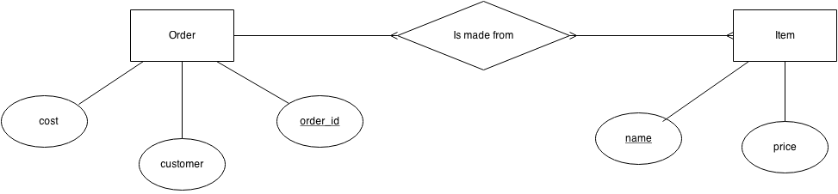

The Order-Item relationship:

Ternary relationship involving a manger, ingredient and supplier:
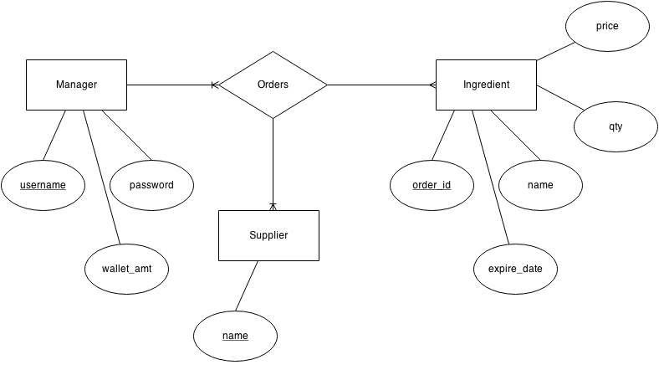
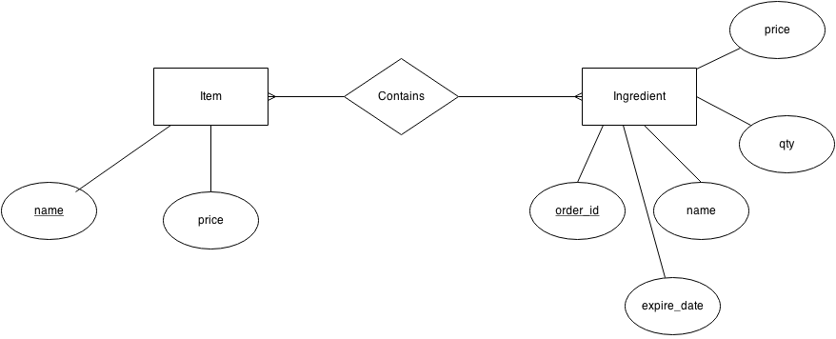
The Item-Ingredient relationship:

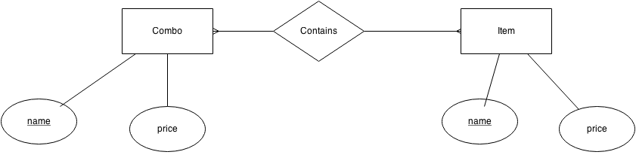
The Combo-Item relationship:

Index Page:
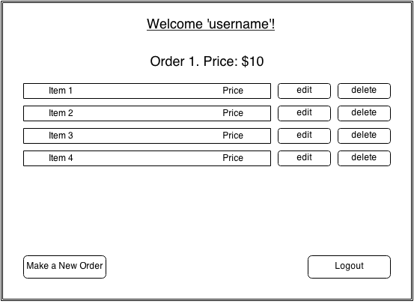

4. Implementation Details:
It is important that my application make use of a DBMS because the application is designed with two important features:
1) It will be deployed via a web interface.
2) It will store and manipulate sensitive data relating to personal/corporate records (user payment information, company/user wallet amounts).

A DBMS will provide a secure environment where the tables for Order Central can be stored. In addition to this, a DBMS will be able to optimize data access and use making my application more responsive and more appealing to management and customers.

In addition to these advantages, using a DBMS will allow me to increase the functionality of my website by using PHP scripts that can be embedded into HTML. This powerful server-side language can act as a template language allowing me to dynamically alter my HTML. In addition, it provides an API to access my MySQL database records with acting as the glue between my HTML files and the data that they display.

5. Evaluation

Testing is a very important part of the design process. My method for testing is to break the website down into different blocks of functionality and test the combinations of those functional blocks. For example, a user can create an order composed of different items. There can also be multiple users creating orders. A logical test for these two aspects of the application is to test out the ordering functionality of the website on multiple user accounts.
Another place where testing and evaluation is key is in making sure that the user authentication and account creation system works. Here, I tested out my account creation and user authentication by creating different accounts and then attempting to log in using these accounts. To make sure that I wasn't able to log in without entering correct credentials, I would attempt to log in incorrectly (incorrect username/password, lack of username/password, etc.). By receiving the automatic error responses that I had hard-coded into the website, I knew that my authentication code was working.
In addition to testing, it is important to know when and where things go wrong in sections of my code. One of the most likely places to get errors is while performing queries using the MySQL API. In order to catch these errors, I would evaluate the value returned while performing the query and output an error message to the screen if something went wrong. By seeing the error output from MySQL and using the 'find' functionality of my text editor, I could quickly isolate the areas of code that were not working.

6. Future Work
There are many things that I would like to do to make my web site more fully-featured and useful. However, I would start by looking to improve my overall design of the website and make my design more general and configurable. Right now, there are many areas in the code where it was easy and necessary to hard-code a feature in order to build the proof-of-concept for this website. In addition, much of my code-base is not well commented or easy to understand. In the future, I would look to fix these certain hard-coded spots and make my code and design easier to read.
In addition, being new to using PHP, I feel that I did not design my application with a deep understanding of security and how it relates to PHP. I did take some steps (such as keeping usernames and passwords in a database). However, I feel that if this website was going to be put into use in the real world, I would want to go back and examine/test my website for security flaws so that no private data would be compromised during its use.

7. Lessons Learned
I think that the majority of my errors stemmed from not reading documentation in depth for PHP before beginning the project. Because of this, I ran into several confusing errors (such as confusing header() with include) which cost me a lot of my time trying to debug. Although, I was eventually able to solve these errors by careful analysis of my own code, it did detract from time that could have been spent adding more features to the site.
Another source of headache, was a lack of a clear design before I started developing the website. As a result, I often would end up writing code that would later be deleted or not used. This could have been averted by spending time before starting any coding and developing a broad technical overview of my website.

Tables SQL Code:
CREATE TABLE Users( username CHAR(32),
password CHAR(32),
user_type CHAR(32),
wallet_amt REAL,

PRIMARY KEY (username),
);

CREATE TABLE Items( name CHAR(32),
price REAL,

PRIMARY KEY (name),
);

CREATE TABLE Orders(
order_id INTEGER,
customer CHAR(32),

PRIMARY KEY (order_id),

FOREIGN KEY (customer) REFERENCES Users
ON UPDATE CASCADE
ON DELETE CASCADE
);

CREATE TABLE Items_Orders(
order_id INTEGER,
item_name CHAR(32),

PRIMARY KEY (order_id, item_name),

FOREIGN KEY (order_id) REFERENCES Orders
ON DELETE CASCADE
ON UPDATE CASCADE,

FOREIGN KEY (item_name) REFERENCES Items
ON DELETE CASCADE
ON UPDATE CASCADE
);

CREATE TABLE Ingredients ( order_id INTEGER,
name CHAR(32),
expire_date DATE,
qty INTEGER,
price REAL,

PRIMARY KEY (order_id),
);

CREATE TABLE Suppliers ( name Char(32),
PRIMARY KEY (name),
);

CREATE TABLE Combos ( name CHAR(32),
price REAL,
PRIMARY KEY (name),
);

