Question 1:
Part 1:

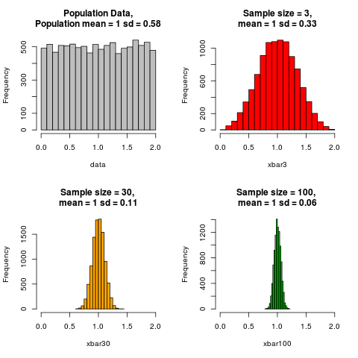

All of the sampling distributions have the same overall shape: symmetric and modal. This looks very similar. However, the sampling distributions only technically reach normality after n=30.

Theoretical standard error =
Sample Size 3: S.E. = 0.33/sqrt(3) = 0.191
Sample Size 30: S.E. = 0.11/sqrt(30) = 0.020
Sample Size 100: S.E. = 0.06/sqrt(100) = 0.006

As the sample size increases, the standard error decreases (presumably towards zero). This is in line with the Central Limit Theorem which says that as the sample size increases, the sample mean should should tend towards the population mean (which for this uniform distribution is (a+b)/2 = (0+2)/2 =1). In addition, the simulated standard deviation decreases as sample size increases. This makes sense, because as the sample sized is increased, the data should be more highly concentrated about the mean.

Part 2:
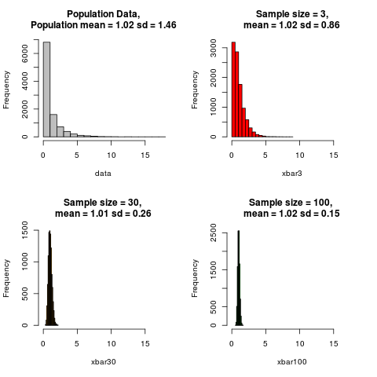

When n reaches 30, the sampling distribution bears resemblence to the normal distribution.

Theoretical standard error =
Sample Size 3: S.E. = 0.86/sqrt(3) = 0.497
Sample Size 30: S.E. = 0.26/sqrt(30) = 0.047
Sample Size 100: S.E. = 0.15/sqrt(100) = 0.015

As the sample size increases, standard error decreases as expected. The sample mean remains almost constant being approximately the same as the population mean.

Part 3:

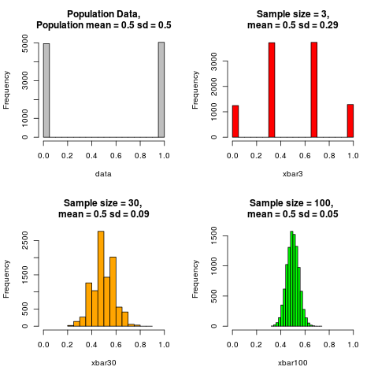

When n reaches 30, the sampling distribution bears resemblence to the normal distribution.

Theoretical standard error =
Sample Size 3: S.E. = sqrt((0.5(1-0.5))/3) = 0.289
Sample Size 30: S.E. = sqrt((0.5(1-0.5))/30) = 0.091
Sample Size 100: S.E. = sqrt((0.5(1-0.5))/100) = 0.05

As the sample size increases, standard error decreases as expected. However, it still remains present in the sampling distributions with higher values of n. Because it is a binomial distribution, the sample mean is the same as the population mean for all sampling distributions.

Part 4:

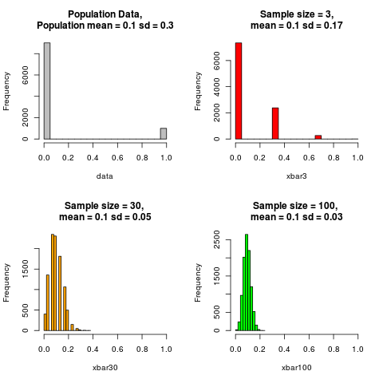

When n reaches 30, the sampling distribution bears some resemblence to the normal distribution. However, it has a noticeable right skew.

Theoretical standard error =
Sample Size 3: S.E. = sqrt((0.1(1-0.1))/3) = 0.173
Sample Size 30: S.E. = sqrt((0.1(1-0.1))/30) = 0.003
Sample Size 100: S.E. = sqrt((0.1(1-0.1))/100) = 9_{E}-4

As the sample size increases, standard error decreases markedly faster than the previous binomial distribution. This is because the numerator for the standard error is less in this part than in the previous. Because it is a binomial distribution, the sample mean is the same as the population mean for all sampling distributions.

Question 2:

