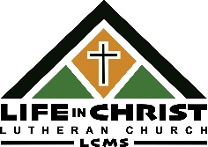
Life in Christ Lutheran Church
2017 W Hwy 61
PO Box 765
Grand Marais, MN 55604

Redeemer Lutheran Church Ladies Guild
500 Central Ave.
Aurora, MN 55705


Preaching Christ Crucified on the North Shore 1 Cor.1:23

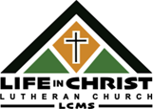
Life in Christ Lutheran Church
2017 W Hwy 61
PO Box 765
Grand Marais, MN 55604

Ruth and Stephen Saunders
900 E Elm Rd
Oak Creek, WI 53154-6472



Alive in Christ Bringing Life in Christ

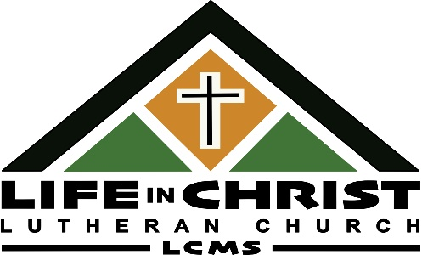
Thank you so much for your recent generous gift. God has exceedingly blessed us through your prayers and gifts.
Alive in Christ Bringing Life in Christ

There are many exciting things happening at Life in Christ. Thank you again and God’s blessings.

Pastor Watt


Thank you so much for your recent and ongoing gifts. God has exceedingly blessed us through your gifts.
Alive in Christ Bringing Life in Christ

There are many exciting things happening at Life in Christ. Thank you again and God’s blessings.

Pastor Watt


Life in Christ Lutheran Church
2017 W Hwy 61
PO Box 765
Grand Marais, MN 55604

St. Johns Lutheran Church
60929 110th Street
Hutchinson, MN 55350


Preaching Christ Crucified on the North Shore 1 Cor.1:23


Life in Christ Lutheran Church
2017 W Hwy 61
PO Box 765
Grand Marais, MN 55604

Fergus Falls Circuit
Minnesota North District-LCMS
2801 32nd St. S
Moorhead, MN 56560



Alive in Christ Bringing Life in Christ


Thank you so much for your recent generous gift. God has exceedingly blessed us through your prayers and gifts.
Alive in Christ Bringing Life in Christ

There are many exciting things happening at Life in Christ. Thank you again and God’s blessings.

Pastor Watt


Thank you so much for your recent and ongoing gifts. God has exceedingly blessed us through your gifts.
Alive in Christ Bringing Life in Christ

There are many exciting things happening at Life in Christ. Thank you again and God’s blessings.

Pastor Watt


Life in Christ Lutheran Church
2017 W Hwy 61
PO Box 765
Grand Marais, MN 55604

Erik & Jody Preus
15231 Elm Road North
Maple Grove, MN 55311


Preaching Christ Crucified on the North Shore 1 Cor.1:23


Life in Christ Lutheran Church
2017 W Hwy 61
PO Box 765
Grand Marais, MN 55604

Donald & Hogie Streich
451 County Rd 8 SW
Buffalo, MN 50003



Alive in Christ Bringing Life in Christ

Thank you so much for your recent generous gift. God has exceedingly blessed us through your prayers and gifts.
Alive in Christ Bringing Life in Christ

There are many exciting things happening at Life in Christ. Thank you again and God’s blessings.

Pastor Watt


Thank you so much for your recent and ongoing gifts. God has exceedingly blessed us through your gifts.
Alive in Christ Bringing Life in Christ

There are many exciting things happening at Life in Christ. Thank you again and God’s blessings.

Pastor Watt

