POLICY
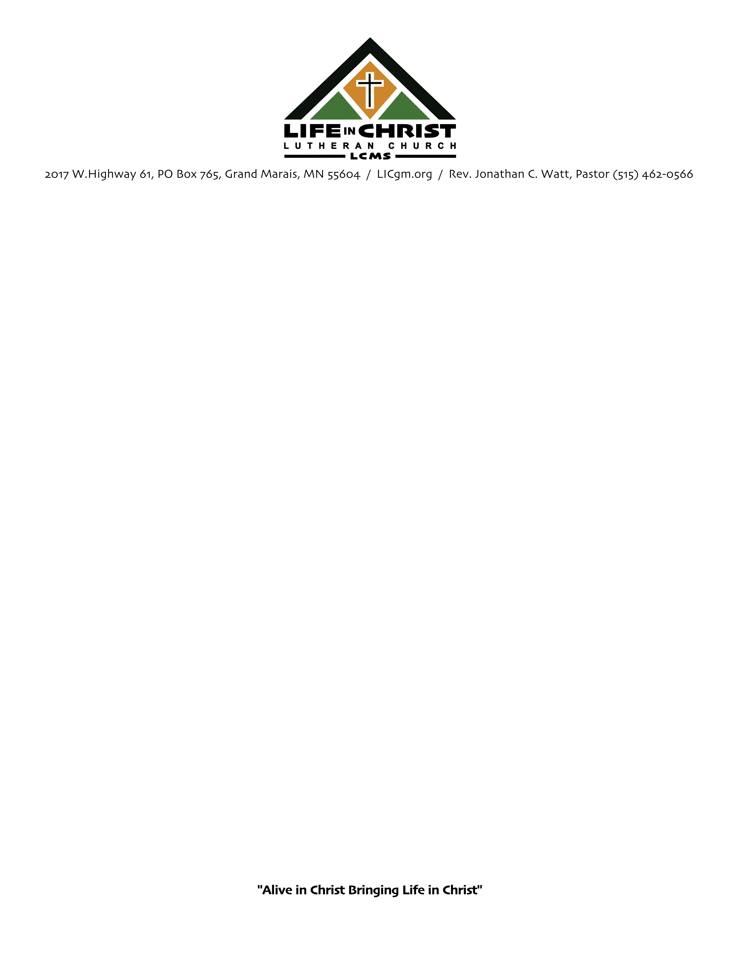
CAMPING ON LIFE IN CHRIST PROPERTY
Proposed
Policy:

It is the policy of Life in Christ Lutheran Church to allow camper parking on the church property for individuals who are members of a Lutheran Church—Missouri Synod congregation.
No one under 18 years of age may camp unless accompanied by a responsible adult who will remain onsite for the entire reservation.
Parking is at the discretion of the Elders. The Elders reserve the right to refuse service to anyone. The Elder reserve the right to waive requested donations.
Definitions:
A camper is defined as combinations of recreational vehicles and trailers that allow people to sleep inside.
Church Property is defined as the campus of Life in Christ Lutheran Church of Cook County Minnesota, inc.
The Elders are the Life in Christ Lutheran Church of Cook County Minnesota, inc. duly elected Board of Elders.
Request for Stay:
Please request your stay in writing (eMail to camp@licgm.org):
Include the following information:
- Name
- Phone number
- eMail address
- Date of arrival
- Date of departure
- Special requests
Stay:
All stays must be approved by the Elders of Life in Christ Lutheran Church.
Check-in:
Check-in time for campsites is during office hours; 8 a.m. to 4pm. Arrangements can be made by calling 515-462-0566.
Check-Out:
Check-out time is no later than 5 p.m.
Life in Christ Lutheran Church, 2017 West Highway 61, PO Box 765 Grand Marais, MN * 515.462.0566 * pastor@licgm.org
Donations:
There is a suggested donation of $20 per night per camper.
- Add $10 for electrical connection.
- Add $10 for sewer services.
Donations made to Life in Christ Lutheran Church, Grand Marais, MN

