Question 1:
What is a database?
A database is a program that helps store data and provides functionality for adding, modifying, and querying that data. (khanacademy.org)
What is a table in a databases?
A table is a database object that contains all the data in a database. Data is organized in a row and column format like a spreadsheet. Each row represents a unique record, and each column represents a field in the record. (Microsoft.com)
What does relational mean in relational databases?
A relational database uses connections (relations) between tables to completely define a object. Data in one table is linked to another table or tables by a unique key.
What is SQL and why do we need it?
SQL is a programming language designed to manage relational databases. It handles all the functions needed to manage a database.
Question 2:
What is the advantage of storing medical records in a database instead of in text
files?
A data base allows relationships to be seen across data. (Quora.com)
What two tables did you think of for a personal medical records database? Why?
Patient table
Appointment table
Name two-three columns that each table will have.
Patient Table - Patient id
Name
Address
Appointment table – appointment id
Patient id
Attending Doctor

What column will you indicate as primary key? What column is foreign key? Why?
Patient id the the patient table and appointment id int the appointment table are primary keys.
Patient id in the appointment table is the foreign key.
These fields will be unique to the patient.
Can the primary key contain a NULL value?
No.
Question 3.


Question 4 - .tree command not found error
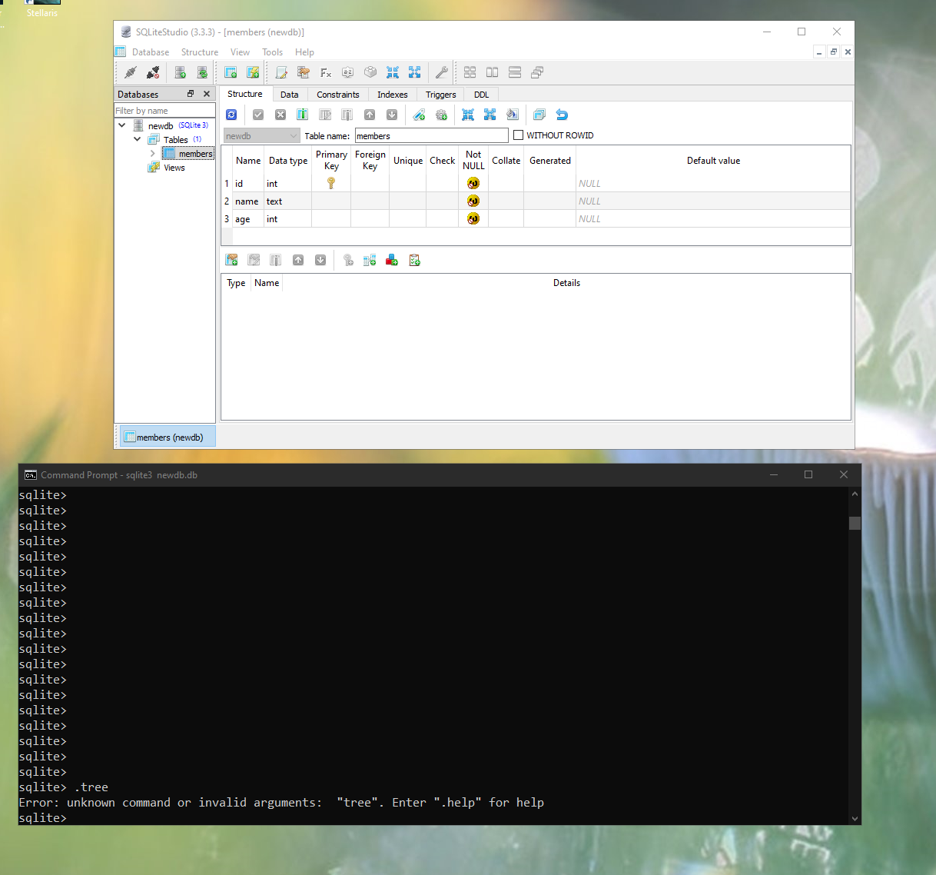
Question 5
Insert into members (id, name, age) values (2, ‘jack’,23)
Insert into members (id, name, age) values (3, ‘fred’,34)
Insert into members (id, name, age) values (4, ‘Nancy’,56)
Insert into members (id, name, age) values (5, ‘Sally’,65)

Question 6
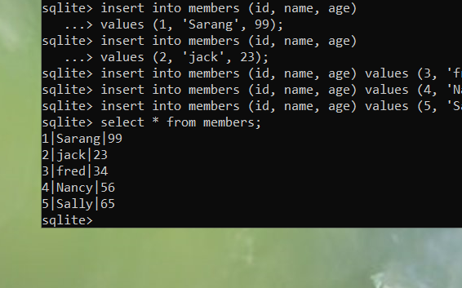
Select name from members;
Question 7
Delete from members where name = ‘Sally’;
Update members set age = 5 where name = ‘fred’;
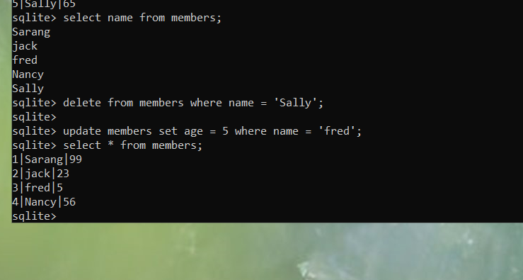
Question 8 - .tree command not working, could not find any information in a internet search
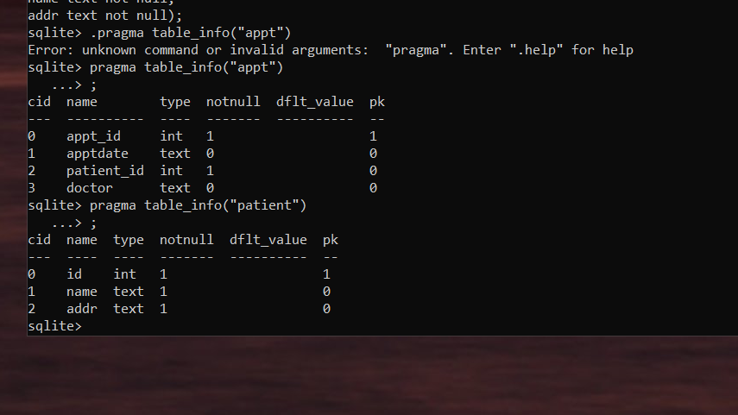
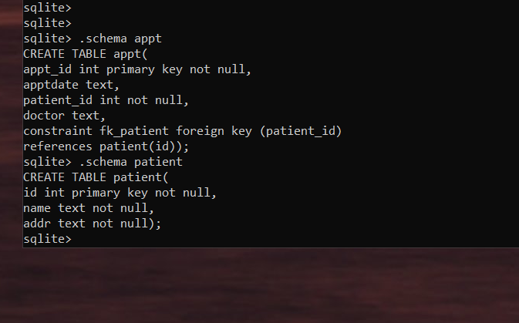
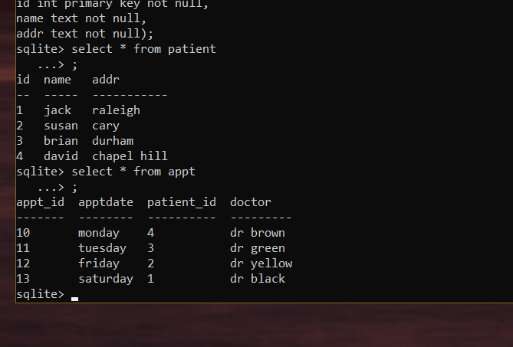
Question 9
1. I don’t believe this lab was helpful in learning about databases and SQL. If I had not already been familiar with SQL I don’t think I would have gotten much from this lab.
2. More examples especially for how to create databases with foreign keys
3. I would rate it 2
Question 10
