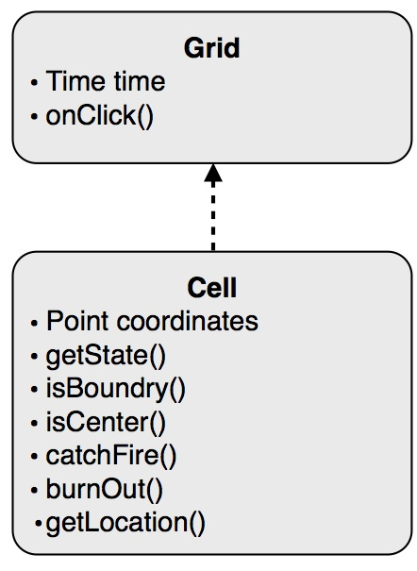**Spreading of Fire Design Document**

**Date: 16 September 2011**

**Document Author(s): Andrew Kofink, James Bruening**

**Design Rationale**

**Figure 1: Class Diagram for Spreading of Fire**

**Document Revision History**

|  |  |  |
| --- | --- | --- |
| **Date** | **Author** | **Change Description** |
| **9/15/2011** | Andrew, James | * Created Design Document |