Virtual Fracture Lab

Copyright Z. Grasley

Experimental lab report, due XX/XX/XXXX

# Getting Started

# You will need to download the free CDF player at: [https://www.wolfram.com/player/](https://urldefense.proofpoint.com/v2/url?u=https-3A__www.wolfram.com_player_&d=DwMFaQ&c=u6LDEWzohnDQ01ySGnxMzg&r=8BazBkWsu90pWeW8f9tFng&m=1LrkZCuS6bv6SMDqjIjgQEtb1O6eMN1QMmyVEdf10Ko&s=xLdrt4XPW9ub_84W5RuLCGS1dQkSHzSjM7CA--8OFOM&e=). After installation of the CDF player, open the CDF file corresponding to the fracture lab. This CDF file will allow you to conduct virtual experiments. Please note that you need to record the data produced in these experiments since the CDF file will NOT save the data when you finish.

# Objectives

The purpose of this exercise is to reinforce the principle of linear elastic fracture mechanics. This will be achieved by running simulated experiments to “break” an unknown specimen in mode 1 tension.

# Introduction

In this interactive exercise, you will apply tensile stress σzz on a dogbone shaped specimen that has a pre-existing flaw (crack) at either the edge of the sample or in the center of the sample. Using linear elastic fracture mechanics principles, you will ascertain the critical stress intensity of the specimen and use this knowledge to determine the material tested (Refer to the table of stress intensity factors of different engineering materials in [1]). In addition, you will run several experiments with different pre-existing crack locations and lengths in order to understand the effects of these variables on fracture properties.

# Procedure

Each group should run at least 5 simulated experiments with different edge crack lengths and at least 5 simulated experiments with different center crack lengths (at least 10 simulations in total). For each experiment, step up the applied tensile force until the specimen fractures. Record the crack length, crack location, and the maximum σzz for each simulation. Please note that the crack length given in the CDF simulator is equal to the parameter ‘*a*’ given in your textbook. Thus, in the simulator, ‘crack length’ refers to the entire flaw length for an edge crack and half of a center flaw length (see Figure 1).

Please note that changing the crack location or the crack length will NOT change the data or the graph already shown on the screen from a previous simulation. You must press the RESET button before changing the crack location and length, then reload the new test sample.

# Calculations

The critical stress intensity factor (a measure of fracture toughness) *Kc* can be calculated using the appropriate equation for Mode I fracture,

,

where  is the maximum axial tensile stress at failure and the length of the crack is *a*. *Y* is a dimensionless parameter or function that depends on both crack and specimen sizes and geometries, as well as the manner of load application. It is common to use *Y*=1.0 for an internal crack and *Y*=1.1 for an edge crack. Note that *K­­c* has unusual units of MPa $\sqrt{m}$ or psi $\sqrt{in}$. Use your extensive engineering judgment to eliminate any data points that you think should be excluded from your analysis.

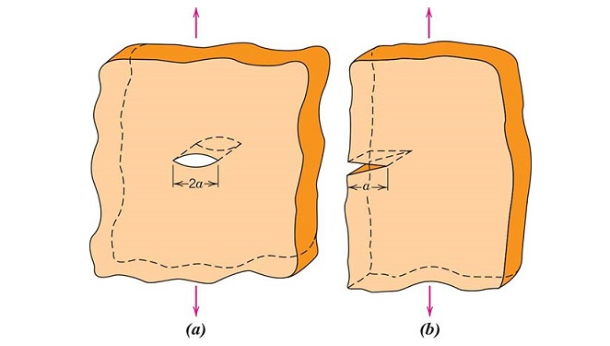

Figure 1. Schematic representations of (a) an interior crack in a plate of infinite width, and (b) an edge crack in a plate of semi-infinite width. From [1].

# Reporting Requirements

Use the formal, experimental lab report format for this lab write up. In addition to meeting the requirements for a formal lab report, please answer the following questions in the discussion section of your lab report.

* What is the average fracture toughness of the specimen?
* What is the standard deviation of the fracture toughness?
* Based on comparison to tabulated values in [1], what material was likely used to fabricate your virtual test specimen?
* How does the crack location affect the failure stress? How does the crack location affect the critical stress intensity factor of the material?
* How would you design an experiment to test the Mode III critical stress intensity factor for this specimen? Would you expect the load required to fracture the specimen to be higher or lower than in Mode I?
* If you could adjust the loading rate, how would you expect the rate at which tensile force is applied on the specimen to influence the measured critical stress intensity factor?

# References

1. Callister, W.D., Jr., Rehtwisch, D.G., Materials Science and Engineering: An Introduction, 10th Edition, Wiley, 2018, ISBN: 978-1-119-40549-8.