Windows 10 Secure System Build
J’len Williams
Texas A&M University–Central Texas
CIS 4342: Computer Security
Professor Scaman
7/19/2026

The Windows 10 Secure System Build project focuses on deploying and hardening a virtualized Windows 10 environment to meet baseline enterprise security expectations. The system was configured using industry-recognized guidance from organizations such as the National Institute of Standards and Technology (NIST, 2020) and the Center for Internet Security (CIS, 2024). These frameworks emphasize layered security, host protection, identity management, and continuous monitoring. Evidence of each configuration is provided in the appendix, and the report concludes with a risk assessment and recommendations for further improvement.

The system was hardened using a layered approach aligned with best practices recommended by NIST and CIS. Renaming the default Administrator account and disabling the Guest account reduces predictable attack vectors and unauthorized access opportunities (see Appendix A, Figures A2 and A3). Password policies requiring a minimum of 12 characters and lockout thresholds follow guidance from NIST’s enterprise password management recommendations, which emphasize length and throttling as primary defenses against brute-force attacks (see Appendix A, Figures A4 and A5; Scarfone & Souppaya, 2013). Windows Defender and Windows Firewall were verified as active, providing host-based protections consistent with CIS Windows 10 Benchmark recommendations (see Appendix A, Figures A6 and A7; CIS, 2024). Encryption using BitLocker or EFS ensures confidentiality of data at rest, a control strongly emphasized in NIST SP 800-123 as part of secure system deployment (see Appendix A, Figure A8; NIST, 2020).

Access control was implemented using NTFS permissions and the principle of least privilege (see Appendix B, Figures B1 and B2). This aligns with CIS guidance on restricting access to sensitive directories and ensuring users only have the permissions necessary to perform their tasks (CIS, 2024). Demonstrations of denied and authorized access confirm the effectiveness of least-privilege enforcement (see Appendix B, Figures B3 and B4).

Auditing for logon and account-management events was enabled to support intrusion detection, consistent with NIST recommendations for monitoring authentication activity and account changes (see Appendix C, Figure C1; NIST, 2020). Generated log evidence shows failed and successful logon attempts (see Appendix C, Figures C2 and C3) and account-management events (see Appendix C, Figure C4), confirming that auditing captures both success and failure conditions.

Software being used in this project is 7-zip installed from online. (see Appendix D, Figure D1) Verification was performed using digital signatures and file hashing (see Appendix D, Figures D2 and D3). NIST highlights the importance of verifying software integrity and authenticity to prevent tampering or unauthorized modification (NIST, 2020). The update mechanism was also reviewed to confirm how the application maintains version integrity (see Appendix D, Figure D4). These controls collectively reduce the attack surface and strengthen the system’s baseline security posture.

Despite the applied controls, several weaknesses remain. Local logs can be cleared or tampered with by attackers, a limitation noted in NIST’s guidance on host-based monitoring (NIST, 2020). Without centralized log forwarding or SIEM integration, long-term detection and correlation are limited. Administrative accounts continue to represent a medium-risk target even when renamed, as privilege escalation remains a critical threat in Windows environments (CIS, 2024). Software installation also introduces risk. Even verified applications expand the attack surface by adding binaries and dependencies that may contain vulnerabilities. NIST emphasizes that software must be continuously monitored and updated to maintain security (NIST, 2020). These weaknesses highlight the need for additional enterprise-level controls beyond initial host hardening.
Password and account policies present a low level of risk because they follow NIST’s recommendations for strong authentication and lockout thresholds (Scarfone & Souppaya, 2013). Administrative accounts remain a medium risk due to their elevated privileges and potential for misuse (CIS, 2024). Logging and auditing also fall into the medium-risk category because local logs can be modified without centralized protection (NIST, 2020). Host-based protections such as Windows Defender and Windows Firewall present a low risk when enabled, but CIS notes that default firewall rules may still allow certain outbound connections (CIS, 2024). Encryption carries a low risk when properly configured, as it protects data at rest. Software installation introduces medium risk due to the potential for vulnerabilities and the need for ongoing patching (NIST, 2020).
Several improvements would strengthen the system further. Implementing centralized logging through a SIEM platform aligns with NIST’s recommendation for secure log management and tamper-resistant monitoring (NIST, 2020). Application whitelisting using tools such as AppLocker follows CIS guidance for reducing unauthorized software execution (CIS, 2024). Enhancing firewall rules beyond default settings would reduce opportunities for data exfiltration or command-and-control communication. Multi-factor authentication (MFA) for administrative accounts would significantly reduce credential-compromise risk, consistent with NIST’s emphasis on layered authentication (Scarfone & Souppaya, 2013). Applying additional CIS Benchmark controls would elevate the system to a more mature security posture.

The Windows 10 Build project demonstrates how foundational security controls create a significantly more resilient operating environment. By implementing identity protections, host-based defenses, access control, encryption, and auditing, the system now aligns with widely recognized best practices from NIST and the Center for Internet Security. These measures collectively reduce exposure to common threats such as unauthorized access, credential attacks, malware, and improper data handling. Although the system is substantially hardened, the evaluation also highlights areas where additional improvements would further strengthen security. Controls such as centralized logging, enhanced firewall rules, application whitelisting, and multi-factor authentication would elevate the system from a standalone hardened workstation to an enterprise-ready endpoint. These enhancements reflect the layered-defense strategies recommended in modern cybersecurity frameworks. This project reinforces the importance of structured hardening, continuous monitoring, and adherence to established security standards. The applied controls provide a strong baseline, and the recommended improvements offer a clear path toward achieving a more mature and comprehensive security posture. The combination of practical configuration work and standards-based analysis demonstrates how thoughtful implementation can meaningfully reduce risk in real-world environments.

References

Center for Internet Security. (2024). CIS Microsoft Windows 10 Benchmark v2.0.0.
https://www.cisecurity.org/benchmark/microsoft_windows_10
National Institute of Standards and Technology. (2020). Guide to general server security (NIST SP 800-123). U.S. Department of Commerce.
https://nvlpubs.nist.gov/nistpubs/Legacy/SP/nistspecialpublication800-123.pdf
Scarfone, K., & Souppaya, M. (2013). Guide to enterprise password management (NIST SP 800-118). National Institute of Standards and Technology.
https://nvlpubs.nist.gov/nistpubs/Legacy/SP/nistspecialpublication800-118.pdf

Appendix A
- Figure A1: Windows Update Status
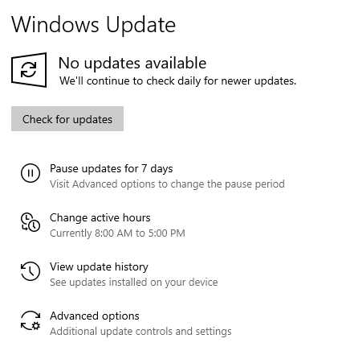
- Figure A2: Renamed Administrator Account
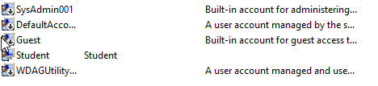
- Figure A3: Guest Account Disabled
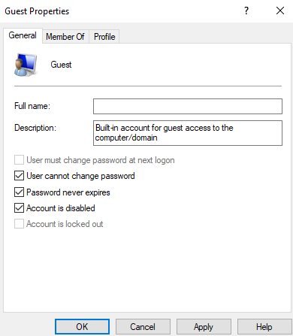
- Figure A4: Password Policy Configuration
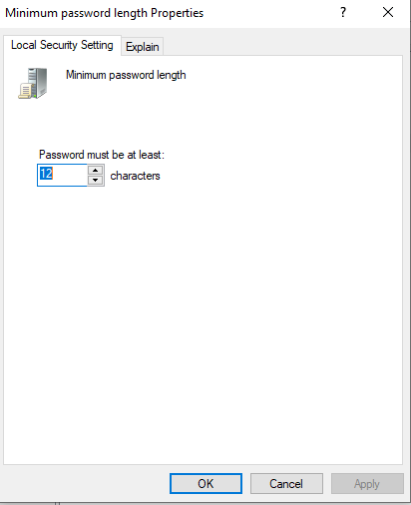
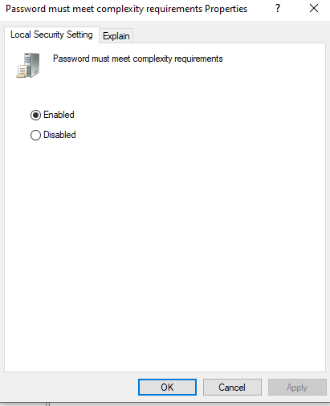
- Figure A5: Account Lockout Threshold
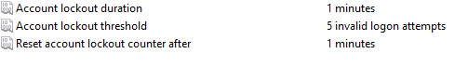

- Figure A6: Windows Defender Enabled
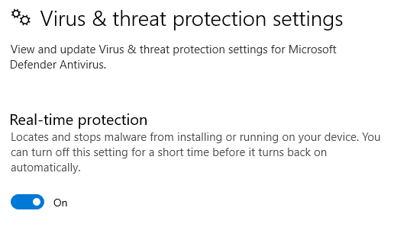
- Figure A7: Windows Firewall Enabled
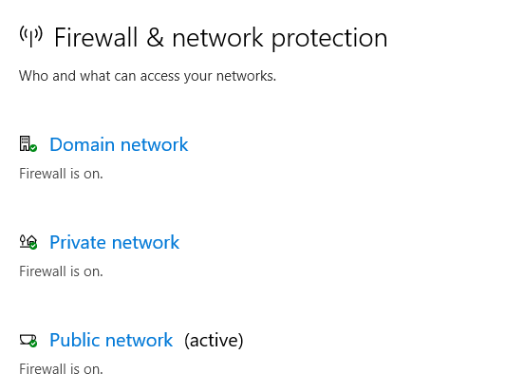
- Figure A8: BitLocker or EFS Encryption Enabled
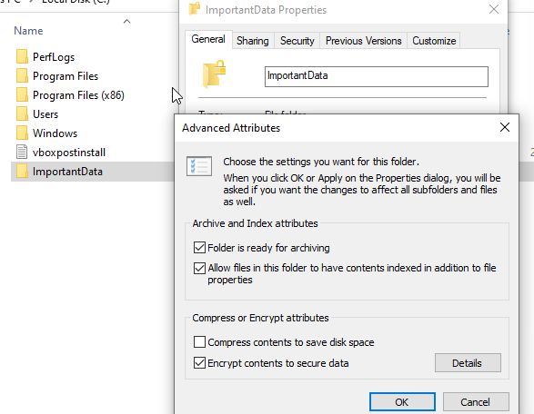
Appendix B
- Figure B1: Folder Structure (Public & Restricted)
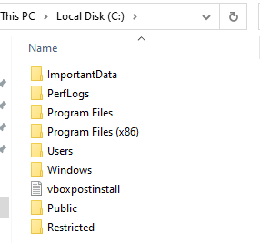
- Figure B2: NTFS Permissions Applied
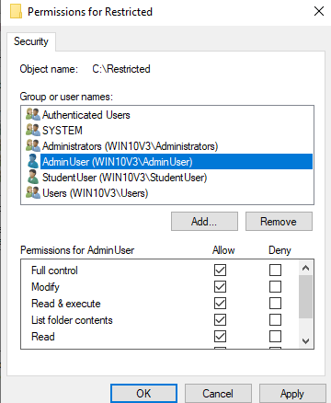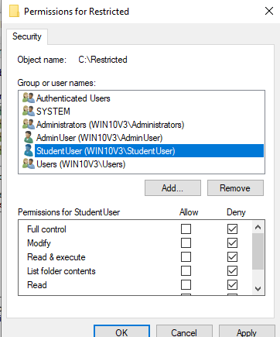

- Figure B3: Denied Access Attempt (Standard User)
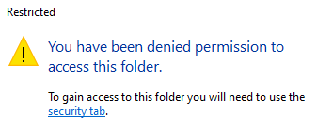
- Figure B4: Authorized Access Attempt (Administrator)
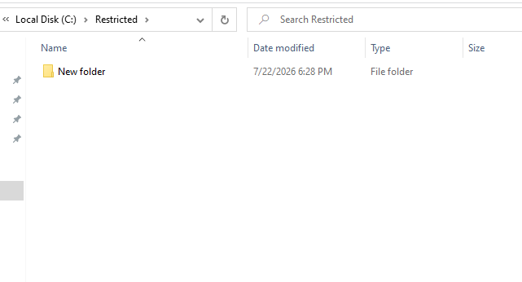
Appendix C
- Figure C1: Audit Policy Settings
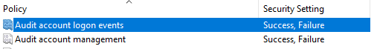
- Figure C2: Failed Logon Event (Event ID 4625)
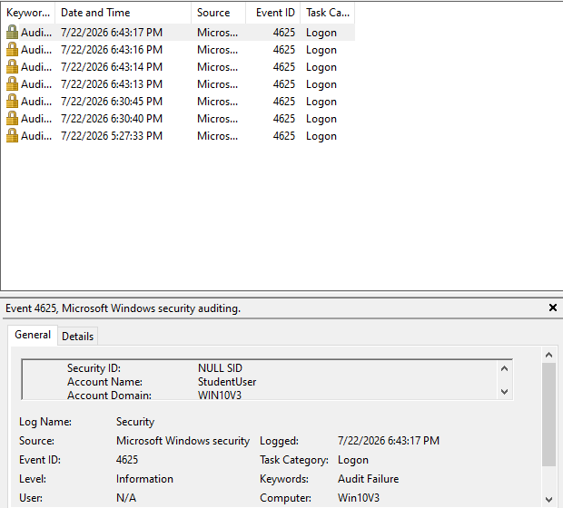

- Figure C3: Successful Logon Event (Event ID 4624)
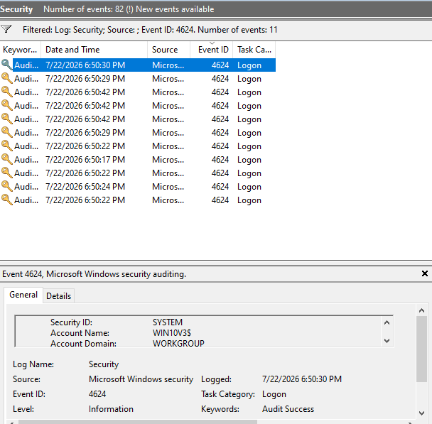
- Figure C4: Account Management Event (Event ID 4738)
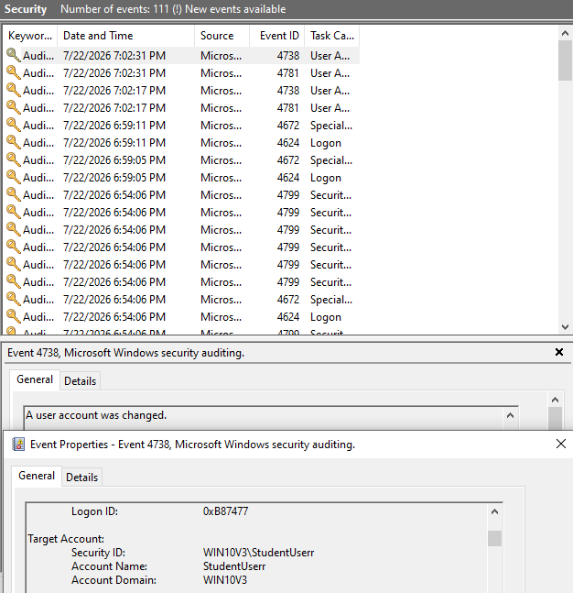

Appendix D
- Figure D1: Installed Software Application
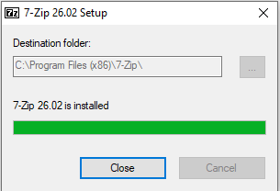
- Figure D2: Digital Signature Verification
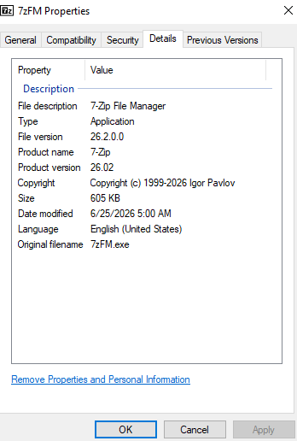
- Figure D3: File Hash Output (PowerShell)
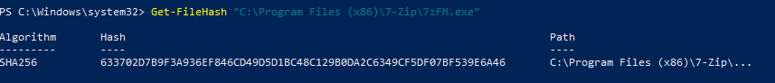

- Figure D4: Update Mechanism Screenshot


