**Understanding Brain Networks**

By Jing Wei Chan

Student Number: 16000092

MSc Complex Networks and Web

Department of Computer Science

University College London

January 2020

# Abstract

Half a page

Table of Contents

Abstract 2

1. Executive Summary 4

2. Background 4

2.1. Motivation for analysing brain networks 4

2.2. Overview of brain network topology 4

2.3. Research Questions 4

3. Literature Survey 5

3.1. Graph Theory Methods: Applications in Brain Networks 5

3.2. The Small World of the Cerebral Cortex 5

3.3. Preferential Detachment During Human Brain Development: Age- and Sex-Specific Structural Connectivity in Diffusion Tensor Imaging (DTI) Data 5

3.4. Task vs Rest: Different network configurations between the coactivation and the resting-state brain networks 5

3.5. Complex Brain Network Analysis and Its Applications to Brain Disorders 6

3.6. Human Brain Networks in Health and Diseases 6

4. Methodology 7

4.1. Data Acquisition and Evaluation 7

4.2. Data Processing 7

5. Results 9

6. Discussion 10

7. Reference 11

8. Appendix 12

# Executive Summary

2 - 3 pages; you should present the question you want to investigate, and briefly discuss:

* + why do you want to investigate this question?
  + why is it important/valuable/useful?
  + why is it novel or interesting?
  + what datasets /algorithms /tools do you use?
  + what are your key results /achievements?
  + how do you evaluate your results?
  + which is your main conclusion?
  + and what do you learn from this coursework?

# Background

1-3 pages. Briefly explain essential technical concepts relevant to the coursework

## Motivation for analysing brain networks

* Nodes/neurons usually work collectively to perform a task
* It is important to use network analysis to uncover information about how the brain works as a whole

## Overview of brain network topology

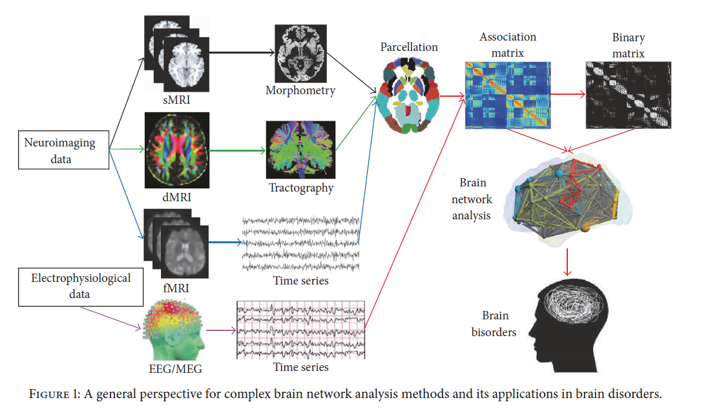

* A lot of parameters to consider when converting from one file to other

## Research Questions

* how do brain networks differ between healthy and ADHD individuals?
* what is the difference in network topology between species?
* what can we tell from the hubs and network communities in the structural network of brains?
* is there a specific model to describe brain network?

# Literature Survey

2-4 pages.

* Introduce and discuss (critically and objectively) about 3 - 5 latest research works
* why they are relevant/interesting/useful? what are their limitations/problem?

## Graph Theory Methods: Applications in Brain Networks

Structural graphs are generally sparse (most possible structural connections in a given nervous systems do not exist) and temporally relatively stable (but subject to plasticity and development). In contrast, functional graphs record statistical dependencies among neuronal time series, and hence are often dense and highly variable across time.

## The Small World of the Cerebral Cortex

Cortical connection patterns exhibit small-world properties, characterized by the simultaneous existence of short paths between all constituent elements and of a high degree of clustering.

The scaled value of path length from the macaque and cat connection matrices are larger than the path length of a random matrix. There is a strong tendency for a positive correlation between path length and cluster index.

There were little or no evidence of scale-free degree distributions in either large-scale or cortico-cortical probabilistic connection matrices.

## Preferential Detachment During Human Brain Development: Age- and Sex-Specific Structural Connectivity in Diffusion Tensor Imaging (DTI) Data

Evidence from MRI indicated a reduction in gray matter (GM) volume and thickness. On the other hand, it also indicated a general increase in white matter (WM) volume with age.

Parameters such as streamline count, edge density, global efficiency and local efficiency of fiber-tract networks were measured over age. It was found that fewer long-distance, thin, and intermodular fiber tracts showed streamline loss than would be expected given how often such fiber tracts could have been affected by chance.

## Task vs Rest: Different network configurations between the coactivation and the resting-state brain networks

The human brain exhibits organized spontaneous fluctuations in the resting-state, enabling researchers to study large-scale brain segregations and integrations. Changes in connectivity modulated by task are important to understand brain integration.

Both the coactivation network and the resting-state network revealed smaller global efficiency and larger clustering coefficient compared with the reference random networks, which characterizes the small world network properties.

Comparison between the coactivation network and the resting- state network revealed greater global efficiency and smaller mean clustering coefficient for the coactivation network compared with the resting-state network.

## Complex Brain Network Analysis and Its Applications to Brain Disorders

Nodes should represent different, functionally uniform neurons. There are currently 6 methods to define nodes:

* Simplest: treat each measurement point as a separate node. However, 1) no guarantee that the measurement points are consistent with the boundaries of functional human cell populations; 2) boundaries of a specific, functionally specialised human cell population may go beyond boundaries of a voxel
* Most common: register experimental data to an a priori anatomical parcellation atlas, such as Brodmann area and Anatomical Automatic Labeling (AAL) atlas
* Treat each voxel as a separate node
* Define nodes according to some a priori criteria
* Use connectivity to define nodes
* Combining pieces of multimodal information

There are currently 3 methods to define edges: structural connectivity functional connectivity and effective connectivity

Many brain disorders have been found to be associated with the abnormal topological structures of brain networks. At the local level, disorder group showed the loss of hub nodes and decreased local efficiency compared with the control group. Therefore, brain network analysis can provide important auxiliary guide for early diagnosis and treatment of brain disorders. The paper covers Alzheimer’s Disease (AD), Schizophrenia (SCZ), Parkinson’s Disease (PD), Multiple Sclerosis (MS) but not ADHD.

## Human Brain Networks in Health and Diseases

Three diffusion-based methods have been used in important studies recently to construct white matter networks: diffusion tensor imaging (DTI), diffusion spectrum imaging (DSI), and diffusion weighted magnetic resonance imaging (DW-MRI). Convergently, these studies suggest that there exists a core of the white matter network which densely interconnects the posterior and medial cortical regions, association cortical hubs, and has longer-range white matter connections to the rest of the brain

Topological measurements such as clustering and small-worldness were inversely correlated with duration of illness in Schizophrenia.

Supekar et al. (2008) showed that the clustering coefficient was significantly reduced in patients with Alzheimer’s disease.

# Methodology

1 - 3 pages. Provide enough information to allow others to reproduce your results. Investigation and methodology must be the best and most direct way.

* how do brain networks differ between healthy and diagnosed individuals (ADHD)?
  + basic properties (including rich club, mixing pattern, second order mixing)
  + centrality measures (betweenness vs closeness)
  + network controllability
* what is the difference in network topology between species?
  + basic properties (including rich club and mixing pattern)
* what can we tell from the hubs and network communities in the structural network of brains?
  + can we tell the differences between community functions?
  + can we tell what is the role of a hub?
* is there a specific model to describe brain network?
  + PFP model (or some other growth model that can produce a similar brain topology)
  + small world, BA power law network (exponent)
  + what is the intent of the network?!!

## Data Acquisition and Evaluation

* ADHD
  + Type: undirected adjacency matrices (signed networks)
  + Consists of different brain specimens such as (typically developing, ADHD inattentive, normal etc)
* Brain fiber tracts from different species
  + Type: directed edgelist files
  + cat, macaque, rhesus, fly
  + provides online interactive visualisation
* Cortial connectivity
  + Type: undirected adjacency matrices
  + Functional coactivations with comparable resting-state fMRI network and node coordinates
  + Cortial connectivity for cat and macaque
* Budapest Connectome
  + Type: directed csv file
  + Node represents structural regions of the human brain
  + Edge represents fiber counts/fiber lengths/electrical connectivity
  + Edge confidence of 20% (84 graphs) and 50% (209 graphs)
  + unified connectome of 477 individuals into a reference brain graph

## Data Processing

* Networkx library in python
  + Able to generate graph object from various file types
  + Customise colour and size of nodes and edges
  + Plot communities
  + Plot distribution
  + Plot adjacency matrix
* MATLAB
  + Louvain modularity algorithm for community detection in adjacency matrices
  + Null and generative network models

# Results

2 - 5 pages

* Present, evaluate and analyse your most interesting/important/revealing results (and leave other results in the appendix)
* Graphic illustrations of your results are encouraged.

# Discussion

1 - 5 pages.

* interesting observations and insightful thoughts
* conclusion on your investigation
* limitations of your work and lessons learnt
* advice for future research

# Reference

# Appendix