DANIELLS PORTFOLIO TRACKER
System Documentation

─────────────────────────────────────

Version: 1.20
Date: 6 March 2026
Author: John Daniells
Classification: Personal / Confidential

1. PURPOSE & INTENT

The Daniells Portfolio Tracker is a personal financial management application designed to provide a real-time, consolidated view of an investment portfolio spanning multiple accounts, asset classes, and wrappers. It serves as a single source of truth for portfolio performance, allocation, goal progress, and retirement planning.
Primary Objectives
- Consolidate holdings across ISAs, SIPPs, GIAs, and crypto wallets into one view.
- Automate daily price fetching from Yahoo Finance after LSE market close (16:30 GMT).
- Track progress toward a £1,400,000 retirement goal by February 2031.
- Provide a browser-accessible interface via GitHub Pages — no local server required.
- Send an automated daily email summary with portfolio value and per-account movements.
- Maintain a complete price history for charting, trend analysis, and audit purposes.
Design Principles
- Static-first: No backend server. All logic runs in the browser via React + Babel.
- Zero-install: Runs directly from any browser — desktop, tablet, or mobile.
- Secure by default: Password-gated with SHA-256 hashing; data only loads post-authentication.
- Automated: GitHub Actions fetches prices and publishes updates without manual intervention.
- Portable: Entire system lives in a single GitHub repository.
2. SYSTEM ARCHITECTURE

The system is composed of five logical layers: a data store (JSON files), an automation layer (GitHub Actions), a hosting layer (GitHub Pages), a presentation layer (React SPA), and a notification layer (Yahoo Mail SMTP). These are all orchestrated via a single GitHub repository.
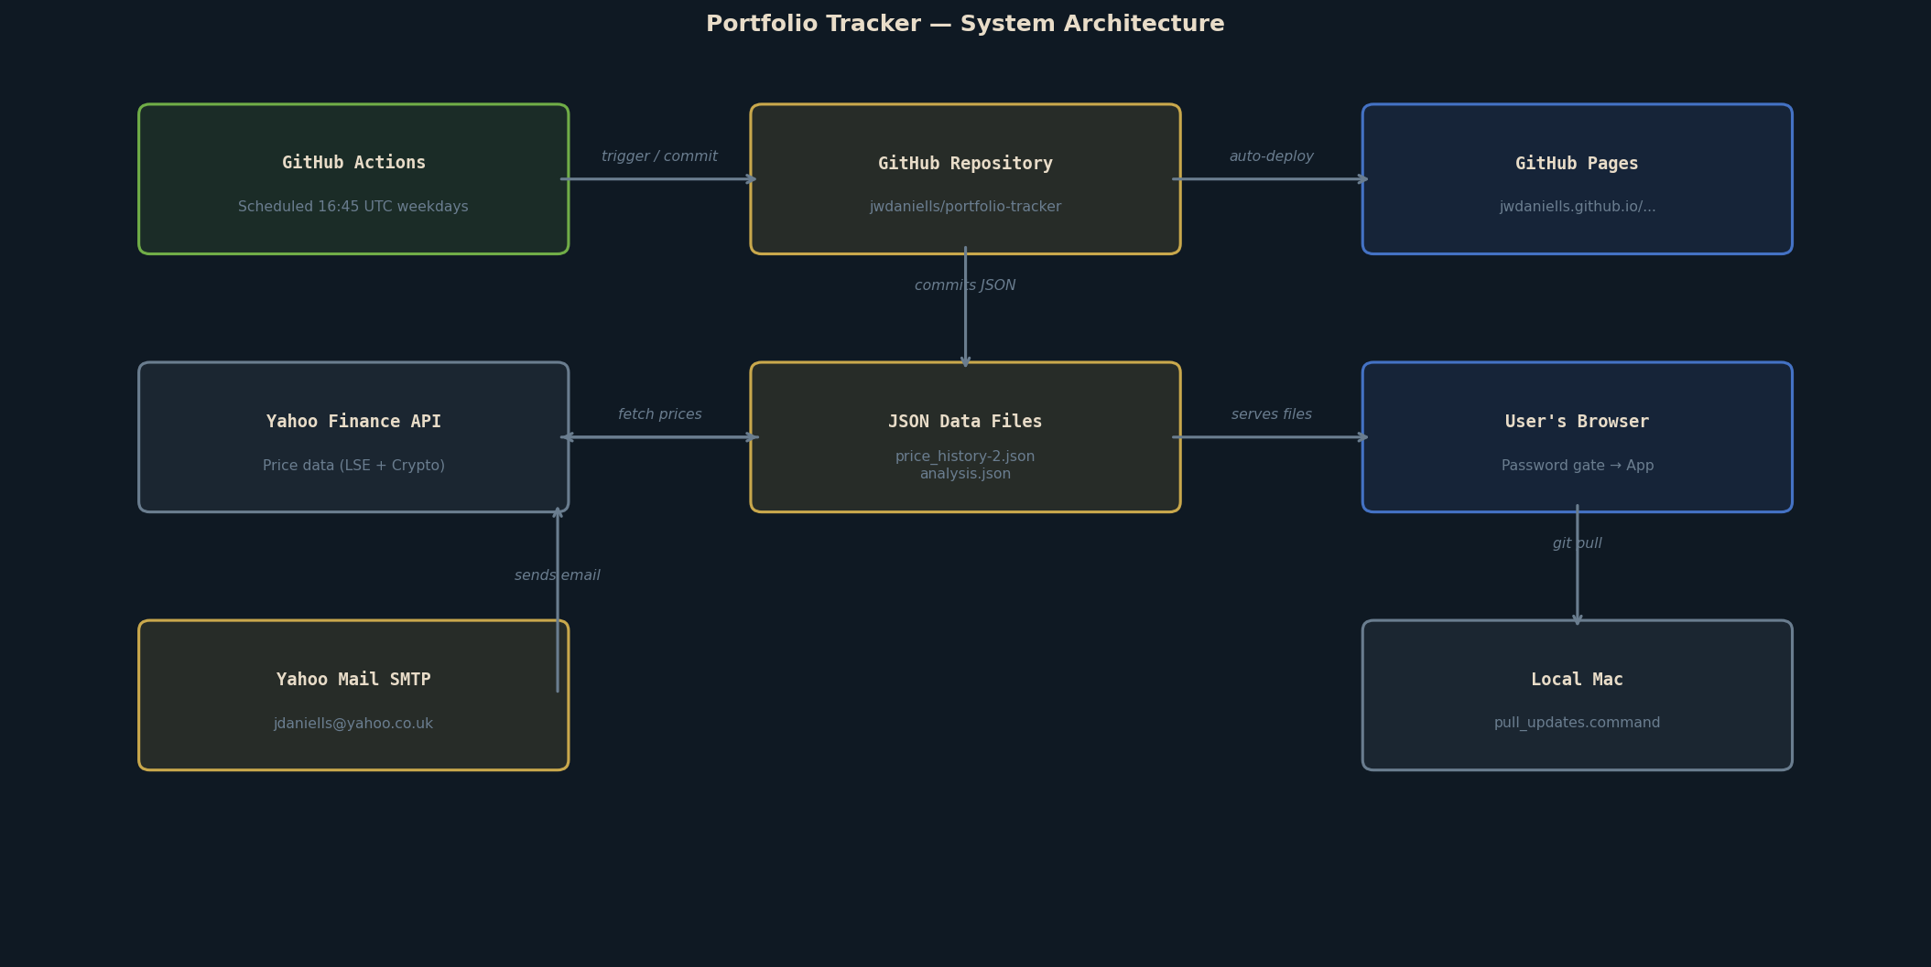
Figure 1: High-level system architecture showing all components and their relationships.
Hosting & Deployment
- Repository: github.com/jwdaniells/portfolio-tracker (public)
- GitHub Pages URL: https://jwdaniells.github.io/portfolio-tracker/
- Branch: main — all commits to main trigger an automatic Pages rebuild (~1 minute).
- No build pipeline required — files are served as-is (HTML, JSX, JSON).
Technology Stack
LAYER | TECHNOLOGY | DETAILS
Frontend | React 18 (UMD) | No build step — loaded from unpkg CDN
Transpiler | Babel Standalone | JSX-to-JS transform in the browser at runtime
Styling | Inline CSS (JS objects) | Dark theme, no external CSS framework
Charts | SVG (hand-built) | Custom SVG paths, no third-party chart library
Data | JSON files | price_history-2.json, analysis.json, reminders.json
Automation | GitHub Actions | Python 3.11 on Ubuntu, runs on cron schedule
Hosting | GitHub Pages | Served from main branch root directory
Notifications | SMTP / action-send-mail | Yahoo Mail SMTP, credentials in GitHub Secrets
Price source | Yahoo Finance v8 API | Direct HTTP — no yfinance library dependency
Security | SHA-256 password gate | browser crypto.subtle — client-side login screen
3. COMPONENT INVENTORY

All files in the repository and their roles:
FILE / ARTEFACT | TYPE | PURPOSE | NOTES
index.html | HTML | Application entry point. Ships the React CDN imports, password gate logic and JSX loader. | Modified to add SHA-256 auth gate (Mar 2026)
portfolio_tracker_v1.20.jsx | React/JSX | Main single-page application. All tabs: Dashboard, Accounts, Allocation, History, Goal, Analysis, Crypto. | 7 tabs; ~500 lines; no build required
retirement.html | HTML | Separate entry point for the Retirement Planner tool. | Linked from nav bar in main app
retirement_planner.jsx | React/JSX | Retirement income and drawdown planning calculator. | State pension, drawdown, ISA/SIPP modelling
price_history-2.json | JSON | Master data store. Holds all account definitions, holdings, prices, history, crypto, and metadata. | Updated daily by GitHub Actions
analysis.json | JSON | AI-generated portfolio analysis and commentary. Read by the Analysis tab. | Manually updated; non-blocking if absent
reminders.json | JSON | User-defined reminders and notes displayed in the app. | Manually maintained
fetch_prices.py | Python | Price fetching script. Calls Yahoo Finance v8 API for all equity, fund, and crypto tickers. Updates JSON. | Run by GitHub Actions at 16:45 UTC weekdays
.github/workflows/fetch-prices.yml | YAML | GitHub Actions workflow definition. Schedules and orchestrates the fetch, commit, and email steps. | Cron: 45 16 * * 1-5
pull_updates.command | Shell | Double-click script for macOS. Runs git pull to sync latest prices from GitHub to local machine. | Optional — only needed for local viewing
.gitignore | Config | Excludes local-only files from the repository (fetch_analysis.py, *.command etc.) | pull_updates.command IS tracked
4. PROCESS FLOWS

4.1 Daily Automated Price Fetch
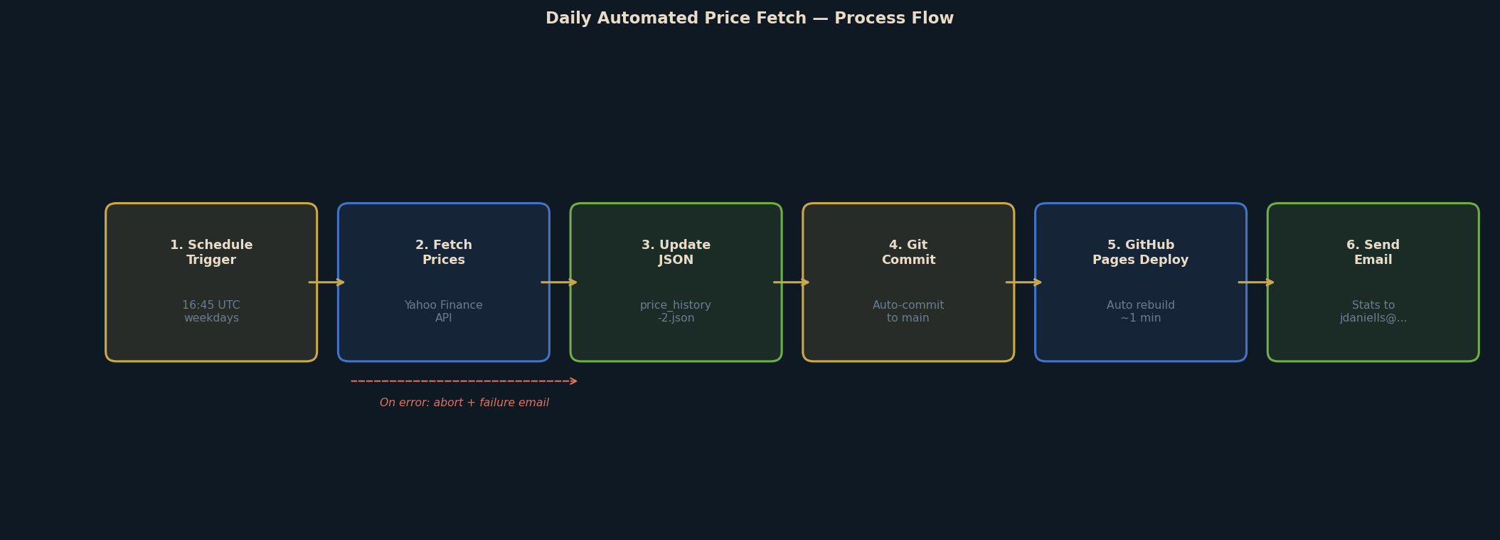
Figure 2: Daily automated price fetch and publish flow.
The cron schedule is: 45 16 * * 1-5 (16:45 UTC, Monday–Friday). This is 15 minutes after the London Stock Exchange closes at 16:30 GMT. In BST (summer, UTC+1) the run time is 17:45 local.
- GitHub Actions checks out the repository on an Ubuntu runner.
- Python 3.11 is installed; requests library installed via pip.
- fetch_prices.py calls the Yahoo Finance v8 chart API for each ticker.
- UK equity and fund prices are returned in pence (GBp) and automatically divided by 100.
- Crypto prices (BTC, ETH, XRP, ADA) are returned directly in GBP.
- If zero prices are fetched, the script aborts — the JSON is never written with corrupt data.
- Updated price_history-2.json is committed back to the repo with message 'Auto-update prices DD Mon YYYY'.
- GitHub Pages automatically rebuilds from the new commit within ~1 minute.
- An email is sent to jdaniells@yahoo.co.uk with per-account stats and a link to the tracker.
- On any failure, a failure alert email is sent instead.
4.2 User Access Flow
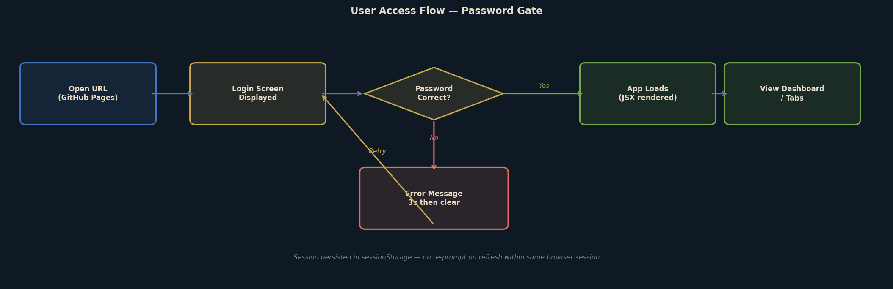
Figure 3: User authentication and application load flow.
The password gate operates entirely client-side:
- The login screen is rendered as plain HTML/CSS — no React/JSX is loaded at this stage.
- The user enters their password; it is hashed in-browser using window.crypto.subtle (SHA-256).
- The hash is compared against a hardcoded hash constant in index.html. The plaintext password is never stored.
- On success, sessionStorage is flagged and the JSX app is fetched, transpiled and mounted.
- Session persists for the duration of the browser tab — refreshing does not require re-entry.
- If the browser tab is closed, the session flag is cleared and the password must be re-entered.
4.3 Data Flow & File Relationships
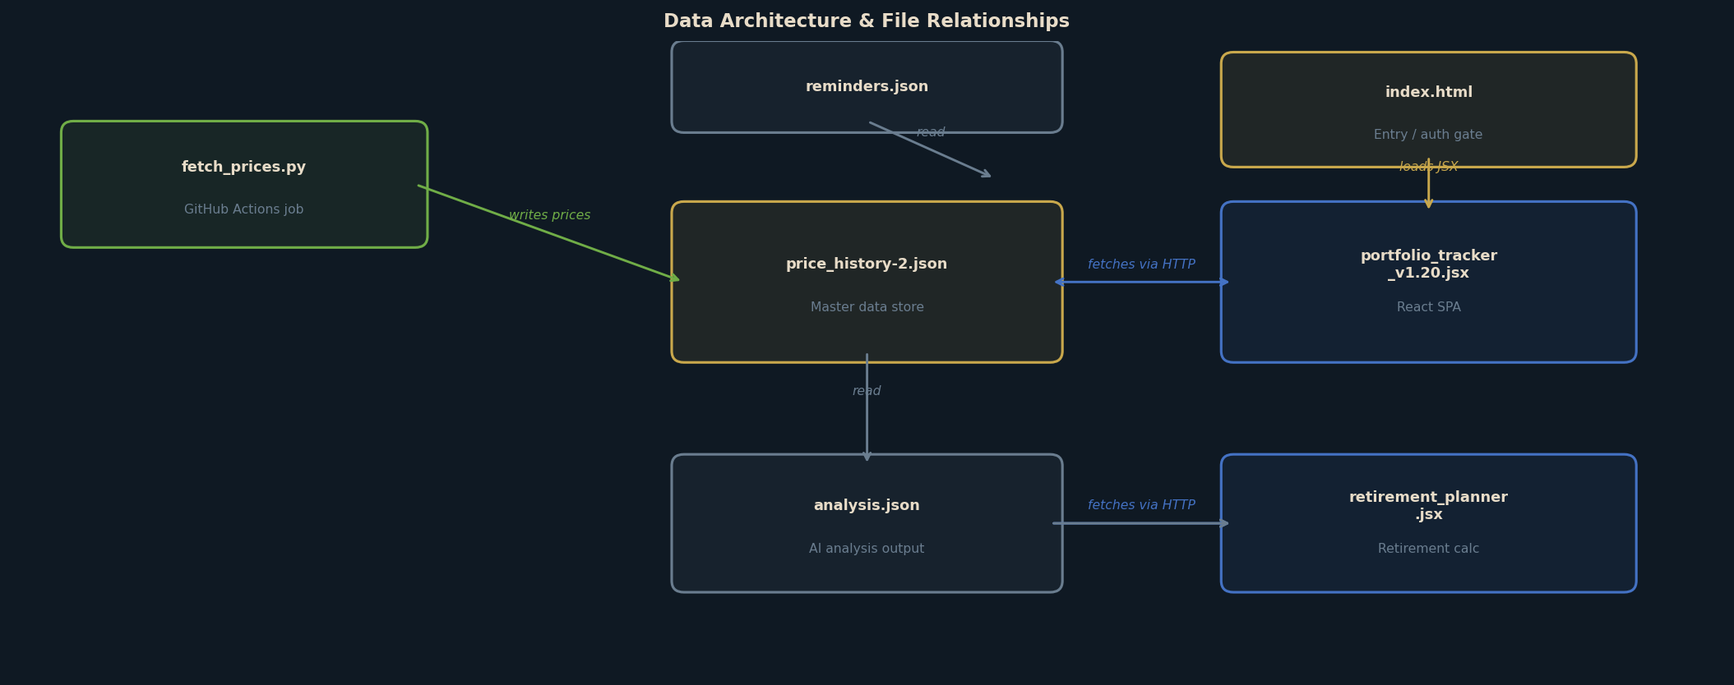
Figure 4: Data architecture and relationships between files.
4.4 Local Sync Flow
When the user wants to view updated prices locally (e.g. via localhost:8765):
- Double-click pull_updates.command in Finder.
- Script runs: git pull in the project directory.
- Latest price_history-2.json is downloaded from GitHub.
- Refresh the local browser to see updated data.
5. DATA ARCHITECTURE

price_history-2.json Structure
This is the master data file. Its top-level structure is:
meta Metadata: version, fetchDate, prevDate, fetchDateDisplay, prevDateDisplay
accounts[] Array of investment accounts. Each contains: id, name, wrapper, provider, holdings[]
holdings[] Per-account holdings: id, ticker, name, units, price, prevPrice, priceDate, costBasis, purchaseDate, bucket, fetchStatus, dividendsReceived
history[] Daily snapshots: date, totalValue, prices{}, notes. One entry per trading day.
crypto[] Cryptocurrency positions: id, name, units, price, prevPrice, priceDate
cryptoHistory[] Daily crypto portfolio total: date, totalValue
Key Data Rules
- prevDate / fetchDate: Only rolled forward when a new trading day is first fetched — prevents 'since last update' showing zero on same-day re-runs.
- History deduplication: If a history entry already exists for today, it is updated in-place (not appended). No duplicate date entries.
- Price currency: Yahoo returns UK securities in pence (GBp/GBX). fetch_prices.py divides by 100 to convert to £.
- Crypto prices: Returned directly in GBP — no conversion needed.
- Abort on empty fetch: If no prices are retrieved, the script exits with code 1 — the JSON is never overwritten with stale/zero prices.
6. SECURITY ARCHITECTURE

Password Protection
- A login screen is displayed before any data or application code is loaded.
- Passwords are hashed using SHA-256 (window.crypto.subtle) — the plaintext never leaves the browser.
- The stored value is a SHA-256 hash in index.html source — not a plaintext password.
- To change the password: echo -n 'newpassword' | shasum -a 256 and replace the hash in index.html.
- Limitation: this is client-side only — a user viewing page source could extract the hash and attempt offline cracking. A strong, unique password is recommended.
GitHub Secrets
- YAHOO_APP_PASSWORD: Yahoo Mail app password for SMTP. Stored as a GitHub repository secret — never in code.
- The GitHub Personal Access Token (PAT) used for pushes is embedded in the git remote URL on the local machine only — it is not committed to the repository.
- Recommendation: rotate the PAT periodically via GitHub Settings → Developer settings → Personal access tokens.
Data Privacy
- The repository is public — source code and JSON data files are visible to anyone with the URL.
- Portfolio values and holdings data are contained in price_history-2.json which is publicly accessible.
- Mitigation: the password gate prevents casual rendering; the public URL is not widely shared.
- For higher privacy, upgrading to GitHub Pro ($4/month) allows private repos with Pages support.
7. APPLICATION — TAB REFERENCE

Dashboard: Main overview. Shows total portfolio value, since-last-update change, cost basis, total gain, annualised return, asset bucket breakdown, fetch status, and a portfolio value history chart.
Accounts: Drill-down into individual accounts. Summary cards per account with value, gain/loss. Click any account to see all holdings with inline price editing capability.
Allocation: Asset allocation view. Shows portfolio breakdown by bucket category (e.g. Global Equity, Core Multi-Asset, High Beta/Blockchain) with percentage bars.
History: Price history table and chart for all recorded date snapshots. Filter by 24H / 1M / 3M / 6M / 1Y / All.
Goal: Retirement goal tracking. Visual projection chart showing Bear / Projected / Bull scenarios toward the £1,400,000 February 2031 goal. Shows estimated dates to reach £1M and full goal. Projection table with value at retirement.
Analysis: Displays AI-generated portfolio commentary loaded from analysis.json. Non-blocking — tab functions without the file.
Crypto: Cryptocurrency portfolio. Shows BTC, ETH, XRP, ADA positions with current GBP value, 24h change, and crypto portfolio history chart.
Retirement Planner: Separate page (retirement.html). Models retirement income scenarios including state pension, drawdown rates, ISA/SIPP balances, and sustainable withdrawal calculations.
8. SUPPORTED INSTRUMENTS & TICKERS

The following instruments are tracked with automated daily price fetches from Yahoo Finance:
TICKER | NAME | YAHOO SYMBOL | TYPE
BCHS | Invesco CoinShares Global Blockchain ETF | BCHS.L | ETF (LSE)
SWDA | iShares Core MSCI World ETF | SWDA.L | ETF (LSE)
BNY | BNY Mellon Multi-Asset Balanced Inst W Acc | 0P0000X2GH.L | Unit Trust
HSBC | HSBC Global Strategy Balanced C Acc | 0P0000WN82.L | Unit Trust
HISL | HSBC Islamic Global Equity Index IC GBP | 0P0001IVNK.L | Unit Trust
LION | Liontrust Sustainable Future Managed 6 Net | 0P0000Y3Y1.L | Unit Trust
PMIT | Premier Miton Diversified Growth D Acc | 0P0001PKIS.L | Unit Trust
VLS80 | Vanguard LifeStrategy 80% Equity A Acc | 0P0000TKZM.L | Unit Trust
RLSE | Royal London Sterling Extra Yield Bond A | 0P000023IY.L | Unit Trust
VGAC | Vanguard FTSE Global All Cap Index GBP Acc | 0P00018XAR.L | Unit Trust
BTC | Bitcoin | BTC-GBP | Cryptocurrency
ETH | Ethereum | ETH-GBP | Cryptocurrency
XRP | XRP | XRP-GBP | Cryptocurrency
ADA | Cardano | ADA-GBP | Cryptocurrency
Note: Unit trusts return prices in pence (GBp) from Yahoo Finance. The fetch script automatically divides by 100 to convert to GBP. ETF prices on .L exchange are also returned in pence.
9. OPERATIONS & MAINTENANCE

Daily Operations (Automated)
No manual intervention is required for daily price updates. The GitHub Actions workflow runs automatically at 16:45 UTC on weekdays.
Manual Tasks
TASK | HOW | FREQUENCY
Update pension value | When running fetch manually: python fetch_prices.py 13500 (pass new value as argument) | Monthly / on statement
Sync local file | Double-click pull_updates.command | After receiving daily email
Change password | echo -n 'newpw' | shasum -a 256 → update PASSWORD_HASH in index.html → git push | As required
Rotate GitHub PAT | GitHub Settings → Personal access tokens → regenerate. Update git remote URL locally. | Annually / on expiry
Add new holding | Edit price_history-2.json — add holding to relevant account, add ticker to YAHOO_SYMBOLS in fetch_prices.py. Git commit + push. | On portfolio change
Update analysis.json | Replace contents with new AI-generated analysis. Git commit + push. | Monthly / as needed
Monitor Actions | Check github.com/jwdaniells/portfolio-tracker/actions for failed runs | If email not received
Trigger manual fetch | GitHub Actions tab → fetch-prices.yml → Run workflow | Ad hoc / testing
Troubleshooting
No email received: Check github.com/.../actions for failed runs. Verify YAHOO_APP_PASSWORD secret is set and Yahoo 'Less secure app access' / app passwords are enabled.
Prices not updating: Check Actions log for fetch errors. Yahoo Finance API occasionally returns empty responses — retry is automatic next day.
Browser shows old data: Hard refresh (Cmd+Shift+R). Cache-busting is built in via ?v=timestamp on JSON URLs.
Password forgotten: Generate a new hash locally and update index.html. Commit and push.
Git push rejected: Run git pull --rebase first (GitHub Actions may have committed new prices since your last pull).
Fetch script error locally: Ensure requests is installed: pip install requests. The script self-installs on GitHub Actions.
10. KEY URLS & REFERENCES

Live Tracker (GitHub Pages): https://jwdaniells.github.io/portfolio-tracker/
GitHub Repository: https://github.com/jwdaniells/portfolio-tracker
GitHub Actions: https://github.com/jwdaniells/portfolio-tracker/actions
GitHub Secrets: https://github.com/jwdaniells/portfolio-tracker/settings/secrets/actions
Yahoo Finance (LSE prices): https://query1.finance.yahoo.com/v8/finance/chart/SWDA.L
Notification Email: jdaniells@yahoo.co.uk

Daniells Portfolio Tracker — System Documentation v1.20 — 6 March 2026 — Personal & Confidential

