DANIELLS PORTFOLIO & RETIREMENT TRACKER
System Documentation

─────────────────────────────────────

Version: 1.20
Date: 6 March 2026
Author: John Daniells
Classification: Personal / Confidential

1. PURPOSE & INTENT

The Daniells Portfolio Tracker is a personal financial management application designed to provide a real-time, consolidated view of an investment portfolio spanning multiple accounts, asset classes, and wrappers. It serves as a single source of truth for portfolio performance, allocation, goal progress, and retirement planning.
Primary Objectives
- Consolidate holdings across ISAs, SIPPs, GIAs, and crypto wallets into one view.
- Automate daily price fetching from Yahoo Finance after LSE market close (16:30 GMT).
- Track progress toward a £1,400,000 retirement goal by February 2031.
- Provide a browser-accessible interface via GitHub Pages — no local server required.
- Send an automated daily email summary with portfolio value and per-account movements.
- Maintain a complete price history for charting, trend analysis, and audit purposes.
Design Principles
- Static-first: No backend server. All logic runs in the browser via React + Babel.
- Zero-install: Runs directly from any browser — desktop, tablet, or mobile.
- Secure by default: Password-gated with SHA-256 hashing; data only loads post-authentication.
- Automated: GitHub Actions fetches prices and publishes updates without manual intervention.
- Portable: Entire system lives in a single GitHub repository.
2. SYSTEM ARCHITECTURE

The system is composed of five logical layers: a data store (JSON files), an automation layer (GitHub Actions), a hosting layer (GitHub Pages), a presentation layer (React SPA), and a notification layer (Yahoo Mail SMTP). These are all orchestrated via a single GitHub repository.
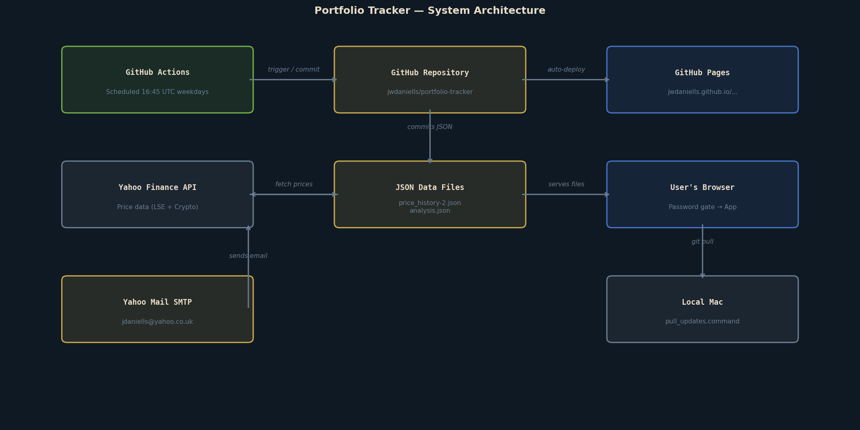
Figure 1: High-level system architecture showing all components and their relationships.
Hosting & Deployment
- Repository: github.com/jwdaniells/portfolio-tracker (public)
- GitHub Pages URL: https://jwdaniells.github.io/portfolio-tracker/
- Branch: main — all commits to main trigger an automatic Pages rebuild (~1 minute).
- No build pipeline required — files are served as-is (HTML, JSX, JSON).
Technology Stack
LAYER | TECHNOLOGY | DETAILS
Frontend | React 18 (UMD) | No build step — loaded from unpkg CDN
Transpiler | Babel Standalone | JSX-to-JS transform in the browser at runtime
Styling | Inline CSS (JS objects) | Dark theme, no external CSS framework
Charts | SVG (hand-built) | Custom SVG paths, no third-party chart library
Data | JSON files | price_history-2.json, analysis.json, reminders.json
Automation | GitHub Actions | Python 3.11 on Ubuntu, runs on cron schedule
Hosting | GitHub Pages | Served from main branch root directory
Notifications | SMTP / action-send-mail | Yahoo Mail SMTP, credentials in GitHub Secrets
Price source | Yahoo Finance v8 API | Direct HTTP — no yfinance library dependency
Security | SHA-256 password gate | browser crypto.subtle — client-side login screen
3. COMPONENT INVENTORY

All files in the repository and their roles:
FILE / ARTEFACT | TYPE | PURPOSE | NOTES
index.html | HTML | Application entry point. Ships the React CDN imports, password gate logic and JSX loader. | Modified to add SHA-256 auth gate (Mar 2026)
portfolio_tracker_v1.20.jsx | React/JSX | Main single-page application. All tabs: Dashboard, Accounts, Allocation, History, Goal, Analysis, Crypto. | 7 tabs; ~500 lines; no build required
retirement.html | HTML | Separate entry point for the Retirement Planner tool. | Linked from nav bar in main app
retirement_planner.jsx | React/JSX | Retirement income and drawdown planning calculator. | State pension, drawdown, ISA/SIPP modelling
price_history-2.json | JSON | Master data store. Holds all account definitions, holdings, prices, history, crypto, and metadata. | Updated daily by GitHub Actions
analysis.json | JSON | AI-generated portfolio analysis and commentary. Read by the Analysis tab. | Manually updated; non-blocking if absent
reminders.json | JSON | User-defined reminders and notes displayed in the app. | Manually maintained
fetch_prices.py | Python | Price fetching script. Calls Yahoo Finance v8 API for all equity, fund, and crypto tickers. Updates JSON. | Run by GitHub Actions at 16:45 UTC weekdays
.github/workflows/fetch-prices.yml | YAML | GitHub Actions workflow definition. Schedules and orchestrates the fetch, commit, and email steps. | Cron: 45 16 * * 1-5
pull_updates.command | Shell | Double-click script for macOS. Runs git pull to sync latest prices from GitHub to local machine. | Optional — only needed for local viewing
.gitignore | Config | Excludes local-only files from the repository (fetch_analysis.py, *.command etc.) | pull_updates.command IS tracked
4. PROCESS FLOWS

4.1 Daily Automated Price Fetch
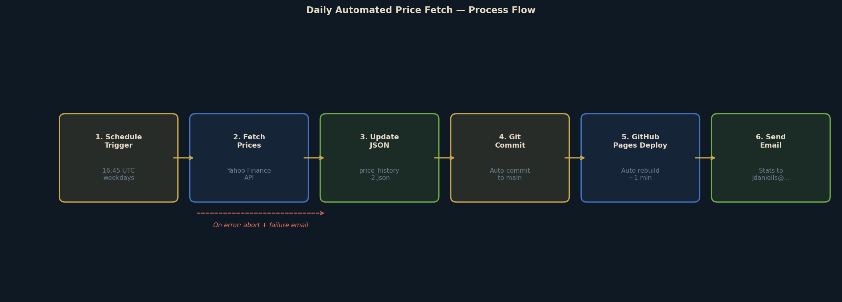
Figure 2: Daily automated price fetch and publish flow.
The cron schedule is: 45 16 * * 1-5 (16:45 UTC, Monday–Friday). This is 15 minutes after the London Stock Exchange closes at 16:30 GMT. In BST (summer, UTC+1) the run time is 17:45 local.
- GitHub Actions checks out the repository on an Ubuntu runner.
- Python 3.11 is installed; requests library installed via pip.
- fetch_prices.py calls the Yahoo Finance v8 chart API for each ticker.
- UK equity and fund prices are returned in pence (GBp) and automatically divided by 100.
- Crypto prices (BTC, ETH, XRP, ADA) are returned directly in GBP.
- If zero prices are fetched, the script aborts — the JSON is never written with corrupt data.
- Updated price_history-2.json is committed back to the repo with message 'Auto-update prices DD Mon YYYY'.
- GitHub Pages automatically rebuilds from the new commit within ~1 minute.
- An email is sent to jdaniells@yahoo.co.uk with per-account stats and a link to the tracker.
- On any failure, a failure alert email is sent instead.
4.2 User Access Flow
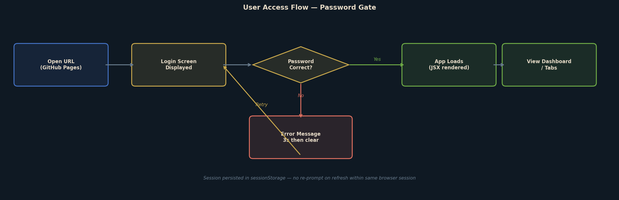
Figure 3: User authentication and application load flow.
The password gate operates entirely client-side:
- The login screen is rendered as plain HTML/CSS — no React/JSX is loaded at this stage.
- The user enters their password; it is hashed in-browser using window.crypto.subtle (SHA-256).
- The hash is compared against a hardcoded hash constant in index.html. The plaintext password is never stored.
- On success, sessionStorage is flagged and the JSX app is fetched, transpiled and mounted.
- Session persists for the duration of the browser tab — refreshing does not require re-entry.
- If the browser tab is closed, the session flag is cleared and the password must be re-entered.
4.3 Data Flow & File Relationships
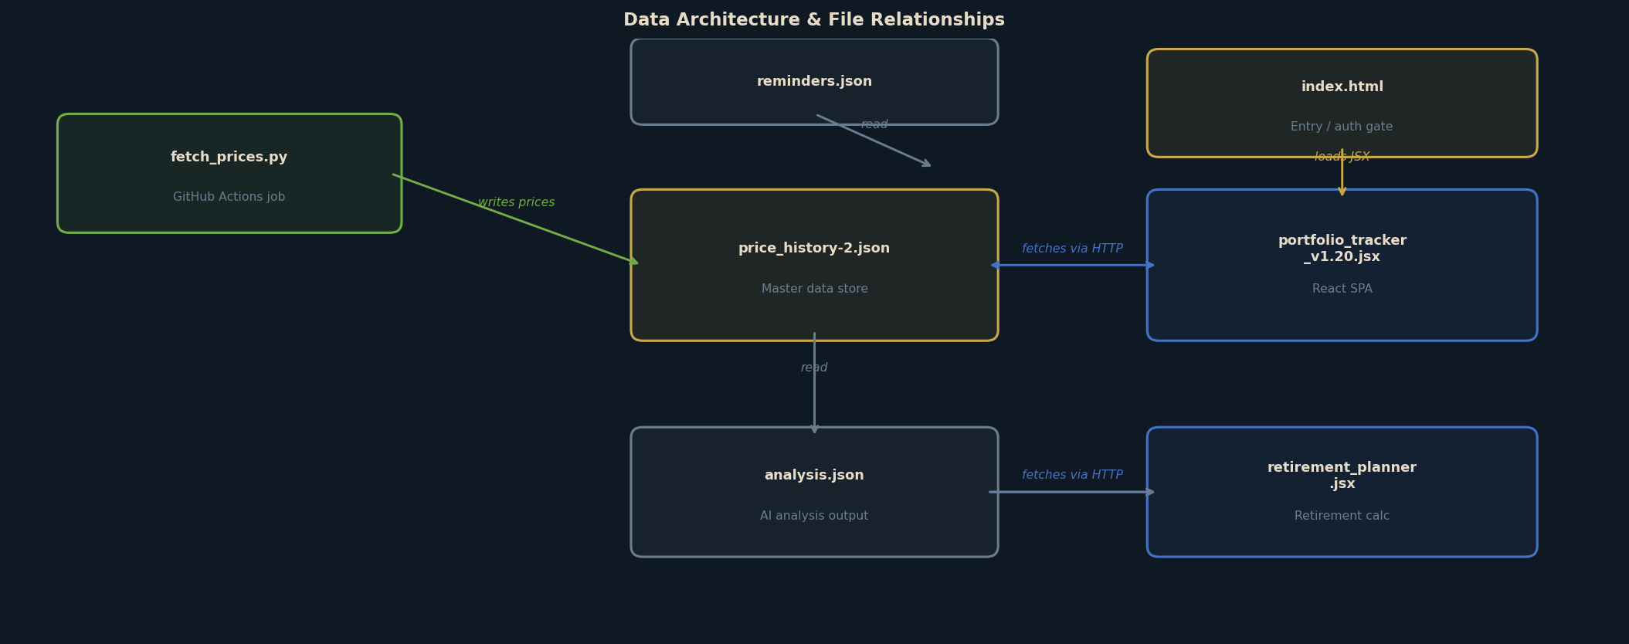
Figure 4: Data architecture and relationships between files.
4.4 Local Sync Flow
When the user wants to view updated prices locally (e.g. via localhost:8765):
- Double-click pull_updates.command in Finder.
- Script runs: git pull in the project directory.
- Latest price_history-2.json is downloaded from GitHub.
- Refresh the local browser to see updated data.
5. DATA ARCHITECTURE

price_history-2.json Structure
This is the master data file. Its top-level structure is:
meta Metadata: version, fetchDate, prevDate, fetchDateDisplay, prevDateDisplay
accounts[] Array of investment accounts. Each contains: id, name, wrapper, provider, holdings[]
holdings[] Per-account holdings: id, ticker, name, units, price, prevPrice, priceDate, costBasis, purchaseDate, bucket, fetchStatus, dividendsReceived
history[] Daily snapshots: date, totalValue, prices{}, notes. One entry per trading day.
crypto[] Cryptocurrency positions: id, name, units, price, prevPrice, priceDate
cryptoHistory[] Daily crypto portfolio total: date, totalValue
Key Data Rules
- prevDate / fetchDate: Only rolled forward when a new trading day is first fetched — prevents 'since last update' showing zero on same-day re-runs.
- History deduplication: If a history entry already exists for today, it is updated in-place (not appended). No duplicate date entries.
- Price currency: Yahoo returns UK securities in pence (GBp/GBX). fetch_prices.py divides by 100 to convert to £.
- Crypto prices: Returned directly in GBP — no conversion needed.
- Abort on empty fetch: If no prices are retrieved, the script exits with code 1 — the JSON is never overwritten with stale/zero prices.
6. SECURITY ARCHITECTURE

Password Protection
- A login screen is displayed before any data or application code is loaded.
- Passwords are hashed using SHA-256 (window.crypto.subtle) — the plaintext never leaves the browser.
- The stored value is a SHA-256 hash in index.html source — not a plaintext password.
- To change the password: echo -n 'newpassword' | shasum -a 256 and replace the hash in index.html.
- Limitation: this is client-side only — a user viewing page source could extract the hash and attempt offline cracking. A strong, unique password is recommended.
GitHub Secrets
- YAHOO_APP_PASSWORD: Yahoo Mail app password for SMTP. Stored as a GitHub repository secret — never in code.
- The GitHub Personal Access Token (PAT) used for pushes is embedded in the git remote URL on the local machine only — it is not committed to the repository.
- Recommendation: rotate the PAT periodically via GitHub Settings → Developer settings → Personal access tokens.
Data Privacy
- The repository is public — source code and JSON data files are visible to anyone with the URL.
- Portfolio values and holdings data are contained in price_history-2.json which is publicly accessible.
- Mitigation: the password gate prevents casual rendering; the public URL is not widely shared.
- For higher privacy, upgrading to GitHub Pro ($4/month) allows private repos with Pages support.
7. APPLICATION — TAB REFERENCE

Dashboard: Main overview. Shows total portfolio value, since-last-update change, cost basis, total gain, annualised return, asset bucket breakdown, fetch status, and a portfolio value history chart.
Accounts: Drill-down into individual accounts. Summary cards per account with value, gain/loss. Click any account to see all holdings with inline price editing capability.
Allocation: Asset allocation view. Shows portfolio breakdown by bucket category (e.g. Global Equity, Core Multi-Asset, High Beta/Blockchain) with percentage bars.
History: Price history table and chart for all recorded date snapshots. Filter by 24H / 1M / 3M / 6M / 1Y / All.
Goal: Retirement goal tracking. Visual projection chart showing Bear / Projected / Bull scenarios toward the £1,400,000 February 2031 goal. Shows estimated dates to reach £1M and full goal. Projection table with value at retirement.
Analysis: Displays AI-generated portfolio commentary loaded from analysis.json. Non-blocking — tab functions without the file.
Crypto: Cryptocurrency portfolio. Shows BTC, ETH, XRP, ADA positions with current GBP value, 24h change, and crypto portfolio history chart.
Retirement Planner: Separate page (retirement.html). Models retirement income scenarios including state pension, drawdown rates, ISA/SIPP balances, and sustainable withdrawal calculations.
8. SUPPORTED INSTRUMENTS & TICKERS

The following instruments are tracked with automated daily price fetches from Yahoo Finance:
TICKER | NAME | YAHOO SYMBOL | TYPE
BCHS | Invesco CoinShares Global Blockchain ETF | BCHS.L | ETF (LSE)
SWDA | iShares Core MSCI World ETF | SWDA.L | ETF (LSE)
BNY | BNY Mellon Multi-Asset Balanced Inst W Acc | 0P0000X2GH.L | Unit Trust
HSBC | HSBC Global Strategy Balanced C Acc | 0P0000WN82.L | Unit Trust
HISL | HSBC Islamic Global Equity Index IC GBP | 0P0001IVNK.L | Unit Trust
LION | Liontrust Sustainable Future Managed 6 Net | 0P0000Y3Y1.L | Unit Trust
PMIT | Premier Miton Diversified Growth D Acc | 0P0001PKIS.L | Unit Trust
VLS80 | Vanguard LifeStrategy 80% Equity A Acc | 0P0000TKZM.L | Unit Trust
RLSE | Royal London Sterling Extra Yield Bond A | 0P000023IY.L | Unit Trust
VGAC | Vanguard FTSE Global All Cap Index GBP Acc | 0P00018XAR.L | Unit Trust
BTC | Bitcoin | BTC-GBP | Cryptocurrency
ETH | Ethereum | ETH-GBP | Cryptocurrency
XRP | XRP | XRP-GBP | Cryptocurrency
ADA | Cardano | ADA-GBP | Cryptocurrency
Note: Unit trusts return prices in pence (GBp) from Yahoo Finance. The fetch script automatically divides by 100 to convert to GBP. ETF prices on .L exchange are also returned in pence.
9. OPERATIONS & MAINTENANCE

Daily Operations (Automated)
No manual intervention is required for daily price updates. The GitHub Actions workflow runs automatically at 16:45 UTC on weekdays.
Manual Tasks
TASK | HOW | FREQUENCY
Update pension value | When running fetch manually: python fetch_prices.py 13500 (pass new value as argument) | Monthly / on statement
Sync local file | Double-click pull_updates.command | After receiving daily email
Change password | echo -n 'newpw' | shasum -a 256 → update PASSWORD_HASH in index.html → git push | As required
Rotate GitHub PAT | GitHub Settings → Personal access tokens → regenerate. Update git remote URL locally. | Annually / on expiry
Add new holding | Edit price_history-2.json — add holding to relevant account, add ticker to YAHOO_SYMBOLS in fetch_prices.py. Git commit + push. | On portfolio change
Update analysis.json | Replace contents with new AI-generated analysis. Git commit + push. | Monthly / as needed
Monitor Actions | Check github.com/jwdaniells/portfolio-tracker/actions for failed runs | If email not received
Trigger manual fetch | GitHub Actions tab → fetch-prices.yml → Run workflow | Ad hoc / testing
Troubleshooting
No email received: Check github.com/.../actions for failed runs. Verify YAHOO_APP_PASSWORD secret is set and Yahoo 'Less secure app access' / app passwords are enabled.
Prices not updating: Check Actions log for fetch errors. Yahoo Finance API occasionally returns empty responses — retry is automatic next day.
Browser shows old data: Hard refresh (Cmd+Shift+R). Cache-busting is built in via ?v=timestamp on JSON URLs.
Password forgotten: Generate a new hash locally and update index.html. Commit and push.
Git push rejected: Run git pull --rebase first (GitHub Actions may have committed new prices since your last pull).
Fetch script error locally: Ensure requests is installed: pip install requests. The script self-installs on GitHub Actions.
10. KEY URLS & REFERENCES

Live Tracker (GitHub Pages): https://jwdaniells.github.io/portfolio-tracker/
GitHub Repository: https://github.com/jwdaniells/portfolio-tracker
GitHub Actions: https://github.com/jwdaniells/portfolio-tracker/actions
GitHub Secrets: https://github.com/jwdaniells/portfolio-tracker/settings/secrets/actions
Yahoo Finance (LSE prices): https://query1.finance.yahoo.com/v8/finance/chart/SWDA.L
Notification Email: jdaniells@yahoo.co.uk

PART 2 — RETIREMENT PLANNER

R1. PURPOSE & OVERVIEW

The Retirement Planner is a standalone financial modelling tool that works alongside the Portfolio Tracker. Its purpose is to project whether the combined investment portfolio will sustain a target retirement income through to age 95, accounting for UK income tax, state pension, defined benefit pensions, PCLS lump sums, mortgage obligations, and inflation.
Key Objectives
- Model year-by-year portfolio drawdown across John's and Elaine's accounts (SIPP, ISA) from retirement in 2031.
- Optimise the SIPP drawdown split between John and Elaine to minimise combined income tax each year.
- Apply UK 2025/26 income tax rules including personal allowance taper above £100k and all three tax bands.
- Model three growth scenarios (Bear 3%, Central 5%, Bull 7% real return) simultaneously.
- Show portfolio exhaustion age — will the money last to 95?
- Calculate PCLS (25% tax-free lump sum) from SIPPs at retirement and model use to clear the mortgage.
- Project inheritance tax (IHT) liability including property value, NRB, RNRB, and taper rules.
- Allow all assumptions to be edited live in the browser with instant recalculation.
R2. ARCHITECTURE & TECHNOLOGY

The Retirement Planner is implemented as a React single-page application, identical in technology to the Portfolio Tracker. It is served from a separate entry point (retirement.html) which dynamically fetches, Babel-transforms and mounts retirement_planner.jsx. The planner reads live portfolio values directly from price_history-2.json so projections always start from current balances.
FILE | ROLE | NOTES
retirement.html | Entry point | Fetches + Babel-transforms the JSX; mounts React app; no password gate
retirement_planner.jsx | Main component | All logic, UI and modelling in a single JSX file (~700 lines)
price_history-2.json | Data source | Live portfolio values loaded on startup to seed projection balances
R3. FINANCIAL PROJECTION MODEL

Pre-Retirement Growth Phase (2026–2031)
Before the retirement year, the model grows each account forward year-by-year applying the selected growth rate plus inflation (nominal return). Monthly contributions of £2,011 are distributed 70% to John's SIPP, 20% to Elaine's SIPP, and 5% each to their ISAs.
Retirement Drawdown Phase (2031 onwards)
- Each year, the model identifies a target net income requirement (base £60,000/year post-mortgage clearing).
- Before the mortgage is cleared (age 67), an additional £19,200/year (£1,600/month) is added to the income target.
- Stepped income reductions apply in later years: -10% from age 75, -15% from age 80, -20% from age 85.
- Guaranteed income (DB pensions, State Pension, LSEG pension) is deducted from the target before any portfolio draw.
- An optimisation loop (1% SIPP split increments) finds the exact John/Elaine SIPP draw split that minimises total tax.
- ISA withdrawals are used only after SIPP capacity is exhausted — ISA income is tax-free.
- Remaining balances grow at the nominal rate each year after drawdown.
- The model runs year-by-year until John reaches age 95 or the portfolio is exhausted.
PCLS (Pension Commencement Lump Sum)
- At retirement (John age 63, 2031), 25% of both SIPPs is taken as tax-free PCLS.
- The combined PCLS is used to clear the outstanding mortgage balance (modelled at £250,000 at retirement).
- After PCLS is taken, the remaining SIPP balances continue to grow and be drawn for income.
- The mortgage cost (£1,600/month) is removed from the income target from the year of clearance onwards.
Income Sources Modelled
SOURCE | OWNER | ANNUAL AMOUNT / NOTES
State Pension | John | £11,502/year from age 67 (2025/26 full new state pension)
State Pension | Elaine | £11,502/year from age 67
Atkins DB Pension | John | £5,000/year from age 65 — not inflation-indexed
Pfizer DB Pension | John | £2,500/year from age 65 — not inflation-indexed
Disney DB Pension | Elaine | £1,237/year from age 65 — not inflation-indexed
Nippon Life Pension | Elaine | £135/year from age 65 — not inflation-indexed
LSEG DC Pension | John | Modelled as 5% annuity equivalent from retirement value
John SIPP drawdown | John | Tax-assessed at marginal rate; optimised split with Elaine
Elaine SIPP drawdown | Elaine | Tax-assessed at marginal rate; receives portion of combined draw
ISA withdrawals | Both | Tax-free; drawn after SIPP capacity used; split proportionally
R4. UK TAX ENGINE

The planner contains a built-in UK income tax engine using 2025/26 rates with frozen thresholds. It is applied independently to John and Elaine to calculate their net income after tax each year.
- Personal Allowance: £12,570 (tapered by £1 for every £2 of income above £100,000)
- Basic rate: 20% on income between Personal Allowance and £50,270.
- Higher rate: 40% on income between £50,271 and £125,140.
- Additional rate: 45% on income above £125,140.
- ISA withdrawals are excluded from the tax calculation entirely.
- The optimiser minimises combined tax by adjusting the relative SIPP draw between John and Elaine.
- A binary-search algorithm iterates to find the exact gross draw that meets the target net income.
Example: if John has £30,000 of guaranteed income, his SIPP drawdown is limited to £20,270 before hitting the higher-rate band. Excess is then drawn from Elaine's SIPP or the ISA to minimise total tax.
R5. INHERITANCE TAX PROJECTION

A separate IHT tab projects the potential inheritance tax liability on the combined estate (investment portfolio + property) across the three growth scenarios, year by year until John's age 95.
- Property value projected at 3% nominal growth per year from current £1.2M.
- Remaining mortgage (currently ~£350,000) reduces estate value until cleared.
- Nil-Rate Band (NRB): £325,000 per person — £650,000 combined.
- Residence Nil-Rate Band (RNRB): £175,000 per person — £350,000 combined — for direct descendant inheritance.
- RNRB tapers by £1 per £2 of estate value above £2,000,000.
- IHT is charged at 40% on estate value above the combined threshold.
- SIPPs are assumed to remain outside the estate (pre-2027 rules — legislation may change).
- ISAs are included in the taxable estate.
R6. APPLICATION SECTIONS

The planner is divided into five sections accessible via a tab bar:
Overview: Summary dashboard. Shows total portfolio at retirement (Bear/Central/Bull), estimated exhaustion age across scenarios, portfolio value at key ages (80, 90), and the year the portfolio is projected to run out (if applicable). A colour-coded chart shows portfolio trajectories across all three scenarios.
Year by Year: Detailed annual projection table. Columns: Year, Ages, Income Target, Guaranteed Income, Portfolio Draw, Tax Paid, Net Income, Total Portfolio, per-account balances. Scrollable; highlights exhaustion year in red.
Income Analysis: Breakdown of income sources for each year: DB pensions by name, State Pension, SIPP drawdown (John/Elaine), ISA draw, and total tax. Useful for understanding tax efficiency over time.
IHT Planner: Inheritance tax projection showing estate value (portfolio + property − mortgage), combined NRB/RNRB, taxable amount, and estimated IHT bill across all three scenarios.
Assumptions: Editable form for all model inputs. Changes apply immediately — no save/submit required. Includes: portfolio values (auto-loaded from price_history-2.json), contribution amounts and split, growth rate scenarios, target income, DB pension details, state pension ages, income step-down ages, mortgage details, PCLS options, and IHT property assumptions.
R7. DEFAULT ASSUMPTIONS

All values are editable in the Assumptions tab. The initial defaults are:
ASSUMPTION | DEFAULT VALUE | NOTES
Retirement year | 2031 | March 2031, John age 63
Target net income | £60,000/year | Post-mortgage, post-tax, in today's money
Monthly contributions | £2,011 | Combined; 70% John SIPP / 20% Elaine SIPP / 10% ISAs
Growth — Bear | 3% real | After inflation
Growth — Central | 5% real | After inflation (default view)
Growth — Bull | 7% real | After inflation
Inflation rate | 2.5% | Used to convert real to nominal returns
Longevity | Age 95 | John's plan-to age
State pension | £11,502/year | Full new state pension (2025/26); from age 67
Mortgage balance | £250,000 | At retirement; cleared via PCLS
Mortgage cost | £1,600/month | Added to income target until cleared
House value (IHT) | £1,200,000 | Current market value; grown at 3%/year
PCLS use | Clear mortgage | 25% tax-free lump from both SIPPs applied to mortgage
Income step-down age 75 | -10% | Reflects lower activity and travel spend
Income step-down age 80 | -15% | More home-based lifestyle
Income step-down age 85 | -20% | Lower discretionary spend
R8. LIMITATIONS & CAVEATS

- Tax rules are based on 2025/26 UK rates with frozen thresholds — future governments may change these significantly.
- SIPP legislation is changing: from April 2027 SIPPs will be included in the taxable estate for IHT purposes. The model does not yet reflect this change.
- Growth rates are assumed constant per year — actual returns will be volatile.
- Inflation is modelled as a flat 2.5% — actual inflation will vary.
- DB pension amounts are held constant (not inflation-linked) — some schemes may provide inflation uplift.
- The model does not currently account for annuity purchase, care home costs, or inter-vivos gifting strategies.
- Property value projections are illustrative — regional and market variations apply.
- This tool is for personal planning purposes only and does not constitute regulated financial advice.

Daniells Portfolio & Retirement Tracker — System Documentation v1.20 — 6 March 2026 — Personal & Confidential

