**LIDAR Technologies and Systems June 6-10 Univ. of Dayton**

**Instructors**:

Paul McManamon, paul@excitingtechnology.com

Edward Watson, edward.watson@vao-llc.com

**Target Audience**: engineers, scientists, managers of EO Sensor systems development.



|  |  |  |  |  |  |
| --- | --- | --- | --- | --- | --- |
| **June 6-10** | | | | | |
| **Mon** | **Tues** | **Wed** | **Thurs** | **Fri** |
|  | 9am-12pm | 9am-12pm | 9am-12pm | 9am-12pm |
| 1-4pm | 1-4pm | 1-4pm | 1-4pm |  |

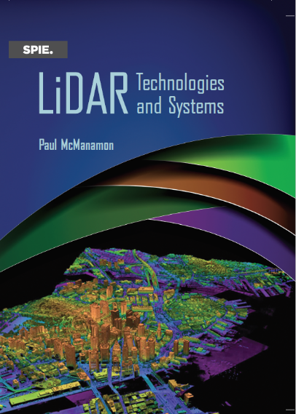

**Venue:** Live Lectures via Zoom or On-site option

Fitz Hall 5th floor, 1519 Brown Street, Dayton, Ohio 45469

**Course Outline:**

Introduction

History of Lidar

Types of Lidar

Atmospheric effects on Lidar

Lidar Range Equation, signal-to-noise ratio, and basic detection theory

Laser sources for Lidar

Lidar Receiver hardware

Beam Steering for Lidar

Lidar Processing

Testing of Lidars, and Lidar Performance Metrics

Lidar Application Design Examples

**Design Exercise – Design a lidar**

**Books:** Textbook: *Lidar Technology and Systems*, by Paul McManamon

Additional Material: *Field Guide to Lidar*, by Paul McManamon

**Course information:**

2022 summer 1st session; EOP 595-62 (Special Problems) Introduction to LIDAR (CRN 3880),

Register for 1 academic credit hour or 2.4 CEUs (continuing education units) professional development. The first 28 people signing up for online participation will be assured a spot in the course. Once the in person registrations are complete more online participation may be allowed.

