**LIDAR Technologies and Systems June 3-7 2024 Univ. of Dayton**

**Instructors**:

Paul McManamon, paul@excitingtechnology.com

Edward Watson, edward.watson@vao-llc.com

**Books**

Textbook: *Lidar Technology and Systems*, by Paul McManamon

Additional Material: *Field Guide to Lidar*, by Paul McManamon

**Target Audience**: engineers, scientists, managers of EO Sensor systems development.

**Venue: Classes will be held in-person, but live participation via zoom is also available. Location: 5th floor of Fitz Hall, 1519 Brown Street, Dayton, Ohio 45469**

**Schedule**:

|  |  |  |  |  |  |
| --- | --- | --- | --- | --- | --- |
|  | **Mon 6/3/24** | **Tue 6/4/24** | **Wed 6/5/24** | **Thu 6/6/24** | **Fri 6/7/24** |
| **9am-12pm** |  |  |  |  |  |
| **1pm-4pm** |  |  |  |  |  |

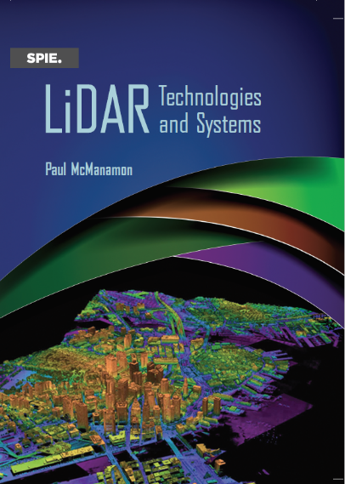

**Course Outline**

Introduction

History of Lidar

Types of Lidar

Atmospheric effects on Lidar

Lidar Range Equation, signal-to-noise ratio, and basic detection theory

Laser sources for Lidar

Lidar Receiver hardware

Beam Steering for Lidar

Lidar Processing

Testing of Lidars, and Lidar Performance Metrics

Lidar Application Design Examples

**Design Exercise – Design a lidar**

Cost will be $1055. per person. Five or more people registering from the same organization will receive a 20% bulk discount.

2024 summer: one graduate academic credit or 2.2 CEUs. Everyone registering either way, please start by calling or emailing Bryan Kyle (937) 229-2797 or email bkyle2@udayton.edu