Objective: To learn about the Digilent Logic Analyzer

Prelab: For the prelab, I rewrote the previous code for Lab 1 to have the two pins toggle at 20 and 10
milliseconds.

Part 1) For part one, I uploaded the code from the prelab to the Arduino. Then, I connected the wires
and selected the appropriate lines by clicking the green “+” in the Waveform interface. I then
ran the program and watched as the pins toggled between HIGH & LOW on different intervals.
Figure 1 displays a screenshot of my work.

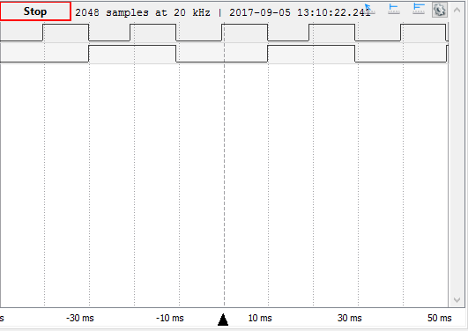
Figure 1: Here we can see the pins toggling between HIGH and LOW separately at different
time intervals. The top wave toggles every 10ms, while the bottom wave toggles
every 20ms.

Finally, the lab instructor verified this as to be the correct output and analysis.

Part 2) In the second portion of the lab, I altered the program from part 1 such that the 10ms pin would
toggle from HIGH to LOW every time the loop ran using the digitalWrite function to set the pin
low and then high. Figure 2 on the following page is a screenshot of the result in the Waveform application.
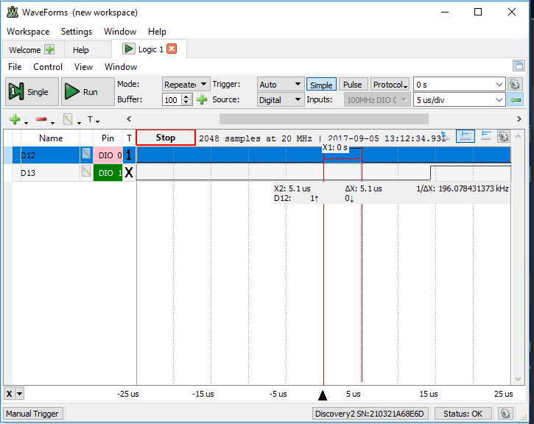
Figure 2: Here we see a zoomed in representation of the pins toggling between high and low. We can
see from this that the distance between pin 12’s toggling (5.1us) was much quicker than
before. If expanded, this would look similar to the example photo given in the Lab description
with the only changes being that the pins are reversed in my code. So the quick toggling pin is
on top instead of bottom.

Part 3) Finally, the third portion of the lab was a repeat of the second portion with a few minor changes.
The code was basically the same, but I accessed the pin directly by using the variable “PORTB”.
This quickened the response time because instead of having to call a function, the computer
could directly access the pin that was being used. Figure 3 is a screenshot of my results.

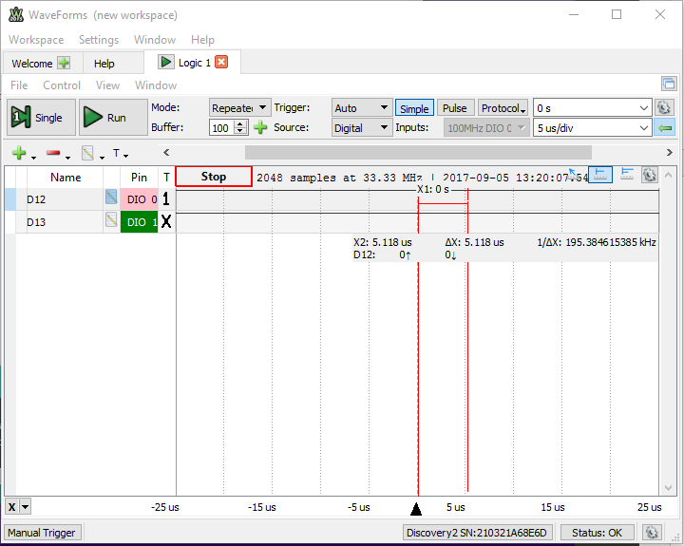
Figure 3: Here we see that the measurement is more accurate counting to the thousandths decimal
place.

Appendix A: Code for Part 1

unsigned long LedTimerTen;
unsigned long LedTimerTwenty;

void setup()
{
pinMode( 12, OUTPUT );
LedTimerTen = millis();
pinMode( 13, OUTPUT );
LedTimerTwenty = millis();
}

//Continually runs the script inside; Bulk of the program
void loop()
{
//Checks if the difference between millis() & LedTimerTen is 10 or greater.
if ( millis() - LedTimerTen >= 10 )
{

//Checks if pin 12 is equal to HIGH
if ( digitalRead( 12 ) == HIGH )
{
digitalWrite( 12, LOW );
}//end if

//else, set pin 12 to high
else
{
digitalWrite( 12, HIGH );
}//end else

LedTimerTen += 10;
}//end if

//Checks if the difference between millis() & LedTimerTwenty is 10 or greater.
if ( millis() - LedTimerTwenty >= 20 )
{
//Checks if pin 13 is set equal to HIGH
if ( digitalRead( 13 ) == HIGH )
{
digitalWrite( 13, LOW );
}//end if

//Otherwise, sets pin 13 to HIGH
else
{
digitalWrite( 13, HIGH );
}//end else

LedTimerTwenty += 20;
}//end if
}//end void loop

Appendix B: Code for Part 2

unsigned long LedTimerTen;
unsigned long LedTimerTwenty;

void setup()
{
pinMode( 12, OUTPUT );
LedTimerTen = millis();
pinMode( 13, OUTPUT );
LedTimerTwenty = millis();
}

//Continually runs the script inside; Bulk of the program
void loop()
{
//Checks if the difference between millis() & LedTimerTwenty is 20 or greater.
if ( millis() - LedTimerTwenty >= 20 )
{
//Accesses pin 12 through the “digitalWrite” function
digitalWrite( 12, HIGH );
digitalWrite( 12, LOW );

//Checks if pin 13 is set to HIGH
if ( digitalRead( 13 ) == HIGH )
{
digitalWrite( 13, LOW );
}//end if

//Otherwise, pin 13 is set to HIGH
else
{
digitalWrite( 13, HIGH );
}//end else

LedTimerTwenty += 20;
}//end if
}//end void loop

Appendix C: Code for Part 3

unsigned long LedTimerTen;
unsigned long LedTimerTwenty;

void setup()
{
pinMode( 12, OUTPUT );
LedTimerTen = millis();
pinMode( 13, OUTPUT );
LedTimerTwenty = millis();
}

//Continually runs the script inside; Bulk of the program
void loop()
{
//Checks if the difference between millis() & LedTimerTwenty is 20 or greater
if ( millis() - LedTimerTwenty >= 20 )
{
//Directly accesses pin 12 through the variable PORTB
PORTB &= ~0x10;
PORTB != 0x10;

//Checks if pin 13 is set to HIGH
if ( digitalRead( 13 ) == HIGH )
{
digitalWrite( 13, LOW );
}//end if

//Otherwise, pin 13 is set to HIGH
else
{
digitalWrite( 13, HIGH );
}//end else

LedTimerTwenty += 20;
}//end if
}//end void loop

