Objective: Understanding ASCII characters and sending data over a serial port.
Prelab: For the prelab, I wrote code that set up the bits per second (baud) to 9600.

- I had to alter the program I wrote for the prelab quite a bit to get it to function correctly. I also enabled a reset option within the code. This was checked off and verified by Charles. This code may be viewed in Appendix A.
- In the second step of the lab, I altered the program to send out the letter ‘Z’ every 500 milliseconds. I then used the logic analyzer to observe the amount of time it took to send the 9-bits it takes to create the ASCII ‘Z’. A screen shot of the logic analyzer is listed in Figure 1.

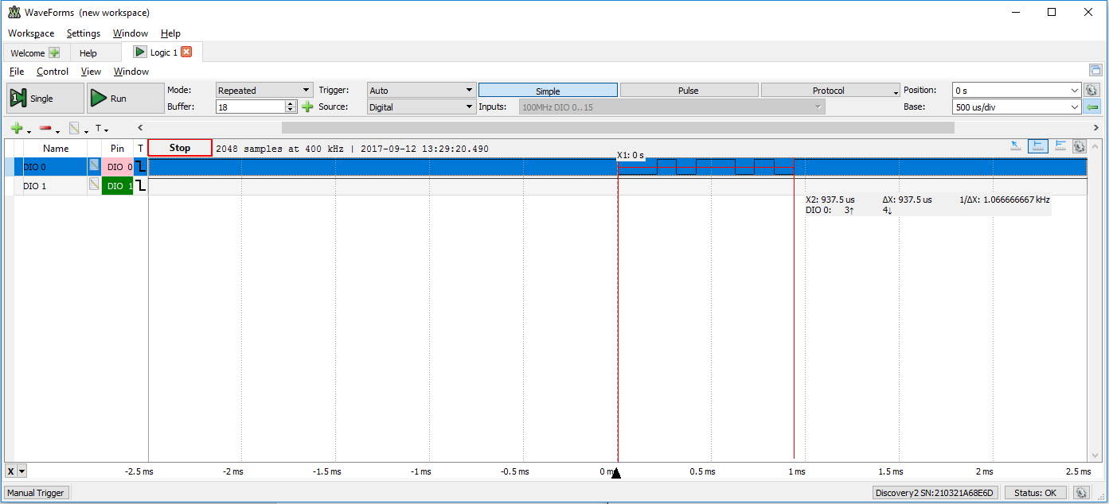
Figure 1: Here we can see the interval in which the 9 bits which comprise ‘Z’ are sent and received.

Questions
- How accurately does the measured bit time match the programmed bit time? Compute the absolute Relative Error.
  - Err = |(T_{M} – T_{P})|/T_{P}
  - T_{M} = 937.5 µs; T_{P} = 500ms
    - |.9375 – 500|/500 = 99% relative error

Appendix A
unsigned long Timer; //int time to keep track of the time
int numb = 0; // creating an int name "incomingByte"
char Letter = 'A'; //this is the letter we will use for our conditional statements

//Setups the variables and functions used
void setup()
{
Serial.begin(9600); // Sets and begins the baud rate to 9600
Timer = millis();
}//end setup

//Loops the main bulk of the code
void loop()
{
if ( millis() - Timer >= 500 )
{
if (Serial.available() > 0)
{
if (Serial.read() == 'R')
{
Letter = 'A';
numb = 0;
}
}//end if

Timer += 500; //appends timer to 500
Serial.print(Letter); //Pushing the char Letter into Serial.write
Serial.println(numb); //Printing the Incoming Byte via Serial.print

//checks to see of the ASCII char Letter is Less than ‘A’
if ( Letter < 'Z' )
{
Letter ++; //if true, iterates char Letter
}
else
{
Letter = 'A';//else sets letter to A
}

//checks if incomingByte is less than 9
if ( numb < 9 )
{
numb ++; //if true, iterates incomingByte
}
else
{
numb = 0;
}
}//end if
}//end loop

Appendix B
unsigned long Timer; //int time to keep track of the time
char Letter = 'Z'; //this is the letter we will use for our conditional statements

//Setups the variables and functions used
void setup()
{
Serial.begin(9600); // Sets and begins the baud rate to 9600
Timer = millis(); // Sets timer equal to the millis() property
}//end setup

//Loops the main bulk of the code
void loop()
{
//if the difference between millis and timer is >= 500, print ‘Z’ and append Timer
if ( millis() - Timer >= 500 )
{
Serial.print(Letter);
Timer += 500;
}//end if
}//end loop

