Objective
- Using timing to consistently read a switch button
Parts
- The program described in the prelab was uploaded into the Arduino. I demonstrated that the message was sent only when the button was pressed.
- Using the Analog Discovery 2, I captured the interval of the debounce operation on LED pin 13.
Questions
- The time I observed on pin 13 was 5.05 ms. This is shown in Figure 1
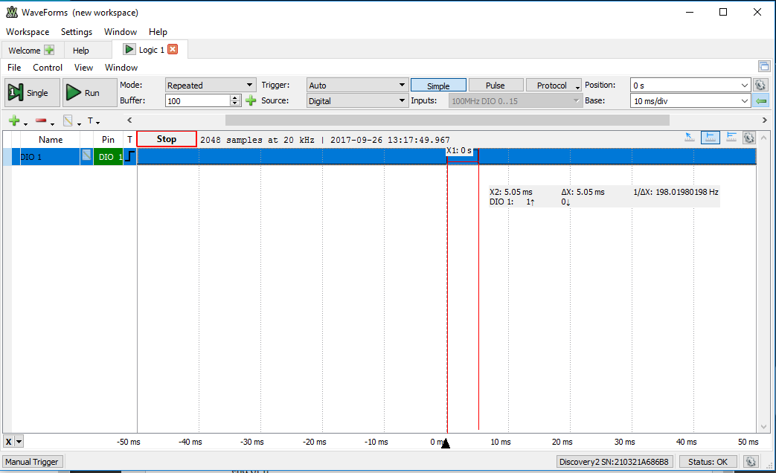
Figure 1: Shown is the interval of the debounce operation measured using the Analog Discovery 2.

Appendix A
int state; //the state of the button
unsigned long Time; //Time to debounce switch
int input; //variable input

enum Button //Initializes an enumerator Button w/idle, wait, low
{
Idle, //enum variable Idle
Wait, //enum variable Wait
Low //enum variable Low
};

Button ButtonState;
int ButtonNextState(int input) //function that is to be called in loop
{
switch (ButtonState)
{
case Idle: //State where nothing is happening
{
if (input == LOW) //If button is LOW
{
Time = millis(); //Record time of high to low transition
ButtonState = Wait; //Move to Wait
digitalWrite(13, HIGH); //Turns the LED on
}
break;
}//end Idle

case Wait: // When Button LOW; Wait for 5 millis
{
if (input == HIGH) //If button is HIGH
{
ButtonState = Idle; //Sets the buttonstate to idle
}
else if (millis() - Time >= 5)//If 5 millis has passed
{
ButtonState = Low; //Setting button state to LOW
digitalWrite(13, LOW); //Turns LED off
return 1; //The button has been pressed
}
break; //Breaks out of the switch case
}//end Wait

case Low: //Sets Button to LOW
{
if (input == HIGH) //checks if the input is set to HIGH
{
ButtonState = Idle; //Sets the buttonstate to idle
}
break; //Breaks out of the switch case
}//end Low
}//end switch-case
return 0;
}//end ButtonNextState
void setup() //sets the declared variables to values
{
pinMode(4, INPUT); //sets pin4 to accept input
Button ButtonState = Idle; //sets buttonstate idle
Serial.begin(9600); //Sets the baud rate to 9600
}

void loop() //the main bulk of code is repeated
{
state = ButtonNextState(digitalRead(4)); //Calls function continually
if (state) //If state is true,
{
Serial.println("Button has been pressed");//Display the button has been pressed
}
}
Appendix B
int state; //the state of the button
unsigned long Time; //Time to debounce switch
int input;//variable input

enum Button //Initializes an enumerator Button w/idle, wait, low
{
Idle, //enum variable Idle
Wait, //enum variable Wait
Low //enum variable Low
};

Button ButtonState; //Variable buttonstate button
int ButtonNextState(int input) //function that is to be called in loop
{
switch (ButtonState) //Switchcase
{
case Idle: //State where nothing is happening
if (input == LOW) //If button is LOW
{
Time = millis(); //Record time of high to low transition
ButtonState = Wait; //Move to Wait
digitalWrite(13, HIGH); //Turns the LED on
}
break; //breaks out of the switch case

case Wait: // When Button LOW; Wait for 5 millis
if (input == HIGH) //If button is HIGH
{
ButtonState = Idle; //Sets buttonstate to idle
}
else if (millis() - Time >= 5) //If 5 millis has passed
{
ButtonState = Low; //Setting button state to LOW
digitalWrite(13, LOW); //Turns LED off
return 1; //The button has been pressed
}
break; //breaks out of the switch case

case Low: //Sets Button to LOW
if (input == HIGH) //checks if the input is HIGH
{
ButtonState = Idle; //Sets buttonstate to idle
}
break; //breaks out of the switch case

}//end switch-case
return 0; //returns zero outside of the switch
}//end ButtonNextState
void setup() //initializes the variables to values
{
pinMode(13, OUTPUT); //activates pin 13 to receive output
pinMode(4, INPUT); //activates pin 4 to accept input
Button ButtonState = Idle; //initializes button buttonstate to idle
Serial.begin(9600); //sets baud rate to 9600
}

void loop() //main bulk of code continually runs
{
state = ButtonNextState(digitalRead(4)); //Calls function continually
if (state) //If the state is true
{
Serial.println("Button has been pressed"); //Print the button has been pressed
}
}

