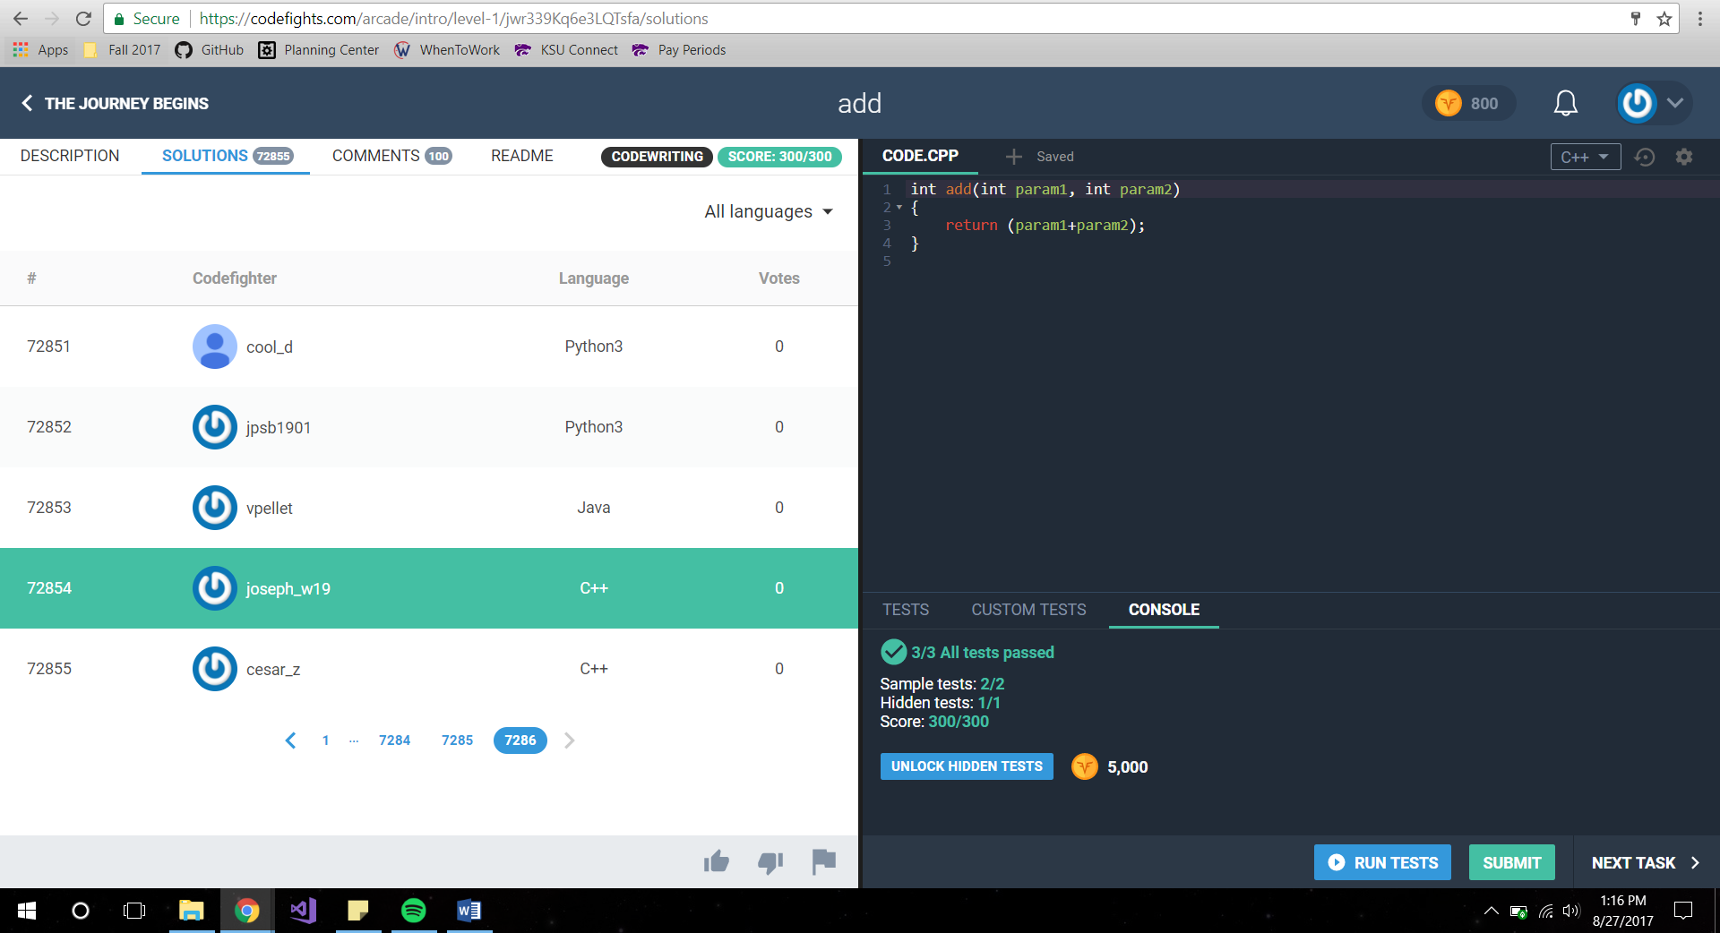

Here are my finished tests from codefights!

* Joe Webster

The first is the top one, the second is the one on the second page!

