**Extrapolating quantum observables with machine learning: Inferring multiple phase transitions from properties of a single phase – Sous Paper**

Abstract

* Machine learning method to predict sharp transitions in a Hamiltonian phase diagram by extrapolating the property of quantum systems
* Used Gaussian Process regression and iterative kernel to maximize kernel’s predicting power
* Capable of extrapolating across transition lines, but also can predict transitions removed from available data
* Method is valuable for searching for phase transitions in space that can not be probed experimentally or theoretically

Introduction

* Wave function of quantum systems are drastically different so extrapolating quantum properties is generally an infeasible problem
  + Sharp transitions separate the different phases of a Hamiltonian
* However, despite these sharp transitions, there other quantum properties that evolve smoothly
  + The evolution of these properties provides insight into the transitions and information about the transition beyond the phase
  + This paper presents a machine-learning method that is trained on the evolution of such smoothly functioning properties to predict where sharp transitions occur
* Characterizing quantum phase transitions is an important problem in quantum condensed-matter physics, and this method would be able to predict / solve for transitions where originally solving the Schrodinger equation was unable to
* In previous works, the ML method required information of the phase on both sides of the transition line; this work can use the information of one phase and extrapolate the property to and across transitions
* To demonstrate, four different problems are tested: lattice polaron model with 0, 1, 2 sharp transitions + mean-field Heisenberg model with a critical temperature

Method

* First, an equation is provided for the lattice polaron model and the conditions for 0, 1, 2, sharp transitions are listed
  + 2 sharp transitions: alpha / beta goes from 0 to large values
  + 0 sharp transition: alpha = 0, aka breathing mode polarons
  + 1 sharp transition: beta = 0, aka SSH polarons
* Gaussian Process (GP) regression is used as the predictive method, TODO: more information of how of GP regression in supplementary material [40]
  + For interpolation: use the simple form for the kernel, any simple kernel will produce accurate results
  + For extrapolation: prediction is sensitive to different kernels, so we need to find the appropriate kernel function TODO: read more about building prediction method following references 47, 48
    - Sidenote: since we want this method to generalize to various physics problems (not just the four mentioned in the paper), we need a way to automate the kernel construction process
    - To select the best combination use Bayesian information criterion (BIC) and the iterative algorithm they described
      * At each iteration you choose a combination of kernels, construct a new GP model, calculate the kernel that yields the highest BIC, use that as the base kernel and then iterate the procedure

**Todo**

* Helper Functions
  + Calculate the Bayesian Information Criterion (BIC)
  + Kernel iterative algorithm
* Figure 4

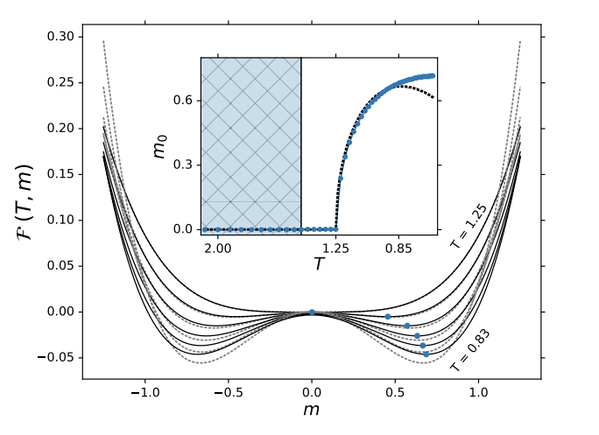

* + First take the equation for the mean-field description and set T_c = 1.25 and plot for certain Ts as shown in the diagram i.e. 0.83, 1.25 etc. the curve is then generated for each T by varying m, the magnetization
  + Generate the data necessary for training in the paramagnetic phase far away from T_c using f(T, m)
  + Extrapolate the function f(T, m) using the iterative kernel method across the critical temperature
  + Compute order parameter m_0 which minimizes f(T, m); what we should see if that there is a sudden spike at T_c