**Analyzing Employee Satisfaction and Job Attrition**

Joshua Wei

Colorado State University Global

MIS581: Business Intelligence and Data Analytics

Dr. Justin Bateh

10/06/2024

**Link to video presentation:** <https://youtu.be/ynP6s2xm0Tw>

**Link to GitHub account:** <https://github.com/jweicsu/MIS581-Portfolio-Project>

**Programming code:**

# Importing necessary libraries

import pandas as pd

import matplotlib.pyplot as plt

import seaborn as sns

import numpy as np

from sklearn.linear_model import LogisticRegression

from sklearn.model_selection import train_test_split

from sklearn.preprocessing import StandardScaler

from sklearn.metrics import confusion_matrix, accuracy_score, roc_curve, auc

import statsmodels.api as sm

from scipy import stats

# Load the dataset (assuming it’s in CSV format)

df = pd.read_csv('HR_Employee_Attrition.csv')

# Convert categorical variables to numerical (if not already done)

df['Attrition'] = df['Attrition'].map({'Yes': 1, 'No': 0})

# For simplicity, focus on a few variables, including Job Satisfaction, Monthly Income, Work-Life Balance

df['JobSatisfaction'] = pd.to_numeric(df['JobSatisfaction'])

df['WorkLifeBalance'] = pd.to_numeric(df['WorkLifeBalance'])

df['MonthlyIncome'] = pd.to_numeric(df['MonthlyIncome'])

# Drop any missing values

df = df.dropna()

# Feature selection and scaling

X = df[['JobSatisfaction']] # You can include other factors like 'MonthlyIncome' or 'WorkLifeBalance'

y = df['Attrition']

# Split the dataset into train and test sets

X_train, X_test, y_train, y_test = train_test_split(X, y, test_size=0.3, random_state=42)

# Scaling the data

scaler = StandardScaler()

X_train_scaled = scaler.fit_transform(X_train)

X_test_scaled = scaler.transform(X_test)

# Logistic Regression Model

log_model = LogisticRegression()

log_model.fit(X_train_scaled, y_train)

# Predict probabilities for test data

y_prob = log_model.predict_proba(X_test_scaled)[:,1]

# Generate plot for logistic regression

plt.figure(figsize=(10, 6))

plt.scatter(X_test, y_test, color='blue', label='Actual Data')

plt.plot(X_test, y_prob, color='red', label='Predicted Probability', linewidth=2)

plt.xlabel('Job Satisfaction')

plt.ylabel('Attrition Probability')

plt.title('Logistic Regression of Job Satisfaction and Attrition')

plt.legend()

plt.grid(True)

plt.show()

# Select relevant features for correlation matrix

correlation_data = df[['Attrition', 'JobSatisfaction', 'WorkLifeBalance', 'MonthlyIncome']]

# Calculate the correlation matrix

corr_matrix = correlation_data.corr()

# Plot the correlation matrix using seaborn

plt.figure(figsize=(8, 6))

sns.heatmap(corr_matrix, annot=True, cmap='coolwarm', linewidths=0.5)

plt.title('Correlation Matrix of Key Variables')

plt.show()

# Perform a Chi-Square test between JobSatisfaction and Attrition

contingency_table = pd.crosstab(df['JobSatisfaction'], df['Attrition'])

chi2, p, dof, expected = stats.chi2_contingency(contingency_table)

# Print Chi-Square results

print(f"Chi-Square value: {chi2}")

print(f"P-value: {p}")

# Visualize the Chi-Square test results with a bar plot

contingency_table.plot(kind='bar', stacked=True, figsize=(10, 6))

plt.title('Chi-Square Test of Job Satisfaction and Attrition')

plt.xlabel('Job Satisfaction')

plt.ylabel('Employee Count')

plt.legend(title='Attrition', loc='upper right')

plt.show()

# Get predictions and calculate accuracy

y_pred = log_model.predict(X_test_scaled)

accuracy = accuracy_score(y_test, y_pred)

print(f"Accuracy of Logistic Regression Model: {accuracy}")

# Plot ROC Curve

fpr, tpr, thresholds = roc_curve(y_test, y_prob)

roc_auc = auc(fpr, tpr)

plt.figure(figsize=(8, 6))

plt.plot(fpr, tpr, color='orange', label=f'ROC curve (area = {roc_auc:.2f})')

plt.plot([0, 1], [0, 1], color='darkblue', linestyle='--')

plt.xlabel('False Positive Rate')

plt.ylabel('True Positive Rate')

plt.title('Receiver Operating Characteristic (ROC) Curve')

plt.legend()

plt.show()

**Figure 1**

*Logistic Regression of Job Satisfaction and Attrition*

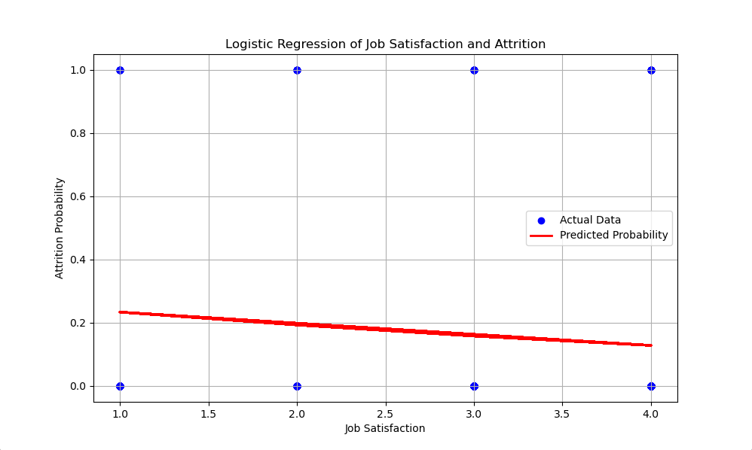

**Table 1**

*Correlation Matrix of Key Variables*

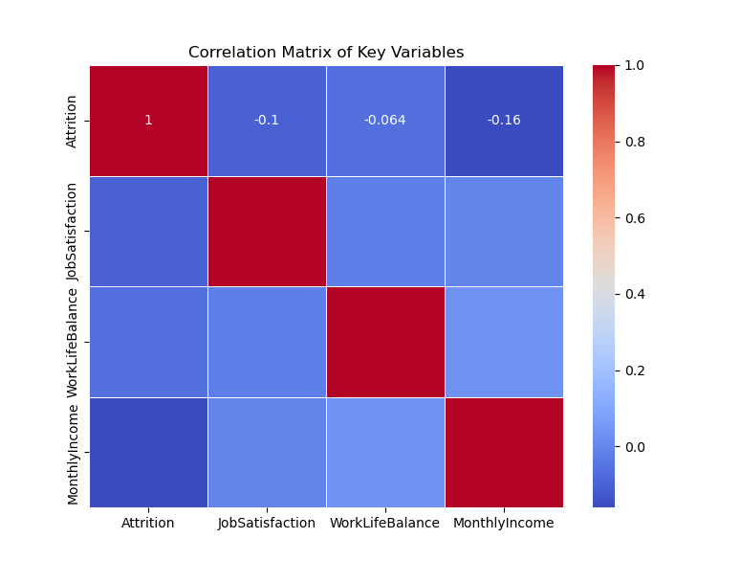

**Figure 2**

*Chi-Square Test of Job Satisfaction and Attrition*

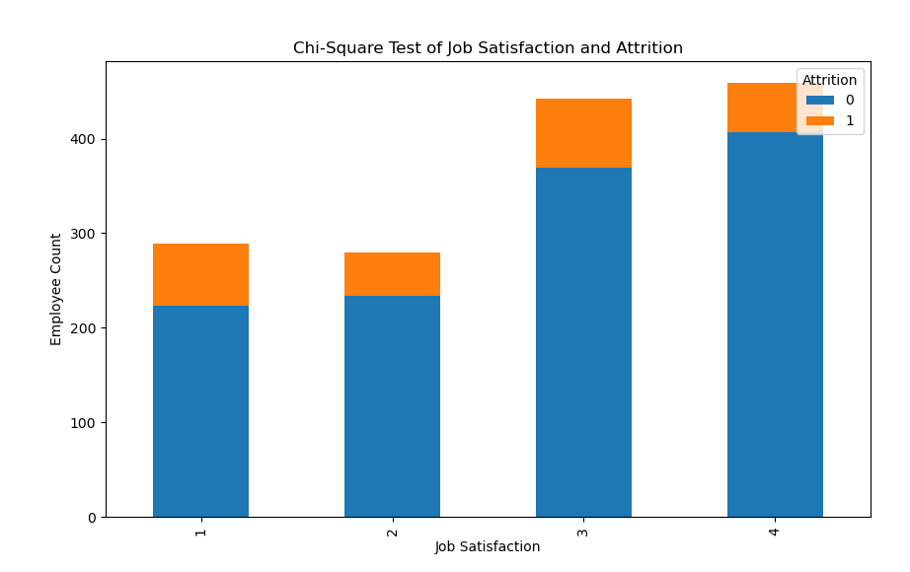

**Figure 3**

*Receiver Operating Characteristic (ROC) Curve for Logistic Regression Model*

