Jack Weissenberger, Homework 3 problem 4.3

This is the code for the first matrix from example 3.7 in the book, all of the other plots were created by changing the input matrix A.

% Jack Weissenberger Homework 3 Problem 4.3

% Given a real 2x2 matrix A, plot the right singular vectors v1 and v2 in

% the unit circle and also the left singular vectors u1 and u2 in the

% appropriate elipse

A = [1 2;

-0 2];

[U, S, V] = svd (A);

S = diag(S);

theta=0:2\*pi/360:2\*pi;

x = cos(theta);

y = sin(theta);

subplot(1,2,1)

plot(x,y)

title('Right Singular Vectors')

hold on

plot([0 V(1,1)], [0 V(2,1)], '-')

plot([0 V(1,2)], [0 V(2,2)], '-')

hold off

unitCirc = [x;y];

elip = A\*unitCirc;

subplot(1,2,2)

plot(elip(1,:) , elip(2,:))

title('Left Singular Vectors')

hold on

plot([0 S(1)\*U(1,1)], [0 S(1)\*U(2,1)], '-')

plot([0 S(2)\*U(1,2)], [0 S(2)\*U(2,2)], '-')

hold off

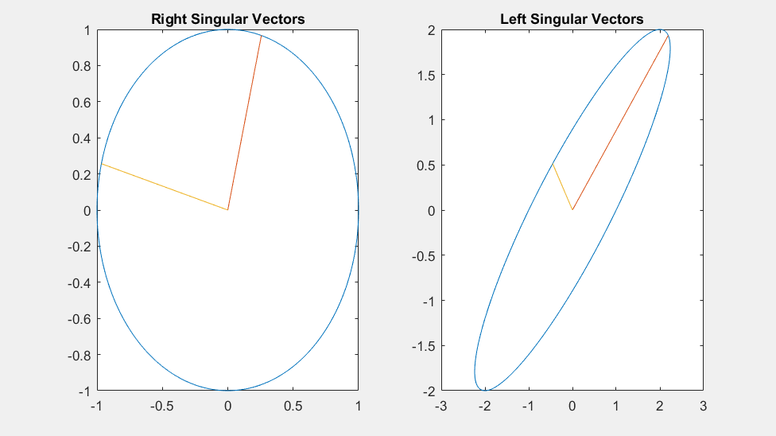

The rest are the from the matrices from 4.1

1. 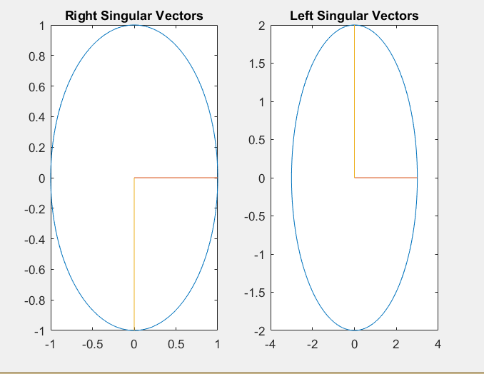
2. 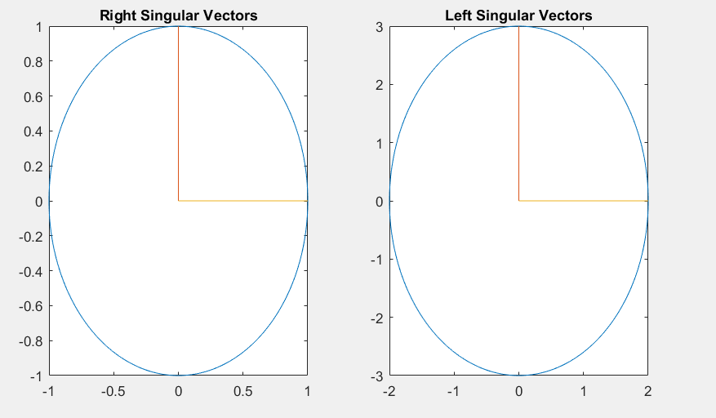
3. 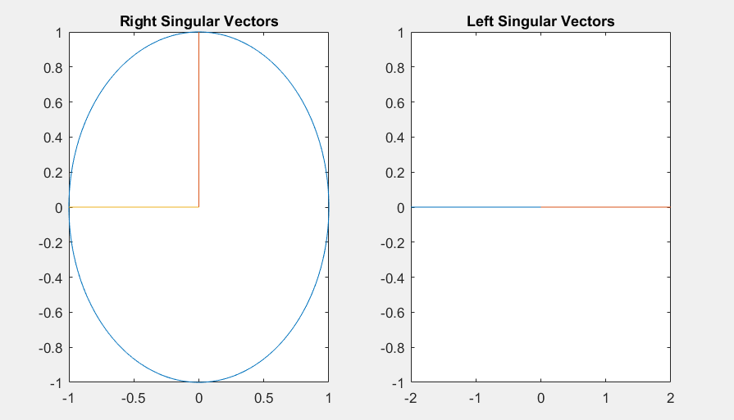
4. 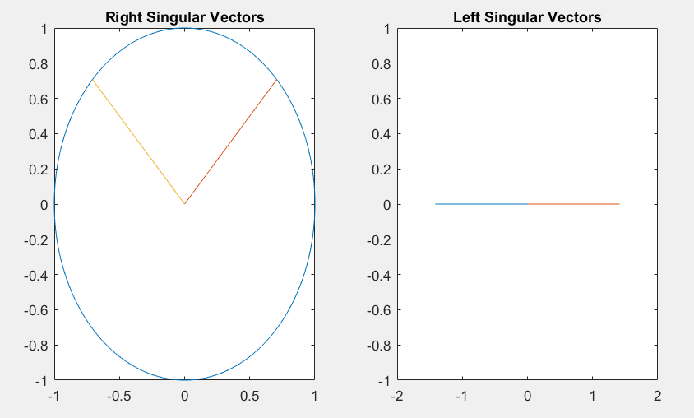
5. 