vector<Mat> input_planes(3);

split(src,input_planes);

The split function divides a three channel image into three single-channel image.

So, imshow( "Original image", src); will display a three-channel image.

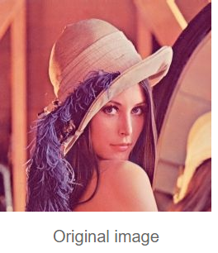

And,

imshow("Red", input_planes[2]);

imshow("Green", input_planes[1]);

imshow("Blue", input_planes[0]);

This three will only display single channel image in Gray(Automated turn into Gray state image). The part or one pixel which is more similar to be “Red/Green/Blue” becomes more “white” displayed in the Gray image.

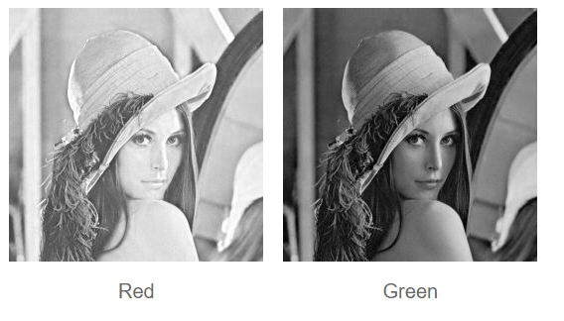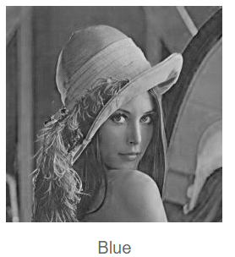

For example, the Red image is more “white” than Blue and Green, because the origin image is inclined to be red.

cvtColor(src, ycrcb_image, CV_BGR2YCrCb);

split(ycrcb_image,input_planes);

imshow("Y", input_planes[0]);

imshow("Cb", input_planes[1]);

imshow("Cr", input_planes[2]);

cvtColor function is transfer color image to other color code image.

CV_BGR2YcrCb is one type of color code.

Y represents lightness, Cb represents the difference between Red channel and Y channel , and Cr represents the difference between Blue channel and Y channel.

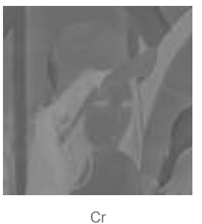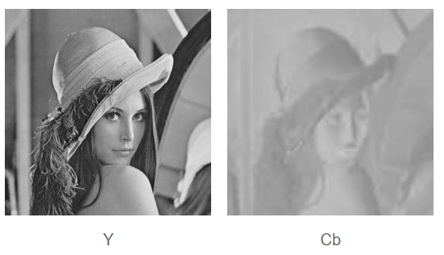

Mat hsv_image;

cvtColor(src, hsv_image, CV_BGR2HSV);

vector<Mat> hsv_planes(3);

split(hsv_image,hsv_planes);

imshow("Hue", hsv_planes[0]);

imshow("Saturation", hsv_planes[1]);

imshow("Value", hsv_planes[2]);

CV_BGR2HSV is a color code object to chrominance.

Hue means types of color. Saturation means the level from non-saturation(gray level) to fully saturation.

Value means relevant color from dark to light.

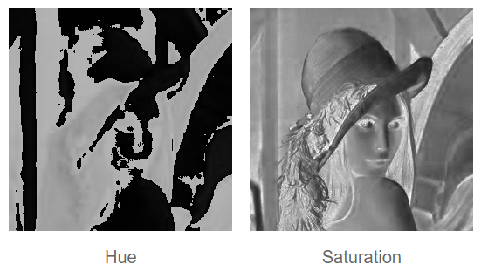

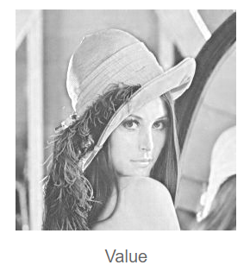

The values of the pixel at (20,25):

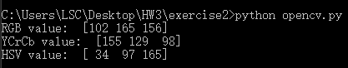

The ranges of pixel values in each channel of each of the above mentioned colorspaces I think is 0-255.