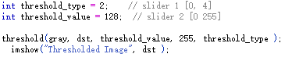

Threshold_Type = 2 = THRESH_TRUNC

THRESH_TRUNC is a threshold method which vary the result in an unique way.

Threshold_value is a defined threshold value. If a pixel value is beyond this value, it’s value will be replaced by a value(in the above pic is 255).

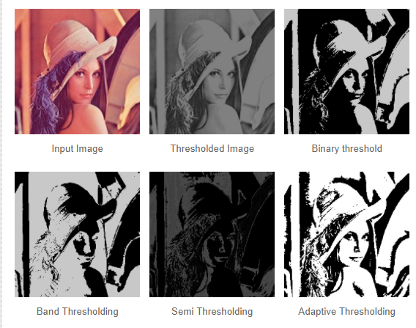

Threshold Image comes from the gray level of input image, and the pixel value beyond threshold value will be replace by 255(255 represents white, 0 represents black).

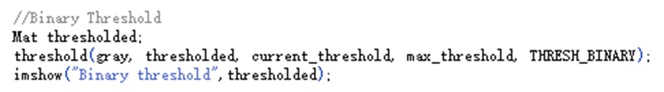

THRESH_BINARY is a method which convert image only in white and black color(each pixel will only be 0 or 255). So, image Binary is only in black and white

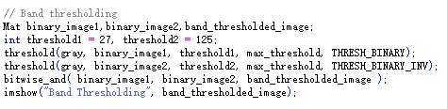

THRESH_BINARY_INV is reverse white to black, vice verse. Band thresholding is a image band image from THRESH_BINARY method and THRESH_BINARY_INV method

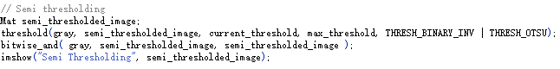

THRESH_OTSU is a method that will find a threshold value when the origin threshold value is not suitable.

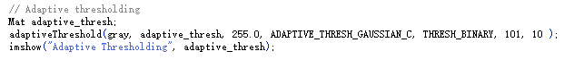

Function adaptiveThreshold() will extract a area and compare the mean value(or other methods) in this area with a pixel in order to define its value. Using this function means threshold value is not a const value but a dynamic suitable value. That’s why Adaptive Threshold is useful(Question 3).

The disadvantages of binary threshold:

I think some pixel value near the threshold value will be(or not )replace by threshold value. So, the result maybe not precise. The contour of origin image can not be display precisely.